Poly(I:C) source, molecular weight and endotoxin contamination affect dam and prenatal outcomes, implications for models of maternal immune activation.

Kowash HM^{1a}, Potter HG^{2a}, Edye ME³, Prinssen EP⁴, Bandinelli, S⁴, Neill JC³*, Hager R^{2b}, Glazier JD^{1,2b}

¹Division of Developmental Biology and Medicine, School of Medical Sciences, Faculty of Biology, Medicine and Health, Manchester Academic Health Science Centre, University of Manchester, Manchester M13 9WL, UK
²Division of Evolution and Genomic Sciences, School of Biological Sciences, Faculty of Biology, Medicine and Health, Manchester Academic Health Science Centre, University of Manchester, Manchester M13 9PT, UK
³Division of Pharmacy and Optometry, School of Health Sciences, Faculty of Medicine, Biology and Health, Manchester Academic Health Science Centre, University of Manchester, Manchester M13 9PT, UK
⁴Roche Innovation Centre, Basel, 124 Grenzacherstrasse, Basel, CH 4070, Switzerland

*Author for correspondence
Professor Jo Neill, Division of Pharmacy and Optometry, School of Health Sciences, Faculty of Medicine, Biology and Health, Manchester Academic Health Science Centre, University of Manchester, Manchester M13 9PT, UK. Joanna.neill@manchester.ac.uk, www.b-neuro.com

Authors’ note

ªHM Kowash and HG Potter shared first co-authorship.

^{b}R Hager and JD Glazier shared last co-authorship.
Abstract
The viral mimetic polyinosinic:polycytidylic acid (poly(I:C)) is increasingly used to induce maternal immune activation (mIA) to model neurodevelopmental disorders (NDDs). Robust and reproducible phenotypes across studies are essential for the generation of models that will enhance our understanding of NDDs and enable the development of improved therapeutic strategies. However, differences in mIA-induced phenotypes using poly(I:C) have been widely observed, and this has prompted the reporting of useful and much needed methodological guidelines. Here, we perform a detailed investigation of molecular weight and endotoxin variations in poly(I:C) procured from two of the most commonly used suppliers, Sigma and InvivoGen. We demonstrate that endotoxin contamination and molecular weight differences in poly(I:C) composition lead to considerable variability in maternal IL-6 response in rats treated on gestational day (GD)15 and impact on fetal outcomes. Specifically, both endotoxin contamination and molecular weight predicted reductions in litter size on GD21. Further, molecular weight predicted a reduction in placental weight at GD21. While fetal body weight at GD21 was not affected by poly(I:C) treatment, male fetal brain weight was significantly reduced by poly(I:C), dependent on supplier. Our data are in agreement with recent reports of the importance of poly(I:C) molecular weight, and extend this work to demonstrate a key role of endotoxin on relevant phenotypic outcomes. We recommend that the source and batch numbers of poly(I:C) used should always be stated and that molecular weight variability and endotoxin contamination should be minimised for more robust mIA modelling.

Key words: maternal immune activation, poly(I:C), endotoxin, molecular weight, IL-6, fetus, placenta, fetal brain, litter size, sex differences.
Highlights
- Poly(I:C) molecular weight (MW) and endotoxin vary significantly between suppliers.
- MW and endotoxin variability predicts rat maternal IL-6 response and litter size.
- MW variability predicts rat placental weight.
- Poly(I:C) supplier predicts a male-specific reduction in fetal brain weight.
Introduction
Maternal immune activation (mIA) caused by infection during pregnancy is an important risk factor for neurodevelopmental disorders (NDDs), such as schizophrenia, in offspring (Brown and Meyer, 2018; Conway and Brown, 2019; Mednick, 1988). To establish causative mechanisms, enabling identification of novel drug targets and more effective therapeutic interventions, global research effort has focussed on simulating infection during pregnancy in animal models and investigating subsequent neurodevelopmental phenotypes and behaviour (Estes and McAllister, 2016; Kentner et al. 2018; Meyer, 2014; Murray et al. 2019). Two of the most widely used immunostimulants, the viral mimetic polyinosinic:polycytidylic acid, poly(I:C), and the bacterial mimetic endotoxin lipopolysaccharide (LPS), induce mIA through activation of toll-like receptors (TLR) 3 and 4, respectively (Alexopoulou et al. 2001), resulting in the release of pro-inflammatory cytokines, with IL-6 and TNF-α responses the most extensively characterised (Alexopoulou et al. 2001; Kentner et al. 2018; Meyer 2014; Smith et al. 2007).

Lack of experimental reproducibility in biomedical research has been recognized as an issue of major concern (Baker 2016; Fanelli 2018), which is highly relevant to investigations using poly(I:C) because of mechanistic implications for modelling NDD pathways (Kentner et al. 2018). This issue has wider biomedical research impact in the fields of immunology (Alexopoulou et al. 2001), neurodegenerative disorders (McCabe et al. 2017), cancer biology and therapeutics (Bianchi et al. 2017). Reproducibility of mIA models is essential for the successful translation to clinically relevant end-points and the robust elucidation of mechanistic pathways for drug discovery.

In our recent mIA studies (Murray et al. 2019), we reported marked variability in maternal IL-6 response that appeared related to different batches of poly(I:C). This observation accords with a recent and thorough investigation demonstrating that IL-6 concentration in mouse maternal plasma, placenta and fetal brain was determined by variability of poly(I:C) molecular weight apparent in different batches from commercial suppliers (Mueller et al. 2019). Poly(I:C) molecular weight is known to impact on TLR3 activation and downstream pathways (Mian et al. 2013; Zhou et al. 2013). Endotoxin contamination of poly(I:C) is also known to affect downstream inflammatory profiles (Marshall-Clarke et al. 2007; Mian et al. 2013). Batch differences in poly(I:C) properties have previously been described (Chow et al. 2016; Harvey and Boksa, 2012), in agreement with a recent systematic evaluation conducted in mice (Mueller et al. 2019).

To first establish the scope of variability reported previously in poly(I:C)-induced mIA phenotypes, we conducted a review of the methodological parameters used in peer-reviewed original articles that reported the use of poly(I:C) to elicit mIA (Figure 1). Of the 175 studies identified, 75.4 % and 4.6 % used poly(I:C) from Sigma and InvivoGen, respectively, whilst 3.4 % used alternative suppliers and 16.6 % did not specify the supplier. We observed that poly(I:C) batches from Sigma differed in colour and texture, and elicited variable maternal cytokine responses (Murray et al. 2019). We thus hypothesised that supplier-dependent heterogeneity in poly(I:C) biophysical properties would impact on mIA responses and associated outcome measures (Kentner et al. 2018) in pregnant rats, leading to inconsistent outcome measures, as has been recently confirmed in a mouse mIA model (Mueller et al. 2019).

We therefore compared poly(I:C) from the two most commonly reported suppliers, Sigma (potassium salt; P9582) and InvivoGen (LMW; tlrl-picw), determining their biophysical properties, mIA (IL-6 response) and effects on phenotypic outcomes (litter size, placental, and fetal body and brain weights) in a rat mIA model recently established in our laboratory (Murray et al. 2019). We used the low molecular weight (LMW) poly(I:C) variant (0.2-1 kb) from InvivoGen, rather than the high molecular weight (HMW) form (1.5-8 kb), because a pilot study conducted in non-pregnant rats (as reported below) showed significant weight loss and mortality, in agreement with Careaga et al. (2018).

Methods
Review of poly(I:C)-induced mIA methodology
A PubMed search was conducted using the search terms ‘polyinosinic:polycytidylic acid maternal immune activation’ (193 papers), ‘poly IC maternal immune activation’ (185), and ‘poly I:C maternal immune activation’ (182) on 03/04/2019 in order to assess the source of poly(I:C) used and reporting of the maternal cytokine response. After removal of duplicates, the remaining 197 papers had the following exclusion criteria applied: reviews (8), commentary/letter to editor (4), in vitro studies (4), articles not translated into English (3), poly(I:C) not used to induce mIA (2), behavioural follow up from a previous mIA paper (1). We have used the PRISMA flow diagram template (Moher et al. 2009) to report the record identification and screening process (Figure 1).
Animals
Adult female Wistar rats were mated with adult male Wistar rats (both Charles River Laboratories, UK). Pregnant females were pair-housed in individually ventilated cages with split-level environmental enrichment (GR1800 Double-Decker Cage, Tecniplast, UK) in a temperature- and humidity-controlled housing room (maintained at 21 ± 2 °C and 55 ± 5 %, respectively) on a standard 12h:12 h light:dark cycle. Animals had ad libitum access to standard rat chow (Special Diet Services, UK) and water throughout. All procedures adhered to the Animals (Scientific Procedures) Act 1986 and were approved by the University of Manchester Animal Welfare and Ethical Review Body.
Poly(I:C) treatment
A pilot study conducted at Roche examined the effects of InvivoGen poly(I:C) HMW and LMW molecular weight forms in 16 non-pregnant adult Wistar female rats (RccHan Envigo, group-housed). Both LMW (lot number PIW-38-04) and HMW (lot number PIC-39-06) forms induced body weight loss (approximately 4 %) by 6 h post-treatment, previously validated by our group as a robust time point for assessing poly(I:C)-induced weight loss (Murray et al. 2019), unchanged thereafter with LMW poly(I:C). With HMW poly(I:C), a progressive decline (up to 10 %) in body weight was observed over 48 h with mortality of 2/8 females at 24 h post-treatment in a subsequent study (HMW lot number PIC-39-04). For this reason, LMW poly(I:C) from InvivoGen was used in all subsequent studies.

Female Wistar rats (n=85) with a mean baseline weight of 265.4 ± 2.2 g were timed-mated and the presence of a vaginal plug taken as gestational day 1 (GD1, term is GD23). Dams were randomised to treatment or vehicle groups. Using our established methodology, pregnant Wistar rats received a single intraperitoneal injection of 10 mg/kg body weight poly(I:C) or corresponding vehicle solution on GD15 (Murray et al. 2019). Poly(I:C), obtained from Sigma (buffered with potassium salt, catalogue number P9582, lot numbers 095M4086V and 096M4023V) or InvivoGen (low molecular weight form, catalogue number tlrl-picw, lot numbers PIW-39-01 and PIW-40-01) was reconstituted according to suppliers’ recommendations at a concentration of 10 mg/ml. The number of dams treated with each lot number were: Sigma 095M4086V, 32; Sigma 096M4023V, 7; InvivoGen PIW-39-01, 11; InvivoGen PIW-40-01, 35. Vehicle was sterile 0.9 % saline or endotoxin-free physiological water for Sigma and InvivoGen sources, respectively. At 3 h post-treatment, a tail vein blood sample was taken from the dam, and centrifuged at 14,000 xg for 1 min, and plasma collected for cytokine analysis.
Fetal harvests
On GD21, dams were anesthetised with 5 % Isoflurane (Abbott, UK) in 2 L/min oxygen and culled by cardiac puncture. All fetuses and placentas were quickly removed from the uterine horn and weighed, following which fetal brains were removed and weighed.
IL-6 assay
Maternal plasma IL-6 concentration was measured 3 h post-treatment as a robust and validated marker of the maternal pro-inflammatory response (Kentner et al. 2018; Murray et al. 2019) using a rat-specific ELISA (Abcam, UK; catalogue number ab100772 or R&D, UK; DuoSet DY506). The intra- and inter-assay coefficients of variation were 4.1 and 11.8 %, respectively.
Endotoxin concentration
Endotoxin concentration in poly(I:C) samples was measured by ToxinSensorTM Chromogenic LAL Endotoxin Assay Kit (GenScript, USA; catalogue number L00350) according to the manufacturer’s instructions.
Molecular weight analyses
Multi-angle light scattering (MALS) was conducted at the University of Manchester Biomolecular Analysis Core Facility to determine poly(I:C) molecular weight. As this technique had not been used previously to quantify molecular weight of poly(I:C) species, loading was based on technical recommendations. An input of 20-50 μg poly(I:C) was loaded onto the column depending on availability of each sample; for all samples the concentration of poly(I:C) loaded remained constant to allow for direct comparison between light-scattering data. A Superose 6 10/300 GL column (GE Healthcare Life Sciences, UK) was used with a total column volume of 24 ml based on the manufacturer’s instructions for samples of an estimated molecular weight between 5-5000 kDa. The column was flushed with phosphate-buffered saline Dulbecco A (ThermoFisher Scientific, USA) using the NGC chromatography system (Bio-Rad, USA) at a flow rate of 0.75 ml/min with maximum pre- and intra-column pressures of 230 and 218 psi respectively. For the light scattering measurement, the column was connected to the Dawn Heleos II, OptiLab reX, and WyattQELS modules (Wyatt technology, UK). The differential index of refraction (dn/dc) was taken as 0.188 ml/g based on previous studies of RNA sedimentation rates (Boedtker, 1968). All MALS data was analysed using Astra version 6.1 (Wyatt technology, UK) using 1 ml fractions from 7.5-16.5 ml column flow-through to determine both the mean molecular weight and the molecular weight distribution.

In addition to the lot numbers used for poly(I:C) injections, an additional lot number from both Sigma (086M4045V) and InvivoGen (PIW-38-04, as used in our pilot study) were used for both endotoxin and molecular weight analyses. Hence, three lot numbers of poly(I:C) from each supplier were evaluated.
Agarose gel electrophoresis
As a low-cost alternative to MALS, poly(I:C) molecular weight differences were visualised by non-denaturing agarose gel electrophoresis. A 1.5 % agarose gel was prepared with 0.01 % GelRed stain (Biotium, USA) and approximately 1 µg poly(I:C) was mixed with 2 μl 5X loading buffer (Bioline, UK) and separated by electrophoresis at 120 V for approximately 2 h.
Statistical analysis
Data are presented as mean ± SEM. For litter size and IL-6 analyses, each data point refers to a dam. For poly(I:C) molecular weight and endotoxin analyses, data points refer to a single vial (‘batch’) of poly(I:C) which may have been used to treat up to five dams. For placenta weights each data point refers to the mean value per litter. Placenta, fetal body and fetal brain weight were analysed as individual data points nested within the dam as a random factor. Sex was analysed as a predictor for outcome variables (Hager et al. 2008). Univariate general linear models (GLMs) and general linear mixed models (GLMMs) were used to analyse data in SPSS (version 22) with treatment group and supplier as fixed factors and other covariates such as litter size where appropriate. For GLMMs, the Satterthwaite approximation was used to estimate degrees of freedom.

Results
Maternal plasma IL-6 concentration was significantly increased by poly(I:C) in both supplier groups and exhibited greater variability with Sigma poly(I:C) compared to InvivoGen (GLM, F_{1,73}=17.47, p<0.001; Figure 2A). Furthermore, we observe that a subgroup of dams treated with a single lot number (Sigma; 096M4023V) appeared to have no IL-6 response to poly(I:C) compared to vehicle. Endotoxin concentration was higher in Sigma poly(I:C) than in InvivoGen poly(I:C), by an order of magnitude, and InvivoGen poly(I:C) consistently exhibited negligible endotoxin contamination (GLM, F_{1,12}=155.78, p<0.001; Figure 2B). Endotoxin concentration was the strongest predictor of maternal IL-6 response (GLM, F_{1,78}=32.96, p<0.001). Supplier (GLM, F_{1,78}=5.26, p=0.025), molecular weight (GLM, F_{1,78}=17.38, p<0.001) and the interaction between molecular weight and endotoxin (GLM, F_{1,78}=29.08, p<0.001) also significantly predicted maternal IL-6.

Supplier differences in polymeric poly(I:C) molecular weight were then investigated by MALS. InvivoGen poly(I:C) exhibited lower inter-batch (vials of the same lot number) variability and mean molecular weight compared to Sigma poly(I:C) (GLM, F_{1,17}=12.85, p=0.003; Figure 2C, 2D). Notably, molecular weight for Sigma poly(I:C) was highly variable (mean molecular weight 100-325 kDa; Figure 2C), compared to the more uniform distribution for InvivoGen poly(I:C) (151-166 kDa; Figure 2E). In agreement with this observation, InvivoGen poly(I:C) batches migrated in an unvarying manner by gel electrophoresis, indicative of similar molecular weight, while Sigma poly(I:C) demonstrated highly variable migratory patterns, revealing a more heterogeneous poly(I:C) population (Figure 2F). To further understand and visualise the influence of poly(I:C) variability on the maternal pro-inflammatory response, molecular weight and endotoxin were plotted against IL-6 response (Figure 3A and B, respectively), revealing distinct clustering of the response as a function of supplier and treatment group.

Litter size was significantly reduced in dams treated with Sigma poly(I:C) but not with InvivoGen (GLM, F_{3,86}=4.41, p=0.006; Figure 4A). Both molecular weight and endotoxin had a significant negative effect on litter size (GLM, F_{1,79}=10.34, p=0.002; and GLM, F_{1,79}=11.22, p=0.001). Placental weight at GD21 was predicted by treatment group (GLMM F_{1,31}=4.24, p=0.048); placentas in the poly(I:C)-treated group were significantly lighter (Figure 4B). Furthermore, placenta weight was significantly reduced with increasing poly(I:C) molecular weight (GLMM, F_{1,25}=4.72, p=0.039), whilst endotoxin had no effect (GLMM, F_{1,26}=1.98, p=0.171). While the only significant predictor of fetal body weight was sex, with males being heavier (GLMM, F_{1,480}=33.60, p<0.001), fetal brain weight was significantly reduced in the poly(I:C) groups (GLMM, F_{1,30}=8.34, p=0.007). This was driven by a significant reduction in brain weight in the Sigma poly(I:C) group, which caused a 1.5 % reduction in brain weight compared to vehicle (GLMM, F_{1,20}=5.64, p=0.028). There was no such effect in the InvivoGen poly(I:C) group (GLMM, F_{1,8}=0.11, p=0.749). Further, the interaction between treatment group and supplier predicted the reduction in fetal brain weight but only in the Sigma poly(I:C) group (GLMM, F_{2,30}=5.12, p=0.012). As expected sex also had a significant effect on fetal brain weight (GLMM, F_{1,481}=3.98, p=0.047) and it was the sex-specific treatment group*supplier interaction which predicted a reduction in brain weight in males exposed to Sigma poly(I:C) (GLMM, F_{3,28}=3.85, p=0.020; Figure 4C) but not females (GLMM, F_{3,35}=0.54, p=0.657; Figure 4D).
Discussion
We have demonstrated that poly(I:C) from the two most commonly used commercial suppliers, Sigma and InvivoGen, differs substantially in its biomolecular characteristics, particularly with respect to molecular weight and endotoxin concentration. The significant interaction between poly(I:C) molecular weight and endotoxin contamination predicted maternal IL-6 responses, which were most variable with Sigma poly(I:C), contingent upon its inherent molecular weight variability and profound endotoxin contamination. In agreement with our findings, mice treated with Sigma poly(I:C) showed a 17-fold difference in maternal IL-6 response between three poly(I:C) batches (Harvey and Boksa, 2012). The broad molecular weight distribution of Sigma poly(I:C) species between lot numbers, containing some high molecular weight forms, is likely to have important outcome consequences. For example, Zhou et al. (2013) demonstrated that high molecular weight poly(I:C) evokes greater efficiency of TLR3 activation in human primary macrophages and neuroblastoma cell lines compared to low molecular weight poly(I:C). Mian et al. (2013) reported that the molecular length of poly(I:C) can differentially influence cytokine production in a cell-specific manner. These findings from cell-based models are highly relevant to animal models of mIA. Administration of poly(I:C) of an unpredictable and unspecified molecular weight composition into a complex in vivo system with multiple cell types, is likely to have important consequences for reproducibility of immune responses and downstream effects, ultimately leading to variability in outcome measures. Indeed, a very recent study has demonstrated this in a mouse mIA model, reporting divergent IL-6 responses both with respect to low and high molecular weight poly(I:C) forms, and also with different poly(I:C) batches, with these observations extending to both the maternal and fetal compartments (Mueller et al. 2019).

Our study extends these observations in pregnant rat dams, investigating poly(I:C) molecular weight and endotoxin content as contributing factors to maternal IL-6 response, with determination of their influence on fetal phenotypic variability. In common with the study of Mueller et al. (2019), we have compared poly(I:C) obtained from two commercial suppliers, Sigma and InvivoGen, and report effects of poly(I:C) molecular weight and endotoxin contamination on maternal IL-6 response, litter size, placental, fetal and fetal brain weights. Importantly, in contrast to Mueller et al. (2019), who concluded that molecular size of poly(I:C) species was likely to drive the observed variable immune responses, with minimal contribution to variability from endotoxin contamination, our data are consistent with an interaction between both of these factors influencing the elicited maternal immune response and fetal phenotypic outcomes. This discrepancy in the role of endotoxin in modulating the maternal cytokine response to poly(I:C) may be caused by, and further highlight the importance of, batch differences within Sigma samples. For example, Mueller et al. (2019) report no marked contamination of poly(I:C) with endotoxin, with most samples having a comparable endotoxin concentration to commercially available endotoxin-free saline. Indeed, only one Sigma poly(I:C) sample in that study had evidence of endotoxin contamination, reported to be 7-10 fold higher than vehicle solutions. In comparison, all of the Sigma poly(I:C) samples analysed in our study had a markedly increased endotoxin concentration of 31-54 times compared to vehicle.

This has profound implications for mechanistic interpretations, as maternal IL-6 is commonly used to indicate effectiveness of the mIA paradigm, with fetal brain and offspring behavioural deficits in mIA models dependent on the magnitude of the elicited maternal IL-6 response (Kentner et al. 2018; Mueller et al. 2019; Murray et al. 2019). Furthermore, IL-6 responses previously attributed solely to the action of poly(I:C), may also be influenced by endotoxin contamination, affecting mechanistic interpretation. Our review of 175 published mIA studies revealed that only a relatively small proportion of studies (approximately 30%) presented data on maternal cytokine response, so the interpretation that outcome effects and phenotypic traits are solely attributable to TLR3-mediated activation may be misleading if poly(I:C) is endotoxin-contaminated (Kentner et al. 2018). Administration of poly(I:C) contaminated with endotoxin will lead to concurrent activation of TLR3 and TLR4, exacerbating pro-inflammatory cytokine responses, supported by our observations here.

To understand more fully the impact of poly(I:C) properties on pathways underpinning NDDs and arising phenotypes, we investigated the effects of poly(I:C) molecular weight and endotoxin variation on key prenatal traits. Reduced litter size has been demonstrated when mIA was induced by InvivoGen high molecular weight poly(I:C) (Ballendine et a. 2015) and endotoxin (LPS) (French et al. 2013). The interaction between the two factors, and variability between batches, may account for disparate observations of reduced (Holloway et al. 2013; Lipina et al. 2013; Yee et al. 2011; this study) or unchanged (Murray et al. 2019; Naviaux et al.2013; Oh-Nishi et al. 2016; Vuillermot et al. 2011) litter size when Sigma poly(I:C) was used. Endotoxin contamination can lead to overstimulation of TLR moieties with exacerbated induction of downstream signalling pathways, such as pro-apoptotic pathways (Monguio-Tortajada et al. 2018). This may contribute to the reductions in placental and fetal brain weights observed here, in agreement with previous observations of endotoxin-induced reduced placental weight (Cotechini et al. 2014) and stimulated fetal brain apoptosis (Boksa, 2010). Notwithstanding this, poly(I:C) from both suppliers can induce a raised placental IL-6 concentration (Hsiao and Patterson, 2011; Koga et al. 2009; Mueller et al. 2019), associated with a reduced placental weight, as shown here and previously (Murray et al. 2019), together with disrupted placental morphological integrity (Koga et al. 2009).

In summary, we show that poly(I:C) molecular weight and endotoxin contamination vary profoundly between batches of the same lot number, having significant individual and interacting effects, impacting on maternal immune responses and subsequent developmental outcome measures. With the widespread use of poly(I:C) as a viral mimetic to induce mIA (Kentner et al. 2018; Meyer 2014; Murray et al. 2019; Smith et al. 2007), consistent poly(I:C) molecular properties and negligible endotoxin contamination are essential to reduce variability in phenotypic outputs, as demonstrated here. This will promote confidence in robust mechanistic interpretation, with the potential for identification of novel biomarkers and loci as therapeutic targets. Finally, we strongly concur with the conclusion of others that the molecular characteristics and properties of poly(I:C) can vary substantially between suppliers and also potentially within different poly(I:C) batches from the same individual supplier. We fully uphold the recommendation that quality control measures regarding poly(I:C) should be implemented to improve the reproducibility of outcomes in mIA models, irrespective of the experimental species used (Mueller et al., 2019).
Acknowledgements
HMK is the recipient of a University of Manchester President’s Doctoral Scholarship, HGP is the recipient of a BBSRC PhD studentship. We gratefully acknowledge funding support from b-neuro.

The authors are very grateful to Dr Thomas Jowitt and Mrs Diana Ruiz Nivia of the Biomolecular Core Facility at the University of Manchester for their help with the molecular weight analysis, Professor Rosalind John at Cardiff University for providing some of the Sigma poly(I:C) samples and Dr Anthony Vernon and Dr Michael Harte for their critical input.
References
Alexopoulou, L. et al. Recognition of double-stranded RNA and activation of NF-kappaB by Toll-like receptor 3. Nature 413, 732-738 (2001).

Baker, M. 1,500 scientists lift the lid on reproducibility. Nature 533, 452-454 (2016).

Ballendine, S. A. et al. Behavioral alterations in rat offspring following maternal immune activation and ELR-CXC chemokine receptor antagonism during pregnancy: Implications for neurodevelopmental psychiatric disorders. Prog. Neuro-Psychopharmacol. Biol. Psychiatry 57, 155-165 (2015).

Bianchi, F. et al. Exploiting poly(I:C) to induce cancer cell apoptosis. Cancer Biol. Ther. 18, 747-756 (2017).

Boedtker, H. Dependence of the sedimentation coefficient on molecular weight of RNA after reaction with formaldehyde. J. Mol. Biol. 35, 61-70 (1968).

Boksa, P. Effects of prenatal infection on brain development and behavior: A review
of findings from animal models. Brain Behav. Immun. 24, 881–897 (2010).

Brown, A. S., Meyer, U. Maternal immune activation and neuropsychiatric illness: a translational research perspective. Am. J. Psychiatry 175, 1073-1083 (2018).

Careaga, M. et al. Variability in PolyIC induced immune response: Implications for preclinical maternal immune activation models. J. Neuroimmunol. 323, 87-93 (2018).

Chow, K. H. et al. Induction of maternal immune activation in mice at mid-gestation stage with viral mimic poly(I:C). J. Vis. Exp. e53643 (2016).

Conway, F., Brown, A. S. Maternal immune activation and related factors in the risk of offspring psychiatric disorders. Front. Psychiatry 10, 430 (2019).

Cotechini, T. et al. Inflammation-induced fetal growth restriction in rats is associated
with altered placental morphometrics. Placenta 35, 575-581 (2014).

Estes, M. L., McAllister, A.K. Maternal immune activation: Implications for neuropsychiatric disorders. Science 353 (6301), 772–777 (2016).

Fanelli, D. Opinion: Is science really facing a reproducibility crisis, and do we need it to? Proc. Natl. Acad. Sci.115, 2628-2631 (2018).

French, S. S. et al. Maternal immune activation affects litter, success, size and neuroendocrine responses related to behavior in adult offspring. Physiol. Behav. 119, 175-184 (2013).

Hager, R. et al. Sex dependent imprinting effects on complex traits in mice. BMC Evol. Biol. 8, 303 (2008).

Harvey, L. & Boksa, P. A stereological comparison of GAD67 and reelin expression in the hippocampal stratum oriens of offspring from two mouse models of maternal inflammation during pregnancy. Neuropharmacology 62, 1767-1776 (2012).

Holloway, T. et al. Prenatal stress induces schizophrenia-like alterations of serotonin 2A and metabotropic glutamate 2 receptors in the adult offspring: role of maternal immune system. J. Neurosci. 33, 1088-1098 (2013).

Hsiao, E. Y., Patterson P.H. Activation of the maternal immune system induces endocrine changes in the placenta via IL-6. Brain Behav. Immun. 25, 604–615 (2011).

Kentner, A. C. et al. Maternal immune activation: reporting guidelines to improve the rigor, reproducibility, and transparency of the model. Neuropsychopharmacology 44, 245-258 (2018).

Koga, K. et al. Activation of TLR3 in the trophoblast is associated with preterm delivery. Am. J. Reprod. Immunol. 61,196-212 (2009).

Lipina, T. V. et al. Maternal immune activation during gestation interacts with Disc1 point mutation to exacerbate schizophrenia-related behaviors in mice. J. Neurosci. 33, 7654-7666 (2013).

Marshall-Clarke, S. et al. Polyinosinic acid is a ligand for toll-like receptor 3. J. Biol. Chem. 282, 24759-24766 (2007).

McCabe, K. et al. Time-course of striatal Toll-like receptor expression in neurotoxic, environmental and inflammatory rat models of Parkinson’s disease. J. Neuroimmunol. 310, 103-106 (2017).

Mednick, S. A. Adult schizophrenia following prenatal exposure to an influenza epidemic. Arch. Gen. Psychiatry 45, 189-192 (1988).

Meyer, U. Prenatal poly(I:C) exposure and other developmental immune activation models in rodent systems. Biol. Psychiatry 75, 307-315 (2014).

Mian, M. F. et al. Length of dsRNA (poly I:C) drives distinct innate immune responses, depending on the cell type. J. Leukoc. Biol. 94, 1025-1036 (2013).

Moher, D. et al. Preferred reporting items for systematic reviews and meta-analyses: the PRISMA statement. PLoS Med. 6, e1000097 (2009).

Mueller, F. S. et al. Influence of poly(I:C) variability on thermoregulation, immune responses and pregnancy outcomes in mouse models of maternal immune activation. Brain Behav. Immun. 1591, 30121-30127 (2019).

Murray, K. M. et al. Evolution of a maternal immune activation (mIA) model in rats: Early developmental effects. Brain Behav. Immun. 75, 48-59 (2019).

Naviaux, R. K. et al. Antipurinergic therapy corrects the autism-like features in the poly(IC) mouse model. PLoS One 8, e57380 (2013).

Oh-Nishi, A. et al. A possible serologic biomarker for maternal immune activation-associated neurodevelopmental disorders found in the rat models. Neurosci. Res. 113, 63-70 (2016).

Smith, S. E. et al. Maternal immune activation alters fetal brain development through interleukin-6. J. Neurosci. 27, 10695-10702 (2007).

Vuillermot, S. et al. Nurr1 is not essential for the development of prepulse inhibition deficits induced by prenatal immune activation. Brain Behav. Immun. 25, 1316-1321 (2011).

Yee, N. et al. Differential effects of maternal immune activation and juvenile stress on anxiety-like behaviour and physiology in adult rats: no evidence for the “double-hit hypothesis”. Behav. Brain Res. 224, 180-188 (2011).

Zhou, Y. et al. TLR3 activation efficiency by high or low molecular mass poly I:C. Innate Immun. 19, 184-192 (2013).

Figure legends
Figure 1. Review of published studies identifiied from PubMed on 03/04/2019, reporting methodological outcomes using poly(I:C) to induce maternal immune activation.

Figure 2. Effect of poly(I:C) supplier on IL-6 response, endotoxin concentration and molecular weight distribution.
A). Measurement of IL-6 concentration in maternal plasma at 3 h post-injection as a marker of poly(I:C)-induced inflammatory response. Sigma poly(I:C) induced a significantly increased and highly variable IL-6 response. This contrasts with InvivoGen poly(I:C), which produced a much less variable and lower IL-6 response, although still significantly higher than vehicle. Each data point represents an individual dam. Bars and error bars represent mean ± SEM. B). Sigma poly(I:C) had a significantly greater concentration of endotoxin compared to InvivoGen poly(I:C). Each data point represents an individual vial of poly(I:C). C) Molecular weight distribution of poly(I:C) quantified using MALS for Sigma poly(I:C) showed that this was far more heterogeneous both within and across batches (blue line for reference represents a quadratic line of best fit to InvivoGen poly(I:C) mean molecular weight distribution with 95 % confidence intervals shown in light blue compared to InvivoGen poly(I:C). Each data point represents a 1ml flow-through fraction from the MALS column, each line represents an individual vial of poly(I:C). D) Mean molecular weight of poly(I:C), which relates to the length of the nucleotide chain, was quantified by MALS. Each data point represents an individual vial of poly(I:C) with bars and error bars showing mean ± SEM. E) Molecular weight distribution of poly(I:C) quantified using MALS for InvivoGen poly(I:C). Each data point represents a 1 ml flow-through fraction from the MALS column, each line represents an individual vial of poly(I:C). F) Non-denaturing agarose gel electrophoresis was used as a simple, inexpensive, and fast method to visualise molecular weight differences between suppliers and/or lot numbers of poly(I:C). The gel shown demonstrates both the heterogeneity of Sigma poly(I:C) samples within and between lot numbers as well as the homogeneity of InvivoGen poly(I:C) samples both within and between lot numbers. A 1 kb ladder is shown in the far right lane. Data points represent dams (2A) or vials of poly(I:C) (2B-F) with symbol types (open, closed, dotted) representing shared lot numbers (Sigma 086M4045V, red closed square, not used for in vivo study; Sigma 095M4086V, red open square, 14 vehicle/18 poly(I:C) dams treated; Sigma 096M4023V, red dotted square, 3 vehicle/4 poly(I:C) dams treated; InvivoGen PIW-38-04, blue dotted square, not used for in vivo study; InvivoGen PIW-39-01, blue closed square, 5 vehicle/6 poly(I:C) dams treated; InvivoGen PIW-40-01, blue open square, 19 vehicle/16 poly(I:C) dams treated). *p<0.05, **p<0.01, ***p<0.001.

Figure 3. Effect of poly(I:C) molecular weight and endotoxin concentration on the maternal IL-6 response shows clustering of supplier and treatment groups.
A) InvivoGen LMW poly(I:C) (blue) has lower mean molecular weight with less variability in than Sigma (red) leading to a more homogenous maternal IL-6 response. B) Endotoxin contamination is low in both InvivoGen vehicle (blue circles) and poly(I:C) samples (blue squares) resulting in a less variable maternal IL-6 response. Whilst Sigma vehicle samples (red circles) also have a low endotoxin concentration and induce a homogenous maternal IL-6 response, Sigma poly(I:C) (red squares) have a consistently elevated endotoxin concentration and induce a wide range of maternal IL-6 responses. Clustering of suppliers and treatment groups are highlighted for clarity. Data points represent vials of poly(I:C) with symbol types (open, dotted) representing shared lot numbers (Sigma 095M4086V, red open square; Sigma 096M4023V, red dotted square; InvivoGen PIW-38-04, blue dotted square; InvivoGen PIW-40-01, blue open square). All scales are log₁₀ transformed to aid data visualisation. Number of dams treated per lot number: Sigma 095M4086V, red open square, 14 vehicle/18 poly(I:C) dams treated; Sigma 096M4023V, red dotted square, 3 vehicle/4 poly(I:C) dams treated; InvivoGen PIW-40-01, blue open square, 19 vehicle/16 poly(I:C) dams treated.

Figure 4. Effect of poly(I:C) on litter size and placental and fetal brain weights at gestational day 21.
A) A reduction in litter size was observed in pregnant female Wistar rats treated with Sigma, but not InvivoGen, poly(I:C). Each data point represents an individual dam with bars and error bars representing mean ± SEM. B) Placental weight was significantly reduced by poly(I:C) in both groups. Placenta weight at GD21 was predicted by treatment group and poly(I:C) molecular weight. C) The interaction between treatment group*supplier predicted a significant reduction in male fetal brain weight at GD21, specifically in the Sigma group, and D) not observed in females. Each data point refers to an individual fetus. *p<0.05, **p<0.01.
Figure 1

PRISMA 2009 Flow Diagram
Full-text articles excluded, with reasons
(n=10 total; n=4 in vitro study, n=3 not translated, n=2 poly(I:C) not used, n=1 follow up study)
Records excluded
(n=12 total; n=8 review articles, n=4 commentary/letter)
Full-text articles assessed for eligibility
(n=185)
Records screened
(n=197)
Studies included in quantitative synthesis (meta-analysis)
(n=0)
Studies included in qualitative synthesis
(n=175)
Records after duplicates removed
(n=197)
Additional records identified through other sources
(n=0)

Identification

Eligibility

Included

Screening
Records identified through database (PubMed) searching
(n=560)

Figure 2
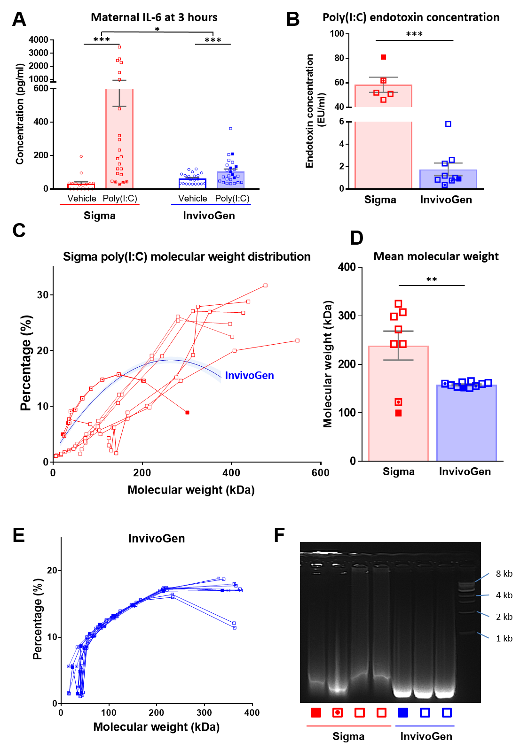
Figure 3
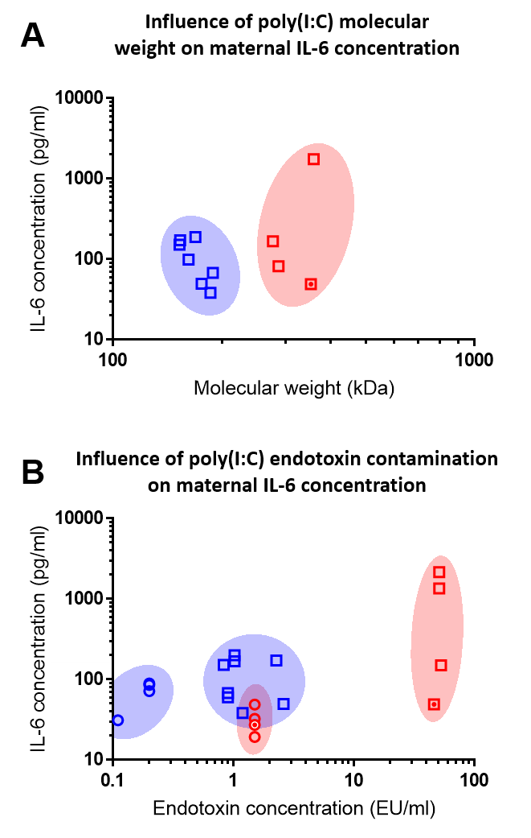
Figure 4
