Tuning the Charge Carriers Migration in Epitaxial BaTiO₃ Thin Film Photoanodes
H. Magnan^{1*}, P. M. Deleuze², J. Brehin¹, T. Plays¹, D. Stanescu¹, W. R. Flavell³, M. G. Silly⁴, B. Domenichini², A. Barbier¹
¹ Université Paris-Saclay, CEA, CNRS, Service de Physique de l'Etat Condensé, 91191, Gif-sur-Yvette, France.
² Laboratoire Interdisciplinaire Carnot de Bourgogne, UMR 6303 CNRS-UBFC, 21078 Dijon Cedex, France
³ Faculty of Science and Engineering Department of Physics and Astronomy School of Natural Sciences The University of Manchester Alan Turing Building Oxford Road Manchester M13 9 PL UK
⁴ Synchrotron SOLEIL, Saint-Aubin - BP48, F-91192 Gif-sur-Yvette Cedex, France

Abstract.
We studied the growth of epitaxial ferroelectric layers BaTiO₃/Pt(001) in the framework of solar water splitting. The stoichiometry, i.e. the Ti/Ba ratio, appears as a crucial parameter not only for the crystallographic structure but also for the photocurrent generation when the sample is used as photoanode. We established an electrochemical poling method using a modulated potential, without altering the sample to control the electric polarization. Importantly, we show that the photoanode efficiency is improved when the polarization of the film is oriented towards the substrate. We demonstrate that this improvement is only due to the electrical field created by screening charges, which allows the separation of photo-generated charges.

- INTRODUCTION
The transformation of solar light into chemical energy in the form of hydrogen, using photoelectrochemical water splitting, is a seductive energy-harvesting/generation method with the important advantage of being environment-friendly and free from carbon dioxide emission.^{1,2} However, highly efficient photoelectrodes are needed to make the method competitive as compared to steam reforming of hydrocarbons. Since the pioneering discovery of photo-assisted water electrolysis using semiconducting TiO₂ in 1972 by Fujishima and Honda,¹ many others oxide materials (Fe₂O₃, WO₃, BiVO₄,...) have been tested for this application.³⁻⁶ Nevertheless, these oxides do not fulfil all the requirements that include stability, light absorption, charge separation and fast reaction kinetics at the electrolyte/semiconductor interface. Different strategies (e.g. doping, nanostructure designs, heterojunction) have been developed to tackle these challenges.^{5,7} In the case of photoanodes, the upward energy band bending at their surfaces is a crucial factor that favors the photocatalytic oxygen evolution reaction,⁸ and the built-in field inside the space charge region (SCR) acts for the separation of photogenerated charges. A SCR can appear in a p-n junction, however the driving forces are limited by the small gap value of the semiconductors used.⁹
Another approach to overcome this limitation is to replace the conventional semiconductor by ferroelectric material in photoelectrodes. Indeed, in ferroelectric-based photovoltaic devices, the spontaneous electric polarization is the driving force behind the photocurrent improvement. Moreover and contrary to conventional p-n junctions where the photovoltage is limited to the electronic bandgap, ferroelectrics can produce voltages that are significantly higher than the band gap.¹⁰ The impact of ferroelectricity in the framework of photocatalytic applications has been studied.^{11,12} In particular, these studies proposed that the screening of the internal polarization induces band bending at the surface which favours oxidation (respectively, reduction) reactions in the case of an internal polarization pointing towards (respectively, outwards) the substrate.^{13,14} The potential use of ferroelectric materials in the framework of solar water splitting is an emerging and promising subject,¹⁵⁻¹⁷ with numerous studies concerning for instance BiFeO₃.¹⁸⁻²⁰ Among them, few publications tried to study the role of the ferroelectric polarization.¹⁵⁻¹⁸ In all these experiments, authors show an increase of the photoanode efficiency when the electric polarization is oriented towards the backside of the electrode. However, puzzling questions remain open as for example: (i) is the higher efficiency due to an improvement of the surface reactivity, and/or to an improvement of the charge separation? and (ii) what are exactly the collateral modifications in the sample induced by the electric polarization?
Bulk BaTiO₃ is a ferroelectric material at room temperature exhibiting a ferroelectric to paraelectric phase transition at about 130 ° C accompanied by a tetragonal to cubic structural transition.²¹ The ferroelectric phase can be stabilized in strained epitaxial layers.²² In a previous study,¹⁵ we showed that epitaxial BaTiO₃ thin films are well-suited for studying the influence of polarization on the photoelectrochemical properties. However, the films were deposited on Nb:SrTiO₃(001), a substrate that shares several properties with the film, like the presence of titanium and oxygen and the positive response to photoelectrolysis. Therefore, with those films it was difficult to detect possible alterations of the sample during the photoelectrochemical measurements and/or the polarization procedure.
Besides, in order to study the role of the polarization on the photoelectrochemical efficiency, it is necessary to establish a non-destructive method to master the electric polarization on large surface which remains a quite tricky issue for freestanding surfaces. In the literature several poling procedures have been proposed, including polarization in electrolyte^{15,23} or electrode on surface.⁹ However, in these studies the authors did not study the possible alteration of the sample surface induced by the poling method.
In the present work we study single crystalline thin films of barium titanate (BaTiO₃) deposited on Pt(001) crystal substrates. The films were elaborated by atomic oxygen assisted molecular beam epitaxy (AO-MBE). AO-MBE allows a fine control of the growth conditions and in particular of the thin films’ stoichiometry and crystalline quality, and avoids the growth of oxygen deficient layers, which have been shown to exhibit reduced ferroelectric properties.²⁴ The epitaxial growth of BaTiO₃/Pt(001) was theoretically predicted²² but not yet experimentally established. Indeed, the face centered lattice parameter of platinum is 0.392 nm, i.e. 1.8 % lower than the in-plane lattice parameter of BaTiO₃ (0.399 nm). The present work aims at studying the photoelectrochemical properties of BaTiO₃/Pt(001) films, especially the influence of the surface stoichiometry and the pristine as well as a potential imposed electrical polarization.

- EXPERIMENTAL SECTION
Sample preparation. Barium titanate was deposited on single-crystalline Pt(001) using AO-MBE, a technique that makes possible the deposition of single crystalline layers of controlled stoichiometry, morphology and thickness.^{4,15,25-29} High purity Ba and Ti (99.99% grade) metals were evaporated from dedicated Knudsen cells in the presence of an atomic oxygen plasma (high brilliance, 350 W power). We obtained well-defined oxides under good vacuum conditions (i.e. 10⁻⁷ mbar working pressure, 10⁻¹⁰ mbar base pressure). The substrate was first radiatively heated at a temperature of ca. 450 °C, with a filament located behind the sample under oxygen plasma during one hour prior to the deposition, a procedure that leads to clean and well define Pt(001) surface. During the growth, the sample was kept at 450°C. The typical oxide deposition rate was estimated to about 0.06 nm/min, thanks to a quartz microbalance. The thickness of one film was cross-checked by specular X-ray reflectivity.
Crystallographic structure and chemistry. In situ Reflection High Energy Electron Diffraction (RHEED) patterns were observed and acquired during film growth to monitor the crystalline structure and the quality of the samples. In situ X-ray photoelectron spectroscopy (XPS) spectra were systematically recorded just after the deposition in order to determine the stoichiometry and the electronic structure of the films. Ti2p, Ba3d, O1s core levels were recorded using Al K_{α} radiation. The composition was also determined in situ by Auger electron spectroscopy (AES) by measuring the Ti_{LMM}/Ba_{MMN} ratio.³⁰
Photoelectrochemistry. The photoelectrochemical water splitting response of our films was studied using a three electrodes cell. All the electrochemical measurements were performed at the room temperature using a NaOH 0.1M solution as electrolyte, a platinum wire as counter electrode and an Ag/AgCl electrode for the potential reference (V_{Ag/AgCl} = +0.97 V vs. RHE). The sample was mounted as anode (working electrode) using a dedicated sample holder designed to allow contact only between the barium titanate surface and the electrolyte. The illumination source was a Newport 1000 W Xe Arc Lamp with an infrared filter providing an incident light flux of around 100 mW/cm² (measured with a Newport 1918-R Power Meter). Potential control and current acquisition between the three electrodes realized using a Princeton Applied Research (PAR) 263A potentiostat controlled by a computer. For photocurrent density – voltage curves, J(V), the potential was swept from -1 V to +0.7 V vs. Ag/AgCl at a rate of 50 mV/s. The photocurrent is defined as the difference between the current recorded under light and without light (dark).
Piezoresponse Measurements. Piezoresponse force microscopy (PFM) images were recorded using a Brücker Dimension ICON microscope under Nanoscope V controller, which is part of the Interdisciplinary Multiscale Atomic Force Microscopy Platform (IMAFMP) at the SPEC laboratory. PFM performed in contact mode was used both to write micron-sized domains by applying various DC voltages on the tip while the backside of the substrate is grounded (PFM-poling) and to read ferroelectric polarization maps at the remanence after the poling (PFM-reading). The PFM-poling with a positive potential applied on the sample surface is expected to induce a remnant polarization oriented towards the substrate (noted P↓) inside the ferroelectric layer, while a negative potential is expected to induce a remnant polarization oriented towards the surface (noted P↑). During the PFM-reading procedure, we measure both the amplitude and the phase of the PFM signal which describe completely the polarization vector at the remanence: amplitude and orientation. The PFM-reading was carried out by applying a drive amplitude (AC voltage) of ± 2V on the sample while the tip was grounded. While the method is great to determine the electric polarization orientation it is not convenient to pole a sample on large surface.
Electrochemical Poling of the sample: a method of soft poling in electrolyte (EC-poling) was developed in order to minimize alteration of sample during poling the procedure. EC-poling was performed in the photoelectrochemical cell, in dark, using NaOH 0.1M as electrolyte. In order to obtain a polarization oriented towards the substrate (i.e. EC-P↓) a DC bias of -0.7 V vs. Ag/AgCl was applied to the sample with the superimposition of a sinusoidal signal of 10 mV amplitude with frequencies varying continuously from 100 kHz down to 10 Hz. The EC-poling procedure lasted 50 minutes. We tested that both the sinusoidal signal with different frequencies and a minimum of 45 minutes duration are necessary for an efficient poling. In order to obtain a polarization oriented towards the surface (i.e. EC- P↑), all parameters remain the same except that the DC bias has to be switched to + 0.7 V vs. Ag/AgCl .
Time-resolved photoelectron spectroscopy (TRPES) was carried out by using a laser-pump / synchrotron radiation (SR) probe method³¹ on the TEMPO beamline³² at synchrotron SOLEIL (Saint-Aubin, France). We used a synchrotron photon energy of 825 eV and two types of laser excitation source : a 10 kHz ns-pulsed laser and acontinuous wave laser emittting at 355 nm and 375 nm , respectively. The laser are operated in a pseudo-continuous mode modulated with a 50% duty cycle at a period up to 2s which induced surface photovoltage (SPV). The surface photovoltage (SPV) was determined by measuring the binding energy of the O1s core level.

- RESULTS AND DISCUSSION

Structure and chemistry.
RHEED patterns of the 10 nm thick BaTiO₃ (001) film grown on a Pt (001) single crystal, shown on figure 1, features straight streaks accounting for an epitaxial two-dimensional growth of the (001) perovskite structured overlayer. Indeed, the observed patterns are consistent with the modelled surface reciprocal lattices depicted on figure 1 (middle) assuming a cube (perovskite) on cube (FCC) <100>_{BaTiO3} // <100>_{Pt} epitaxial relationship. In addition to the structural phase identification, we have also derived from the RHEED patterns strike distances, the evolution of the in-plane lattice parameter as reported on figure 2. Its evolution is consistent with an in-plane compressive epitaxial strain: it progressively increases from the substrate lattice parameter to an asymptotic value. Full lattice relaxation is completed at about 20 nm. The asymptotic value of lattice parameter is estimated ca. 0.400 ± 0.02 nm, a value slightly lower than bulk in-plane parameters of BaTiO₃ at 750K (0.4015 nm) and of BaTiO₃ grown on SrTiO₃ (001) (0.405 nm).³⁰

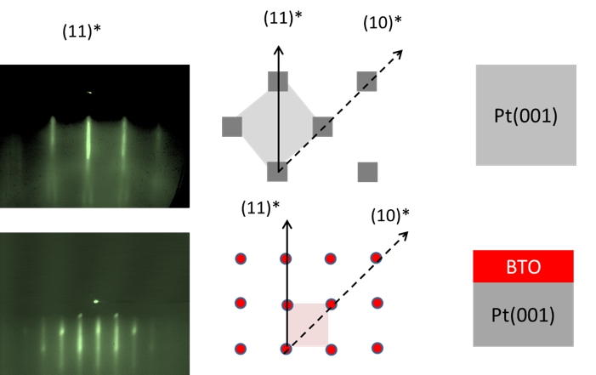
Figure 1. (Left panel) RHEED patterns of a 10 nm thick BaTiO₃ film grown by AO-MBE on Pt (001), prior to (up) and at the end of deposition (down) over the (11)* direction. (middle panel) The corresponding surface reciprocal lattices assuming a cube (perovskite) on cube (FCC) <100>BaTiO3 // <100>Pt epitaxial relationship are represented: making explicit the diffraction directions, the apparent elementary surface unit cell (in the reciprocal space) is also shown. For Pt(001), because it is a face centered cubic (FCC) structure its primitive surface lattice is rotated by 45° with respect to the cube reciprocal space due to extinction rules excluding the h + k = 2n + 1 spots.
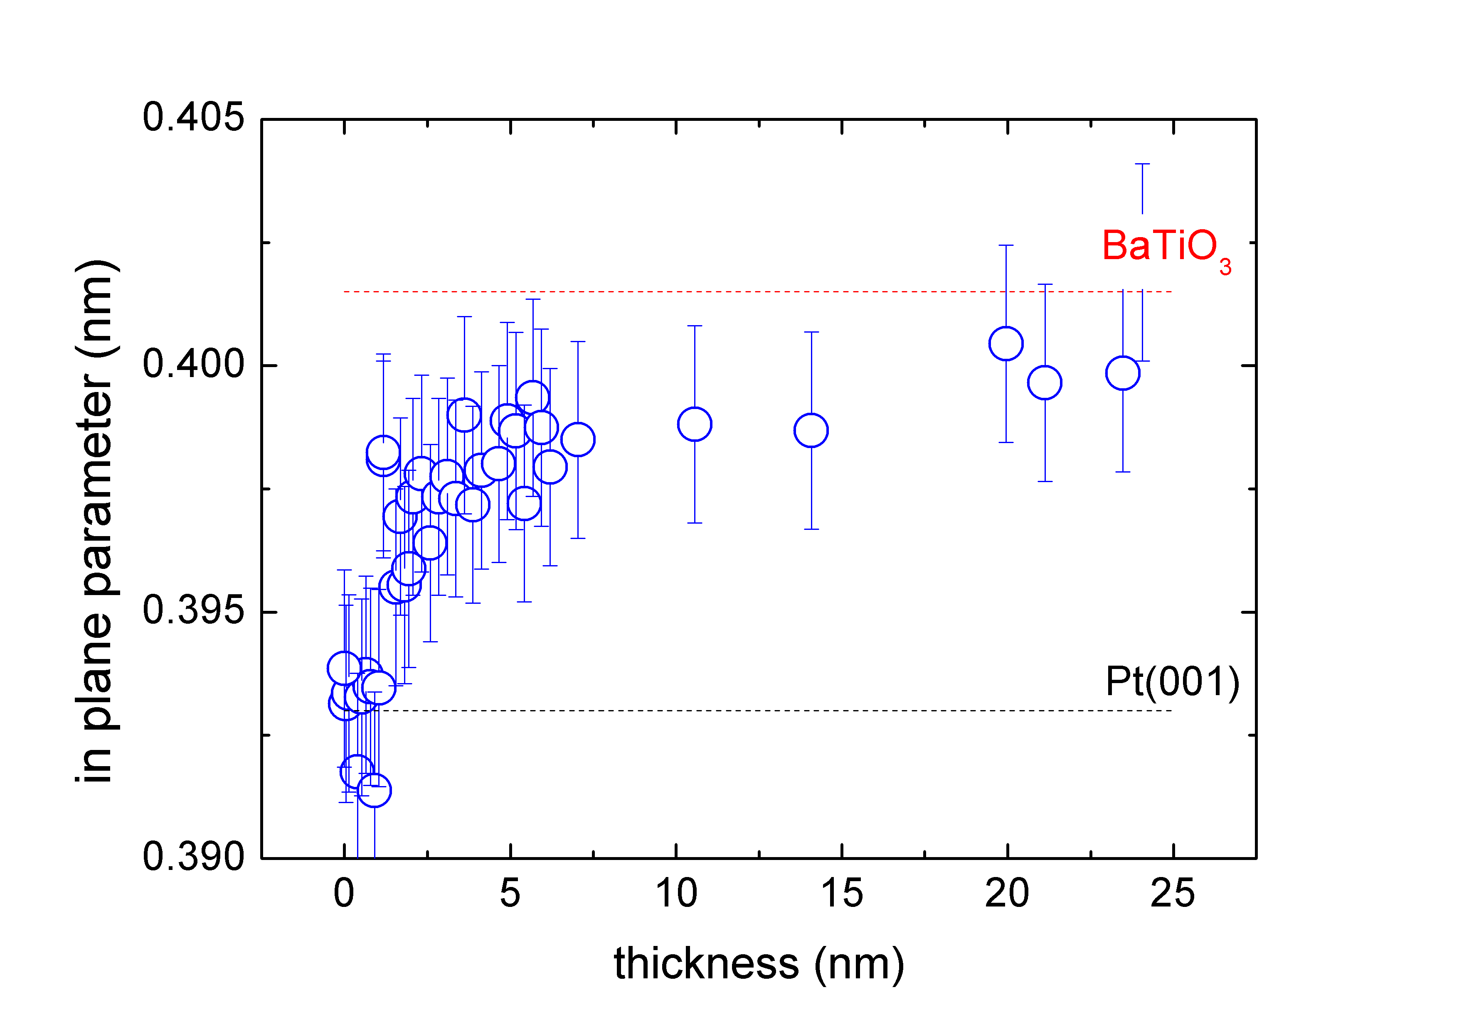
Figure 2. In-plane lattice parameter derived from (11)* direction RHEED patterns as a function of the film thickness for BaTiO₃ film grown by AO-MBE on Pt (001). Dashed lines stand for the lattice parameter of bulk BaTiO₃ and Pt (001) at the deposition temperature (900K) (taking into account the thermal expansion).

Influence of the layer composition (Ti/Ba ratio) on crystallographic structure and on photocurrent.
When BaTiO₃ is grown on SrTiO₃(001), the crystallographic quality of the film is dependent on Ba/Ti ratio,³⁰ and the films having the best RHEED pattern exhibit a raw AES Ti _{LMM}/Ba_{MNN} ratio of ~1.2 which corresponds to a BaO rich surface layer. For BaTiO₃ films deposited on Pt(001), we observed similar phenomena, the RHEED patterns with sharp and straight lines are observed only when the AES ratio is between 1 and 1.8. However, these films exhibit a large range of photocurrent values (typically between 0.001 and 1 mA/cm² at 0.5 V vs Ag/AgCl). The photocurrent may depend on several parameters like thickness of the film, Ti/Ba ratio, and ferroelectric polarization. In order to understand the role of each parameter we have plotted on figure 3: the photocurrent bulk density, i.e. the photocurrent density (J) divided by the thickness of the BaTiO₃ film (θ_{BTO}), as a function of the AES Ti/Ba ratio. First, no significant photocurrent can be measured for films below 3 nm. A more precise analysis of figure 3 shows that the photocurrent bulk density (J/θ_{BTO}) is not constant, which means that the photocurrent is not proportional to the thickness of the film i.e. the amount of light-absorbing material. Moreover, an overall tendency can be evidenced: a higher Ti/Ba ratio, whatever the thickness, is favorable for photocurrent bulk density, the higher photocurrent is also concomitant with a higher RHEED quality. It appears that the best RHEED patterns of BaTiO₃/Pt(001) films are obtained when the Ti/Ba ratio is between 1.3 and 1.8, i.e. still corresponding to a BaO rich layer on surface, but with a lower thickness than in the case of films grown on SrTiO₃(001) substrate. Besides, when comparing different films having the same thickness (10 nm) (crosses in figure 3), one observes that two samples having an equivalent AES Ti/Ba ratio can exhibit very different photocurrent values. It shows that beyond chemical composition and thickness, other parameters, like polarization, can influence the photocurrent.
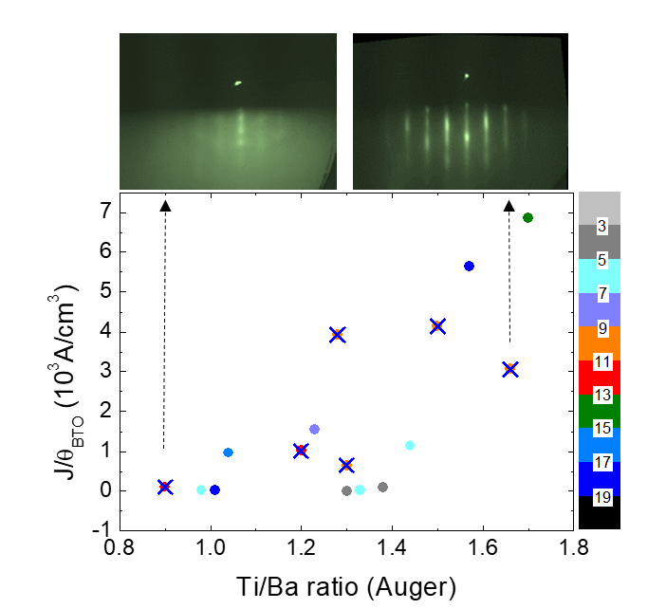
Figure 3. (lower panel) Photocurrent bulk density ((J/θ_{BTO}), see text) as a function of AES Ti _{LMM}/Ba_{MNN} ratio for different films (thickness from 2 nm to 25 nm) of BaTiO₃ film grown by AO-MBE on Pt (001) at 0.5 v vs Ag/AgCl, (circles of different color, corresponding to different thicknesses). Crosses correspond to films with a thickness of 10 nm. Color scale indicate the value of thickness in nm. (upper panel) RHEED patterns over the (11)* direction for two 10 nm BaTiO₃/Pt (001) films with Auger ratio of 0.9 (left) and 1.66 (right).

BaTiO₃ stability in the electrolyte.
When studying photoelectrodes, it is mandatory to evaluate their stability with respect to the electrolyte and/or with respect to the photoelectrochemical reaction. During the photoelectrochemical experiment (J(V) scans) we observe no significant modification of the photocurrent even after one hour of experiment, showing that the sample is stable with respect to the photoelectrochemical reaction. However the XPS spectra of the sample (after reaction) show that the photoelectrochemical experiment induces deposition of carbon on the surface and a relative diminution of Ba species (see figure 4). More precisely, the (Ti/Ba)_{XPS} ratio deduced from the area of Ti2p_{3/2} and Ba3d_{5/2} photoemission peaks and corrected by the respective Scofield factors vary from 0.63 (on the as-grown sample) to 0.75 (on the same sample after photoelectrolysis). The shape of the Ti2p peak remains unchanged while the higher binding energy Ba3d components (at 781.5 eV and 796.9 eV) vanish after photoelectrolysis (figure S1, see supporting information). These components correspond to a chemical state of Ba often labelled Baβ, which corresponds to Ba near the topmost surface region.^{30,33} We have already shown³⁰ that this β component is decreasing after ethanol bath. Here we show that the surface Ba atoms are also instable in NaOH at pH 13. Let us note that this modification of the surface (decrease of barium surface species) is observed as soon as the surface is immersed in the electrolyte, but further baths have no effect. Therefore, the photoanode surface that reacts during the photoelectrolysis experiment is already the modified surface, with less barium, and which remains stable during photoelectrolysis.

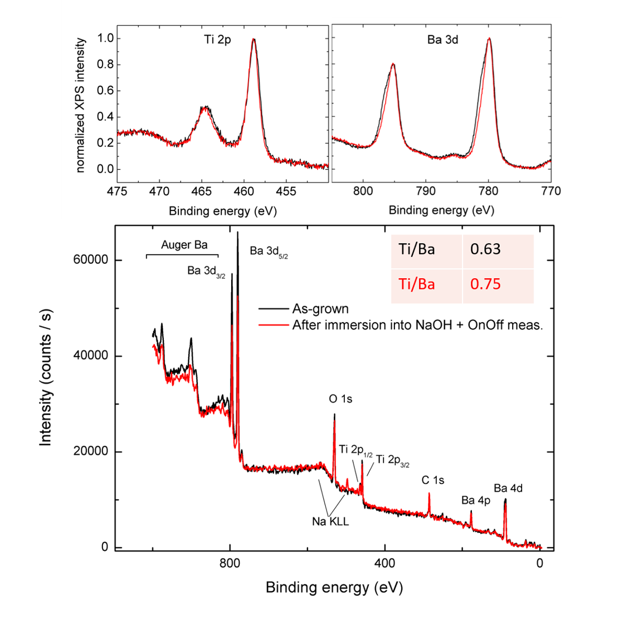

Figure 4. Photoemission scans for a 10 nm BaTiO₃/Pt (001) films with AES Ti/Ba ratio =1.3 , as grown sample (black), after photoelectrochemical measurements (red). (lower panel) survey scans, (inset) corresponding (Ti/Ba)_{XPS} ratio; (upper panel) normalized Ti 2p and Ba 3d photoelectron peaks.

Influence of the ferroelectric polarization.
In a previous paper¹⁵, we determined that when the polarization of BaTiO₃ films is oriented towards the substrate (P↓) it is favorable for an efficient photoelectrolysis. However, the method used in this publication, involving high voltage (8 V) in an electrolyte, induces not only the change of the polarization but also drastic chemical changes in the film and/or even its dissolution in the electrolyte. Indeed, using very high voltages to polarize ferroelectric films can also induce ion migration and resistance changes.³⁴ Therefore, in the present study, we developed a softer poling method: EC-poling (see experimental section), and special care was taken to follow any changes in film composition during the EC-poling. The on-off current density curves for different EC polarizations are shown on figure 5. It confirms that the EC-P↓ is favorable when the BaTiO₃ film is used as photoanode. With respect to the EC-P↑ state, the EC-P↓ induces a sizeable reduction of the onset potential on the J(V) curves equal to 0.64 V and an increase by a 2.3 factor of the photocurrent at 0.2 V vs Ag/AgCl. By applying different successive EC poling, we observe that the values of photocurrent are not completely reversible (see inset of figure 5), which could be interpreted as if the EC-P↓ state cannot be easily reverted. One can also notice no significant modification of transient currents between different states of polarization, showing that the kinetics at the surface is not influenced by the polarization.
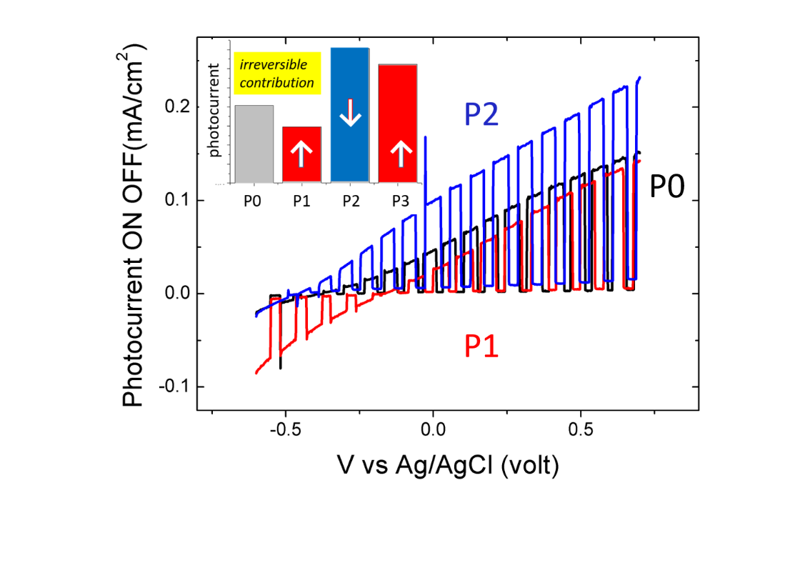
Figure 5. On-off current density versus applied voltages vs Ag/AgCl for a 10 nm BaTiO₃/Pt (001) films with AES Ti/Ba ratio =1.5 for different successive EC-poling: as-grown: P0 (black line), EC- P↑ poled: P1 (red line) and EC- P↓ poled: P2 (blue line). (inset) photocurrent density at 0.2 V vs Ag/AgCl for different successive polarizations: P0 (gray), P1(red), P2 (blue), EC- P↑ poled: P3 (red).
Since the EC - P↓ polarization is the best one for photoelectrolysis, we have characterized this polarization state in detail. Just after the growth, the films were characterized by PFM and for most of them the polarization is found to be slightly oriented towards the substrate (P↓). However, we noticed that a long annealing under oxygen plasma at 500°C might lead to a mainly P↑ polarized film. Indeed, on figure 6 (a,c), one can clearly see that the PFM images acquired on an annealed film, the surface regions PFM-poled with ± 8 V exhibit contrast in both amplitude and phase images. The well-defined phase contrast of 176° between the two PFM-poled regions confirms the ferroelectric character of the film (figure 6, f). Moreover, there is no phase contrast between the unpoled region and the -8V PFM-poled regions, meaning that the polarization of this annealed film is probably mostly P↑ oriented. The PFM images recorded on the same sample after the EC-P↓ polarization are represented on figure 6 (b,d). The phase contrast between the two PFM-poled regions is still high (165°), however the unpoled region in the phase image is no longer homogeneous and at least 50 % of its surface is now oriented like + 8V PFM-poled zone. Therefore, the polarization of the film has changed in order to be now more P↓ polarized, showing that the EC-poling procedure is efficient. The PFM amplitude images are consistent with these observations: on the annealed sample, before the EC-poling, higher amplitude is observed when the sample is PFM-poled with -8V in the same direction than the native one, while on the EC-P↓ polarized sample the amplitudes of both PFM-poled zones are of the same level.

The electronic structure of the sample before and after the EC-poling has been studied by XPS (figure 7). Intensity and shape of the photoemission peaks are almost unchanged after the EC-poling process, showing that the procedure does not alter the film. Only the positions of the photoemission peaks are modified: a rigid shift of 0.25 eV of binding energy for all the photoemission peaks towards higher binding energy is observed. This phenomenon can be seen as a further proof of P↓ polarization, since previous studies evidenced a decrease of photoemission threshold for positive PFM-poled zone.¹⁵ Indeed, the decrease of the photoemission threshold leads to a rigid shift of all the photoemission peaks towards higher binding energy.

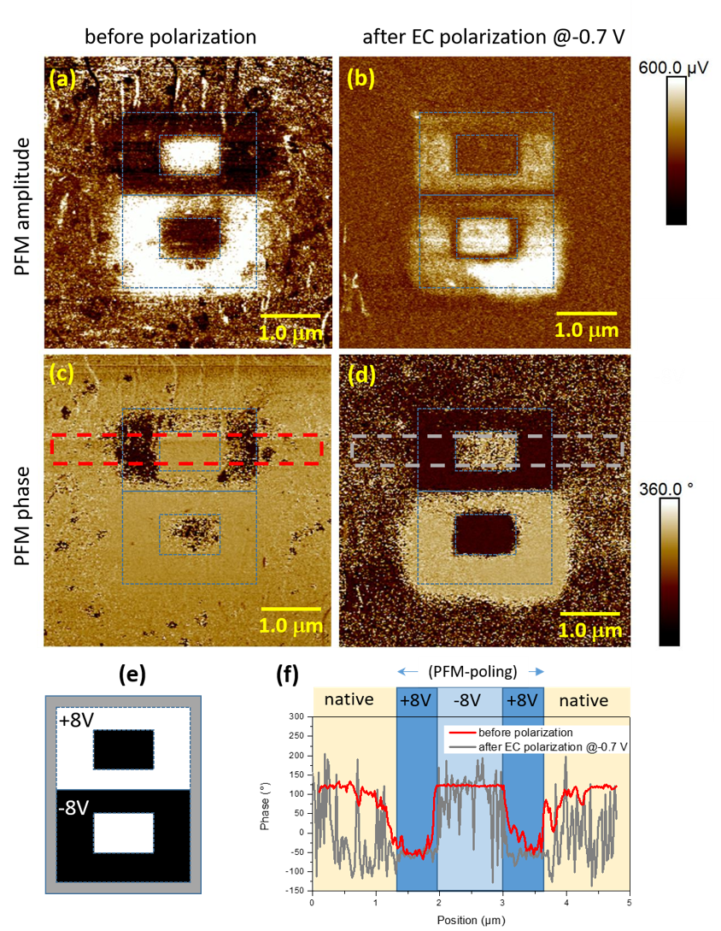
Figure 6. PFM amplitude images (a,b) and PFM phase images (c,d) at ferroelectric remanence after PFM-poling using the pattern (e) composed of -8V (black) and +8V (white) regions. These PFM images were recorded on an 18 nm BaTiO3/Pt (001) film with AES Ti/Ba ratio =1.6 after long 500°C annealing under oxygen plasma (a,c) and after EC- P↓ poling (b,d). The polarization of the film is deduced from the contrast between both PFM PFM- P↓ and PFM- P↑ poled zones and the native zone of the sample part not influenced by the PFM (external part of the images). (f) Phase profile corresponding to the highlighted region in (c,d) marked by the dashed red and gray rectangles, respectively.
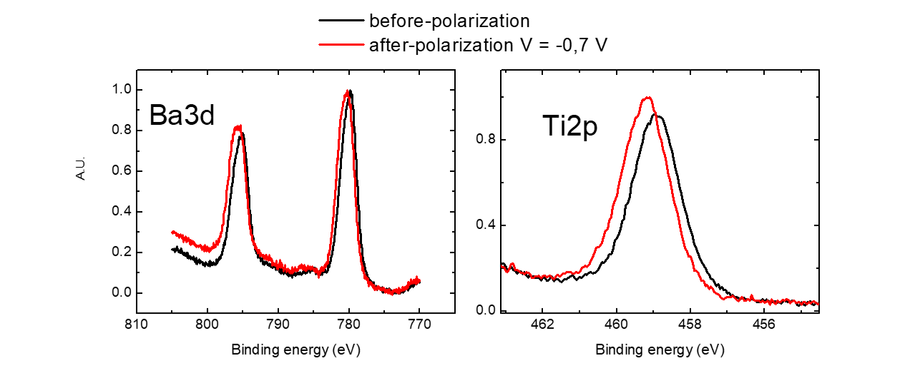
Figure 7. Ba3d and Ti2p photoemission peaks recorded on the same sample than in figure 6: an 18 nm BaTiO₃/Pt (001) film with AES Ti/Ba ratio =1.6 after long 500°C annealing under oxygen plasma (black line) and after EC- P↓ polarization (red line).

In order to bette understand the exact role of the P↓ polarization on the photocurrent efficiency, we have measured different films by time-resolved (TR) spectroscopy. This method allows to measure the charges carrier lifetime.³⁵ Three representative samples were measured (figures 8, S2-3, see supporting information): sample S1, a long time annealed sample, which is P↑ polarized, as determined by PFM; sample S2, an as-grown sample, naturally slightly P↓ polarized and sample S1-EC-POL, sample S1 after EC-P↓. The position of the O1s photoemission peak of sample S1 during laser modulation is represented on figure 8. When the laser is on, the steady-state kinetic energy is higher than the value in the dark, and same sign for this kinetic energy shift (ΔKE) is observed for the three measured films. Both ΔKE onset and decay are fitted using exponential curve derived from reference ³⁶:
$∆KE\left(t\right)=∆V exp⁡{\left(\frac{t}{τ}\right)}^{β}$ Eq.(1)
where ΔKE(t) is the relative position of the O1s peak, ΔV is the O1s shift theoretically recorded at saturation, τ is the decay time constant and β is a decay exponent which should be between 0 and 1. The fit parameters are indicated on figure 8. In the following, we will discuss the decay curves. Under illumination, core level shift toward higher kinetic energy can have two different origins: (i) surface photovoltage for a p-type semiconductor, or a (ii) photoconductance phenomena. We will discuss and examine these two hypothesis in the following.

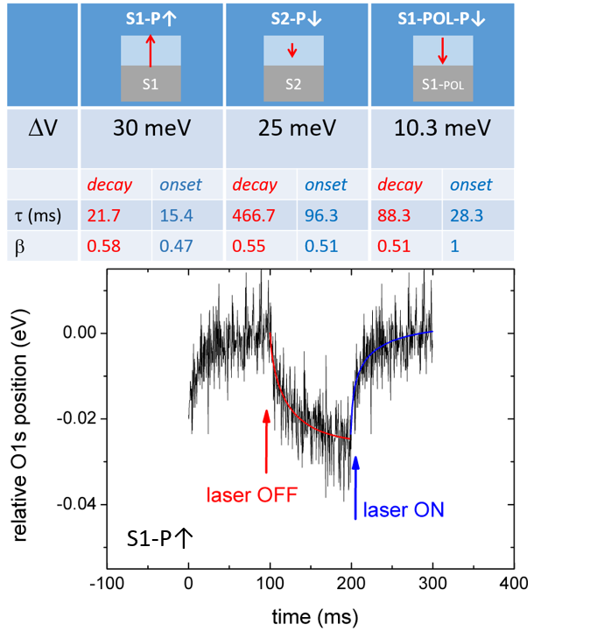
Figure 8. (table) parameters of the decay and onset fits using Eq. (1) for S1-P↑: 25 nm BaTiO₃/Pt (001) film after long 500°C annealing under oxygen plasma, mainly P↑ polarized determined by PFM. S2-P↓: 10 nm BaTiO₃/Pt (001) naturally P↓ polarized determined by PFM. S1-EC-POL-P↓: S1 sample after EC- P↓ polarization. (bottom) relative kinetic energy of O1s peak recorded on the S1–P↑ sample, during laser modulation. The laser modulation is indicated by the arrows. The decay and onset are fitted using Eq. (1) decay (red line), onset (blue line).

According to the theory developed in reference ³⁵, one can discriminate between n and p type semiconductors by looking at the sign of kinetic energy shift. In the case of a p-type semiconductor, after photoexcitation by the laser, the transfer of electrons towards the surface favored by the built in electric field, is accompanied by a reduced downward band bending (figure S4, see supporting information). Since X-ray photoemission is surface sensitive (few nm), the probed region is thinner than the depletion region and all the photoemission peaks are shifted towards higher kinetic energies when the laser is on. According to this model, a higher kinetic energy with laser on corresponds to a surface photovoltage of p-type semiconductor, while an n-type semiconductor exhibits lower kinetic energy with laser on. The three studied films exhibit positive SPV, i.e. the sign of p-type semiconductors. Since BaTiO₃ thin films are expected to be n-type, this result is surprising. However, if the films exhibit a downward band bending (p-type semiconductor), one expects this band bending to increase when the amount of negative charges increases at the surface, which is the case when the P↑ polarization increases. In a TR experiment ΔV can be an evaluation of band bending since the laser on state at saturation corresponds to flat band while laser off corresponds to regular band bending condition. Therefore, according to the value of polarization, we expect ΔV(S1)> ΔV(S2) > ΔV(S1-POL) and it is what we observe. Moreover, in this case, electrons migrate towards the surface when the laser is on, and according to the field in the charge region, we will expect that the lifetime of electrons at the surface will increase with the amount of band bending, therefore we expect τ(S1) > τ(S2) > τ(S1-POL). This second expectation is not met because both τ(S2) and τ(S1-POL) are higher than τ(S1) (see in parameter table in figure 8), thus we must examine the second hypothesis.

When the sample is insulating, charging phenomenon can occur during photoemission process. Charging phenomena in photoemission are known to increase the width of photoemission peaks and to shift the positions towards lower kinetic energies [37]. If the sample is illuminated with light, with a wavelength above the band gap, the charging phenomenon can disappear thanks to photoconductivity [38]. Thus, the photoemission peak will retrieve its normal position, i.e. a shift towards higher kinetic energy with respect to the measurement in dark. With this assumption, ΔV is expected to be proportional to the charging effect. The polarization in the film favors the photoemission yield when the polarization is oriented towards the surface (P↑) (scheme 1). The photoemission process leaves positive charges at the surface, which are completely compensated when laser is on, thanks to the photoconductance phenomena, and partially compensated when laser is off. We will now describe the current of compensation (J_{e}, electron current towards the surface). When the laser is off: J_{e} will be the sum of the drift current (J_{drift} :favored or not by the internal field) and the diffusion current (J_{diff}: due to carrier gradient). Assuming that charging intensity is proportional to the photoemission yield, we expect ΔV(S1)> ΔV(S2) > ΔV(S1-POL). Besides, positive charges are left by the photoemission process; their lifetime will depend on the velocity of electrons to reach the surface in order to compensate the positive charges. The internal field favors electrons drift towards the surface only when polarization is oriented towards the surface (P↑)(scheme 1), although the diffusion current (J_{diff}) of electrons is always oriented towards the surface. Therefore, assuming that conductivity and carrier diffusion constant remain the same for the three samples, we should have τ(S1)< τ(S2) < τ(S1-POL). However, we can see that the second inequality is not satisfied, the experimental lifetime of S1-POL being between the two others values. It means that in the S1-POL sample, the drift current is lower than predicted, the diffusion coefficient is higher or a new way to promote electrons towards the surface is possible. Importantly, it is known that artificial polarization may induce oxygen ion and vacancy migration leading to a drastic change of film resistance [34]. The EC-poling procedure at -0.7 V may also induce reduction of the sample and the migration of oxygen vacancies may lead to the formation of conductive filaments.³⁹ These conductive filaments can then act as new route for electron migration, and thus highly decrease the lifetime of positive charges at the surface, i.e. involving τ(S1-POL-R_{reduced}) << τ(S1-POL). Moreover, the decrease of the resistance of the BaTiO₃ film is confirmed by comparing the measurements of photoelectrochemical dark current recorded on sample S1 and S1-POL (figure 9). A summary of the mechanisms influencing lifetime with respect to polarization is illustrated on Scheme 1, assuming that the surface photovoltage measured in our samples is due to photoconductance phenomena. Hence, time-resolved spectroscopy seems to confirm that when polarization is oriented towards the substrate (resp. the surface), it favors the migration of electrons towards the substrate (resp. the surface), even though when the film is artificially EC-polarized, new conduction channels are created decreasing the film resistance.
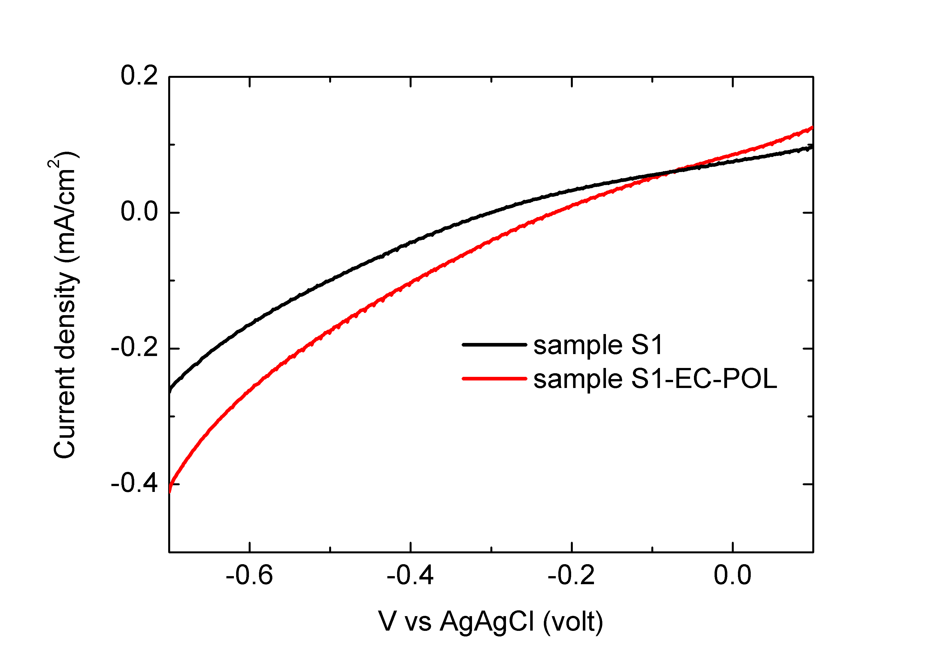
Figure 9. Dark current density recorded on S1-P↑, and S1-EC-POL-P↓ samples

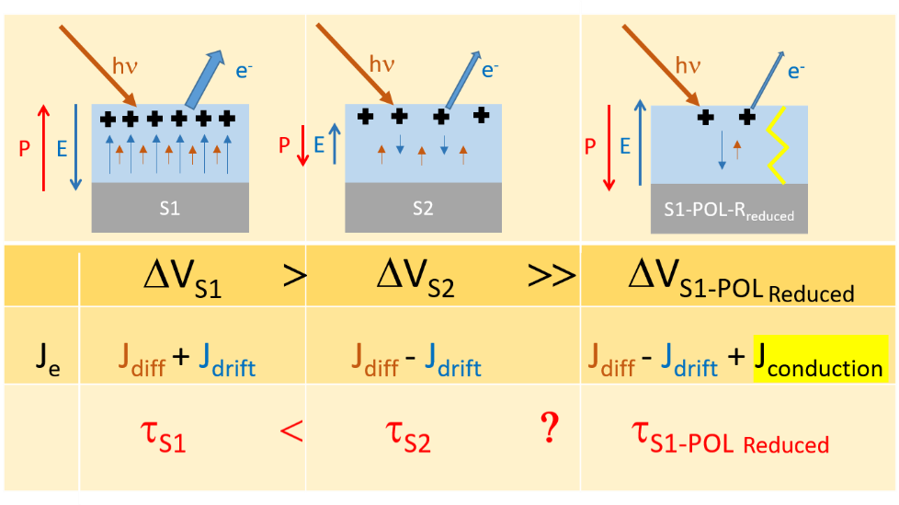
Scheme 1. Illustration of the mechanism of photoinduced core level shift due to photoconductivity. The kinetic energy shift is proportional to the amount of positive charges created during photoemission process. The lifetime is dependent on the capacity of electrons to reach the surface, i.e. the amount of current compensation (J_{e}). P and E are respectively the polarization and the depolarization field. Dark crosses schematize positive charge and blue arrows the electron drift current, brown arrows the diffusion current of electrons and yellow line the conducting filament.

Let us now discuss the two models. On one hand, we cannot exclude that the kinetic energy shift is due to change in band bending but with this model we have no explanation about the higher decay time for the S2-P↓ sample. Moreover, there is also no justification for a higher decay time in the S1-POL sample with lower resistance compared to the S1 sample, with higher resistance. On the other hand, the model of photoconductance allows to explain the sign and the amplitude of ΔKE, and the variation of decay time for the three samples. To explain why classical surface photovoltage does not occurs in these ferroelectric films let us rise some consideration. In ferroelectric films, the band bending is mainly due to charge screening, if the amount of screening charges cannot be easily modified by photogenerated charges (contrarily to the general semiconductor case) then the band bending remains rigid upon illumination. With this assumption, the ΔKE is then dominated by photoconductance phenomena.

- CONCLUSION
We studied the growth of BaTiO₃ thin films deposited on Pt(001). AO-MBE proved to be able to realize high quality crystalline epitaxial films. We evidenced that the Ti/Ba ratio is a critical parameter in order to obtain high quality RHEED patterns and measurable photocurrents. When the Ti/Ba ratio is outside the critical range, the low photocurrent is clearly correlated to the disordered crystallographic structure, which can increase the recombination rate and/or induce a detrimental change the depletion layer width. These films are suitable for studying the influence of the electric polarization on the photoelectrochemical and electronic properties. When the sample is introduced in the electrolyte, the extreme BaO surface layer is mostly removed. However, no further modifications are observed and the photocurrent is stable during the photochemical experiment. We developed a new efficient soft poling procedure based on modulated low potential, which preserves the quality of the film. This method allows us to confirm that the efficiency of the photoanode is higher when the electrical polarization is oriented towards the substrate. The polarization can be reverted but the procedure is not completely reversible. We have characterized in details the P↓ EC-poled film by PFM, XPS and TR spectroscopy, and compared with pristine P↓ or P↑ polarized films. These experiments evidence that P↓ polarization induces an electric field in the sample that favors the drift of electrons towards the substrate. However, the EC-polarized film is slightly different from pristine polarized film since it exhibits a decrease of resistance thanks to probable conductive filaments created during the poling procedure. These filaments may leave scars in the sample and thus explain the partial non-reversibility of the poling procedure.
The role of the polarization in the photoelectrochemical reaction can now be elucidated. The field induced by the polarization, created by internal screening charges, increases separation of photo-generated charges, but does not seem to influence the surface reactivity.

Corresponding Author (*)

E-mail : helene.magnan@cea.fr. Phone: +33 (0)1 69 08 94 04.
REFERENCES

[1] Fujishima, A.; Honda, K. Electrochemical Photolysis of Water at a Semiconductor Electrode. Nature 1972, 238, 37-38.
[2] Grätzel, M. Photoelectrochemical Cells. Nature 2001, 414, 338-344.
[3] Sivula, K.; Le Formal, F.; Gratzel, M. Solar Water Splitting: Progress Using Hematite (α-Fe2O3), Photoelectrodes. ChemSusChem 2011, 4, 432 – 449
[4] Rioult, M.; Magnan, H.; Stanescu, D.; Barbier, A. Single Crystalline Hematite Films for Solar Water Splitting: Ti-Doping and Thickness Effects. J. Phys. Chem. C 2014, 118, 3007-3014.
[5] Su, J.; Guo, L.; Bao, N.; Grimes, C.A. Nanostructured WO3/BiVO4 Heterojunction Films for Efficient Photoelectrochemical Water Splitting. Nano Lett. 2011, 11, 1928–1933
[6] Kim, T.W.; Choi, K-S. Nanoporous BiVO4 Photoanodes with Dual-Layer Oxygen Evolution Catalysts for Solar Water Splitting. Science 2014, 343, 990-994
[7] Sivula, K.; Le Formal, F.; Gratzel, M. WO3-Fe2O3 Photoanodes for Water Splitting: A Host Scaffold, Guest Absorber Approach. Chem. Mater. 2009, 21, 2862–2867
[8] Walter, M. G.; Warren, E. L.; McKone, J. R.; Boettcher, S.W.; Mi, Q.; Santori, E. A.; Lewis, N. S. Solar Water Splitting Cells. Chem. Rev. 2010, 110, 6446–6473
[9] Huang, W.; Harnagea, C; Tong, X.; Benetti, D.; Sun, S.; Chaker, M.; Rosei, F.; and Nechache, R. Epitaxial Bi2FeCrO6 Multiferroic Thin-Film Photoanodes with Ultrathin p‑Type NiO Layers for Improved Solar Water Oxidation. ACS Appl. Mater. Interfaces 2019, 11, 13185−13193
[10] Grinberg, I.; West, D. V.; Torres, M.; Gou,G.; Stein, D. M.; Wu, L.; Chen, G.; Gallo, E. M.; Akbashev, A. R.; Davies, P. K. et al. Perovskite Oxides for Visible-Light-Absorbing Ferroelectric and Photovoltaic Materials. Nature 2013, 503, 509-512
[11] Tiwari, D.; Dunn, S. Photochemistry on a Polarisable Semi-Conductor: What do we Understand Today? J. Mater. Sci. 2009, 44, 5063-5079
[12] Song, W.; Salvador, P. A.; Rohrer, G. S. Influence of the Magnitude of Ferroelectric Domain Polarization on the Photochemical Reactivity of BaTiO3. ACS Appl. Mater. Interfaces 2018, 10, 41450−41457
[13] Cui, Y.; Briscoe, Y.; Dunn, S. Effect of Ferroelectricity on Solar-Light-Driven Photocatalytic Activity
of BaTiO3-Influence on the Carrier Separation and Stern Layer Formation Chem. Mater. 2013, 25, 4215-4223
[14] Giocondi, J. L.; Rohrer, G. S. Spatially Selective Photochemical Reduction of Silver on the Surface of Ferroelectric Barium Titanate. Chem. Mater. 2001, 13, 241-242
[15] Rioult, M.; Datta, S.; Stanescu, D.; Stanescu, S.; Belkhou, R.; Maccherozzi, F.; Magnan, H.; Barbier, A. Tailoring the Photocurrent in BaTiO3/Nb:SrTiO3 Photoanodes by Controlled Ferroelectric Polarization. Appl. Phys. Lett. 2015, 107, 103901/1-4
[16] Yang, W.; Yu, Y.; Starr, M.B.; Yin, X.; Li, Z.; Kvit, A.; Wang, S.; Zhao, P.; Wang, X. Ferroelectric Polarization-Enhanced Photoelectrochemical Water Splitting in TiO2−BaTiO3 Core−Shell Nanowire Photoanodes. Nano Lett. 2015, 15, 7574−7580
[17] Ji, W.; Yao, K.; Lim, Y-F.; Liang, Y. C.; Suwardi, A. Epitaxial Ferroelectric BiFeO3 thin films for Unassisted Photocatalytic Water Splitting. Appl. Phys. Lett. 2013, 103, 062901/1-4
[18] Huang, Y-L.; Chang, W. S.; Van, C. N.; Liu, H-J.; Tsai, K-A.; Chen, J-W.; Kuo, H-H.; Tzeng, W-Y.; Chen, Y-C.; Wu, C-L. et al. Tunable Photoelectrochemical Performance of Au/BiFeO3 Heterostructure. Nanoscale, 2016, 8, 15795-15801
[19] Song, J. ; Kim, T.L.; Lee, J.; Cho, S. Y.; Cha, J.; Jeong, S.Y.; An, H.; Kim, W. S.; Jung, Y-S.; Park, J. et al. Domain-Engineered BiFeO₃ Thin-Film Photoanodes for Highly Enhanced Ferroelectric Solar Water Splitting. Nano Res. 2018, 11, 642–655
[20] Dos Santos, W.S.; Rodriguez, M.; Afonso, A. S.; Mesquita, J. P. ; Nascimento, L. L. ; Patrocínio, A. O. T. ; Silva, A. C. ; Oliveira, L. C. A.; Fabris, J. D. ; Pereira, M. C. A Hole Inversion Layer at the BiVO₄/Bi₄V₂O₁₁ Interface Produces a High Tunable Photovoltage for Water Splitting. Sci Rep 2016, 6, 31406.
[21] Choi, K. J.; Biegalski, M; Li, Y. L.; Sharan, A.; Schubert, J.; Uecker, R.; Reiche, P.; Chen, Y. B.; Pan, X. Q; Gopalan ,V.; Chen, L.-Q.; Schlom, D. G.; Eom, C. B. Enhancement of Ferroelectricity in Strained BaTiO3 Thin Films. Science 2004, 306(5698), 1005-1009
[22] Deleuze, P-M.; Mahmoud, A.; Domenichini, B.; Dupont, C. Theoretical Investigation of the Platinum Substrate Influence on BaTiO3 Thin Film Polarisation. Phys. Chem. Chem. Phys. 2019, 21, 4367-4374
[23] Cao, D.; Wang, Z.; Nasori,; Wen, L.; Mi, Y.; Lei, Y. Angew. Switchable Charge-Transfer in the Photoelectrochemical Energy-Conversion Process of Ferroelectric BiFeO3 Photoelectrodes. Chem. Int. Ed. 2014, 53, 11027-11031
[24] Niu, G.; Yin, S.; Saint-Girons, G.; Gautier, B.; Lecoeur, P.; Pillard, V.; Hollinger, G.; Vilquin, B. Epitaxy of BaTiO3 Thin Film on Si(001) using a SrTiO3 Buffer Layer for Non-Volatile Memory Application. Microelectron. Eng. 2011, 88, 1232-1235
[25] Magnan, H.; Stanescu, D.; Rioult, M.; Fonda, E. ; Barbier, A. Enhanced Photoanode Properties of Epitaxial Ti Doped α-Fe₂O₃ (0001) Thin Films. Appl. Phys. Lett. 2012, 101, 133908/1-4.
[26] Rioult, M.; Stanescu, D.; Fonda, E. ; Barbier, A.; Magnan, H. Oxygen Vacancies Engineering of Iron Oxides Films for Solar Water Splitting. J. Phys. Chem C. 2016, 120, 7482-7490
[27] Magnan, H.; Stanescu, D.; Rioult, M.; Fonda, E.; Barbier, A. Epitaxial TiO₂ Thin Film Photoanodes: Influence of Crystallographic Structure and Substrate Nature. J. Phys. Chem. C 2019, 123, 9, 5240-5248
[28] Rioult, M.; Belkhou, R.; Magnan, H.; Stanescu, D.; Stanescu, S.; Maccherozzi; F.; Rountree, C.; Barbier, A. Local Electronic Structure and Photoelectrochemical Activity of Partial Chemically Etched Ti-Doped Hematite. Surf. Sci. 2015, 641, 310-313.
[29] Barbier, A.; Belkhou, R.; Ohresser, P.; Gautier-Soyer, M.; Bezencenet, O.; Mulazzi, M.; Guittet, M. J.; Moussy, J. B. Electronic and Crystalline Structure, Morphology, and Magnetism of Nanometric Fe₂O₃ Layers Deposited on Pt(111) by Atomic-Oxygen-Assisted Molecular Beam Epitaxy. Phys. Rev. B 2005, 72, 245423/1-7.
[30] Barbier, A.; Mocuta, C.; Stanescu, D.; Jegou, P.; Jedrecy, N.; Magnan, H. Surface Composition of BaTiO3/SrTiO3(001) Films Grown by Atomic Oxygen Plasma Assisted Molecular Beam Epitaxy, J. Appl. Phys. 2012, 112, 114116/1-9
[31] Spencer, B.F., Graham, D.M., Hardman, S.J.O., Seddon, E.A., Cliffe, M.J., Syres, K.L., Thomas, A.G., Stubbs, S.K., Sirotti, F., Silly, M.G., et al. Time-Resolved Surface Photovoltage Measurements at n-Type Photovoltaic Surfaces: Si(111) and ZnO(101¯ 0). Phys. Rev. B. 2013, 88 ,195301/1-16
[32] Polack, F., Silly, M.G., Chauvet, C., Lagarde, B., Bergeard, N., Izquierdo, M., Chubar, O., Krizmancic, D., Ribbens, M., Duval, J.P., Basset, C., Kubsky, S., Sirotti, F. TEMPO: a New Insertion Device Beamline at SOLEIL for Time Resolved Photoelectron Spectroscopy Experiments on Solids and Interfaces. AIP conference proceeding 2010, 1234: 185-188.
[33] Mukhopadhyay, S. M.; Chen, C.S. Surface Chemical States of Barium Titanate: Influence of Sample Processing, J. Mater. Res. 1995, 10, 1502-1507
[34] Stanescu, D.; Magnan, H.; Sarpi, B.; Rioult, M.; Aghavnian, T.; Moussy, J-B.; Rountree, C. L.; Barbier, A. Electrostriction, Electroresistance, and Electromigration in Epitaxial BaTiO3‑Based Heterostructures: Role of Interfaces and Electric Poling. ACS Appl. Nano. Mater. 2019, 2, 3556-3569
[35] Spencer, B. F.; Cliffe, M. J.; Graham, D. M.; Hardman, S. J. O., Seddon, E. A., Syres, K. L., Thomas, A. G., Sirotti, F.; Silly, M. G.; Akhtar, J. et al. Dynamics in Next-Generation Solar Cells: Time-Resolved Surface Photovoltage Measurements of Quantum Dots Chemically Linked to ZnO (10-10). Faraday Discuss., 2014, 171, 275-298
[36] Chu, L. H.; Chen, Y. F.; Chang, D. C. ; Chang C. Y. ; The Long-Term Relaxation and Build-up Transient of Photoconductivity in Si1-xGex/Si Quantum Wells. J. Phys.: Condens. Matter 1995, 7, 4525-4532
[37] Cros. A, Charging Effects in X-ray Photoelectron Spectroscopy. Journal of Electron Spectroscopy and Related Phenomena 1992, 59, 1-14
[38] Soto, R. (2016-04-01). Kinetic Theory and Transport Phenomena. : Oxford University Press
[39] Karpov, V. G.; Niraula, D. Resistive Switching in Nanostructures. Sci. Rep. 2018, 8, 12212.

Author Contributions
The manuscript was written through contributions of all authors. All authors have given approval to the final version of the manuscript.

Notes
The authors declare no competing financial interest.
Supporting information
Decomposition of the Ba 3d_{5/2} XPS peak and parameters used for the fit, PFM images on S1 and S2 samples, and photocurrent measured on S1, S2 and S1-POL, photovoltage represented in band diagram.

ACKNOWLEDGMENT
This work was supported by the ANR PHOTO-POT project, grant ANR-15-CE05-0014 of the French Agence Nationale de la Recherche. The authors also thank the ANR for financial support through project ANR-17-EURE-0002 (EIPHI Graduate School). SOLEIL Synchrotron is acknowledged for granting the beamtime for TRPES experiments TEMPO beamline. C. L. Rountree is thanked for providing advice and good work conditions on the PFM plateform.

TOC Graphic.
