SAFETY OF G-CSF WITH CONCURRENT CHEMO-RADIOTHERAPY IN LIMITED-STAGE SMALL CELL LUNG CANCER - SECONDARY ANALYSIS OF THE RANDOMISED PHASE 3 CONVERT TRIAL

Fabio Gomes¹, Corinne Faivre-Finn^{2,3}, Hitesh Mistry⁴, Andrea Bezjak⁵, Nicolas Pourel⁶, Pierre Fournel⁷, Jan Van Meerbeeck⁸, Fiona Blackhall^{1,2}
¹ Department of Medical Oncology, The Christie NHS Foundation Trust, Manchester, UK
² Division of Cancer Sciences, School of Medical Sciences, University of Manchester, Manchester, UK
³Department of Radiotherapy-related Research, The Christie NHS Foundation Trust, Manchester, UK
⁴ Division of Cancer Sciences/Pharmacy, University of Manchester, Manchester, UK
⁵ Canadian Cancer Trials Group, Princess Margaret Cancer Center, Toronto, Ontario, Canada
⁶ Institut Sainte Catherine, Avignon, France
⁷ Department of Medical Oncology, Institut de Cancerologie de la Loire, St. Priest En Jarez, France
⁸ ERN/Lung, Department of Pulmonology & Thoracic Oncology, Antwerp University Hospital, Antwerp, Belgium

Corresponding author: Dr Fabio Gomes, Department of Medical Oncology, The Christie NHS Foundation Trust, Wilmslow Road, Manchester, M20 4BX, United Kingdom; Tel: +44-(0)-161-956-1454; E-mail: fabio.gomes2@nhs.net

ABSTRACT
Objectives: The use of granulocyte colony-stimulating factors (G-CSF) during concurrent chemo-radiotherapy (cCTRT) for small cell lung cancer is not recommended by the American Society of Clinical Oncology due to safety concerns. This secondary analysis explored the safety and the role of prophylactic G-CSF (proG-CSF) in the delivery of cCTRT. Material and Methods: Secondary analysis of 487 patients treated as per protocol on the phase 3 CONVERT trial which randomized patients between once-daily RT or twice-daily. Results: 180 of 487 eligible patients (37%) received proG-CSF, 60 (33%) as primary prophylaxis and 120 (67%) as secondary prophylaxis following myelotoxic events. The regimen incidence of febrile neutropenia (FN) was 22%. Its incidence in the proG-CSF group reduced significantly when proG-CSF was administered (22% vs 10%; OR 0.4; 95%CI 0.2-0.7; p=0.002). The rate of blood transfusion was higher in the proG-CSF group (51% vs 31%; OR 2.4; 95%CI 1.6-3.5; p<0.001). The incidence of severe thrombocytopenia was also higher is this group (28% vs 15%; OR 2.2; 95%CI 1.4-3.5; p=0.001). But this was significantly higher in those on secondary vs primary prophylaxis (34% vs 15%; OR 2.9; 95%CI 1.3-7.4 p=0.009) No differences observed in RT-related toxicity, treatment-related mortality or any survival outcomes. The optimal dose intensity (85% or higher) of cisplatin was achieved in more patients within the proG-CSF group (75% vs 67%; OR 1.5; 95%CI 0.9-2.3; p=0.056). Conclusion: There was no evidence that G-CSF directly caused myelotoxicity, instead most patients started G-CSF due to higher myelotoxicity risk. G-CSF maintained the planned dose intensity and there was no detrimental effect on survival. G-CSF may be considered as a supportive measure in this setting.
KEY WORDS: small cell lung cancer, SCLC, concurrent chemo-radiotherapy, cCTRT, G-CSF
1 - INTRODUCTION
Small cell lung cancer (SCLC) accounts for 13% of all lung cancer cases and is associated with poor prognosis due to a rapid doubling time, early dissemination and an aggressive systemic nature [1]. Thirty percent of patients are diagnosed with limited-stage disease (LS-SCLC) and the standard of care in this group is concurrent chemo-radiotherapy (cCTRT) leading to 5-year survival rates of 20-30%. [2-5] However cCTRT is associated with significant toxicity, in particular haematological toxicity, which can impact on the delivery of full dose cCTRT.

Granulocyte colony-stimulating factors (G-CSF) are part of the supportive care armamentarium for safe delivery of chemotherapy (CTx). G-CSF mobilizes the neutrophils´ precursor cells reducing the severity of neutropenia and the risk of a febrile neutropenia (FN) by at least 50% [6]. Both the American Society of Clinical Oncology (ASCO) and the European Society of Medical Oncology (ESMO) recommend the routine use of prophylactic G-CSF (proG-CSF) overall in two common oncology settings [6, 7]. Firstly, as primary prophylaxis when the risk of FN with a given CTx regimen is known to be 20% or higher or between 10-20% but associated with significant comorbidities/older age. Secondly, as secondary prophylaxis for patients who already experienced a neutropenic complication (e.g. FN) on a prior CTx cycle, to whom a treatment delay or reduced dose may compromise their outcomes.

G-CSF is recommended to be administered 24-72 hours after CTx to prevent additional cytotoxicity to the mobilised neutrophil precursor cells [6, 7]. However, concurrent RT, particularly in the setting of LS-SCLC, is given daily for several weeks and there is a theoretical risk of increased damage to these mobilised precursor cells affecting several blood lineages. Therefore, whilst the use of proG-CSF during CTx is widely recommended, the ASCO guidelines recommend against their use during cCTRT, particularly during thoracic RT that involves the mediastinum [7]. This recommendation is based on a phase 3 randomized study from the early 90´s which explored the safety of a different type of CSF (granulocyte-macrophage (GM-CSF)) during cCTRT for LS-SCLC. This study randomized 230 patients and reported significantly more severe thrombocytopenia (grade 3+: 54% vs 12%, p<0.001) and toxic deaths of any cause (9 vs 1 case, p<0.01) in patients who received GM-CSF [8].

Since then the use of GM-CSF has been widely replaced by G-CSF and several other retrospective and non-randomized phase 2 studies have been published suggesting that G-CSF in the context of cCTRT is safe despite a higher risk of thrombocytopenia (grade 3+ incidence varying between 15-54%), [9-12]. In this context, the current practice with regards to the use of G-CSF during cCTRT varies between countries.

The phase 3 CONVERT trial was designed as a superiority randomized trial to compare the standard twice-daily (BD) RT regimen to a higher dose of RT delivered once-daily (OD) in LS-SCLC [13]. Although the trial was negative for its primary outcome of overall survival (OS), the OS in the study (25-30 months; p=0.14) was better than historical studies (16-24 months) [13]. Moreover, the trial reported lower incidences of treatment-related toxicity and the use of G-CSF was permitted in the trial protocol as per investigator choice. In this unplanned secondary analysis, we report on the safety, OS and progression free survival (PFS) in patients who received G-CSF during cCTRT in the CONVERT trial.

2 - PATIENTS AND METHODS
2.1 - Study design
This is an unplanned secondary analysis of the phase III CONVERT trial. Patients with LS-SCLC (stage I-III) were randomized (1:1) to receive RT twice daily (BD) or a higher dose of RT once daily (OD) concurrently with CTx [13]. Patients were eligible if Eastern Cooperative Oncology Group Performance Status (PS) 0-1 or 2 if cancer-related rather than comorbidity-related and the RT target volume was acceptable by the local radiotherapist. This trial recruited a total of 547 patients from 73 centres across 8 countries between April 2008 and November 2013. It was designed to show the superiority of OD RT and not powered to show equivalence. The primary endpoint was OS and the secondary endpoints included PFS, treatment relative dose-intensity and toxicity according to the Common terminology Criteria for Adverse Events (CTCAE version 3.0). More detailed information on eligibility criteria, CONSORT diagram, patient characteristics and study outcomes have been previously published [13]. The local and multicentre research ethics committees approved the trial. All patients provided written informed consent and the study was conducted according to the Declaration of Helsinki and Good Clinical Practice Guidelines. The trial was registered at ClinicalTrials.gov (NCT00433563).

2.2 - Intervention
RT was administered BD (45Gy in 30 fractions over 19 days) or OD (66Gy in 33 fractions over 45 days) and commenced on day 22 of cycle 1, coinciding with the second cycle of CTx in patients not experiencing CTx-related delays due to toxicity. CTx consisted of four to six cycles of 3-weekly cisplatin (75mg/m² day 1 or 25mg/m² days 1-3) and etoposide (100mg/m² days 1-3). The protocol allowed the use of proG-CSF (either primary or secondary prophylaxis) as per investigator choice. The formulation and duration of treatment with proG-CSF were therefore determined by the local practice at each participating site. There were no specific recommendations regarding primary prophylaxis. In case of significant neutropenic events (FN or severe neutropenia causing treatment delays), CTx at full dose supported by secondary proG-CSF was recommended. However, this was not mandated, and a 20% dose reduction instead was an option. Moreover, the use of prophylactic antibiotics (proATB) was permitted as per investigator choice and recommended as primary prophylaxis, at least with cycle 1, if bronchial obstruction was present. Patients without evidence of progressive disease on imaging and with no clinical evidence of brain metastases within six weeks after the last cycle of CTx, were offered prophylactic cranial RT. After completion of study treatment and resolution of acute side effects, patients were followed 3-monthly for 1 year and then 6-monthly for up to five years.

2.3 - Analysis and statistical considerations
The population included in this secondary unplanned analysis was the population treated as per-protocol, i.e. only patients who received cCTRT after randomisation were included. The primary aim was to assess the safety of proG-CSF, whilst the secondary aim was to explore its role supporting the delivery of cCTRT.
The proG-CSF group was defined as the group who received this supportive measure with at least one CTx cycle. Two sub-groups were defined: 1) primary proG-CSF, which included those with a planned use of proG-CSF before a significant neutropenic event (FN or severe neutropenia); 2) secondary proG-CSF, which included those with a planned use of proG-CSF after a significant neutropenic event.
Whilst the pattern of proG-CSF usage was analysed, data on formulation or duration of treatment with proG-CSF was not available for analysis.

For the primary safety analysis, the events of interest were the incidence of severe events (grade 3-4): FN, infections, anaemia, thrombocytopenia and RT-induced pneumonitis and oesophagitis. Other events included: rate of blood and platelet transfusion and rate of hospitalization (any cause). The outcomes of interest for the secondary analysis on the role of proG-CSF during cCTRT were the relative dose intensity (RDI) and survival outcomes (OS and PFS). The optimal delivered RDI was defined as 85% or higher of the initially planned RDI [14, 15].

In order to explore potential correlations between the use of proG-CSF and the events/outcomes of interest, two types of analysis were performed: 1) outcomes/events were explored within each group as a whole, taking only into consideration if these occurred at any point during cCTRT regardless of the timing when proG-CSF was given; and 2) outcomes/events were explored per cycle within each group, taking therefore into consideration the timing between events and exposure to proG-CSF.
The potential correlations were explored using the chi-squared or Wilcoxon rank sum test. The survival outcomes (OS and PFS) were estimated from randomisation to death (any cause) or to local/metastatic progression/death, respectively. Kaplan-Meier curves were used to estimate survival functions and the long-rank test to compare differences between the groups. For all the statistical tests used in this analysis, a two-sided P value was used and less than 0.05 indicated statistical significance. All analyses were conducted in R v3.1.1.

3 - RESULTS
3.1 - Patient Characteristics
Among the 547 patients enrolled in the CONVERT trial, 487 received cCTRT as per-protocol and were therefore evaluable for this analysis. A total of 180 patients (37%) received proG-CSF at least with one CTx cycle during cCTRT, of which 60 patients (33%) received it as primary prophylaxis and 120 patients (67%) as secondary prophylaxis. In the univariable analysis there were no significant differences in the baseline characteristics between these groups (Table 1).

The delivery of proG-CSF was recorded for each CTx cycle and its use in the whole study population increased progressively from 8% for cycle 1 and 31% by cycle 4 (Table 2). Amongst those who received proG-CSF, the second cycle of CTx accounted for the peak in new-starters, with 58 patients (32%) starting on this cycle. This coincides with the planned start of RT at the second cycle of CTx. Regarding the pattern of administration, patients received on average 2.4 cycles with proG-CSF. A total of 129 patients (72%) continued on proG-CSF once started until the end of cCTRT. The remaining 51 patients (28%) had interruptions where one or more subsequent CTx cycle(s) did not include the use of proG-CSF.

3.2 - Febrile neutropenia and infections
The overall incidence of FN (grade 3-5) in this analysis was 22% (105 patients). The overall incidence of FN on the proG-CSF group was significantly higher compared to the naïve group (29% vs 17%; OR 2.0; 95%CI 1.3-3.2; p<0.001). However, FN was one of key triggers for starting proG-CSF (secondary prophylaxis), which was the case in 79% of these patients. Therefore, when exploring the timing of events within the proG-CSF group, the incidence of FN was 60% lower in CTx cycles with proG-CSF compared to those cycles without it (10% vs 22%; OR 0.4; 95%CI 0.2-0.7; p=0.002) (Table 3).
The incidence of severe infections (grade 3-5) on the proG-CSF group was significantly higher compared to the naïve group (16% vs 9%; OR 1.8; 95%CI 1.0-3.3; p=0.043). Similar to above, 79% of patients with severe infections within the proG-CSF group, started on proG-CSF as secondary prophylaxis due to prior neutropenic events. Focusing on the proG-CSF group, the incidence of severe infections on CTx cycles supported by proG-CSF was similar to cycles without it (8% vs 12%; OR 0.6; 95%CI 0.3-1.3; p=0.165) (Table 3).

A total of 237 (49%) received proATB, which in 99% of cases was used as primary prophylaxis for an average of 2 cycles and 85% of these started with cycle 1. A total of 84 patients (17%) received both proATB and proG-CSF with at least one CTx cycle. Focusing on the cycles covered with both these supportive measures, the FN incidence was 14% and the severe infection incidence was 5%.

3.3 - Anaemia and thrombocytopenia
There was no significant difference in the incidence of severe anaemia (grade 3-4) in those patients in the proG-CSF group compared with the naïve group (16% vs 11%; OR1.5; 95%CI 0.8-2.6; p=0.180) (Table 3). However, the rate of blood transfusion was significantly higher in the proG-CSF group (51% vs 31%; OR 2.4; 95%CI 1.6-3.5; p<0.001). Moreover, focusing on this group, the rate of blood transfusion during CTx cycles supported by proG-CSF was higher compared to cycles without it (37% vs 25%; OR 1.7; 95%CI 1.1-2.8; p=0.017) (Table 3).

With regard to thrombocytopenia, the incidence of severe events (grade 3-4) in the proG-CSF group was significantly higher (28% vs 15%; OR 2.2; 95%CI 1.4-3.5; p=0.001). Moreover, the incidence of thrombocytopenia within the proG-CSF group during CTx cycles supported by proG-CSF was higher than in cycles without it (20% vs 11%; OR 2.0; 95%CI 1.1-3.8; p=0.029). Amongst the group treated with the proG-CSF who developed severe thrombocytopenia, 82% had started on proG-CSF after neutropenic events (secondary prophylaxis). Additionally, the incidence was significantly higher in those within the secondary vs primary prophylaxis sub-groups (34% vs 15%; OR 2.9; 95%CI 1.3-7.4 p=0.009) (Table 3). Lastly, the rate of platelet transfusion was similar regardless of the use of proG-CSF (8% vs 6%; OR 1.5; 95%CI 0.7-3.2; p=0.388).

3.4 - Hospitalization
The hospitalization rate (any cause) was higher in the proG-CSF group (77% vs 67%; OR 1.6; 95%CI 1.0-2.5; p=0.038). However within the proG-CSF group this rate was not significantly higher during CTx cycles supported by proG-CSF compared with cycles without it (66% vs 57%; OR 1.4; 95%CI 0.9-2.2; p=0.129) (Table 3).

3.5 - Acute RT-related toxicity
The incidence of severe (grade 3-4) acute esophagitis was similar between patients in the proG-CSF group and in the naïve group (19% vs 20%; OR 0.9; 95%CI 0.6-1.5; p=0.821). There were no cases of severe (grade 3-4) acute pneumonitis in the studied population nor any RT-related adverse events resulting in death.

3.6 - Relative dose intensity
The RDI was assessed for each individual component of cCTRT: cisplatin, etoposide and RT. An optimal delivered RDI (85% or higher of the planned dose) for RT was achieved in over 97% of patients regardless of the use of proG-CSF. The optimal delivery of cisplatin was achieved in a numerically higher proportion of patients in the proG-CSF group compared to the naïve group (75% vs 67%; OR 1.5; 95%CI 0.9-2.3; p=0.056). The findings were similar regarding the optimal delivery of etoposide, favouring the proG-CSF group (85% vs 78%; OR 1.6; 95%CI 1.0-2.7; p=0.045).

3.7 - Survival
The median OS and PFS were evaluable for all 487 patients in this analysis. The treatment-related mortality rate for the population included in this analysis was 1% (2 out of 6 cases were in the proG-CSF group). There were no differences in OS and PFS between the proG-CSF group and the naïve group with a median OS and PFS of 30-31 and 15-17 months, respectively (Figure 1).
The median OS was improved for those patients who achieved an optimal RDI with CTx on univariable analysis (HR 0.77; CI 95% 0.61-0.98; p=0.035; for cisplatin). However, this was not confirmed once adjusted for the baseline clinical characteristics (HR 0.80; CI95% 0.61-1.04; p=0.099). No significant differences were found on PFS according to RDI.

4 - DISCUSSION
The use of proG-CSF during CTx is widely accepted as a supportive measure to accelerate recovery from CTx-induced neutropenia and reduce the risk of severe neutropenic complications, allows the safe delivery of higher-intensity treatment regimens. However, its role when combined with RT, particularly during thoracic cCTRT, is controversial and practice is variable.

In this multicentre study, proG-CSF use was permitted according to investigator choice and local practice. The absence of significant differences in the overall baseline characteristics suggests that the different local practices across the 73 recruiting centres played an important role in determining G-CSF use. Over a third of patients received proG-CSF during cCTRT and its use increased after each CTx cycle with a peak of new starters at the 2nd cycle. This is consistent with its use mainly as secondary prophylaxis following significant neutropenic events, which was the case in 2/3 of patients.

Patients on the proG-CSF group had a higher incidence of severe thrombocytopenia and a higher rate of blood transfusion, despite no difference in the incidence of severe anaemia. This suggests that patients were having more anaemia (mild-moderate grade) and were given a blood transfusion when approaching the grade 3 (severe) threshold. However, patients on the proG-CSF group also had a higher incidence of FN, which for many triggered the start of proG-CSF. Therefore, when analysing the incidence of these events per cycle according to exposure to proG-CSF, whilst there was higher rate of blood transfusion and severe thrombocytopenia, the incidence of FN was lower during those cycles where proG-CSF was used, which is consistent with the mechanism of action of G-CSF. The question then is whether the anaemia and thrombocytopenia are potentiated by the G-CSF given during thoracic cCTRT or whether these events are a result of a selection bias where patients at higher risk of myelotoxicity were started on proG-CSF. The first and more obvious clue is that most patients on proG-CSF were started as secondary prophylaxis and were therefore at a higher risk of myelotoxicity. A second clue is found on the review of the thrombocytopenia data. Platelets have a very short life span particularly when compared with red cells. Hence that, in principle, if G-CSF during thoracic cCTRT has a direct detrimental effect on other blood cell lineages, an impact on platelets count should be more easily identified. When focusing on the primary and secondary prophylaxis sub-groups, the incidence of severe thrombocytopenia is significantly higher in the context of secondary prophylaxis (34% vs 15%; p=0.009). Furthermore, the incidence of severe thrombocytopenia whilst on primary prophylaxis is the same as those in the G-CSF naïve group, which mimics the pattern seen with FN. Therefore, there is no evidence that G-CSF had a direct causal effect on the risk of thrombocytopenia or anaemia. Instead these patients had a higher risk of myelotoxicity which was the reason for starting secondary proG-CSF in the first place. However, by starting G-CSF in this higher risk group instead of reducing CTx dose on subsequent cycles after a significant myelotoxic event may consequently accentuate the risk of further anaemia and thrombocytopenia.

Another important point is the role proG-CSF plays in the delivery of cCTRT. Data showed that whilst considering the wide confidence intervals, more patients in the proG-CSF group achieved an optimal dose intensity for CTx (defined as at least 85% of the initially planned per patient) with no detrimental effect on survival. Maintaining the planned CTx dose intensity safely is a key aim for oncologists with the intent to give patients the best possible chances for long term survival. In fact, data also showed that delivering that optimal dose intensity of cisplatin was associated with improved OS (yet only significant on univariate analysis).

Whilst this is the largest published dataset in the cCTRT setting to allow the use of proG-CSF in LS-SCLC there are several limitations. This is an unplanned secondary analysis and the absence of strict criteria in the trial protocol promoted a skewed population where the vast majority on proG-CSF were due to secondary prophylaxis following myelotoxic events. Moreover, this same flexibility resulted in an inconsistent use of proG-CSF where many patients received isolated CTx cycles with G-CSF which was not continued in subsequent cycles. Lastly, the lack of data on G-CSF formulation and duration of treatment limited the scope of this analysis.

As previously mentioned, the use of proG-CSF in routine practice varies significantly across countries. On one hand, ESMO and ASCO recommend primary prophylaxis with G-CSF when the risk of FN as a consequence of CTx is high (defined as a risk of 20% or above or between 10-20% in selected cases) ⁶⁻⁷. Therefore, it is important to note that the FN incidence for this cCTRT population was 22% (even with proG-CSF use in 37% of patients). On another hand, the ASCO guidelines do not recommend the use of proG-CSF during cCTRT with RT to the mediastinum [7]. This was based on a randomized trial [8] in the early 90’s that used GM-CSF, instead of G-CSF, which has a broader effect in the blood cell lineages affecting also earlier precursors. But in recent years a number of changes in the routine management of cancer patients have taken place. Firstly, GM-CSF has been replaced by G-CSF in solid tumours. Secondly, the supportive care armamentarium for patients undergoing intensive anti-cancer treatments has been revolutionised and ESMO has recently highlighted the value of supportive care during cCTRT for lung cancer which includes the use of proG-CSF [16]. Lastly, RT techniques have also evolved dramatically allowing a more precise and safer delivery of treatment [17]. This is supported by the toxicity rates reported in this study, which were lower than previously reported [13].

5 - CONCLUSIONS
This secondary analysis is the first evidence in the context of a randomised phase III trial for patients with LS-SCLC supporting the use of proG-CSF during thoracic cCTRT as a safe measure. There was no evidence that G-CSF in this setting directly caused myelotoxicity, and no detrimental effect on survival was observed. Its use may be considered to maintain the planned CTx dose intensity. Ultimately, the benefit of proG-CSF versus delays/dose reductions in survival outcomes from patients with LS-SCLC is still unclear.

6 - ACKNOWLEDGEMENTS
The authors would like to acknowledge the National Cancer Research Institute (NCRI), the National Institute for Health Research (NIHR) Manchester Biomedical Research Centre, the Manchester Clinical Trials Unit, the Cancer Research UK Lung Centre of Excellence and The Christie Charity.

7 - FUNDING
The CONVERT trial was supported by Cancer Research UK Clinical Trials Awards and Advisory Committee (Grant reference number C17052/A8154), French Ministry of Health, Programme Hospitalier de Recherché Clinique (Grant reference number: NAT 2007-28-01), Canadian Cancer Society Research Institute (Grant Reference Number: #021039), and the European Organisation for the Research and Treatment of Cancer (Cancer Research Fund, Lung Cancer and Radiation Oncology Groups). Professor Corinne Faivre-Finn is supported by a grant from the National Institute for Health Research (NIHR) Manchester Biomedical Research Centre.

8 - REFERENCES
1. Society AC. Cancer Facts & Figures 2016. In Atlanta: American Cancer Society. 2016.
2. Warde P, Payne D. Does thoracic irradiation improve survival and local control in limited-stage small-cell carcinoma of the lung? A meta-analysis. Journal of Clinical Oncology 1992; 10: 890-895.
3. Pignon JP, Arriagada R, Ihde DC et al. A meta-analysis of thoracic radiotherapy for small-cell lung cancer. N Engl J Med 1992; 327: 1618-1624.
4. Huncharek M, McGarry R. A meta-analysis of the timing of chest irradiation in the combined modality treatment of limited-stage small cell lung cancer. Oncologist 2004; 9: 665-672.
5. Turrisi AT, Kim K, Blum R et al. Twice-Daily Compared with Once-Daily Thoracic Radiotherapy in Limited Small-Cell Lung Cancer Treated Concurrently with Cisplatin and Etoposide. New England Journal of Medicine 1999; 340: 265-271.
6. Klastersky J, on behalf of the EGC, de Naurois J et al. Management of febrile neutropaenia: ESMO Clinical Practice Guidelines†. Annals of Oncology 2016; 27: v111-v118.
7. Smith TJ, Bohlke K, Lyman GH et al. Recommendations for the Use of WBC Growth Factors: American Society of Clinical Oncology Clinical Practice Guideline Update. J Clin Oncol 2015; 33: 3199-3212.
8. Bunn PA, Jr., Crowley J, Kelly K et al. Chemoradiotherapy with or without granulocyte-macrophage colony-stimulating factor in the treatment of limited-stage small-cell lung cancer: a prospective phase III randomized study of the Southwest Oncology Group. J Clin Oncol 1995; 13: 1632-1641.
9. Sheikh H, Colaco R, Lorigan P et al. Use of G-CSF during concurrent chemotherapy and thoracic radiotherapy in patients with limited-stage small-cell lung cancer safety data from a phase II trial. Lung Cancer 2011; 74: 75-79.
10. Lilenbaum R, Samuels M, Taffaro-Neskey M et al. Phase II Trial of Combined Modality Therapy with Myeloid Growth Factor Support in Patients with Locally Advanced Non-small Cell Lung Cancer. Journal of Thoracic Oncology 2010; 5: 837-840.
11. Karcznmarczyk A, Nawrocki S. Toxicity of g-csf given for neutropenia during chest radiotherapy in limited-stage small cell lung cancer (SCLC). Journal of Clinical Oncology 2007; 25: 18148-18148.
12. Srivastava R, Ajmeri AN, Al-Qawasmi L et al. Safety of use of granulocyte colony stimulating factor during concurrent chemotherapy and thoracic radiotherapy in limited-stage small-cell lung cancer. Journal of Clinical Oncology 2018; 36: e20570-e20570.
13. Faivre-Finn C, Snee M, Ashcroft L et al. Concurrent once-daily versus twice-daily chemoradiotherapy in patients with limited-stage small-cell lung cancer (CONVERT): an open-label, phase 3, randomised, superiority trial. The Lancet Oncology 2017; 18: 1116-1125.
14. Havrilesky LJ, Reiner M, Morrow PK et al. A review of relative dose intensity and survival in patients with metastatic solid tumors. Critical Reviews in Oncology/Hematology 2015; 93: 203-210.
15. Lyman GH. Impact of chemotherapy dose intensity on cancer patient outcomes. J Natl Compr Canc Netw 2009; 7: 99-108.
16. De Ruysscher D, Faivre-Finn C, Nackaerts K et al. Recommendation for supportive care in patients receiving concurrent chemotherapy and radiotherapy for lung cancer<sup>&#x2730;</sup>. Annals of Oncology 2020; 31: 41-49.
17. Chan C, Lang S, Rowbottom C et al. Intensity-modulated radiotherapy for lung cancer: current status and future developments. J Thorac Oncol 2014; 9: 1598-1608.

Table 1: Baseline patient characteristics per use of proG-CSF
 | Naïve group  (n=307) | proG-CSF group  (n=180) | p | Primary  proG-CSF  (n=60) | Secondary  proG-CSF  (n=120) | p
Age (years), median  (range) | 61  (29-81) | 62  (36-81) | 0.385 | 63  (36-77) | 62  (37-81) | 0.493
Gender  Male  Female | 178 (58)  129 (42) | 92 (51)  88 (49) | 0.168 | 29 (48)  31 (52) | 63 (53)  57 (47) | 0.712
ECOG PS  0  1  2 | 151 (49)  146 (48)  10 (3) | 76 (42)  98 (54)  6 (3) | 0.324 | 33 (55)  25 (42)  2 (3) | 43 (36)  73 (61)  4 (3) | 0.046
UICC/AJCC Stage  I  II  III  Unknown | 2 (1)  56 (18)  233 (76)  16 (5) | 2 (1)  19 (11)  149 (83)  10 (5) | 0.148 | 2 (3)  7 (12)  46 (77)  5 (8) | 0 (0)  12 (10)  103 (86)  5 (4) | 0.124
Biochemical factors  Elevated LDH  Hyponatremia  Elevated ALP | 67 (22)  51 (17)  8 (3) | 49 (27)  42 (23)  2 (1) | 0.215  0.089  0.429 | 16 (27)  16 (27  2 (3) | 33 (28)  26 (22)  0 (0) | 0.999  0.575  0.219
GTV (cc), median  (range) | 86.0  (0.5-635.10) | 79.0  (2.2-593.0) | 0.371 | 62  (2.2-593.0) | 85  (6.3-447.8) | 0.096
FEV1/FVC ratio, median (range) | 0.86  (0.36-2.76) | 0.85  (0.42-3.65) | 0.951 | 0.82  (0.42-1.21) | 0.86  (0.42-3.65) | 0.190
Cancer-related symptoms present | 260 (85) | 146 (81) | 0.369 | 46 (77) | 100 (83) | 0.382
Intervention arm  RT OD  RT BD | 152 (50)  155 (50) | 86 (48)  94 (52) | 0.783 | 31 (52)  29 (48) | 55 (46)  65 (54) | 0.562

Abbreviations: ALP, alkaline phosphatase; BD, twice-daily arm; ECOG PS, Eastern Co-operative Oncology Group Performance Status; FEV1, forced expiratory volume in 1 second; FVC, forced vital capacity; proG-CSF, prophylactic granulocyte-colony stimulating factor; GTV, gross tumour volume; LDH, lactate dehydrogenase; OD, once-daily arm; RT, radiotherapy; UICC/AJCC, Union for International Cancer Control / American Joint Committee on Cancer
Table 2: Use of proG-CSF across cycles of chemotherapy
CTx cycles  Patients, n (%) |  | proG-CSF group  (n=180)
 |  | Use per cycle  n (%) ª | New starters per cycle  n (%) ^{b}
Cycle 1 | 487 (100) | 39 (8) | 39 (22)
Cycle 2 | 487 (100) | 80 (16) | 58 (32)
Cycle 3 | 475 (98) | 120 (25) | 47 (26)
Cycle 4 | 436 (90) | 134 (31) | 27 (15)
Cycle 5 | 123 (25) | 34 (28) | 9 (5)
Cycle 6 | 109 (22) | 26 (24) | 0 (0)

ª Percentage calculated based on the number of patients who had CTx that cycle
^{b} Percentage calculated based on the number of patients who received proG-CSF

Abbreviations: CTx, chemotherapy; proG-CSF, prophylactic granulocyte-colony stimulating factor.

Table 3: Incidence of haematological toxicity, infections and hospitalization
 | Naïve group  (n=307),  all CTx cycles, n (%) | proG-CSF group  (n=180)
 |  | all CTx cycles,  n (%) | cycles with  G-CSF,  n (%) | cycles without G-CSF,  n (%) | Primary proG-CSF sub-group (n=60) | Secondary proG-CSF sub-group (n=120)
 |  |  |  |  | all cycles,  n (%) | all cycles,  n (%)
Febrile Neutropenia | 52 (17) | 53 (29) | 18 (10) | 40 (22) | 11 (18) | 42 (35)
p value | <0.001 |  | 0.002 |  | 0.029
Infections* | 29 (9) | 29 (16) | 14 (8) | 22 (12) | 6 (10) | 23 (19)
p value | 0.043 |  | 0.165 |  | 0.168
Anaemia* | 35 (11) | 29 (16) | 19 (11) | 19 (11) | 11 (18) | 18 (15)
p value | 0.180 |  | >0.999 |  | 0.709
Blood transfusion | 94 (31) | 92 (51) | 66 (37) | 45 (25) | 32 (53) | 60 (50)
p value | <0.001 |  | 0.017 |  | 0.793
Thrombocytopenia* | 46 (15) | 50 (28) | 36 (20) | 20 (11) | 9 (15) | 41 (34)
p value | 0.001 |  | 0.029 |  | 0.009
Platelet transfusion | 18 (6) | 15 (8) | 12 (7) | 7 (4) | 4 (7) | 11 (9)
p value | 0.388 |  | 0.346 |  | 0.796
Hospitalization | 207 (67) | 138 (77) | 118 (66) | 103 (57) | 45 (75) | 93 (78)
p value | 0.038 |  | 0.129 |  | 0.844
* grade 3-4
Abbreviations: CTx, chemotherapy; proG-CSF, prophylactic granulocyte-colony stimulating factor.

A

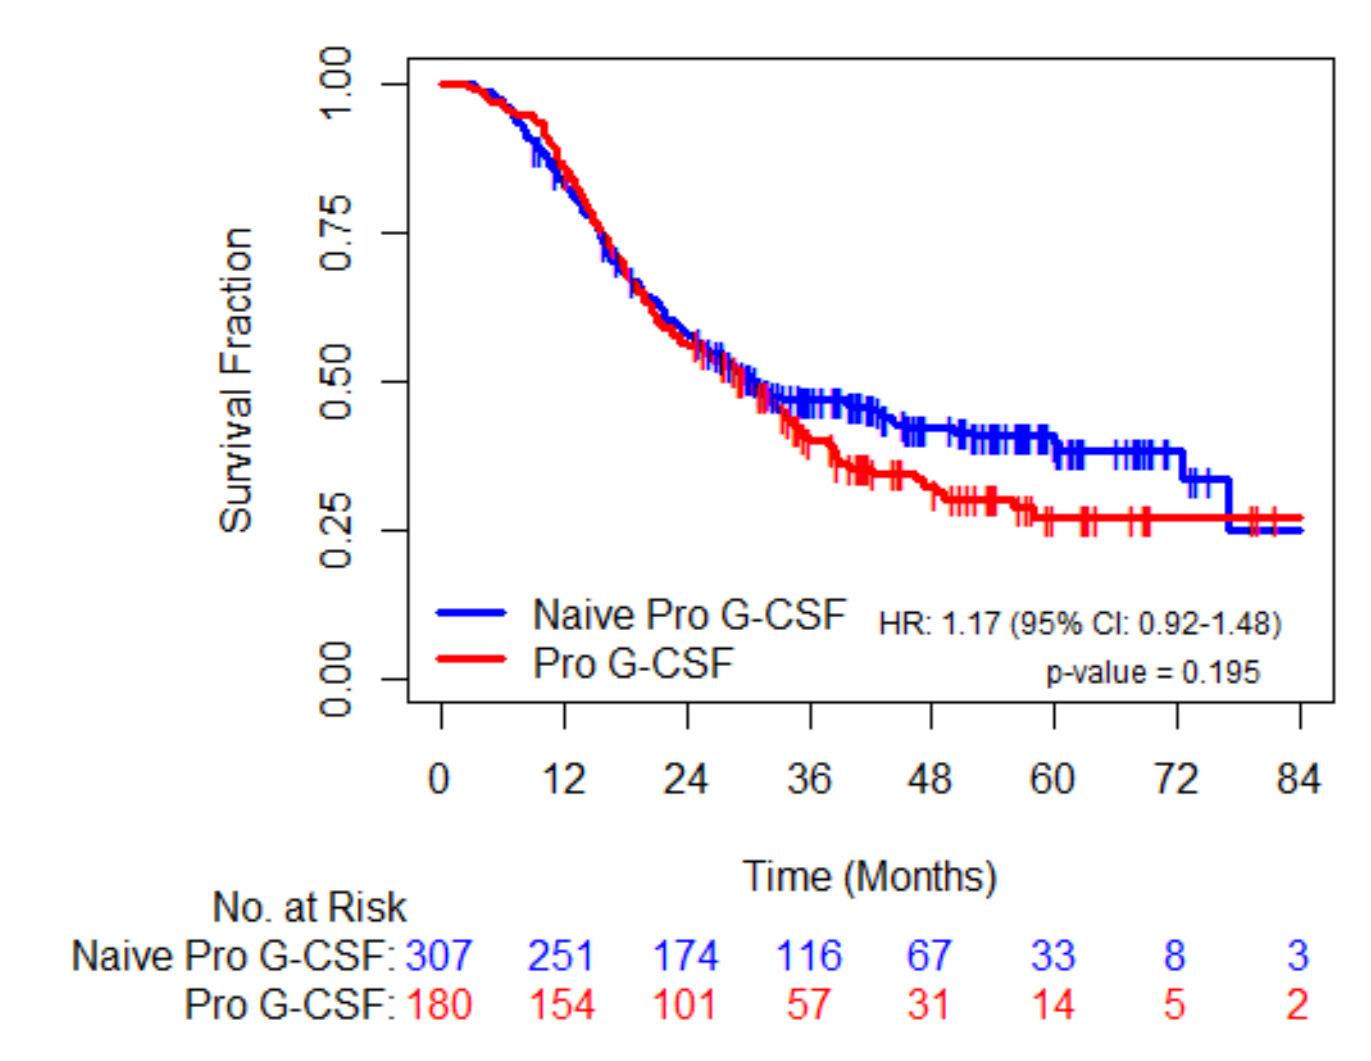

B

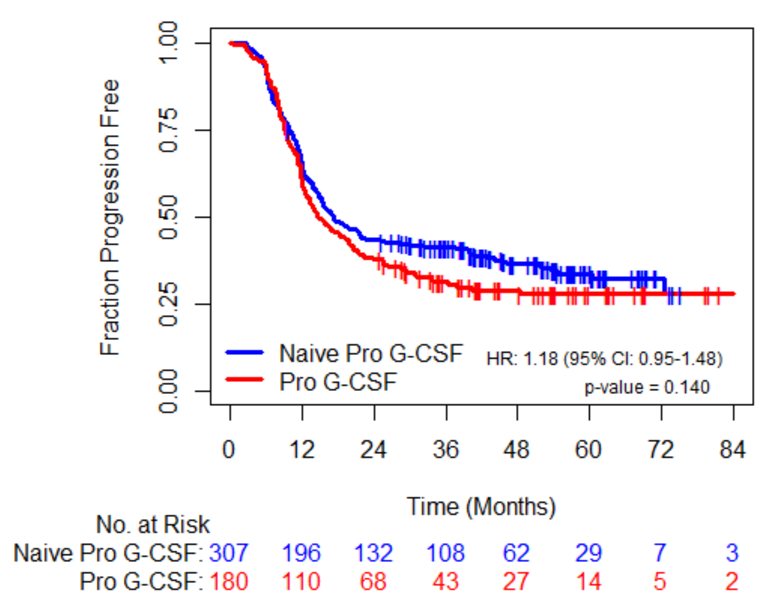

Figure 1: Overall survival and progression free survival per use of proG-CSF
A = OS (naïve group: median 31 months (26-43); proG-CSF group: median 30 (23-35)). Adjusted for clinical variables HR = 1.18 (0.91-1.51), p = 0.208.
B = PFS (naïve group: median 17 months (15-22); proG-CSF group: median 15 (13-20)). Adjusted for baseline clinical characteristics HR = 1.16 (0.92-1.48), p = 0.215.

Abbreviations: OS, overall survival; PFS, progression free survival; proG-CSF, prophylactic granulocyte-colony stimulating factor

