This is the author's version of the work. It is posted here by permission of the AAAS for personal use, not for redistribution. The definitive version was published in Science , (20/10/22)

doi: 10.1126/science.abo0431

**Noble gases and nitrogen in samples of asteroid Ryugu record its volatile sources and recent surface evolution**

**Authors:** Ryuji Okazaki1*, Bernard Marty2, Henner Busemann3, Ko Hashizume4, Jamie D. Gilmour5, Alex Meshik6, Toru Yada7, Fumio Kitajima1, Michael W. Broadley2, David Byrne2, Evelyn Füri2, My E.I. Riebe3, Daniela Krietsch3, Colin Maden3, Akizumi Ishida8, Patricia Clay5, Sarah A. Crowther5, Lydia Fawcett5, Thomas Lawton5, Olga Pravdivtseva6, Yayoi N. Miura9, Jisun Park10,11, Ken-ichi Bajo12, Yoshinori Takano13, Keita Yamada14, Shinsuke Kawagucci15,16, Yohei Matsui15,16, Mizuki Yamamoto1, Kevin Righter17, Saburo Sakai13, Naoyoshi Iwata18, Naoki Shirai19,20, Shun Sekimoto21, Makoto Inagaki21, Mitsuru Ebihara19, Reika Yokochi22, Kunihiko Nishiizumi23, Keisuke Nagao24, Jong Ik Lee24, Akihiro Kano25, Marc W. Caffee26,27, Ryu Uemura28, Tomoki Nakamura8, Hiroshi Naraoka1, Takaaki Noguchi29, Hikaru Yabuta30, Hisayoshi Yurimoto12, Shogo Tachibana31, Hirotaka Sawada7, Kanako Sakamoto7, Masanao Abe7,32, Masahiko Arakawa33, Atsushi Fujii7, Masahiko Hayakawa7, Naoyuki Hirata33, Naru Hirata34, Rie Honda35, Chikatoshi Honda34, Satoshi Hosoda7, Yu-ichi Iijima7†, Hitoshi Ikeda7, Masateru Ishiguro36, Yoshiaki Ishihara37, Takahiro Iwata7, Kosuke Kawahara7, Shota Kikuchi38,39, Kohei Kitazato34, Koji Matsumoto32,39, Moe Matsuoka40, Tatsuhiro Michikami41, Yuya Mimasu7, Akira Miura7, Tomokatsu Morota25, Satoru Nakazawa7, Noriyuki Namiki32,39, Hirotomo Noda32,39, Rina Noguchi42, Naoko Ogawa7, Kazunori Ogawa37, Tatsuaki Okada7,43, Chisato Okamoto33†, Go Ono44, Masanobu Ozaki7,32, Takanao Saiki7,32, Naoya Sakatani45, Hiroki Senshu38, Yuri Shimaki7, Kei Shirai7,33, Seiji Sugita25, Yuto Takei7, Hiroshi Takeuchi7, Satoshi Tanaka7, Eri Tatsumi25,46, Fuyuto Terui47, Ryudo Tsukizaki7, Koji Wada38, Manabu Yamada38, Tetsuya Yamada7, Yukio Yamamoto7, Hajime Yano7,32, Yasuhiro Yokota7, Keisuke Yoshihara7, Makoto Yoshikawa7,32, Kent Yoshikawa7, Shizuho Furuya7, Kentaro Hatakeda48, Tasuku Hayashi7, Yuya Hitomi48, Kazuya Kumagai48, Akiko Miyazaki7, Aiko Nakato7, Masahiro Nishimura7, Hiromichi Soejima48, Ayako Iwamae48, Daiki Yamamoto7,49, Kasumi Yogata7, Miwa Yoshitake7, Ryota Fukai7, Tomohiro Usui7, Harold C. Connolly Jr.50, Dante Lauretta51, Sei-ichiro Watanabe28, Yuichi Tsuda7

**Affiliations:**

1Department of Earth and Planetary Sciences, Kyushu University, Fukuoka, 819-0395, Japan.

2Université de Lorraine, CNRS, CRPG, F-54000 Nancy, France.

3Institute of Geochemistry and Petrology, Eidgenössische Technische Hochschule (ETH) Zürich, 8092 Zürich, Switzerland.

4Faculty of Science, Ibaraki University, Mito, 310-8512, Japan.

5Department of Earth and Environmental Sciences, The University of Manchester, Manchester M13 9PL, UK.

6Physics Department, Washington University, Saint Louis, MO, 63130, USA.

7Institute of Space and Astronautical Science, Japan Aerospace Exploration Agency (JAXA), Sagamihara, 252-5210, Japan.

8Department of Earth Science, Tohoku University, Sendai, 980-8578, Japan.

9Earthquake Research Institute, The University of Tokyo, Tokyo, 113-0032, Japan.

10Physical Sciences, Kingsborough Community College, The City University of New York, Brooklyn, NY, 11235, USA.

11Department of Earth and Planetary Sciences, American Museum of Natural History, NY, 10024, USA.

12Department of Earth and Planetary Sciences, Hokkaido University, Sapporo, 060-0810, Japan.

13Biogeochemistry Research Center, Japan Agency for Marine-Earth Science and Technology (JAMSTEC), Yokosuka, 237-0061, Japan.

14Department of Chemical Science and Engineering, Tokyo Institute of Technology, Yokohama, 226-8503, Japan.

15Research Institute for Global Change, JAMSTEC, Yokosuka, 237-0061, Japan.

16Institute for Extra-cutting-edge Science and Technology Avant-garde Research (X-star), JAMSTEC, Yokosuka, 237-0061, Japan.

17Astromaterials Research and Exploration Science, Mailcode XI2, National Aeronautics and Space Administration (NASA) Johnson Space Center, Houston, TX, 77058, USA.

18Faculty of Science, Yamagata University, Yamagata, 990-8560, Japan.

19Graduate School of Science and Engineering, Tokyo Metropolitan University, Hachioji, 192-0397, Japan.

20Department of Chemistry, Faculty of Science, Kanagawa University, Hiratsuka, Kanagawa, 259-1293, Japan.

21Institute for Integrated Radiation and Nuclear Science, Kyoto University, Osaka, 590-0494, Japan.

22Department of the Geophysical Sciences, The University of Chicago, Chicago IL, USA.

23Space Sciences Laboratory, University of California, Berkeley, CA, 94720, USA.

24Division of Earth Sciences, Korea Polar Research Institute, Incheon, 21990, Korea.

25School of Science, The University of Tokyo, Tokyo, 113-0033, Japan.

26Department of Physics and Astronomy, Purdue University, West Lafayette, IN 47907, USA.

27Department of Earth, Atmospheric, and Planetary Sciences, Purdue University, West Lafayette, IN 47907, USA.

28Department of Earth and Environmental Sciences, Nagoya University, Nagoya, 464-8601, Japan.

29Division of Earth and Planetary Sciences, Kyoto University, Kyoto, 606-8502, Japan.

30Department of Earth and Planetary Systems Science, Hiroshima University, Higashi-Hiroshima, 739-8526, Japan.

31UTokyo Organization for Planetary and Space Science, The University of Tokyo, Tokyo, 113-0033, Japan.

32Department of Space and Astronautical Science, The Graduate University for Advanced Studies, Hayama 240-0193, Japan.

33Department of Planetology, Kobe University, Kobe, 657-8501, Japan.

34Aizu Research Cluster for Space Science, University of Aizu, Aizu-Wakamatsu, 965-8580, Japan.

35Center of Data Science, Ehime University, Matsuyama, 790-8577, Japan.

36Department of Physics and Astronomy, Seoul National University, Seoul, 08826, Republic of Korea.

37JAXA Space Exploration Center, JAXA, Sagamihara, 252-5210, Japan.

38Planetary Exploration Research Center, Chiba Institute of Technology, Narashino, 275-0016, Japan.

39National Astronomical Observatory of Japan, Mitaka, 181-8588, Japan.

40Geological Survey of Japan, National Institute of Advanced Industrial Science and Technology, Ibaraki, 305-8567, Japan.

41Faculty of Engineering, Kindai University, Higashi-Hiroshima, 739-2116, Japan.

42Faculty of Science, Niigata University, Niigata, 950-2181, Japan.

43Department of Chemistry, The University of Tokyo, Tokyo 113-0033, Japan.

44Research and Development Directorate, JAXA, Sagamihara, 252-5210, Japan.

45Department of Physics, Rikkyo University, Tokyo, 171-8501, Japan.

46Instituto de Astrofísica de Canarias, University of La Laguna, Tenerife, Spain.

47Department of Mechanical Engineering, Kanagawa Institute of Technology, Atsugi, 243-0292, Japan.

48Marine Works Japan Ltd., Yokosuka, 237-0063, Japan.

49Department of Earth and Planetary Science, Tokyo Institute of Technology, Ookayama, Tokyo, 152-8550, Japan.

50Department of Geology, School of Earth and Environment, Rowan University, Glassboro, NJ, 08028, USA.

51Lunar and Planetary Laboratory, University of Arizona, Tucson, AZ, 85705, USA.

**\*Corresponding author. E-mail: okazaki.ryuji.703@m.kyushu-u.ac.jp**

†Deceased.

**Abstract:**

The near-Earth C-type asteroid (162173) Ryugu is expected to be enriched in volatile species that may also have contributed to Earth’s inventory. Ryugu samples were returned to Earth by the Hayabusa2 spacecraft. We report noble gas and nitrogen isotopes, finding they are dominated by pre-solar and primordial components, incorporated at Solar System formation. Noble gas concentrations are higher than those in Ivuna-type carbonaceous (CI) chondrites. Several host phases of isotopically different nitrogen exist, with heterogeneous abundances between the samples. Noble gases and nitrogen indicate a close relationship of Ryugu with CI chondrites. Noble gases produced by galactic cosmic rays, corresponding to ~5 Myr exposure, and those of implanted solar wind record the recent irradiation history after Ryugu migrated to its current orbit.

**Main Text:**

The Hayabusa2 spacecraft returned to Earth on 2020 December 6, after collecting surface and subsurface samples from asteroid (162173) Ryugu (*1*). Ryugu is a hydrous and carbonaceous (C-type) asteroid thought to have chemical and mineralogical compositions similar to primitive stony meteorites, carbonaceous chondrites (*2*). Carbonaceous chondrites contain high abundances of volatile elements and molecules, including hydrogen, carbon, nitrogen, noble gases, and organic compounds, making them a potential source of volatiles delivered to Earth and the other terrestrial planets (*3, 4*). Nitrogen and noble gases in different carbonaceous chondrites vary in their chemical abundances and isotopic ratios. This diversity is thought to be primarily inherited from primordial (prior to Solar System formation) source materials, but could also reflect processes that occurred in the interior of asteroids after their accretion, such as thermal metamorphism and aqueous alteration (*5, 6*). Ryugu is thought to have originated from a ~100 km-diameter parent body (*7*) that has experienced aqueous alteration to variable extents (*7, 8*). The timing of the aqueous alteration on the Ryugu’s parent body has been determined by radioactive isotopes, about 3 to 7 Myr after Solar System formation (about 4.56 Gyr ago) (*7, 8*). After the aqueous alteration, the parent body has been catastrophically disrupted and re-accumulated to form a rubble pile asteroid, Ryugu (*9, 10*).

Noble gas isotopes can also be used to assess surface activities on rocky bodies of the Solar System, such as modification by impacts (heating, cratering, mixing, and rock fragmentation), and solar wind (SW) and cosmic ray irradiations (e.g., *11*). Remote-sensing observations of Ryugu by Hayabusa2 revealed signs of impacts, space weathering, and surface heating (*9, 12–15*). Energetic particle irradiation could alter susceptible surface materials, such as organic molecules. Determining the effects of SW and cosmic ray irradiation requires distinguishing characteristic noble gas signature originating from SW implantation, galactic cosmic rays (GCRs, from outside the Solar System), and solar cosmic rays (SCRs, from the Sun).

**Ryugu grains**

Ryugu grains were collected during the first and second Hayabusa2 touchdown (TD) operations (*1, 16*). The samples we were assigned from the first TD (hereafter denoted Ryugu-A samples, A0105-series) were collected from the surface of Ryugu at an equatorial region by shooting a 5 g tantalum projectile at a velocity of ~300 m s-1 (*1, 16, 17*) and stored in Chamber A of the sample collection instrument (*18*). The second TD samples were collected from a site near a crater (*1*) generated by an artificial impact (*19*) and stored in Chamber C (denoted Ryugu-C samples, C0106-series) (*16–18*). Since the depth of the artificial crater is ~1.7 m (*20*), the Ryugu-C samples may include subsurface materials as well as surface materials similar to the Ryugu-A samples. Because asteroid surface materials are generally fragmented rocks (so-called breccia) consisting of different lithologies, we performed a combination of non-destructive analyses prior to destructive (high precision) isotope measurements for pelletized samples (*21*) (Fig. S1). Fourier-transform infrared (FTIR) spectroscopy, field-emission scanning electron microscopy (FESEM) observations, and energy dispersive X-ray spectroscopy (EDS) measurements were performed for non-destructive analyses (*21*). After these non-destructive examinations, abundances and isotopic compositions of noble gases and nitrogen were destructively measured in 21 individual Ryugu samples (Fig. S1 and Table S1). The pelletized samples were analyzed without exposure to Earth’s atmosphere at any point, including during sample preparation, transportation, weighing, and introduction to the instruments for all analyses (*21*). The fragments of material generated during pelletization were also collected and used for noble gas analyses (*21*) (Table S1). The masses of the pelletized samples are between 0.05 and 0.1729 mg, while those of the fragment samples are between 0.0006 and 0.0115 mg (Table S1).

**Mineralogy and petrography**

The FESEM observations and EDS measurements showed that the pelletized Ryugu grains are mainly composed of fine-grained matrices, in which the major mineral phase is phyllosilicates (Figs. 1, S2, and S3). The modal abundances of magnetite and sulfide grains in 16 Ryugu-A samples are 5±1 % and 2±1 %, respectively, within errors identical to those (5±2 % and 3±1 %) of 8 Ryugu-C samples (*21*). These values are also identical to those (4.3 % and 1.1 %) (*22*) in Ivuna-type carbonaceous (CI) chondrites within errors, but are distinct from those (2.2 % and 2.0 %) in Mighei-type (CM) and those (1.0 % and 21.0 %) in dehydrated CI-like carbonaceous chondrites (*23*).

The FTIR spectra of our Ryugu samples show absorption bands at 3698.8 cm-1 (2.70 µm) due to O-H stretching modes of phyllosilicates (*24*) and at 2968.4 cm-1 (3.37 µm) due to C-H stretching (*24*) (Fig. 2), which is consistent with earlier results for the Ryugu samples (*18*). The close relationship between Ryugu and CI chondrites has previously been reported using other techniques (*7, 8, 25, 26*). Further spectral features are shown in Figs. S4 and S5. These non-destructive results indicate that our samples are typical Ryugu grains with a CI-like lithology, containing no clasts with CM or dehydrated CI-like chondrite characteristics (*23*).

**Noble gas isotopes**

We measured noble gases (stable isotopes of helium, neon, argon, krypton, and xenon) in the Ryugu samples by stepped heating (*21*). Based on their isotopic ratios, we interpret the He in the Ryugu samples as superpositions of two components: one is primordially trapped He, designated P1 {also known as “Q” gas, residing in an unknown [most likely carbonaceous] phase named “Q” for quintessence (*27, 28*)}, and the other is pre-solar HL {hosted by presolar nano-diamonds and named after its Xe isotopic composition enriched in heavy [134Xe and 136Xe] and light [124Xe and 126Xe] isotopes compared to solar Xe (*28 and references therein*)}. In addition to P1 and HL gases, there are contributions of SW (*11, 29*), and SCR/GCR-produced (cosmogenic) components (Fig. S6). Most of the samples contain Ne from major components HL-Ne and P1-Ne (Fig. 3A), though their relative abundances are uncertain, which affects our estimation of SW-Ne abundances. Although we cannot rule out implantation-fractionated SW [FSW (*30*)], the elemental abundances of the Ryugu samples (Fig. S7A) are consistent with mixing between just HL and P1. Two samples (A0105-01 and C0106-06) record clear contributions from pre-solar Ne components, almost pure 22Ne carried by pre-solar graphite and/or SiC, {called G [originated from the He burning shell of Red Giant AGB stars] and R [radiogenic origin, the decay product of 22Na] components (*28*)} as found at higher temperatures (>900 °C) of stepped heating Ne data (Fig. 3B and Data S1). Only samples A0105-06 and A0105-15 plot a mixing line between SW and P1, evidence for a clear contribution of SW-Ne in their compositions (Fig. 3A). The rest of samples have only a minor contribution from SW visible at lower temperatures in their step heating data (Fig. 3B).

The 38Ar/36Ar ratios of the Ryugu samples range between 0.186±0.001 and 0.194±0.007 (Data S1), which are similar to the value expected for P1 (0.1873±0.0007: *27, 28*) or other trapped components (*28*). The SW-rich samples also fall within this range of 38Ar/36Ar (Data S1). The higher 38Ar/36Ar ratios (>0.187) are not correlated with cosmogenic 21Ne concentrations, which could be due to higher concentrations of the target elements for cosmogenic 38Ar production, such as K and Ca, in some of the samples. The 40Ar/36Ar ratios range from 4 to 70, probably with substantial instrumental contamination, due to the small amounts of 40Ar in the Ryugu samples. Concentrations of 40Ar vary from 5×10-6 to 2×10-4 cm3 g-1 at standard temperature and pressure (STP), suggesting heterogeneously distributed potassium in the samples and variable atmospheric contamination from the instrument.

We interpret the isotopic ratios of Xe as dominated by P1, with variable contributions from HL and SW components (Figs. S7B and S8, and Data S1), though cannot exclude a small contamination by Earth’s Xe. Some samples could have cosmogenic contributions, but large uncertainties and the dominant presence of trapped Xe prevent us from unambiguously identifying its presence. Sample A0105-15 (which has abundant SW-Ne) has a Xe composition similar to that of SW-Xe in its 130Xe to 136Xe isotopes, (Fig. S8), but is depleted in 124Xe and 126Xe isotopes (Data S1). Excesses in 129Xe, which formed from the decay of short-lived 129I, are observed in some samples with 129Xe/132Xe ratios higher than that for P1-Xe (1.042) (*27*). Isotopic ratios of Kr are dominated by the P1 and SW components (Fig. S9). Some variations from P1 are observed for Kr and Xe isotopes, likely due to interferences from hydrocarbons, which can substantially affect the less abundant Kr and Xe isotopes when measuring such small sample masses (Figs. S8 and S9).

**Nitrogen abundances and isotopes**

Nitrogen isotopes were extracted by stepped heating and measured for four pelletized samples (Table S1). The total (organic and inorganic) carbon content was also determined for the two samples (A0105-07 and C0106-07) (*21*). The δ15N [difference to the atmospheric 15N/14N ratio (*31*) in ‰] values of A0105-07 and C0106-07 are +1.7±0.5 and 0.0±0.4 ‰, respectively (Table S2). Other Ryugu samples have been reported to have higher values in the range +39 to +43 ‰ [observed range in C-rich grains: (*25*)] or +43.0 ± 9.0 ‰ {averaged value for mg-sized aggregates of Ryugu-A [A0106] (*26*)}, consistent with δ15N value of CI chondrites between +31 and +52 ‰ (*32–36*). The two lowest ratios in our Ryugu samples are more similar to the dehydrated CI chondrite Yamato-980115 (hereafter Y-980115) of ₋2.8 ‰ (*37*) (Fig. 4). The δ15N of A0105-05 and C0106-06 are +18.1±0.9 and +19.5±0.9 ‰ respectively (Table S2), between two other samples (A0105-07 and C0106-07) and CI chondrites (Fig. 4). The nitrogen abundances of our samples are between 700 and 900 ppm (Table S2), two to three times lower than in CIs (*32–36*), but similar to Y-980115 (*37*) and the highly altered CM chondrite Meteorite Hills 01070 (hereafter MET 01070) (*36*) (Fig. 4). We find an inverse linear trend between the nitrogen isotope ratios and the nitrogen abundances (Fig. 4), suggesting the presence of at least two phases: one with δ15N up to +70 ‰, and the other with δ15N close to the Earth’s atmosphere composition.

The lighter δ15N value observed in some of our samples cannot be due to a fractionation process, which would result in enrichment of heavier isotopes relative to the lighter ones in the nitrogen-poor fractions. Atmospheric contamination would increase the nitrogen abundance, and shift the δ15N value closer to zero. Hence, the variation in δ15N among our samples cannot be due to atmospheric contamination or diffusive loss of nitrogen (Fig. 4).

**Ryugu’s parent body**

Our Ryugu samples have lower abundances of 15N than CI chondrites (*32–36*). Insoluble organic material (IOM) of CI chondrites has lower δ15N values than the bulk samples of CI chondrites (*38*), which could indicate that nitrogen in IOM is also 15N-poor. Hence, a possible 15N-rich material in CIs is soluble organic or inorganic phases, which could have been lost from the Ryugu samples to variable extent.

The dehydrated CI chondrite Y-980115 resembles to our Ryugu samples in nitrogen compositions (*37*), but has mineralogy and lithology indicative of heating after aqueous alteration (reactions of rocks with liquid water) (*23*), different from Ryugu samples. Therefore, the 15N-rich phase in Y-980115 is likely to have been lost through a devolatilization process and the remaining 15N-poor phase in Y-980115 is different to that in our Ryugu samples.

The measured total carbon abundances of the samples A0105-07 and C0106-07 are 6.8±0.2 and 6.4±0.1 wt%, respectively. The atomic C/N ratios are 112±5 and 88±3, respectively (Table S2). These carbon contents are 50% higher than those in CI chondrites [C/N ranging between 17 and 32 (*32–36*)], other Ryugu samples (*7, 8, 25, 26*), and Y-980115 (*37*). This indicates decoupling between nitrogen and carbon host phases could have occurred. We attribute the observed variations in the δ15N, nitrogen and carbon abundances to sample heterogeneity at a small spatial scale (Table S1). Considering this heterogeneity, we suggest that various host phases of nitrogen with distinct isotopic ratios are likely still present in Ryugu grains. The heterogenous effects of aqueous alteration and dehydration or devolatilization on Ryugu materials could be responsible for the variation. The similarity of those two samples to the dehydrated CI chondrite Y-980115 indicates that some devolatilization process may be responsible for the depletion of the 15N-rich phase from our samples. This is consistent with the results of thermogravimetric analysis of a Ryugu A-series sample (*8*), in which the release of interlayer water was found only above 90 °C. Such devolatilization could occur on the surface of Ryugu or in its subsurface layers. It is unlikely to have occurred in the interior of the Ryugu parent body, because thermal modeling (*7*) has shown the internal heating did not reach 50 °C. Devolatilization more likely occurred on Ryugu by some heating mechanism, such as solar radiation heating (*8*). However, the total carbon content in Y-980115 (*37*) is lower than those in our Ryugu samples, so we suggest that the devolatilization mechanism that affected Y-980115 is different from the one that occurred on Ryugu, which is more enriched in carbon than CI chondrites. In addition to devolatilization, variable degrees of aqueous alteration could also be responsible. This could be due to a temperature increase at the subsurface layer of the Ryugu’s parent body, or a low amount of available water to drive alteration reactions (*7*). The least altered materials in Ryugu samples are found as clasts in Ryugu samples (*7*), which could contain a 15N-rich host phase.

The Ne and Xe isotope ratios in individual Ryugu samples show that Ryugu materials contain the host phases of primordial and pre-solar components, thought to be phase Q, presolar diamonds, SiC, and graphite (*27, 28*). These components were present in the early Solar System (*28*) prior to the formation of Ryugu’s parent body, and also commonly contained in other CI chondrites (Fig. 3 and Data S1). The elemental ratios of the heavy noble gases, 36Ar, 84Kr, and 132Xe, are closest to the P1 noble gas component (Fig. S7B), and hence their abundances reflect mainly the P1 abundance. With the exception of the SW-rich sample (A0105-15), the weighted mean values of the heavy noble gas concentrations in Ryugu samples are 1.5×10-6, 2.0×10-8, and 1.9×10-8 cm3 STP g-1 for 36Ar, 84Kr, 132Xe, respectively. These averages are similar to the highest value found in a CI chondrite (*39*). Some individual grains have ~2 to 3 times higher concentrations than the highest CI chondrite value (Fig. 5), also above the highest concentrations observed in bulk CM and other chondritic materials (*39–41*).

In contrast to the low nitrogen abundances, the P1 gas in the Ryugu samples shows no evidence of having been lost during aqueous alteration episodes. The P1 gas in the Ningqiang ungrouped carbonaceous chondrite has been shown to be resistant to aqueous alteration (*42*), which is consistent with the high P1 abundances in the Ryugu samples. However, abundances of P1 gas in CM chondrites are correlated with their petrologic types, with lower P1 in CMs which experienced higher degrees of aqueous alteration (*41*). Mineralogical studies have found that the degree and condition of alteration differs between CI, CM, and Renazzo-type (CR) chondrite parent bodies (*6*). We hypothesize that the difference in the degree (or conditions) of aqueous alteration controls the P1 gas abundances. If this is correct, the degree of aqueous alteration experienced by the Ryugu parent body is similar to that for CI chondrites.

In addition to P1 and pre-solar noble gas components, Ningqiang as many other non-hydrated meteorites contain another noble gas component, referred to as Ar-rich gas (*28*), which is lost during hydrothermal experiments (*42, 43*). The Ar-rich gas is also found in some less altered CR and CM chondrites (*41, 44*). It has been suggested that the host phase of Ar-rich gas is susceptive to aqueous alteration, with amorphous silicate being one of its host phases (*41, 43, 44*). Our measurements of the Ryugu samples do not show the presence of Ar-rich gas, but do indicate the presence of SW gas – likely acquired recently, during surface exposure on Ryugu. Even if the Ryugu source material originally contained such amorphous silicates, the Ar-rich gas would have been easily lost during the decomposition of amorphous silicates. The absence of Ar-rich gas in the Ryugu samples is consistent with it appearing only in the least aqueously altered carbonaceous chondrites. All these lines of evidence indicate that Ryugu’s parent body formed from similar volatile components, and experienced similar aqueous alteration processes, to CI chondrites.

**Cosmic ray and SW irradiations**

Concentrations of 4He in the individual Ryugu samples vary from 9×10-5 to 6×10-3 cm3 STP g-1, and 22Ne from 5×10-8 to 1×10-5 cm3 STP g-1 (Data S1), which we interpret as variable contributions of SW-derived gases. Based on the Ne isotopic ratios, we calculated the SW-derived 20Ne and cosmogenic 21Ne concentrations by subtracting contributions of the other Ne components (Table S3). The smallest cosmogenic 21Ne concentration is found in a SW-20Ne rich grain (A0105-15). No systematic differences in the cosmogenic 21Ne concentrations are observed between the Ryugu-A and Ryugu-C samples (Fig. 6), although the high SW-20Ne concentrations were observed only in two surface samples (Ryugu-A).

We expected the SW-20Ne and cosmogenic 21Ne concentrations to be positively correlated, as this has been observed in meteorites of all classes originating from the surface layer of fragmental incoherent rocky debris (so-called regolithic meteorites) (e.g., *45, 46*). This requires grains to have been well mixed through the surface layer of the meteorites’ parent bodies, and experienced negligible grain-surface modification. However, we do not observe a correlation (Fig. 6). Most of the Ryugu samples have lower 21Ne than the trend observed in lunar soils and regolithic meteorites (*45–49*), implying a shorter exposure to SW. We calculated SW exposure ages of ≳3500, ≳250, and ≳1 to 50 years for the A0105-15, A0105-06, and the other samples, respectively. We calculated the SW-20Ne flux at the current orbit of Ryugu [semi-major orbital axis 1.19 au (*50, 51*)] using implantation rates measured by the Genesis mission (*52*), finding 4 × 10-9 cm3 STP cm-2 yr-1. This calculation assumes spherical grains with a diameter of 0.8 mm (equivalent to the measured sizes) and a density of 1.8 g cm-3 (*7*), and that the samples did not experience any grain-surface modification by pulverization or fragmentation. We therefore regard the resulting SW exposure ages as lower limits.

The concentrations of cosmogenic 21Ne in our samples, excluding the SW-rich sample A0105-15, range from 3 × 10-9 to 8 × 10-9 cm3 STP g-1. This variation is smaller than observed in the SW-20Ne concentrations. We calculated the weighted means of the cosmogenic 21Ne concentrations for each of the Ryugu-A and Ryugu-C samples, using the sample mass as the weighting factor. The cosmogenic 21Ne concentrations are (4.8±0.8)×10-9 and (4.1±0.7)×10-9 cm3 STP g-1 for the Ryugu-A and Ryugu-C samples (excluding A0105-15), respectively. The different sampling condition between the Ryugu-A and Ryugu-C explains their different exposure to SW/cosmic-rays, brecciation, and meteoroid impacts. Abundances of the cosmogenic radionuclide 10Be were reported to be ~12.8 and ~7.3 decays (or disintegrations) per minute per kg for the Ryugu-A and Ryugu-C samples, respectively (*53*), reflecting their different shielding conditions.

The low concentrations of SW in the Ryugu samples lead us to conclude that the samples have not been transported vertically (mixed to shallower and deeper levels) by meteoroid impacts, but instead remained at a specific shielding. A shielding of 150 g cm-2 is applied for the Ryugu-C samples based on the 10Be abundances (*53*), which corresponds to a physical depth of 1.3 m [assuming a Ryugu surface layer density of 1.2 g cm-3 (*50*)] and is close the artificial crater depth of 1.7 m (*20*). The calculated production rate of 21Ne (P21) at 150 g cm-2 shielding is 0.79 × 10- 9 cm3STP g-1 Myr-1 (*54*) assuming 2π steradian exposure on a 1.19 au orbit (*50, 51*) and CI chondrite composition (*55*). For the Ryugu-A samples, we assumed that they had a lower shielding of 2 to 5 g cm-2, appropriate for material just below the surface. At this shielding, cosmogenic 21Ne can be produced by GCRs and SCRs, but SW-implanted Ne was rare. The calculated P21 at this shielding is 0.90 × 10-9 cm3 STP g-1 Myr-1. Using these production rates, we obtained cosmic ray exposure (CRE) ages of 5.3±0.9 and 5.2±0.8 Myr for the Ryugu-A and Ryugu-C samples, respectively. These CRE ages are averaged values for each sampling site, whereas individual grains show some variations in their cosmogenic 21Ne concentrations. This variation can be explained by variable shielding conditions and chemical compositions. For the SW-rich samples A0105-15, its CRE age is >100,000 yr, obtained using a P21 of ~3 × 10- 9 cm3 STP g-1 Myr-1 for the shielding of 0 to 1 g cm-2 (*54*), where SW and SCR can be implanted at the grain surface. The CRE age of A0105-15 is longer than its SW exposure age, indicating that the SW-rich sample was temporarily brought to the surface but was mostly buried at a deeper depth similar to the other Ryugu-A samples. Because only a small fraction (~10 vol.%, estimated from two SW-rich grains out of the 16 grains studied) of surface material seems to be mixed with subsurface material, a large fraction of surface layer materials down to several cm could have been ejected to space or shifted across the surface to lower gravitational potential regions, such as the mid-latitude region (*50, 51*) in ~5 Myr (the CRE ages of the samples).

We compare the Ryugu’s CRE ages to those of meteorites, which primarily reflect their duration of exposure in interplanetary space (during transit to Earth), rather than exposure on their parent bodies (as is the case for Ryugu). We calculated expected cosmogenic 21Ne concentrations in CI chondrites of (11 to 25) × 10-9 (Alais), (3 to 6) × 10-9 (Ivuna), (6 to 11) × 10-9 (Orgueil), and 3 × 10-9 (Tonk) cm3 STP g-1, using previous measurements of Ne isotopes (*23, 56*). Using a production rate of 1.5 × 10-9 cm3 STP g-1 Myr-1, calculated for a 100 cm-diameter body irradiated from 4π steradians (*57*), these concentrations correspond to CRE ages of 2 to 17 Myr. These calculations assume no SCR contribution and a constant GCR flux. Similar CRE ages for CI chondrites have previously been obtained based on cosmogenic radionuclides (*58*), indicating that the CRE ages of CI chondrites reflect their space exposure histories, with little contribution of additional parent body exposures. In the case of such multi-stage irradiations, the abundances of cosmogenic radionuclides should be lower than those of stable isotopes due to their decay during intervals between exposures. Only Ivuna is thought to have experienced multi-stage irradiation (*58*).

Two of five CI chondrites are known to have short CRE ages, 0.1 to 0.2 Myr (*58*), and >50 % of CM chondrites also have short (<10 Myr) CRE ages (*41, 59, 60*), indicating similar transport times to Earth. Although many CM chondrites are regolithic and contain SW noble gases (e.g., *41*), which necessitates cosmic-ray exposure on the CM parent body, the duration of that exposure is not well determined. The Ryugu surface layer must have been irradiated by GCRs for a duration similar to the space exposure of CI (and possibly CM) chondrites. The lower collision frequency at the near-Earth orbit of Ryugu than at the main asteroid belt (MAB) (*61, 62*) could be responsible for the surface residence time of Ryugu dust/grains. However, the parent bodies of CI and CM chondrites could have experienced frequent collisions in the MAB, causing shorter surface residence times. Lunar surface materials likewise record a low-frequency collision history, because the Moon is also a near-Earth object. The higher concentrations of SW-20Ne and cosmogenic 21Ne in lunar soils reflect their longer surface and subsurface residence time (*47–49*), compared to samples of Ryugu (Fig. 6).

The CRE ages of our samples constrain the orbital evolution of Ryugu, which is thought to have migrated from the MAB into its current near-Earth orbit (*7, 13–15*). Because the crater production rate within the MAB is about 30 times higher than that in near-Earth orbits (*61, 62*), the regolith residence time in the top 1 m layer of Ryugu’s surface was previously reported to be 2 to 8 Myr for near-Earth bombardment rates, or ~0.1 to 0.3 Myr for MAB bombardment rates (*7, 13, 14*). Our derived surface residence time of ~5 Myr is more consistent with the near-Earth bombardment rate, indicating that Ryugu’s orbit changed ~5 Myr ago.

After the migration from the MAB to near-Earth orbit, Ryugu could have experienced other surface evolution processes, in addition to impact bombardment. The spectral variations (red and blue material) observed across Ryugu’s surface has been interpreted as indicating a temporary orbital excursion near the Sun could have produced the red material by intense heating and faster migration of surface materials (*9*, *13*). Our stepped heating measurements show that ~30 % of cosmogenic 21Ne, corresponding to ~1 Myr of GCR exposure at 150 g cm-2 shielding, is released at 100 °C, at least from some samples (Fig. 3B and Data S1). This supports the suggestion by (*8*) that Ryugu samples have not experienced heating above 100 °C, and newly demonstrates that the heating could have occurred in the past ~1 Myr. Therefore, our data indicate surface alteration and migration more than 1 Myr ago, rather than more recent processes, as responsible for the spectral-color distribution, if the surface heating produced the red material.

The absence of a correlation between SW-20Ne and cosmogenic 21Ne, and the scarcity of SW in the Ne isotopic ratios indicates that only a limited number of the Ryugu grains were exposed to solar wind. However we cannot rule out the possibility that the fraction of SW-rich grains was previously higher, before some grains escaped to space or migrated to other regions of Ryugu. Thermal and/or mechanical effects, such as atmospheric heating of the Hayabusa2 reentry capsule, or fragmentation and pulverization in the sample catcher during the return to Earth, could also have altered the SW inventory. The CRE ages of the Ryugu samples are shorter than those of lunar soils and regolithic meteorites (*45–49*), which could be explained by higher mechanical vulnerability on Ryugu. Particle ejections have been observed on the C-type asteroid (101955) Bennu (*63*), which could be related to grain-surface modification processes on Ryugu. Grain destruction by impact bombardment and/or phyllosilicate dehydration is predicted to be efficient on the C-type asteroid Ryugu (*8, 63*).

**Comparison with micrometeorites**

Meteoroids and micrometeorites are exposed to SW, SCRs, and GCRs during their transit from their parent bodies to the Earth. Solar-wind signatures are also commonly observed in un-melted micrometeorites (UMMs) collected from Antarctic snow and ice, most of which have similar composition and mineralogy to CI and CM chondrites (*64–67*). Unlike the Ryugu samples, the SW-20Ne concentrations in UMMs are correlated with cosmogenic 21Ne concentrations (Fig. 6). Some SW-20Ne and cosmogenic 21Ne must have been lost from UMMs by heating during atmospheric entry (*68*) and recoil effects (*69*), which could disturb the correlation between the SW and cosmogenic Ne concentrations. Still, most of the UMMs contain higher amounts of SW-20Ne concentrations than the Ryugu samples (Fig. 6). This indicates that the UMMs acquired most of their SW and cosmogenic Ne not on the surface of their parent bodies but in interplanetary space. Unlike the UMMs, only a small fraction of the Ryugu samples was exposed on the surface to SW, while cosmogenic 21Ne was produced in both the surface and subsurface layers. Therefore, Ryugu’s (and possibly other near-Earth asteroids’) surface material cannot be the major source of UMMs. Short (~250 yr for ~1 mm-diameter grains, as observed in A0105-06) exposure of Ryugu grains to SW in interplanetary space (e.g., after ejection from Ryugu by impact) would increase the SW, but could not lead the correlation between SW and cosmogenic Ne concentrations.

**Survival of pristine Ryugu material**

Although the nitrogen data indicates some devolatilization has occurred, low temperature gas-extraction steps (<200 °C) released 35–70 % of 22Ne, and the Ne isotopic composition was consistent with mixing of SW and cosmogenic components (Fig. 3BandData S1). CI chondrites release smaller fractions (20 to 30 %) of the total Ne content by 300 °C (*70*). It is possible that CI chondrites have lost some fraction of their easily released noble gases during or after the falling on to Earth, while the Ryugu grains retain highly volatile noble gases acquired during surface evolution. Any temperature increase of higher than 100 °C on the Ryugu’s surface has not occurred within the past 1 Myr. The primordial and pre-solar noble gases in the Ryugu samples are released at higher temperatures, >900 °C (Data S1). Atmospheric entry heating or terrestrial weathering could be responsible for the difference (*71*).

**Conclusions**

We measured noble gas and nitrogen abundances and isotopic compositions in individual grains returned from the surface and subsurface layers of near-Earth asteroid Ryugu. Ne and Xe are enriched in primordial and pre-solar noble gases, specifically the P1 and HL components. These isotopic compositions, and the elemental abundances are similar to those in CI chondrites. Nitrogen in Ryugu exhibits differences from CI chondrites: some of the samples are depleted in nitrogen and have lower δ15Nvalues. These results indicate that Ryugu contains several host phases that have not lost their volatiles and are not mixed with each other.

We used the Ne isotopes to determine the amount of SW, GCR, and SCR irradiations after the formation of Ryugu. The CRE ages of ~5 Myr for the grains are compatible with near-surface residence times estimated for near-Earth bombardment rates, indicating that Ryugu left the main asteroid belt at least several Myr ago. The current surface and subsurface materials on Ryugu have not experienced heating above 100 °C within the last ~1 Myr.

References and Notes

1. Y. Tsuda et al., Hayabusa2 mission status: Landing, roving and cratering on asteroid Ryugu. *Acta Astronaut.* **171**, 42–54 (2020).

2. S. Watanabe et al., Hayabusa2 Mission Overview. *Space Sci. Rev.* **208**, 3–16 (2017).

3. B. Marty, The origins and concentrations of water, carbon, nitrogen and noble gases on Earth. *Earth. Planet. Sci. Lett.* **313–314**, 56–66 (2012).

4. M.W. Broadley et al., Identification of chondritic krypton and xenon in Yellowstone gases and the timing of terrestrial volatile accretion. *Proc. Natl. Acad. Sci.* **117**, 13997–14004 (2020).

5. G.R. Huss, A.E. Rubin, J.N. Grossman, “Thermal metamorphism in chondrites” in *Meteorites and the Early Solar System II* (University of Arizona Press, Tucson, 2006), pp. 567–586.

6. A. Brearley, “The action of water” in *Meteorites and the Early Solar System II* (University of Arizona Press, Tucson, 2006), pp. p. 584–624 (2006).

7. T. Nakamura et al., Formation and evolution of carbonaceous asteroid Ryugu: Direct evidence from returned samples. *Science* (2022). 10.1126/science.abn8671

8. T. Yokoyama et al., Samples returned from the asteroid Ryugu are similar to Ivuna-type carbonaceous meteorites. *Science* (2022). 10.1126/science.abn7850

9. S. Sugita et al., The geomorphology, color, and thermal properties of Ryugu: Implications for parent-body processes. *Science* **364** (2019). 10.1126/science.aaw0422

10. P. Michel et al., Collisional formation of top-shaped asteroids and implications for the origins of Ryugu and Bennu. *Nat. Commun.* **11**, 2655 (2020). 10.1038/s41467-020-16433-z

11. D.D. Bogard, L.E. Nyquist, W.C. Hirsch, D.R. Moore, Trapped solar and cosmogenic noble gas abundances in Apollo 15 and 16 deep drill samples. *Earth Planet. Sci. Lett.* **21**, 52–69 (1973).

12. N. Hirata et al., The spatial distribution of impact craters on Ryugu. *Icarus* **338** (2020) 10.1016/j.icarus.2019.113527

13. T. Morota et al., Sample collection from asteroid (162173) Ryugu by Hayabusa2: Implications for surface evolution. *Science* **368**, 654–659 (2020).

14. Y. Cho et al., Geologic history and crater morphology of Asteroid (162173) Ryugu. *J. Geophy. Res.: Planets* **126** (2021). 10.1029/2020JE006572

15. N. Takaki et al., Resurfacing processes constrained by crater distribution on Ryugu. *Icarus* **377** (2022). 10.1016/j.icarus.2022.114911

16. S. Tachibana et al., Pebbles and sand on asteroid (162173) Ryugu: in situ observation and particles returned to Earth. *Science* **375**, 1011-1016 (2022).

17. H. Sawada et al. Hayabusa2 sampler: Collection of asteroidal surface material. *Space Sci. Rev.* **208**, 81–106 (2017).

18. T. Yada et al., Ryugu: Preliminary analysis of the Hayabusa2 samples returned from C-type asteroid Ryugu. *Nature Astronomy* **6**, 214–220 (2022).

19. T. Saiki et al., Small carry-on impactor of Hayabusa2 mission. *Acta* *Astronaut.* **84**, 227–236 (2013).

20. M. Arakawa et al., An artificial impact on the asteroid (162173) Ryugu formed a crater in the gravity-dominated regime. *Science* **368**, 67–71 (2020).

21. Materials and methods are available as supplementary materials.

22. J. Alfing, M. Patzek, A. Bischoff, Modal abundances of coarse-grained (>5µm) components within CI-chondrites and their individual clasts – Mixing of various lithologies on the CI parent body(ies). *Geochemistry* **79** (2019). 10.1016/j.chemer.2019.08.004

23. A.J. King et al., The Yamato-type (CY) carbonaceous chondrite group: Analogues for the surface of asteroid Ryugu? *Geochemistry* **79** (2019). 10.1016/j.chemer.2019.08.003

24. G. Matrajt et al., FTIR and Raman analyses of the Tagish Lake meteorite: Relationship with the aliphatic hydrocarbons observed in the Diffuse Interstellar Medium. *Astronomy Astrophys.* **416**, 983–990 (2004).

25. L. Remusat et al., H- and N-isotope distributions in the insoluble organic matter of Ryugu samples. *Lunar Planet. Sci. Conf.* **53rd**, #1448 (2022).

26. H. Naraoka et al., Soluble organic compounds in asteroid 162173 Ryugu. *Lunar Planet. Sci. Conf.* **53rd**, #1781 (2022).

27. H. Busemann, H. Baur, R. Wieler, Primordial noble gases in “phase Q” in carbonaceous and ordinary chondrites studied by closed-system stepped etching. *Meteorit. Planet. Sci.* **35**, 949–973 (2000).

28. U. Ott. Planetary and pre-solar noble gases in meteorites. *Chemie der Erde* **74**, 519–544 (2014).

29. V.S. Heber et al., Noble gas composition of the solar wind as collected by the Genesis mission. *Geochim. Cosmochim. Acta* **73**, 7414–7432 (2009).

30. A. Grimberg et al., Solar wind neon from Genesis: Implications for the lunar noble gas record. *Science* **314**, 1133–1135 (2006).

31. T.B. Coplen, H.R. Krouse, J.K. Böhlke, Reporting of nitrogen-isotope abundances (Technical Report). *Pure Appl. Chem.*, **64**, 907–908 (1992).

32. C.-C. Kung, R.N. Clayton, Nitrogen abundances and isotopic compositions in stony meteorites. *Earth Planet. Sci. Lett.* **38**, 421–435 (1978).

33. F. Robert, S. Epstein, The concentration and isotopic composition of hydrogen, carbon and nitrogen in carbonaceous meteorites. *Geochim. Cosmochim. Acta* **46**, 81–95 (1982).

34. J.F. Kerridge, Carbon, hydrogen and nitrogen in carbonaceous chondrites: Abundances and isotopic compositions in bulk samples. *Geochim. Cosmochim. Acta* **49**, 1707–1714 (1985).

35. V.K. Pearson, M.A. Sephton, I.A. Franchi, J.M. Gibson, I. Gilmour, Carbon and nitrogen in carbonaceous chondrites: Elemental abundances and stable isotopic composition. *Meteorit. Planet. Sci.* **41**, 1899–1918 (2006).

36. C.M.O'D. Alexander et al., The Provenances of asteroids, and their contributions to the volatile inventories of the terrestrial planets. *Science* **337**, 721–723 (2012).

37. Q.H.S. Chan, Y. Chikaraishi, Y. Takano, N.O. Ogawa, N. Ohkouchi, Amino acid compositions in heated carbonaceous chondrites and their compound-specific nitrogen isotopic ratios. *Earth Planet. Space* **68** (2016). 10.1186/s40623-016-0382-8

38. C.M.O’D. Alexander, M. Fogel, H. Yabuta, G.D. Cody, The origin and evolution of chondrites recorded in the elemental and isotopic compositions of their macromolecular organic matter. *Geochim. Cosmochim. Acta* **71**, 4380–4403 (2007).

39. E. Mazor, D. Heymann, E. Anders, Noble gases in carbonaceous chondrites. *Geochim. Cosmochim. Acta* **34**, 781–824 (1970).

40. C.A. Goodrich et al., The first samples from Almahata Sitta showing contacts between ureilitic and chondritic lithologies: Implications for the structure and composition of asteroid 2008 TC3. *Meteorit. Planet. Sci.* **54**, 2769–2813 (2019).

41. D. Krietsch et al., Noble gases in CM carbonaceous chondrites: Effect of parent body aqueous and thermal alteration and cosmic ray exposure ages. *Geochim. Cosmochim. Acta* **310**, 240–280 (2021).

42. Y. Yamamoto, R. Okazaki, T. Nakamura, Effects of experimental aqueous alteration on the abundances of argon-rich noble gases in the Ningqiang carbonaceous chondrite. *Meteorit. Planet. Sci.* **41**, 541–551 (2006).

43. T. Nakamura, M. Zolensky, M. Sekiya, R. Okazaki, K. Nagao, Acid-susceptive material as a host phase of argon-rich noble gas in the carbonaceous chondrite Ningqiang. *Meteorit. Planet. Sci.* **38**, 243–250 (2003).

44. T. Obase et al., Water-susceptible primordial noble gas components in less-altered CR chondrites: A possible link to cometary materials. *Geochim. Cosmochim. Acta* **312**, 75–105 (2021).

45. R. Wieler, H. Baur, A. Pedroni, P. Signer, P. Pellas, Exposure history of the regolithic chondrite Fayetteville: I. Solar-gas-rich matrix. *Geochim. Cosmochim. Acta* **53**, 1441–1448 (1989).

46. T.E. Ferko et al., The irradiation history of the Ghubara (L5) regolith breccia. *Meteorit. Planet. Sci.* **37**, 311–327 (2002).

47. J.K. Agrawal, K. Gopalan, M.N. Rao, Solar wind and cosmogenic rare gases in Luna 16 and 20 soils and their correlation with cosmic ray produced fossil tracks in lunar samples. *Pramana* **3**, 176–185 (1974).

48. J.L. Jordan, D. Heymann, S. Lakatos, Inert gas patterns in the regolith at the Apollo 15 landing site. *Geochim. Cosmochim. Acta.* **38**, 65–78 (1974).

49. N.B. Bhai, K. Gopalan, J.N. Goswami, M.N. Rao, T.R. Venkatesan, Solar cosmic ray produced neon and xenon isotopes and particle tracks in feldspars from lunar fines 14148 and 24087. *Proc. Lunar Planet. Sci. Conf.* **9th**, 1629–1645 (1978).

50. S. Watanabe et al., Hayabusa2 arrives at the carbonaceous asteroid 162173 Ryugu—a spinning top-shaped rubble pile. *Science* **364**, 268–272 (2019).

51. S. Kikuchi et al., Hayabusa2 pinpoint touchdown near the artificial crater on Ryugu: Trajectory design and guidance performance. *Adv. Space Res.* **68**, 3093–3140 (2021).

52. A. Grimberg, H. Baur, F. Bühler, P. Bochsler, R. Wieler, Solar wind helium, neon, and argon isotopic and elemental composition: Data from the metallic glass flown on NASA’s Genesis mission. *Geochim. Cosmochim. Acta* **72**, 626–645 (2008).

53. K. Nishiizumi et al., Exposure conditions of samples collected on Ryugu’s two touchdown sites determined by cosmogenic nuclides. *Hayabusa Symposium 2021*, S3-1 (2021).

54. C.M. Hohenberg, K. Marti, F.A. Podosek, R.C. Reedy, J.R. Shirck, Comparisons between observed and predicted cosmogenic noble gases in lunar samples. *Proc. Lunar Planet. Sci. Conf.* **9th**, 2311–2344 (1978).

55. K. Lodders, B. Fegley Jr., *The planetary scientist's companion.* (Oxford University Press, New York, 1998).

56. L. Schultz, L. Franke, Helium, neon, and argon in meteorites: A data collection. *Meteorit. Planet. Sci.* **39**, 1889–1890 (2004).

57. I. Leya, J. Masarik, Cosmogenic nuclides in stony meteorites revisited. *Meteorit. Planet. Sci.* **44**, 1061–1086 (2009).

58. K. Nishiizumi, M.W. Caffee, Exposure histories of CI1 and CM1 carbonaceous chondrites. *Lunar Planet. Sci. Conf.* **43rd**, #2758 (2012).

59. G.F. Herzog, M.W. Caffee, “Cosmic-ray exposure ages of meteorites” in *Treatise on Geochemistry* (Elsevier, Oxford, ed. 2, 2014) pp. 419-453.

60. E.R.D. Scott, G.F. Herzog, Short cosmic-ray exposure ages of CI and CM chondrites may reflect disintegration of volatile-rich asteroids at perihelion. *Lunar Planet. Sci. Conf.* **52nd**, #1833 (2021).

61. W.F. Bottke Jr. et al., Linking the collisional history of the main asteroid belt to its dynamical excitation and depletion. *Icarus* **179**, 63–94 (2005).

62. D.P. O’Brien, R. Greenberg, The collisional and dynamical evolution of the main-belt and NEA size distributions. *Icarus* **178**, 179–212 (2005).

63. D.S. Lauretta et al., Episodes of particle ejection from the surface of the active asteroid (101955) Bennu. *Science* **366** (2019). 10.1126/science.aay3544

64. T. Osawa, K. Nagao, Noble gas compositions of Antarctic micrometeorites collected at the Dome Fuji Station in 1996 and 1997. *Meteorit. Planet. Sci.* **37**, 911–936 (2002).

65. T. Osawa, T. Nakamura, K. Nagao, Noble gas isotopes and mineral assemblages of Antarctic micrometeorites collected at the meteorite ice field around the Yamato Mountains. *Meteorit. Planet. Sci.* **38**, 1627–1640 (2003).

66. K. Bajo et al. Single grain noble gas analysis of Antarctic micrometeorites by stepwise heating method with a newly constructed miniature furnace. *Earth Planet. Space* **63**, 1097–1111 (2011).

67. R. Okazaki et al. Mineralogy and noble gas isotopes of micrometeorites collected from Antarctic snow. *Earth. Planet. Space* **67** (2015). 10.1186/s40623-015-0261-8

68. E. Füri, A. Aléon-Toppani, B. Marty, G. Libourel, L. Zimmermann, Effects of atmospheric entry heating on the noble gas and nitrogen content of micrometeorites. *Earth Planet. Sci. Lett.* **377–378**, 1–12 (2013).

69. R. Trappitsch, I. Leya, Cosmogenic production rates and recoil loss effects in micrometeorites and interplanetary dust particles. *Meteorit. Planet. Sci.* **48**, 195–210 (2013).

70. D.C. Black, On the origins of trapped helium, neon and argon isotopic variations in meteorites–II. Carbonaceous meteorites. *Geochim. Cosmochim. Acta* **36**, 377–394 (1972).

71. A.J. King, K.J.H. Phillips, S. Strekopytov, C. Vita-Finzi, S.S. Russell, Terrestrial modification of the Ivuna meteorite and a reassessment of the chemical composition of the CI type specimen. *Geochim. Cosmochim. Acta* **268**, 73–89 (2020).

72. R.C. Reedy, Solar-proton production of neon and argon. *Proc. Lunar Planet. Sci. Conf.* **23rd**, 1133–1134 (1992).

73. J.F. Ziegler, *Nucl. Instrum. Methods Phys. Res.* *B* **219-220**, 1027–1036 (2004).

74. M. Honda et al., Redetermination of the 21Ne relative abundance of the atmosphere, using a high resolution, multi-collector noble gas mass spectrometer (HELIX-MC Plus). *Inter. J. Mass Spectrom.* **387**, 1–7 (2015).

**SOM References:**

75. B. Harbecke, Application of Fourier’s allied integrals to the Kramers-Kronig transformation of reflectance data. *Appl. Phys. A,* **40**, 151–158 (1986).

76. R. Okazaki, K. Nagao, Primordial and cosmogenic noble gases in the Sutter’s Mill CM chondrite. *Meteorit. Planet. Sci.* **52**, 669–689 (2017).

77. A. Ishida, K. Hashizume, T. Kakegawa, Microbial nitrogen cycle enhanced by continental input recorded in the Gunflint Formation. *Geochem. Persp. Let.* **4**, 13–18 (2017).

78. J.D. Gilmour, I.C. Lyon, W.A. Johnston, G. Turner, Relax: an ultrasensitive, resonance ionization mass-spectrometer for xenon. *Rev. Sci. Instrum.* **65**, 617–625 (1994).

79. S.A. Crowther et al., Characteristics and applications of RELAX, an ultrasensitive resonance ionization mass spectrometer for xenon. *J. Anal. At. Spectrom.* **23**, 938–947 (2008).

80. T. Lawton, “On the xenology of comets and other primitive reservoirs in the solar system”, thesis, The University of Manchester (2021).

81. C.A. Schneider, W.S. Rosband, K.W. Eliceiri, NIH Image to ImageJ: 25 years of image analysis. *Nature Methods* **9**, 671–675 (2012).

82. P.R. Heck et al., Lifetimes of interstellar dust from cosmic ray exposure ages of presolar silicon carbide. *Proc. Natl. Acad. Sci.* **117**, 1884–1889 (2020).

83. H. Baur, “Numerische Simulation und praktische Erprobung einer rotationssymmetrischen Ionenquelle für Gasmassenspektrometer”, thesis, ETH Zürich, Zürich, Switzerland (1980).

84. M.E.I. Riebe et al., Cosmic-ray exposure ages of six chondritic Almahata Sitta fragments. *Meteorit. Planet. Sci.* **52**, 2353–2374 (2017).

85. K. Kitazato et al., The surface composition of asteroid 162173 Ryugu from Hayabusa2 near-infrared spectroscopy. *Science* **364**, 272–275 (2019).

86. D. Takir, K.R. Stockstill-Cahill, C.A. Hibbitts, Y. Nakauchi, 3-µm reflectance spectroscopy of carbonaceous chondrites under asteroid-like conditions. *Icarus* **333**, 243–251 (2019).

87. H.C. Bates, K.L.D. Hanna, A.J. King, N.E. Bowles, S.S. Russell, A spectral investigation of aqueously and thermally altered CM, CM-an, and CY chondrites under simulated asteroid conditions for comparison with OSIRIS-REx and Hayabusa2 observations. *JGR Planets* **126** (2021). 10.1029/2021JE006827

88. M. Matsuoka et al., Spectral and mineralogical alteration process of naturally-heated CM and CY chondrites. *Geochim. Cosmochim. Acta* **316**, 150–167 (2022).

89. S. Potin et al., Style and intensity of hydration among C-complex asteroids: A comparison to desiccated carbonaceous chondrites. *Icarus* **346** (2020). 10.1016/j.icarus.2020.113826

90. F.A. Miller, C.H. Wilkins, Infrared spectra and characteristic frequencies of inorganic ions. *Anal. Chem.* **24**, 1253–1294 (1952).

91. M. Zolensky, R. Barrett, L. Browning, Mineralogy and composition of matrix and chondrule rims in carbonaceous chondrites. *Geochim Cosmochim. Acta* **57**, 3123–3148 (1993).

92. M.K. Weisberg, M. Prinz, R.N. Clayton, T.K. Mayeda, The CR (Renazzo-type) carbonaceous chondrite group and its implications. *Geochim Cosmochim. Acta* **57**, 1567–1586 (1993).

93. A.J. Brearley, Phyllosilicates in the matrix of the unique carbonaceous chondrite, Lewis Cliff 85332 and possible implications for the aqueous alteration of CI chondrites. *Meteoritics Planet. Sci.* **32,** 377–388 (1997).

94. M. Ozima, F.A. Podosek, *Noble Gas Geochemistry* (Cambridge Univ. Press, New York, ed. 2, 2002).

95. C.M. Hohenberg, B. Hudson, B.M. Kennedy, F.A. Podosek, Xenon spallation systematics in Angra dos Reis. *Geochim. Cosmochim. Acta.* **45**, 1909–1915 (1981).

96. K. Marti, P. Eberhardt, J. Geiss, Spallation, fission, and neutron capture anomalies in meteoritic krypton and xenon. *Z. Naturforschg.* **21a**, 398–413 (1966).

**Acknowledgments:**

We thank the anonymous reviewers and the editors for their helpful comments and suggestions. Hayabusa2 was developed by JAXA, in collaboration with the German Aerospace Center, the Centre National d’Études Spatiales, NASA, and other universities, institutes, and companies in Japan. The sampler system was developed by JAXA, The University of Tokyo, Hokkaido University, Kyushu University, Japan Agency for Marine-Earth Science and Technology, and other universities, institutes, and companies in Japan. **Funding:** RO was supported by JSPS KAKENHI (grant JP19H01959, JP20H05846). BM, EF, MWB and DB were supported by the European Research Council (PHOTONIS Advanced Grant # 695618 and VOLATILIS Starting Grant 715028) and by the Centre National d’Etudes Spatiales (CNES). The work by D.K., M.R. and H.B. was carried out within the framework of the NCCR Planets and the Ambizione program supported by the Swiss NSF (grants 200020_182649, [51NF40-182901](https://www.mysnf.ch/grant.aspx?id=a319566c-4b7d-4670-baa4-0e8073149d42), PZ00P2_193331). JG, SC, TL and LF were funded by STFC grants numbers ST/R000751/1 and ST/V000675/1. PLC was supported by UKRI FLF grant number MR/S03465X/1. KH and AI were supported by JSPS KAKENHI Grant Number JP20H00190. **Author contributions:** RO led the sample preparation and NG-MS analysis at Kyushu U. with YNM. RO also wrote the paper with contributions from other members of the Hayabusa2-initial-analysis volatile team (BM, HB, KH, JDG, AM, TY, FK, MWB, DB, EF, MEIR, DK, CM, AI, PC, SAC, LF, TL, OP, YNM, JP, KB, YT, KY, SK, YM, MY, KR, SSak, NI, NS, SSek, MI, ME, RY, KNis, KNag, JIL, AK, MWC, RU). Hayabusa2 capsule recovery and curation was led by HS, ST, YNM, KS, YT, HY, and RO. FESEM&EDS analyses at JAXA was led by TY. FTIR spectroscopy at JAXA was led by FK. Nitrogen and NG-MS analyses at CRPG-Nancy were led by MWB, BM, DB, and EF. Xe-MS analysis at Manchester: led by JG, TL, SC and LF. NG-MS analysis at Washington U. was led by AM and OP. NG-MS analysis at ETH Zürich was performed by HB, DK, CM and MEIR. Nitrogen&NG-MS analyses at Ibaraki U. were led by KH and AI. All authors discussed the results and commented on the manuscript. **Competing interests:** The authors declare no competing interests. **Data and materials availability:** Data values from our analyses are listed in Tables S2 to S3. Data S1, the images, and simulation results are available on the JAXA Data Archives and Transmission System (DARTS) at <https://data.darts.isas.jaxa.jp/pub/hayabusa2/paper/>sample/Okazaki_2022a. The input parameters used in the simulation are shown in (*21*). Data for all Hayabusa2 samples and other mission data from the mission are available at <https://www.darts.isas.jaxa.jp/curation/hayabusa2> and <https://www.darts.isas.jaxa.jp/planet/project/hayabusa2/>, respectively. The samples of Ryugu are curated by the JAXA Astromaterials Science Research Group; distribution for analysis is through an Announcement of Opportunity available at https://jaxa-ryugu-sample-ao.net. The samples we used are listed in Table S1.

Supplementary Materials

Materials and Methods

Supplementary Text

Figs. S1 to S9

Tables S1 to S3

References (*75*–*96*)



**Fig. 1.** **Back scattered electron image of a Ryugu pellet sample (A0105-10).** The sample is mainly composed of phyllosilicates (dark grey regions). Spherical magnetite aggregates, thin magnetite plates, and iron sulfide grains are also present. Carbonates are found close to magnetites and sulfides. Red arrows indicate minerals labeled "mt" for magnetite, "po" for pyrrhotite (iron sulfide), and "ca" for carbonate (rimmed with red dotted ovals), respectively.

**Fig. 2. Infrared spectroscopy of a Ryugu pelletized sample (A0105-05).** (A) FT-IR spectrum of this sample.The absorption band at 3698.8 cm-1 (2.70 µm), due to the O-H stretching mode of phyllosilicates, was observed in all samples. The band at 2968.4 cm-1 (3.37 µm) aliphatic C-H stretching was also observed in all samples, although with weak intensity for A0105-06 and A0105-10. (B) An image of the sample under the FT-IR spectroscopy. The white square in the image indicates the analyzed area (aperture size 450 × 450 µm2).

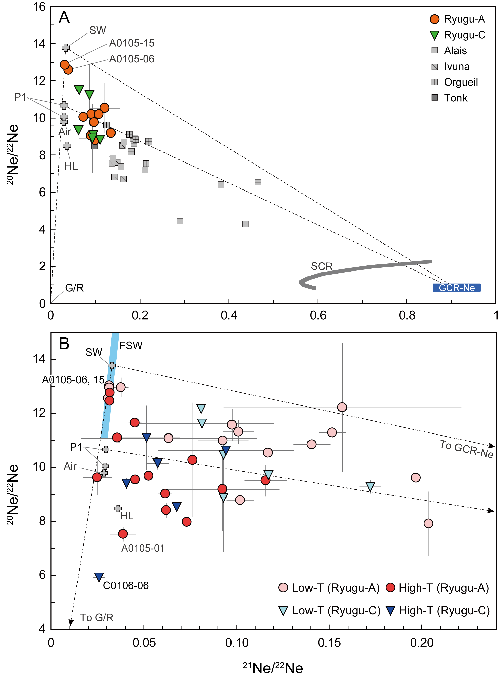**Fig. 3.** **Isotopic ratios of Ne in the Ryugu samples.** (A) Ne isotope ratios measured from Ryugu A-series samples (orange circles) and C-series samples (green inverted triangles). CI chondrite (Alais, Ivuna, Orgueil, and Tonk) compositions (gray squares) are shown for comparison. A dark blue box is an expected composition of GCR Ne. A gray solid curve shows a composition range of SCR-Ne. Compositions of SW, P1, HL, Air, and G/R are shown in gray crosses. Dotted lines are mixing lines for SW-G/R, SW-GCR, and P1-GCR. The Ryugu values are consistent with mixing of Ne with P1, HL, and GCR-Ne; two samples (labelled) also require a contribution from SW. (B) Isotope ratios of Ne extracted by stepped heating. A light blue box is a compositional range of fractionated SW, FSW. Ne compositions of low temperature fractions (Low-T, ≤200 °C or the first laser-heating extractions) are shown in light red circles or light blue inverted triangles. High temperature fractions (High-T, >900 °C fractions or the later laser-heating extractions) are shown in red circles and dark blue inverted triangles. The isotopic compositions of Ne released at low-T indicate a contribution from SW in most of the examined samples, while those at high-T exhibit contributions from P1 or HL, and G or R components. Isotopic compositions expected for GCR and SCR Ne were calculated using the GCR and SCR-Ne production rates (*57, 72*) and the CI chondrite composition (*55*). The composition of FSW(*30*)*,* was for penetration depths between 20 and 100 nm, calculated using a simulation software (*73*) assuming CI elemental abundances (*55*) (*21*). Data sources are (*23, 56*) for CI chondrites, (*27, 28*) for P1, HL, G, and R components, (*29*) for SW, and (*74*) for Earth’ atmosphere.

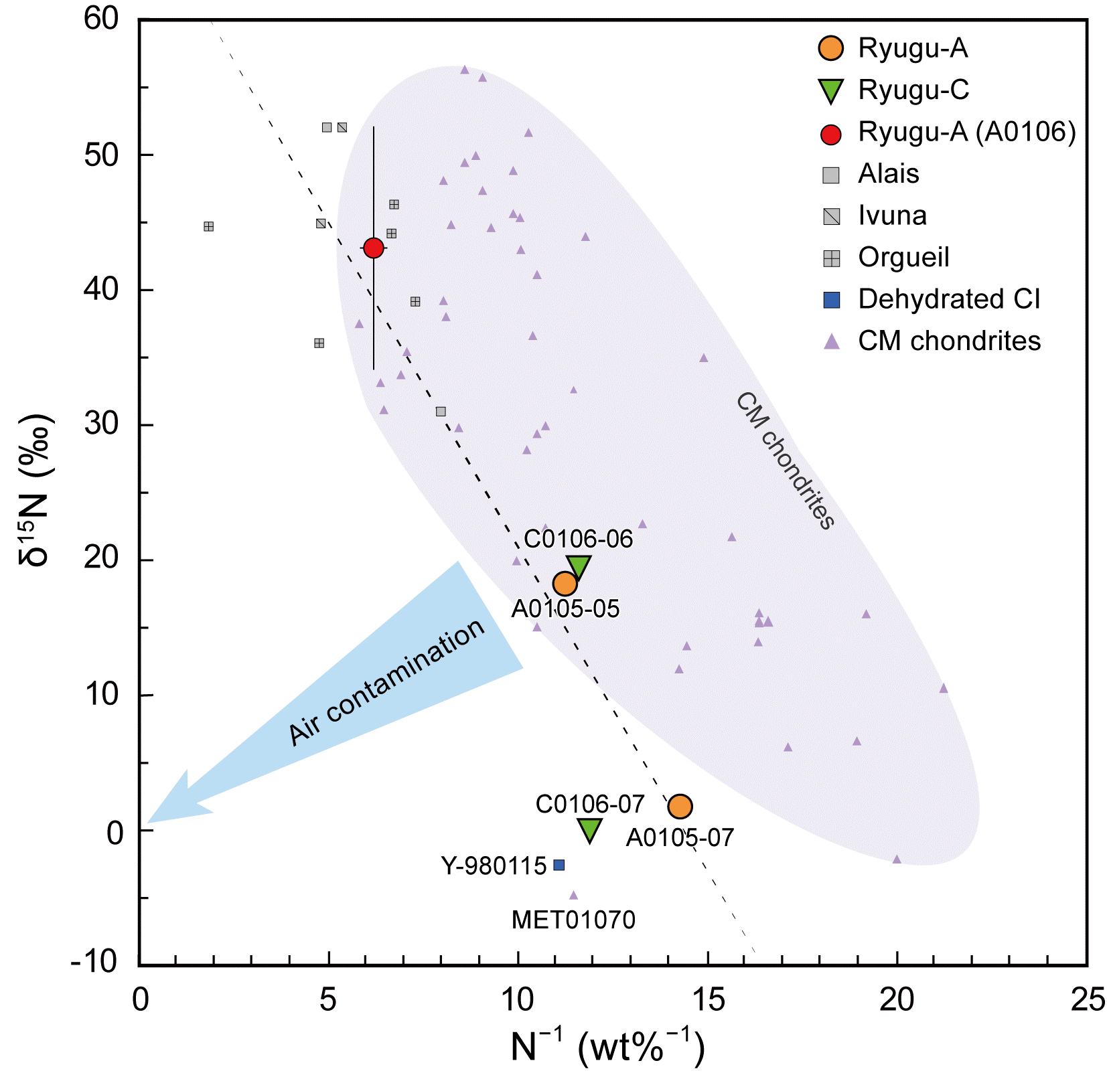

**Fig. 4.** **Nitrogen isotopic compositions and inverse concentrations of the Ryugu pellet samples.** Nitrogen compositions of each of the pelletized Ryugu-A (A0105-series samples, orange circles) and Ryugu-C (C0106-series samples, green inverted triangles) are shown. Uncertainties (1σ) for our data are smaller than the symbols sizes. An average composition of Ryugu-A aggregates (A0106, a red circle) (*26*), CI chondrite (Alais, Ivuna, and Orgueil) compositions (gray squares) (*32–34, 36*), a dehydrated CI chondrite (Y-980115) composition (a dark blue square) (*37*), and CM chondrite compositions (purple triangles) (*34–36*) are also shown for comparison. A dotted line is a regression line calculated for Ryugu samples and CI chondrites. The δ15N values of A0105-07 and C0106-07 are ~0 and ~+20 ‰, lower than those of CI chondrites, but are close to Y-980115 and the highly altered CM chondrite, MET 01070 (*36*). Two other samples (A0105-05 and C0106-06) have values intermediate between A0105-07/C0106-07 and A0106 compositions.

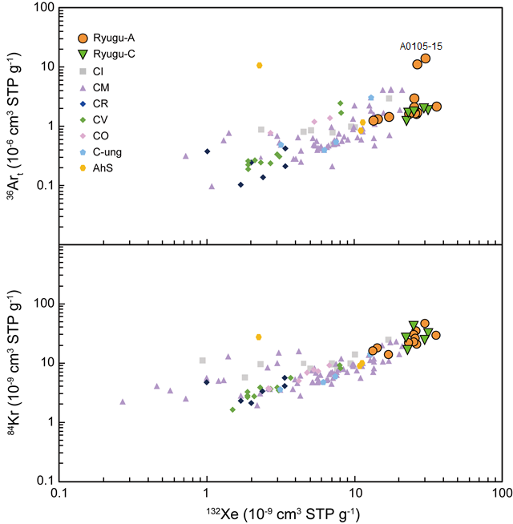

**Fig. 5.** **Concentrations of the dominant isotopes of trapped argon, krypton, and xenon.** Concentrations of 36Ar, 84Kr, and 132Xe in the Ryugu-A (orange circles) and Ryugu-C (green inverted triangles) are shown. Uncertainties (1σ) are 0.5 to 7 % (Data S1), smaller than the symbol sizes. Abundances in CI (gray squares), CM (purple triangles), Renazzo-type (CR) (dark blue diamonds), Vigarano-type (CV) (green diamonds), Ornans-type (CO) (purple diamonds) chondrites, ungrouped carbonaceous chondrites (labelled C-ung) (light blue pentagons), and a carbonaceous-chondrite-like clast from the Almahata Sitta polymict ureilite (AhS) (an orange hexagon). The Ryugu grains contain higher abundances of noble gases than other chondritic materials. Data sources are (*39, 41*) for CI, CM, CR, CV, CO chondrites, (*41*) for C-ung, and (*40*) for AhS.

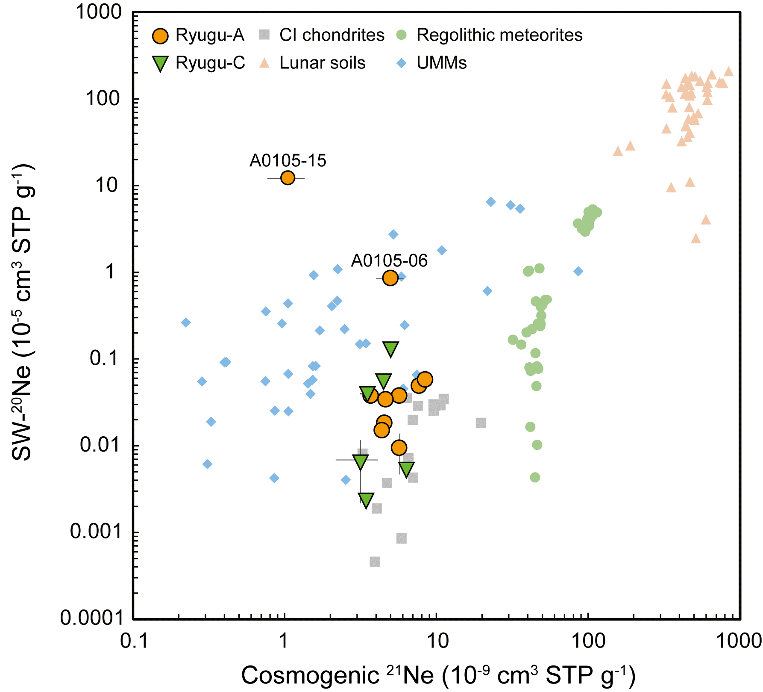

**Fig. 6.** **Concentrations of SW 20Ne and cosmogenic 21Ne.** Concentrations of SW-20Ne and cosmogenic 21Ne in Ryugu-A (orange circles) and Ryugu-C (green inverted triangles) are shown. These concentrations in CI chondrites (gray squares) (*23, 56*), regolithic meteorites (light green circles) (*45, 46*), lunar soils (pink triangles) (*47–49*), and UMMs (light blue diamonds) (*64–67*) are also shown for comparison. Two Ryugu samples (A0105-06 and A0105-15) have high SW-20Ne. No correlation between SW-20Ne and cosmogenic 21Ne is evident.