Abstract
Previous studies have established the relationship between ethical leadership and a variety of positive follower outcomes. They have investigated a number of psychological mechanisms that mediate these relationships. In terms of mediators, follower organizational identification has been found to mediate the relationship between ethical leadership and follower job performance. In this research, we incorporate a second distinct and theoretically important type of social identification process, relational identification with the leader, along with organizational identification, and examine their mediating effects on follower performance and voice outcomes. Further, we bring the implicit theory of morality to the behavioral ethics literature and examine follower morality beliefs as a moderator. Using a Romanian sample of 302 followers under the supervision of 27 leaders, we found that ethical leadership has an indirect effect on follower job performance and voice (through the mediating mechanisms of both organizational and relational identifications) and that these relationships are stronger for followers who held the implicit theory that a person’s moral character is fixed. Theoretical and practical implications are discussed.

Keywords: Ethical leadership; relational identification; organizational identification; voice; implicit theory of morality

Ethical Leadership and Follower Voice and Performance:
The Role of Follower Identifications and Entity Morality Beliefs

An increasing amount of research has supported the significant impact of ethical leadership (Brown, Treviño, & Harrison, 2005), on follower outcomes, including follower job performance (Piccolo, Greenbaum, Hartog, & Folger, 2010; Walumbwa, Morrison, & Christensen, 2012; Walumbwa, Mayer, Wang, Wang, Workman, & Christensen, 2011) , voice (Avey, Palanski, & Walumbwa, 2011; Brown, et al., 2005; Walumbwa & Schaubroeck, 2009), and other positive (Kacmar, Bachrach, Harris, & Zivnuska, 2011; Mayer, Aquino, Greenbaum, & Kuenzi, 2012; Mayer, Kuenzi, Greenbaum, Bardes, & Salvador, 2009; Schaubroeck, Hannah, Avolio, Kozlowski, Lord, Trevino, Dimotakis, & Peng, 2012), and negative behaviors (Mayer et al., 2012; Stouten et al., 2010). Recently, more attention has been paid to understanding the mediating mechanisms that underlie these relationships. The ethical leadership construct was initially proposed to rely on social learning processes to produce its effects (Brown et al., 2005). More recently, researchers have emphasized the prominent role of social identification processes by focusing on organizational identification as a mediator (Walumbwa et al., 2011). We propose a model that includes two types of social identification mechanisms as mediators and that proposes a moderator of these effects that is new to the behavioral ethics literature, implicit morality beliefs.
Identification processes have previously been proposed as a potential mediating mechanism (e.g., Brown & Mitchell, 2010) in the ethical leadership/outcome relationship (Walumbwa et al., 2011). We expand the prior exclusive focus on organizational identification to account for the likely important role played by an employee’s relational identification with the leader. Relational identification represents the extent to which one defines oneself in terms of a given role–relationship (Sluss & Ashforth, 2007), in this case, the relationship with the ethical leader. Relational identification seems to be particularly important because, especially for supervisory leaders, regular interaction with the leader is likely, and the relationship to the leader is psychologically closer than is the relationship to the organization. Therefore relational identification should play a particularly important mediating role in the relationship between ethical leadership and employee outcomes (Ashforth, Harrison, & Corley, 2008; Carmeli, Atwater, & Levi, 2011; Sluss & Ashforth, 2008; Zhang, Chen, Chen, Liu, & Johnson, 2012).
Perhaps more importantly, we propose that these identification processes will operate differently for employees holding different implicit morality beliefs. Individuals hold and utilize different implicit theories to make sense of the social world (Gopnik & Wellman, 1994; Kelly, 1955). These beliefs represent unspoken assumptions that can influence how people understand and structure their experiences. Although the implicit theory of managers has been shown to influence procedural justice and performance appraisal of employees (e.g., Heslin, Latham, & VandeWalle, 2005; Heslin & VandeWalle, 2011), and the implicit theory of morality in particular has been shown to influence individuals’ understanding of and responses toward moral situations (Chiu, Hong, & Dweck, 1997; Dweck, Chiu, & Hong, 1995), research has not yet considered how this important morality belief influences the reactions of employees toward ethical leadership. The implicit theory of morality seems particularly relevant to the study of ethical leadership because implicitly held assumptions about ethical people, and systems should influence how employees react to ethical leaders. Thus, we propose that the implicit theory of morality will help to explain why individuals with different implicit morality beliefs should react differently to ethical leaders.
We chose to study two outcomes, follower job performance and voice behavior, because, first, job performance is such a critical outcome (Piccolo et al., 2010; Walumbwa et al., 2011; Walumbwa et al., 2012). Second, follower voice is an important type of contextual performance (LePine & Van Dyne, 2001) that ethical leaders can also influence (Walumbwa & Schaubroeck, 2009). Voice behavior refers to a follower voluntarily expressing constructive ideas, comments, suggestions, and questions, and has profound implications for learning in organizations (Burris, 2012; Detert & Burris, 2007; Liang, Farh, & Farh, 2012; Morrison, 2011; Podsakoff, Whiting, Podsakoff, & Mishra, 2011). Additionally, as a type of cooperative and extra-role behavior, it has ethical implications (Kish-Gephart, Detert, Treviño, & Edmondson, 2009; LePine & Van Dyne, 1998; 2001). Moreover, voice seems to be particularly relevant given our study of identification processes. An employee who identifies with an ethical leader and with the organization is likely to feel safer about speaking up. Finally, examining these two outcomes simultaneously has the advantage of testing the impact of ethical leadership on two follower outcomes with less (job performance) and more (voice behavior) ethical implications, providing a more complete picture regarding ethical leadership effects. These outcomes are also particularly relevant to the mediating mechanisms. A follower who identifies with the leader and the organization is likely to wish to perform at a higher level and will feel safer speaking up.
We found support for our theoretical model (see Figure 1) in a field survey in Romania with data collected at two points in time and from multiple sources. We measured ethical leadership and entity morality beliefs in the first wave and follower identification with the leader and organization in the second wave. Job performance and voice behavior were rated by supervisors during the second wave.
This research makes several important contributions. First, we answer ‘how’ questions related to the social identification mediating mechanisms that connect ethical leadership to outcomes. Our research finds that relational identification and organizational identification independently and equally contribute to the effectiveness of ethical leadership. Second, we contribute to the ethical leadership literature by introducing the implicit theory of morality into the conversation about ‘who’ reacts to ethical leadership differently. As one reviewer noted, the ethical leadership literature has thus far focused less on the role of followers and moderators. Our study does both, bringing in a moderator that seems particularly suited to understanding follower reactions to ethical leaders. Third, we study two particularly relevant outcomes, job performance and voice behavior. Finally, this research contributes to the literature on implicit theory of morality by investigating its impact in the context of leader-follower interactions.
----------------------------------
Insert Figure 1 about here
----------------------------------
Hypotheses
Ethical Leadership and Follower Identifications
Ethical leadership is defined as ‘‘the demonstration of normatively appropriate conduct through personal actions and interpersonal relationships, and the promotion of such conduct to followers through two-way communication, reinforcement, and decision-making,’’ (Brown et al., 2005, p. 120). Ethical leaders are honest, trustworthy, approachable, caring, and fair in their decision making. Ethical leaders also lead on ethics. Specifically, ethical leaders serve as ethical role models for their subordinates, establish and communicate ethical standards to their subordinates, and enforce those standards through rewards and sanctions.
Brown and colleagues’ (Brown et al., 2005) used social learning theory (Bandura, 1986) to theorize that followers of ethical leaders learn appropriate behaviors by observing the behavior of these attractive, legitimate, and credible role models. However, research (e.g., Walumbwa et al., 2011) has also begun to investigate other psychological influence mechanisms through which ethical leadership likely influences followers. We propose to contribute to that line of work by focusing on the mediating role of follower relational identification in addition to organizational identification.
Organizational identification involves strong emotional attachment with the focal organization and internalization of the organization’s success (Mael & Ashforth, 1992). Walumbwa et al. (2011) found that organizational identification helps to explain the impact of ethical leadership on follower job performance. This makes sense because most employees think about leaders as representatives of the organization, its values and policies. In addition, ethical leaders are thought to increase followers’ feelings of trust in the organization, which provides favorable conditions for the development of organizational identification. Ethical leaders are also thought to increase followers’ feelings of organizational respect and self-esteem, enhancing organizational identification (Tyler, 1999; Tyler & Blader, 2003). If employees identify with the organization they are likely to wish to perform at a higher level.
Both theoretical discussion (Sluss & Ashforth, 2007) and recent empirical research (Sluss, Ployhart, Cobb, & Ashforth, 2012; Zhang et al., 2012) have shown that relational identification is conceptually and empirically distinct from organizational identification and that relational identification is an important identification outcome of leadership (Carmeli et al., 2011; Walumbwa & Hartnell, 2011). Follower relational identification with leaders refers to the extent to which the subordinate’s self-concept is defined by the relationship with the leader (Carmeli et al., 2011;Walumbwa & Hartnell, 2011). Social identification theory posits that group members will identify with the focal group or an important member of the group (e.g., the group leader) when doing so meets their fundamental needs such as belongingness and affiliation. We propose that ethical leadership should impact follower relational identification with the leader because ethical leaders are, by definition, “attractive, credible, and legitimate as ethical role models in part by engaging in behaviors that are evaluated by followers as normatively appropriate, and that suggest altruistic (rather than selfish) motivation,” (Brown et al., 2005, p. 120). Ethical leaders treat followers with care, respect and fairness, and they make decisions that are perceived to be principled. As a result, followers should be more likely to identify with the leader and to demonstrate cooperative behaviors (e.g., voice). Relational identification seems to be especially important when the ethical leader is a supervisory-level leader. The employee is likely to interact regularly with this leader, and observe his or her actions and decisions, all of which provide opportunity for identification to occur. By focusing on organizational and relational identifications together, we offer a theoretically coherent set of mediators that hinge on social identification processes.
Hypothesis 1a: Ethical leadership is positively related to follower relational identification with the leader.
Hypothesis 1b: Ethical leadership is positively related to follower identification with the organization.
Mediating Role of Follower Identifications
We propose that both follower organizational identification and relational identification will mediate the relationships between ethical leadership and follower voice behavior and job performance. We know that followers who identify with the organization tend to perform better in their jobs (van Knippenberg, 2000; Walumbwa, Avolio, & Zhu, 2008). This is because followers who highly identify with the organization align their interests with those of the organization, or even sacrifice their own self-interest for the collective (Ashforth et al., 2008; van Knippenberg, 2000; van Knippenberg & van Schie, 2000).
Followers who identify more with their organization are also more likely to engage in discretionary pro-organization behaviors (van Dick, Grojean, Christ, & Wieseke, 2006). Speaking up (voice) is one such behavior that may result from organizational identification (Lipponen, Bardi, & Haapamäki, 2008; Liu, Zhu, & Yang, 2010; Tangirala & Ramanujam, 2008). Voice is a behavior that involves proactively making suggestions to supervisors and management to enhance organizational efficiency by expressing concerns about current and potential problems or challenges (Morrison, 2011). Because voice is intended to aid organizational success, followers with stronger organizational identification are more likely to engage in voice behavior.
We have already proposed that followers of an ethical leader will have higher levels of organizational identification. To them, the leader represents the organization and its policies and procedures. Therefore, they are likely to believe that the treatment they receive from their leader reflects, at least in part, the organization the leader represents. As a result, they should want to help that organization with which they identify through work performance as well as suggestions for improvement and change (i.e., voice).
We turn now to follower relational identification with the leader (Chang & Johnson, 2011; Walumbwa & Hartnell, 2011). Leaders are known to influence follower behavior and performance in part by shaping follower identities (Ashforth et al., 2008; Avolio, Walumbwa, & Weber, 2009; Ellemers, De Gilder, & Haslam, 2004; Hogg, 2001; Lord & Brown, 2001; Lord, Brown, & Freiberg, 1999). Lord and colleagues (Lord et al., 1999, p. 167) suggested that “leaders can profoundly influence subordinates’ self-concepts, and thereby influence follower behavior and other social processes.” We have argued that stronger ethical leadership will be associated with stronger relational identification with the leader. That relational identification should help to explain why followers of an ethical leader are more likely to perform well and to speak up to their leaders. Sluss and Ashforth (2007) argue that, with stronger relational identification comes social attraction, interpersonal connection, a feeling of belongingness, and openness to influence from the admired and respected identification target (the leader in this case). Followers of an ethical leader with whom they identify should want to meet that leader’s performance expectations Followers who identify with their ethical leader should also feel more comfortable speaking up to that leader about problems because, with identification should come comfort with the leader and trust that speaking up is safe. Thus we propose,
Hypothesis 2a: Follower relational identification mediates the positive relationship between ethical leadership and follower voice behavior.
Hypothesis 2b: Follower organizational identification mediates the positive relationship between ethical leadership and follower voice behavior.
Hypothesis 3a: Follower relational identification mediates the positive relationship between ethical leadership and follower job performance.
Hypothesis 3b: Follower organizational identification mediates the positive relationship between ethical leadership and follower job performance.
The Moderating Role of Follower Entity Morality Beliefs
Although ethical leadership has been shown to influence followers’ behaviors, we know less about whether followers with different characteristics react to ethical leaders differently. We propose that followers are likely to vary in the extent to which they identify with and internalize the values and behaviors of their leaders. We bring individuals’ implicit morality beliefs into this conversation and posit that individuals’ implicit morality beliefs are likely to play an important role in how followers react to ethical leaders. Entity morality theory provides guidance for the development of our hypotheses because, given its focus on people’s beliefs about ethics, ethical people, and structures.
In general, people hold implicit theories about human attributes (e.g., morality, intelligence, personality) to help them structure their experiences (Gopnik & Wellman, 1994; Heider, 1985; Kelly, 1955). These beliefs provide a meaning system which influences judgments, interpretations, and behavioral responses. Implicit theories have been shown to shape individuals’ responses to a variety of social situations and personal experiences (Chiu, Hong, et al., 1997; Dweck, 2000; Dweck et al., 1995; Hong, Chiu, Dweck, Lin, & Wan, 1999). In particular, beliefs about the fixedness (referred to as entity beliefs) and malleability (referred to as incremental beliefs) of human attributes have sometimes been conceptualized as standing on opposite ends of a continuum and the implicit theories held by individuals lie somewhere along this continuum. We take this approach in our research, following the example of Tabernero and Wood (1999: 125) who observed that implicit theories reflect “a simple belief about plasticity or fixedness.”
Implicit beliefs have the potential to affect how followers perceive and react to their leaders. Because implicit beliefs have been found to be domain-specific, different implicit beliefs are likely to be relevant depending on what types of leadership variables are under investigation. For example, if a study were to examine the impact of leaders’ competence, implicit theories of intelligence would be relevant. Of particular relevance to the current study are entity morality beliefs (Chiu, Dweck, et al., 1997). In the moral domain, those with strong entity morality beliefs conceive people’s moral character and traits as more fixed than malleable. They also perceive the moral order as more static and are concerned about conforming to prescribed duties and obligations to maintain the existing social order and to preserve the status quo (Chiu, Dweck, et al., 1997). Therefore, in the face of an ethical leader, individuals with stronger entity morality beliefs should see an ethical leader’s moral characteristics as more fixed and that ethical leader’s behavior as a consistent, authentic and genuine expression of the leader’s moral character and principles. When employees with stronger “entity morality beliefs” observe an ethical leader’s behavior, they are more likely to make an internal attribution (Chiu et al., 1997), seeing those ethical leadership behaviors as reflective of fixed, innate moral traits and integrity of the leader (Hong, Chiu, Dweck, & Sacks, 1997). In addition, compared with those with weaker entity morality beliefs, individuals with stronger entity morality beliefs tend to be more certain when making behavioral predictions of their leaders’ ethical behaviors across different situations and over time (Dweck et al., 1995).Therefore, followers with stronger entity morality beliefs are likely to perceive an ethical leader as a consistent and credible ethical role model who upholds moral standards and values that represent both the leader and the organization, thus attracting stronger relational identification with the leader and stronger organizational identification. Further, followers with stronger entity morality beliefs should be more receptive and responsive to ethical leadership behaviors, enabling them to develop a stronger relational identification with their leader and stronger identification with the organization the leader represents. By contrast, with weak ethical leadership, we expect that individuals with stronger entity morality beliefs will see the weak ethical leader’s traits as relatively fixed. In addition, they would be less likely to speak up (i.e., engage in voice), because they see organizational change as unlikely or even impossible.
In short, followers with stronger entity morality beliefs should expect ethical leadership to be more trait-like, relatively stable, and consistent. As a result, they should view ethical leaders as more authentic and dependable which should enhance their social identification with the leaders (Ashforth, et al., 2008). Therefore, we expect that, for followers with stronger entity morality beliefs, ethical leadership will strengthen follower identification with the ethical leader (relational identification). Moreover, followers with stronger entity morality beliefs are also concerned about conforming to prescribed duties and obligations and are invested in the existing status quo (Chiu et al., 1997). Thus, we propose that followers with stronger entity morality beliefs should also identify more strongly with the organization that the ethical leader represents.
Hypothesis 4a: Ethical leadership has a stronger positive relationship with follower relational identification for followers with stronger entity morality beliefs.
Hypothesis 4b: Ethical leadership has a stronger positive relationship with follower organizational identification for followers with stronger entity morality beliefs.
Finally, we expect that ethical leadership will be more positively related to follower identifications and thereby work-related outcomes for those followers with stronger entity morality beliefs. As suggested earlier, positive follower outcomes can be derived from both relational identification (Carmeli et al., 2011; Sluss & Ashforth, 2007, 2008; Walumbwa & Hartnell, 2011) and organizational identification (Ashforth et al., 2008; Dukerich, Golden, & Shortell, 2002; Riketta, 2005; Tangirala & Ramanujam, 2008; van Dick, et al., 2006). In addition, we argued earlier that both relational and organizational identifications will mediate the positive relationships between ethical leadership and follower voice, as well as job performance (see H2a, b and H3a, b). Taken together, we expect that under ethical leadership, people with stronger entity morality beliefs are more likely to develop stronger relational identification and organizational identification. Because of these stronger identifications, they are more likely to make constructive suggestions to their leaders and deliver better job performance.
Hypothesis 5a: Ethical leadership has a stronger mediated positive relationship (through relational identification) with follower voice behavior to supervisor for followers with stronger entity morality beliefs.
Hypothesis 5b: Ethical leadership has a stronger mediated positive relationship (through relational identification) with follower job performance for followers with stronger entity morality beliefs.
Hypothesis 5c: Ethical leadership has a stronger mediated positive relationship (through organizational identification) with follower voice behavior to supervisor for followers with stronger entity morality beliefs.
Hypothesis 5d: Ethical leadership has a stronger mediated positive relationship (through organizational identification) with follower job performance for followers with stronger entity morality beliefs.

Methods
Context -Romania
We collected data in Romania, an eastern European country which provides a unique context for studying ethical leadership for several reasons. First, around 1989 regime change happened spontaneously, similar to other Central and Eastern European countries such as Hungary, Bulgaria, and Poland. Romanian organizations have faced a multitude of ethical matters due to political, social, and economic transformations (Heintz, 2002). Congruent with the macroeconomic environment, Romanian organizations have undergone comprehensive restructuring exercises due to the transition from a central planned economy into a capitalist market economy (Ibrahim & Galt, 2002). Significant changes such as privatizations and reforms have taken place in the last 20 years. These changes are also pervasive among the manufacturing organizations sampled in this study. Because leadership is viewed as a key factor in organizations undergoing transition and development (Avolio, Zhu, Koh, & Bhatia, 2004), we expected that this context would provide an ideal test of the relationships between ethical leadership and follower voice behavior and job performance.
Moreover, the political, economic, and social changes also impact employees’ working attitudes and behaviors. Due to the transformation and the increasing pluralism, employees are influenced by both the increased political and cultural integration with other European countries and the previous traditional socialist values. Further, Romania presents an interesting context as it represents a group of Central and Eastern European countries with common historical, political, and economic backgrounds. Moreover, as a new member of European Union since January 2007, Romania is the second largest market in terms of population within Central and Eastern European countries (Eurostat, 2011). Given the political and economic significance of this area, Romania presents a novel and important context for studying ethical leadership.
Sample and Data Collection
We collected our data from office employees working in three separate organizations’ head offices in Romania. All organizations are companies that sell metallurgical products or construction materials such as steel tubes, galvanized iron and plates, highway guardrail, concrete plants, flooring, and decorative precast equipment and facilities. Research access was gained through personal and professional contacts with the head-office Directors of the companies. High levels of support were received from all three companies. We selected followers who had no supervisory positions in the organization.
Each company set up a temporary office for survey completion. In order to reduce concerns of common method bias (Podsakoff, MacKenzie, Lee, & Podsakoff, 2003; Podsakoff, MacKenzie, & Podsakoff, 2012), we collected our survey data in two waves. For the first wave, a trained research assistant was based in the companies for data collection. Within the three organizations’ head offices, there are 426 followers that form the total population for the study. During the first wave collection, we were able to approach 407 of these followers during their office hours. A structured questionnaire was compiled in English and then translated into Romanian following double-translation rules (Sperber, Devellis, & Boehlecke, 1994). Questionnaires including independent variables (i.e. ethical leadership), moderator (i.e. entity morality beliefs), and demographic questions were distributed to these 407 followers. Followers completed questionnaires by the self-administrated method in either the research assistant’s office or respondents’ own desks. Each respondent was instructed about the purpose of the study to assure them of strict confidentiality of the data which would not be shared with supervisors or the company. They were instructed on how to complete the survey and assured that their participation in the study was voluntary. Since the research assistant is a bilingual speaker of English and Romanian, respondents’ questions could be answered during the data collection. Most respondents completed the first wave questionnaires within 10 minutes without difficulties. Respondents sealed completed questionnaires and returned them individually to the research assistant. In her own office, the research assistant noted the participants’ names on the envelopes to enable matching the later second wave survey and supervisors’ ratings. From the first wave survey, we collected 375 useful responses (124, 139, and 112 from three companies respectively) from 27 departments, which resulted in a response rate of 92.1%. This response rate is close to other studies receiving strong support from senior managers (Huang, Iun, Liu, & Gong, 2010; Liden, Wayne, & Sparrowe, 2000).
The second wave of data collection was conducted close to one month after the first wave survey. For the second wave, we intended to approach only the employees who had returned useful responses in wave one (i.e., 375 followers). However, 20 employees were either not in their offices during the second wave or decided not to attend the second wave survey. Therefore, we managed to reach 355 followers in the second wave. The same procedure described for the first wave was used. Questionnaires including mediating variables (i.e. relational identification and organizational identification) were distributed to these 355 employees at their offices. Finally, we collected a total of 302 matched and useful responses (94, 117, and 91 from three companies respectively), which resulted in a response rate of 85.1% for the second wave survey and an overall response rate of 74.2%. The final matched sample consists of respondents between 19 and 59 years of age, with an average age of 34.12 (S.D. = 8.57). A majority (65.9%) of participants held college degrees, 4.6% had master or higher degrees, and 29.5% had high school education or lower. The average employee had been with the company for 41.64 months (S.D. = 34.16). Women comprised 46.7% of the respondents. Based on the collected 302 followers’ responses from 27 departments, we then, with help from the Managing Directors of the head offices, contacted those followers’ immediate supervisors to rate the respondents’ voice behaviors and job performance (i.e. dependent variables). The immediate supervisors are the department heads who are responsible for employees’ daily work, so they are most appropriate for evaluating followers’ voice behaviors and job performance. All supervisors responded to our request, resulting in a response rate of 100%.

Measures
All questions, unless otherwise stated, were scored on a seven-point scale with response options ranging from 1 (“strongly disagree”) to 7 (“strongly agree”). Alphas of all measures are presented in Table 2.
Ethical leadership. Ethical leadership was measured using the 10-item scale developed by Brown et al. (2005). Employees were asked to consider their immediate supervisors and indicate the extent to which they agree or disagree with descriptions of their supervisors. Sample items include “listens to what employees have to say”; and “disciplines employees who violate ethical standards.” The Cronbach’s alpha score is .92. In this study, because we are interested in how each individual responds to his or her leader’s ethical leadership behavior, we conceptualize ethical leadership at the individual level. We checked the within-group variance of ethical leadership ratings by computing ICC1 and ICC2 scores. ICC1 and ICC2 scores for ethical leadership are .21 and .75 respectively, which suggests that individual perception accounts for the majority of the variance of the rating (Bliese, 2000). Because some limited variance of ethical leadership may be explained by group (followers who are under the same supervisor) membership, we control for the potential group effects in testing our model (explained below).
Relational identification. Relational identification was measured with the 10-item scale developed by Walumbwa and Hartnell (2011). Sample items include “I share the success of my supervisor,” and “I am proud to tell others I work with this supervisor.” The Cronbach’s alpha score is .78.
Organizational identification. We measured followers’ organizational identification with five items from Mael and Ashforth (1992). It is extensively validated and is the most widely used measure of organizational identification. Sample items include “when someone criticizes my organization, it feels like a personal insult”; “when someone praises my organization, it feels like a personal compliment”; and “my organization’s successes are my successes”. The Cronbach’s alpha score is .86.
Entity morality beliefs. We asked participants to rate their own implicit theories of human morality in the first wave of survey with the well-established scale of eight items (Chiu, Dweck, et al., 1997). The scale has two sets of questions. One set has four questions assessing belief in the fixed nature of human morality (sample item: “A person’s moral character is something very basic about them and it can’t be changed much”). The other set asks four questions assessing beliefs on the malleability of human morality (sample item: “When it is necessary, a person’s moral character can be changed”). Following the work of others, we then aggregated the 8 items into one composite entity morality beliefs scale, with lower scores representing weaker entity morality beliefs and higher scores representing stronger entity morality beliefs. This composite scale approach is consistent with much recent research (see Chiu, Dweck, et al., 1997; Dweck, Chiu, & Hong, 1995; Levy & Dweck, 1996). The Cronbach’s alpha score for the aggregated scale is .87.
Dependent variables. Supervisors assessed follower voice behavior and job performance with nine and four items respectively. We used the speaking up scale developed by Liu et al. (2010) based on an earlier general voice scale (Van Dyne & LePine, 1998). A sample item was “develop and make recommendations to you concerning issues that affect the company.” The Cronbach’s alpha score is .89. Job performance was measured by a four-item seven-point scale (Walumbwa, et al., 2008). A sample item was “how competently does he/she perform the job.” The Cronbach’s alpha score is .83.

Data Analyses and Results
Evidence of Construct Validity
To further examine the validity of the scales utilized in this study, we conducted confirmatory factor analysis (CFA). After a scale refinement procedure, we removed two items of the ten-item relational identification scale (“I praise my supervisor when speaking with friends”; and “I respect the views and suggestions of my supervisor”), due to low factor loadings (r = .36 and .47 respectively). Upon examination, we noted that these two items have slightly different semantic meanings compared to the remaining items. In addition, the correlation between the refined scale and the unrefined scale is very high (r =.97). For parsimony purposes, we used the shorter scale. No item was removed from other scales. A CFA with the proposed factor structure achieved adequate fit: χ²=1725.24**, df = 881, CFI = .91, TLI = .90, RMSEA = .05. All of the estimated factor loadings of the indicators for the underlying constructs are significant (p < .001) and above the minimum of .50 threshold (Fornell & Larcker, 1981). In addition, we compared the fit of the proposed model with more constrained models in which two highly correlated factors (e.g., ROID and OID, voice behavior, and job performance) were set to load on a single factor. CFA results demonstrated that the hypothesized model fits the data significantly better than the alternative models, in that there is a significant difference in the change of Chi square between the alternative models and the proposed model. All the above tests provide evidence for the validity and independence of all the measurements utilized in this study (see Table 1).
----------------------------------
Insert Table 1 about here
----------------------------------
Table 2 presents the descriptive statistics and further scale validity tests. AVE scores of all measures in the measurement model exceed the .50 threshold (Fornell & Larcker, 1981). Cronbach’s alpha estimates of all latent variables exceeded the .70 threshold (Nunnally, 1978). The square roots of all AVE scores are higher than the correlations of any pairs involving the focal variable, which supports the discriminant validities of the scales (Fornell & Larcker, 1981). Taken together, these tests, coupled with the CFAs above, support the convergent and discriminant validities of the measurement scales.
----------------------------------
Insert Table 2 about here
----------------------------------
Hypothesis Testing
We applied mediated moderation path modeling to test our hypotheses using the M-PLUS 6.0 program (Muthén & Muthén, 2010), because it can perform better than traditional regression analyses in testing complex models involving both mediation and moderation (Iacobucci, Saldanha, & Deng, 2007). The M-Plus can also deal with non-independence of ratings by leaders for follower voice behavior, and job performance, as well as ratings of ethical leadership by followers supervised by the same leader due to the stratified and clustering nature of our data structure. Through the command of “type = complex,” M-Plus provides a way to adjust for clustering or classification in data analysis, taking into account non-independence of the endogenous variables. This is particularly necessary for our data, as the ratings of follower voice behavior and job performance were rated by 27 different supervisors. Indeed, ICC1 for job performance is .34, and for voice behavior is .20. We used M-Plus software to simultaneously examine the moderation and mediation model involving multiple mediators (i.e., organizational, and relational identifications) and DVs (voice, and performance). This model can examine the moderated mediation in one model and calculate the conditional direct and indirect effects, indirect effects of products, and total indirect effect across all IVs simultaneously. Therefore, M-Plus can accomplish the same functions that are featured in the INDIRECT or PROCESS software (Hayes, 2012; 2013). In addition, this path analysis using M-PLUS enables examination of the significance of the indirect effects of multiple mediators, and provides a powerful and robust method of obtaining confidence intervals for specific indirect effects and their significance levels (Preacher & Hayes, 2008).We ran a model based on our proposed conceptual framework without a direct path from ethical leadership to the two outcome variables (voice behavior and job performance). We also ran another model which included the direct paths. Little difference exists between the model with the direct paths, and the model without the direct paths from ethical leadership to follower outcomes. Because neither of the two direct paths was significant, for the sake of parsimony, we reported the model without these two direct paths (i.e., full mediation model). The model achieved adequate overall fit (χ² = 25.29**, df = 6, CFI = .97, TLI = .91, RMSEA = .10). CFI and TLI scores indicate excellent model fit. Although the RMSEA score is slightly higher than the recommended score, it is still within the acceptable range of up to .10 (Browne & Cudeck, 1993). Figure 2 shows the results in the format of the graphic representation of the proposed conceptual model. Table 3 presents the results including the moderator (entity morality beliefs).
---------------------------------------------
Insert Figure 2 & Table 3 about here
----------------------------------------------
Hypothesis 1a and Hypothesis 1b predicted that ethical leadership is positively related to follower relational identification with the leader and identification with the organization. H1a and H1b are supported (β =.89, p < .001; β = .52, p < .001 respectively) (see Table 3).
Hypothesis 2a predicted that follower relational identification mediates the positive relationship between ethical leadership and follower voice behavior. Table 4 presents the reported indirect effects of ethical leadership by M-plus based on our model specification. It shows that H2a is supported (β = .18, p < .001). Hypothesis 2b states that follower organizational identification mediates the positive relationship between ethical leadership and follower voice behavior. Hypothesis 2b is also supported (β = .24, p < .001).
----------------------------------
Insert Table 4 about here
----------------------------------
We hypothesized that follower relational identification and organizational identification mediate the positive relationship between ethical leadership and follower job performance (Hypothesis 3a and Hypothesis 3b). Table 4 shows that both hypotheses are supported (β = .37, p < .001; and β = .25, p < .001 respectively). We also conducted a post-hoc test by comparing the potential differential mechanisms of organizational identification versus relational identification. We found no statistically significant difference. Thus, both organizational identification and relational identification appear to act as equally important mediation mechanisms for the effects of ethical leadership on employee performance and voice behaviors. We predicted that ethical leadership would have a stronger positive relationship with follower relational identification (Hypothesis 4a) and follower organizational identification (Hypothesis 4b) for followers with stronger entity morality beliefs. Both hypotheses are supported (see Table 3), as the interaction between follower entity morality beliefs and ethical leadership is significantly related to relational identification (β = .42, p < .001) and organizational identification (β = .23, p < .001). The results mean that ethical leadership has a stronger impact on follower relational identification and organizational identification for followers with stronger entity morality beliefs. We plotted Figures to illustrate the pattern of these interactive effects, based on a standard procedure with one standard deviation above and below the mean representing higher and lower values of the moderator and testing the significance of the simple slopes (Aiken & West, 1991; Edwards & Lambert, 2007). All variables are standardized except the two outcome variables: follower voice behavior and job performance. Figure 3 shows that when entity morality beliefs are higher, the relationship between ethical leadership and follower relational identification is stronger (β = 1.31, p < .001). When entity morality beliefs are lower, the relationship is weaker, and still statistically significant (β = .47, p < .001). Figure 4 shows that when entity morality beliefs are higher, the relationship between ethical leadership and employee organizational identification is stronger (β = .75, p < .001). When entity morality beliefs are lower, the relationship is weaker, and still statistically significant (β = .29, p < .05).
-------------------------------------
Insert Figures 3 & 4 about here
-------------------------------------
Finally, we expect that the moderating effect of entity morality beliefs on follower identifications will pass to the two outcome variables: follower voice behavior and job performance (Hypothesis 5a, 5b, 5c, and 5d). To test these hypotheses, we used M-plus to calculate the indirect moderating effects involving entity morality beliefs and ethical leadership through both relational identification and organizational identification. Table 4 presents the test results under the heading of indirect moderating effects. Hypothesis 5a predicts that ethical leadership has a stronger mediated positive relationship (through relational identification) with follower voice to supervisor for followers with stronger entity morality beliefs. Hypothesis 5a is supported (β = .08, p < .01). Figure 5 shows that when entity morality beliefs are higher, the indirect relationship between ethical leadership and employee voice through relational identification is strongerr (β = .26, p < .001). When entity morality beliefs are lower, the relationship is weaker, and still statistically significant (β = .10, p < .001).
----------------------------------
Insert Figure 5 about here
----------------------------------
Hypothesis 5b states that ethical leadership has a stronger mediated positive relationship (through relational identification) with follower job performance for followers with stronger entity morality beliefs. Hypothesis 5b is also supported (β =.18, p < .001). Figure 6 shows that when entity morality beliefs are higher, the indirect relationship between ethical leadership and employee job performance through relational identification is stronger (β = .55, p < .001). When entity morality beliefs are lower, the relationship is weaker, and still statistically significant (β = .19, p < .001).
----------------------------------
Insert Figure 6 about here
----------------------------------
We also predicted that ethical leadership would have a stronger mediated positive relationship (through organizational identification) with follower voice behavior (Hypothesis 5c) and with follower job performance (Hypothesis 5d) for followers with stronger entity morality beliefs. Both Hypothesis 5c and Hypothesis 5d are supported (β = .11, p < .001; and β = .11, p < .001 respectively). Figure 7 shows that when entity morality beliefs are higher, the indirect relationship between ethical leadership and follower voice behavior through relational identification is stronger (β = .35, p < .001). When entity morality beliefs are lower, the relationship is weaker, and still statistically significant (β = .13, p < .05). Figure 8 shows that when entity morality beliefs are higher, the indirect relationship between ethical leadership and follower job performance through organizational identification is stronger (β = .36, p < .001). When entity morality beliefs are lower, the relationship is weaker, and still statistically significant (β = .14, p < .05).
---------------------------------------
Insert Figures 7 & 8 about here
----------------------------------------
Discussion
In this research, we found that ethical leadership is positively related to two important follower outcomes (i.e., voice behavior and job performance) through dual social identification mechanisms (i.e., relational identification and organizational identification). Drawing from entity morality theory, we also found that the impacts of ethical leadership differ across individuals depending on the strength of their entity morality beliefs. Importantly, although followers with stronger entity morality beliefs are less likely to engage in voice behavior (note that the bivariate correlation with voice is negative), and entity morality beliefs are unrelated to job performance) these same individuals tend to be receptive to the influence of ethical leadership in terms of developing stronger relational identification with the leader and with the organization, which in turn increases both follower voice behavior and job performance.
Contributions to Research
This research makes a number of theoretical contributions. First, we advance ethical leadership research by identifying dual social identification mechanisms as mediators of the ethical leadership relationship with follower performance and voice. We found that relational identification and organizational identification act as equally important mediating mechanisms between ethical leadership and two positive follower outcomes, voice behavior, and job performance, extending the work of Walumbwa and colleagues (2011) that studied only organizational identification. To our knowledge, relational identification has not been previously studied as a mediator between ethical leadership and outcomes. Relational identification is a unique construct that is distinct from organizational identification, and can provide novel insights into the role of employee social identification processes in understanding employee outcomes (Sluss & Ashforth, 2007). It makes theoretical sense that followers would be inclined to identify personally with a leader who cares about them, treats them fairly, is open to their input, and sets ethical standards, and that doing so would influence important outcomes. In fact, our study shows that there is a significant positive relationship between ethical leadership and relational identification and that relational identification has a significant positive effect on both job performance and voice behavior even when organizational identification is included in the theoretical model. These findings demonstrate that relational identification should be considered as an important mediator (along with organizational identification) in understanding ethical leadership’s effects on these positive follower outcomes. Identifying personally with the ethical leader is an important contributor to both follower outcomes, but especially to job performance.
Similarly, we found that after relational identification is included in the model, organizational identification still plays an important mediation role in the process of how ethical leadership affects follower job performance and voice behavior. Thus, our study has contributed to the understanding of two social identification mechanisms that mediate the impacts of ethical leadership on follower outcomes. It appears to be important to include both of them because they have similar impacts on performance but somewhat different impacts on voice behavior. Our research also contributes to the follower identification literature by demonstrating that (a) ethical leadership is positively related to both follower organizational and relational identifications, (b) both identifications are important antecedents of follower outcomes (voice behavior, and job performance), and (c) both identifications mediate the relationship between ethical leadership and follower job performance and voice behavior.
In our research, we focused on the two identification processes as mediators. But, that does not mean that other, previously studied processes are unimportant. Social learning (Bandura, 1986) provides the theoretical underpinning for understanding ethical leadership’s effects. Followers learn from ethical leaders who are credible and attractive role models and they are likely to follow their ethical lead. In addition, from a social exchange perspective (Ekeh, 1974; Emerson, 1976), ethical leaders treat followers in a fair and caring manner, leading to feelings of trust and the desire to reciprocate (and perhaps the desire to identify with the leader). Although challenging, future research may wish to incorporate multiple mediators in a single study.
This research also addresses the important question of when ethical leadership matters more by identifying an important individual difference that has not yet been considered in the behavioral ethics literature. We bring the theory of entity morality beliefs to behavioral ethics in an attempt to understand how this individual difference impacts the relationship between ethical leadership, mediators, and follower outcomes. The application of entity morality beliefs to understand organizational phenomena remains quite limited despite research showing that people with entity beliefs in general have profound implications for people’s interpretation of information and meaning making (Chiu, Dweck, et al., 1997; Chiu, Hong, et al., 1997; Dweck, et al., 1995). Our application of implicit beliefs to understanding the impact of leadership on followers is limited to one domain of implicit beliefs (implicit morality beliefs). As noted earlier, implicit beliefs are relevant across multiple domains (e.g., personality, intelligence, morality). The choice of implicit morality beliefs is appropriate for our research due to its focus on how followers react to ethical leadership. Future research should select the domain of implicit theories to match the domain of the chosen leadership variable. Our research demonstrates that follower’ entity morality beliefs moderate how they react to ethical leaders in terms of identifications. Specifically, the relationships between ethical leadership and relational and organizational identification are enhanced for followers with stronger entity morality beliefs, and in turn, these employees are more likely to speak up to supervisors and perform better in their jobs. These followers are more likely to be influenced by ethical leaders because they see their ethical leaders as consistent moral agents who are guided by ethical imperatives. They consider the observed ethical leadership behaviors to be relatively stable, leading them to perceive the ethical leader as genuine (Dweck, et al., 1995). They are also likely to see the ethical leader as representative of an existing moral order that guides behavioral standards in the organization (Chiu, Dweck, et al., 1997), thus inviting relational and organizational identifications. Such identifications then contribute to their willingness to speak up and to perform at a high level. We believe that entity morality beliefs are particularly pertinent to the study of ethical leadership’s effects because of the focus on beliefs about morality and future research should consider how else it may impact ethical leaders’ effects. But, the theory may also offer new insights to the study of other leadership styles (e.g., transformational leadership, servant leadership) and organizational phenomena that have moral content and we encourage researchers to consider its role in shaping organizational behaviors in future studies.

Implications for Practices
The positive impacts of ethical leadership on voice behavior and job performance are consistent with the findings of prior studies, contributing to our growing understanding of the importance of ethical leadership for positive follower behaviors that go beyond the more obvious ones- reducing deviance and unethical behavior. Even if organizations are not interested in promoting ethical leadership for its own sake, our research offers solid scientific evidence regarding the instrumental value of ethical leadership for organizations that are interested in higher performance and voice. Our study suggests that ethical leadership should be encouraged within organizations because it improves voice behavior and job performance by increasing two important types of identification. Some research does exist on traits that are associated with ethical leadership (Walumbwa & Schaubroeck, 2009), suggesting opportunities for selection processes that are aimed at identifying ethical leadership in managerial recruits. Once in the organization, perhaps ethical leaders can be identified through 360-degree feedback mechanisms and rewards for associated behaviors can be built into the performance management system. We are not aware of work on whether or how ethical leadership can be developed through training and development activities. Perhaps organizations can build upon work that has been published on successful transformational leadership development (e.g., Dvir, Eden, Avolio, & Shamir, 2002). The positive effect of relational identification on follower outcomes suggests that strong and favorable follower relational identification with their ethical leaders should be encouraged. Also, the positive effect of organizational identification on follower outcomes indicates the development and monitoring of employees’ identification with their organization as effective tactics for maintaining and enhancing employees’ performance, and motivating them to speak up. Therefore, ethical managers should not only maintain good relationships with their followers but also develop relevant programs to cultivate followers’ identification and affiliation with their organizations, both of which will help them make constructive suggestions to their managers and deliver better job performance.
Moreover, our research suggests that ethical leadership does not impact follower voice equally. On the one hand, followers with stronger entity morality beliefs are reluctant to speak up, likely because they do not believe that change is likely and thus think there is no point or value in voicing. But, importantly, having an ethical leader can break their silence. Our research shows that ethical leadership is important in mobilizing people, even those people with strong entity morality beliefs, to speak up. More specifically, we found that ethical leadership is particularly effective in enhancing identifications and performance for those followers with strong entity morality beliefs. Therefore, if ethical leadership is in place, the liability of having followers with stronger entity morality beliefs as reluctant ”voicers” is less of a concern for an organization.
As noted above, although employees with strong entity morality beliefs are less likely to speak up to their supervisors, they will perform better in their jobs and offer more constructive suggestions to supervisors when they perceive that they are led by stronger ethical leaders. This suggests that organizations, especially those that hire and promote ethical leaders, should consider recruiting employees with strong entity mortality beliefs. For example, organizations can measure entity morality beliefs in the recruitment and selection process, so that organizations can take this factor into selection consideration. Furthermore, organizations may also consider developing training or other programs (Valentine & Fleischman, 2004) and practices aimed at enhancing employees’ entity morality beliefs.
Strengths, Limitations, and Future Research
First, this study has contributed to ethical leadership research by proposing and testing a moderated mediation model that examines ethical leadership effectiveness in a Romanian sample, an under-researched context in management research. The findings suggest that ethical leadership operates in and is particularly important in this new cultural context. However, we acknowledge that this study’s Romanian sample in a single industry may limit the generalizability of these results. For example, Romania is a country that tends to have a high power distance culture (PDI = 90 out of 100, Hofstede, 2014), which might affect voice behaviors. It is likely that followers in a high power-distance culture are even less likely to voice (than are those in low power-distance cultures) due to perceived powerlessness in relation to their leaders. In addition, power distance might also affect how ethical leadership affects followers’ voice, so that when power distance is higher, ethical leadership might exert a stronger influence on follower voice, as ethical leadership is likely to create a more comfortable and safe environment for followers to voice. Therefore, we suggest that future research should (a) test our theoretical model using larger and broader samples and in other cultural contexts; and/or (b) incorporate power distance as a potential moderating or contextual variable to test the effect of ethical leadership on voice.
We collected our data in two waves of surveys and obtained supervisor ratings of follower voice behavior and job performance. Therefore, concerns about common methods bias are reduced by our design. Nevertheless, our data are cross-sectional meaning that causal inferences should not be drawn. On the other hand, the proposed model is theoretically sound and reverse causality seems unlikely. However, future research can benefit from an experimental or longitudinal research design. For example, from a longitudinal perspective, a three-wave survey (where independent variables, mediation variables, and outcome variables are measured in three waves over time) can add additional methodological rigor. In addition, given some conceptual overlap between ethical leadership and idealized influence, it would be helpful to control for the effect of idealized influence when examining ethical leadership effectiveness, although Brown, Trevino, and Harrison (2005) found that ethical leadership can significantly predict leadership effectiveness (r = .21, p < .01), even after controlling for the effect of idealized influence.
Further, identifying potential individual differences in the impact of ethical leadership is important, and introducing entity morality theory to this literature helps to address questions about ‘when’ ethical leadership effects are stronger. Future work should examine the role of other individual differences, including other types of implicit theories regarding human nature (e.g., entity personality theory, Chiu, Hong, & Dweck, 1997). Research of this type will contribute to understanding of the complexity of leadership and its influence mechanisms. For example, as we mentioned earlier, implicit personality beliefs might be applied to understanding how leader traits influence followers’ behaviors. It would also be interesting for future research to examine the extent to which the moderating effect of implicit beliefs on the impact of leadership is domain-specific. In other words, future research can investigate whether implicit personality beliefs and implicit morality beliefs are related, and whether such a relationship would be translated into a moderating effect of implicit personality beliefs on the impact of ethical leadership.
In our study, organizational identification has a stronger relationship with voice behavior than does relational identification. We did not hypothesize a difference. But, if we had, we might have predicted that relational identification would be more important for voice behavior because followers generally speak up to their supervisors. Therefore, strong ethical leadership (which includes openness, trustworthiness, and fairness) should increase perceptions that it is safe to do so. However, the effect on voice behavior appears to operate more strongly through organizational identification, suggesting that an employee needs to identify with the organization in order to risk speaking up. This may be because many of today’s organizations have systems and processes in place to protect those who speak up, especially about misconduct. Therefore, it may take identification with the organization to convince employees that it is truly safe to voice concerns. But, this may also depend on the subject of the voice. If the voice is directed at organizational improvement, it would make sense that organizational identification would increase such voice. Future research may wish to distinguish among types of voice behaviors.
Like previous research on ethical leadership adopting Brown et al.’s (2005) conceptualization and operationalization, we treated ethical leadership as a single factor and found that it had high reliability. Yet, it is possible that the two aspects of ethical leadership identified in early qualitative research (i.e., moral person and moral manager) (Trevino et al., 2000) might differentially affect employee outcomes. Or, entity morality beliefs may moderate their differential effects. Future research may wish to develop a survey measure of ethical leadership that allows the separation of moral person and moral manager aspects so that these questions can be tested.
Ethical leadership was conceptualized and operationalized at the “individual level” as an individual follower’s perception of the leader’s ethical leadership. But, ethical leadership as rated by followers has also been aggregated to the team/collective level when the research is focused on team ethical leadership and team outcomes, and if the within-group agreement is sufficiently high (Brown et al. 2005; Schaubroeck et al., 2012). The choice of whether to treat ethical leadership at the individual or collective level depends on the focal research questions and the dependent variables. The present research focuses on how employees’ perceptions of ethical leadership are associated with their individual work-related outcomes, with a specific focus on identification mediators and the moderating effect of individual followers’ entity morality beliefs. Therefore, treating ethical leadership at the individual level is appropriate for the present research (see also Kacmar et al., 2010).
Conclusion
This study makes an important contribution to ethical leadership research by examining how and why ethical leadership is effective in enhancing follower voice behavior, and job performance by highlighting the mediation roles of both relational identification and organizational identification. Further, this study contributes to ethical leadership theory development by identifying when the effects of ethical leadership differ by examining the moderating role of follower entity morality beliefs (Whettten, 1989). Thus, we provide a more complete and comprehensive understanding of how to translate ethical leadership behavior into positive follower outcomes such as voice behavior and job performance. We hope that our study will stimulate further investigation into the underlying influence mechanisms and the conditions under which ethical leadership affects follower outcomes.
References
Aiken, L. S., & West, S. G. (1991). Multiple regression: Testing and interpreting interactions. Newbury Park, CA: Sage.
Ashforth, B. E., Harrison, S. H., & Corley, K. G. (2008). Identification in organizations: An examination of four fundamental questions. Journal of Management, 34(3), 325-374.
Ashforth, B. E., & Mael, F. (1989). Social identity theory and the organization. Academy of Management Review, 14, 20-39.
Avey, J., Palanski, M., & Walumbwa, F. (2011). When leadership goes unnoticed: The moderating role of follower self-esteem on the relationship between ethical leadership and follower behavior. Journal of Business Ethics, 98(4), 573-582. doi: 10.1007/s10551-010-0610-2
Avey, J., Wernsing, T., & Palanski, M. (2012). Exploring the process of ethical leadership: The mediating role of employee voice and psychological ownership. Journal of Business Ethics, 107(1), 21-34. doi: 10.1007/s10551-012-1298-2
Avolio, B., Walumbwa, F., & Weber, T. J. (2009). Leadership: Current theories, research, and future directions. Annual Review of Psychology, 60, 421–449. doi: 10.1146/annurev.psych.60.110707.163621
Avolio, B.J., Zhu, W., Koh, W., & Bhatia, P. (2004). Transformational leadership and organizational commitment: Mediating role of psychological empowerment and moderating role of structural distance. Journal of Organizational Behavior, 25, 951-968.
Bandura, A. (1986). Social foundations of thought and action: A social cognitive theory. Englewood Cliffs, NJ: Prentice-Hall.
Bliese, P. D. (2000). Within-group agreement, non-independence, and reliability: Implications for data aggregation and analysis. In K. J. Klein & S. W. Kozlowski (Eds.), Multilevel theory, research, and methods in organizations: Foundations, extensions, and new directions, pp. 349-381. San Francisco, CA: Jossey-Bass.
Brown, M. E., & Mitchell, M. S. (2010). Ethical and unethical leadership: Exploring new avenues for future research. Business Ethics Quarterly, 20, 583-616.
Brown, M. E., Treviño, L. K., & Harrison, D. A. (2005). Ethical leadership: A social learning perspective for construct development and testing. Organizational Behavior and Human Decision Processes, 97(2), 117-134. doi: 10.1016/j.obhdp.2005.03.002
Browne, M., & Cudeck, R. (1993). Alternative ways of assessing model fit. In K. Bollen & J. Long (Eds.), Testing Structural Equation Models (pp. 136-161). Newbury Park, CA: Sage.
Burris, E. R. (2012). The risks and rewards of speaking up: Managerial responses to employee voice. Academy of Management Journal, 55(4), 851-875. doi: 10.5465/amj.2010.0562
Carmeli, A., Atwater, L., & Levi, A. (2011). How leadership enhances employees’ knowledge sharing: The intervening roles of relational and organizational identification. The Journal of Technology Transfer, 36(3), 257-274. doi: 10.1007/s10961-010-9154-y
Chang, C. H., & Johnson, R. E. (2011). Not all leader-member exchanges are created equal: Importance of leader relational identity. The Leadership Quarterly, 21, 796-808.
Chiu, C., Dweck, C. S., Tong, J. Y., & Fu, J. H. (1997). Implicit theories and conceptions of morality. Journal of Personality and Social Psychology, 73(5), 923-940. doi: 10.1037/0022-3514.73.5.923
Chiu, C.Y., Hong, Y., & Dweck, C. S. (1997). Lay dispositionism and implicit theories of personality. Journal of Personality and Social Psychology, 73(1), 19-30. doi: 10.1037/0022-3514.73.1.19
Detert, J. R., & Burris, E. R. (2007). Leadership behavior and employee voice: Is the door really open? Academy of Management Journal, 50(4), 869-884.
Dukerich, J. M., Golden, B. R., & Shortell, S. M. (2002). Beauty is in the eye of the beholder: The impact of organizational identification, identity, and image on the cooperative behaviors of physicians. Administrative Science Quarterly, 47(3), 507-533.
Dvir, T., Eden, D., Avolio, B., & Shamir, B. (2002). Impact of transformational leadership on follower development and performance: A field experiment. Academy of Management Journal, 45(4), 735-744.
Dweck, C. S. (2000). Self-theories. New York, NY: Psychology Press.
Dweck, C. S., Chiu, C.Y., & Hong, Y. (1995). Implicit theories and their role in judgments and reactions: A world from two perspectives. Psychological Inquiry, 6(4), 267-285.
Edwards, J. R., & Lambert, L. S. (2007). Methods for integrating moderation and mediation: A general analytical framework using moderated path analysis. Psychological methods, 12(1), 1-22.
Ekeh, P. P. (1974). Social exchange theory: The two traditions. London, U.K.: Heinemann Educational.
Ellemers, N., De Gilder, D., & Haslam, S. A. (2004). Motivating individuals and groups at work: A social identity perspective on leadership and group performance. Academy of Management Review, 29(3), 459-478.
Emerson, R. M. (1976). Social exchange theory. Annual Review of Sociology, 2, 335-362.
Eurostat (2011). Population grows in twenty EU member states. Available at http://epp.eurostat.ec.europa.eu/cache/ITY_OFFPUB/KS-SF-11-038/EN/KS-SF-11-038-EN.PDF (accessed 21 November 2012).
Fornell, C., & Larcker, D. F. (1981). Evaluating structural equation models with unobservable variables and measurement error. Journal of Marketing Research, 18(1), 39-50.
Gopnik A., & Wellman H.M. (1994).The theory theory. In L.A. Hirschfeld, S.A. Gelman (Eds.), Mapping the mind, pp. 257–293. Cambridge, U.K.: Cambridge University Press.
Hayes, A. F. (2012). PROCESS: A versatile computational tool for observed variable mediation, moderation, and conditional process modeling. White paper. Retrieved from http://www.afhayes.com/public/process2012.pdf.
Hayes, A. F. (2013). Introduction to mediation, moderation, and conditional process analysis: A regression-based approach. New York: Guilford Press.
Heider F. (1958). The psychology of interpersonal relations. New York: Wiley
Heintz, M. (2002). Changes in work ethics in post-socialist Romania. Unpublished PhD thesis, University of Cambridge.
Heslin, P. A., Latham, G. P., & VandeWalle, D. (2005). The effect of implicit person theory on performance appraisals. Journal of Applied Psychology, 90(5), 842-856. doi: 10.1037/0021-9010.90.5.842
Heslin, P. A., & VandeWalle, D. (2011). Performance appraisal procedural justice: The role of a manager's implicit person theory. Journal of Management, 37(6), 1694-1718. doi: 10.1177/0149206309342895
Hofstede, G. (2014). What about Romania? Retrieved from: http://geert-hofstede.com/romania.html (retrieved 11/09/2014).
Hogg, M. A. (2001). A social identity theory of leadership. Personality and Social Psychology Review, 5(3), 184-200. doi: 10.1207/s15327957pspr0503_1
Hong, Y., Chiu, C.Y., Dweck, C. S., Lin, D. M.S., & Wan, W. (1999). Implicit theories, attributions, and coping: A meaning system approach. Journal of Personality and Social Psychology, 77(3), 588-599. doi: 10.1037/0022-3514.77.3.588
Hong, Y. Y., Chiu, C. Y., Dweck, C. S., & Sacks, R. (1997). Implicit theories and evaluative processes in person cognition. Journal of Experimental Social Psychology, 33(3), 296-323. doi: 10.1006/jesp.1996.1324
Huang, X., Iun, J., Liu, A., & Gong, Y. (2010). Does participative leadership enhance work performance by inducing empowerment or trust? The differential effects on managerial and non-managerial subordinates. Journal of Organizational Behavior, 31(1), 122-143.
Iacobucci, D., Saldanha, N., & Deng, X. (2007). A meditation on mediation: Evidence that structural equations models perform better than regressions. Journal of Consumer Psychology, 17(2), 139-153.
Ibrahim, G., & Galt, V. (2002). Bye-bye central planning, hello market hiccups: Institutional transition in Romania. Cambridge Journal of Economics, 26, 105-118.
Kacmar, K. M., Bachrach, D. G., Harris, K. J., & Zivnuska, S. (2011). Fostering good citizenship through ethical leadership: Exploring the moderating role of gender and organizational politics. Journal of Applied Psychology, 96(3), 633-642. doi: 10.1037/a0021872
Kelly G.A. (1955). The psychology of personal constructs. New York: Norton.
Kish-Gephart, J. J., Detert, J. R.; Trevino, L. K., & Edmondson, A. C. (2009). Silenced by fear: Psychological, social, and evolutional drivers of voice behavior at work. Research in Organizational Behavior, 29, 163-193.
LePine, J. A., & Van Dyne, L. (1998). Predicting voice behavior in work groups. Journal of Applied Psychology, 83(6), 853-868.
LePine, J. A., & Van Dyne, L. (2001). Voice and cooperative behavior as contrasting forms of contextual performance: Evidence of differential relationships with big-five personality characteristics and cognitive ability. Journal of Applied Psychology, 86(2), 326-336.
Levy, S. R., & Dweck, C. S. (1996). An expanded measure of implicit theories. Unpublished manuscript, Columbia University. New York.
Liang, J., Farh, C. I. C., & Farh, J.L. (2012). Psychological antecedents of promotive and prohibitive voice: A two-wave examination. Academy of Management Journal, 55(1), 71-92. doi: 10.5465/amj.2010.0176
Liden, R.C., Wayne, S.J., Sparrowe, R.T. (2000). An examination of the mediating role of psychological empowerment on the relations between the job, interpersonal relationships, and work outcomes. Journal of Applied Psychology, 85(3), 407-416.
Lipponen, J., Bardi, A., & Haapamäki, J. (2008). The interaction between values and organizational identification in predicting suggestion-making at work. Journal of Occupational & Organizational Psychology, 81(2), 241-248.
Liu, W., Zhu, R., & Yang, Y. (2010). I warn you because I like you: Voice behavior, employee identifications, and transformational leadership. The Leadership Quarterly, 21(1), 189-202.
Lord, R. G., & Brown, D. J. (2001). Leadership, values, and subordinate self-concepts. The Leadership Quarterly, 12(2), 133-152. doi: 10.1016/s1048-9843(01)00072-8
Lord, R. G., Brown, D. J., & Freiberg, S. J. (1999). Understanding the dynamics of leadership: The role of follower self-concepts in the leader/follower relationship. Organizational Behavior and Human Decision Processes, 78(3), 167-203. doi: 10.1006/obhd.1999.2832
Mael, F. A., & Ashforth, B. E. (1992). Alumni and their alma mater: A partial test of the reformulated model of organizational identification. Journal of Organizational Behvaiour, 13, 103-123.
Marsh, H. W., & Hocevar, D. (1985). Application of confirmatory factor analysis to the study of self-concept: First- and higher order factor models and their invariance across groups. Psychological Bulletin, 97(3), 562-582. doi: 10.1037/0033-2909.97.3.562
Mayer, D. M., Aquino, K., Greenbaum, R. L., & Kuenzi, M. (2012). Who displays ethical leadership, and why does it matter? An examination of antecedents and consequences of ethical leadership. Academy of Management Journal, 55(1), 151-171. doi: 10.5465/amj.2008.0276
Mayer, D. M., Kuenzi, M., Greenbaum, R., Bardes, M., & Salvador, R. (2009). How low does ethical leadership flow? Test of a trickle-down model. Organizational Behavior and Human Decision Processes, 108(1), 1-13.
Morrison, E. W. (2011). Employee voice behavior: Integration and directions for future research. Academy of Management Annals, 5(1), 373-412. doi: 10.1080/19416520.2011.574506
Muthén, L. K., & Muthen, B. O. (2010). M-plus User’s Guide (5th ed.). Los Angeles, CA: Muthen & Muthen.
Nunnally, J. (1978). Psychometric theory (2nd ed.). New York: MacGraw-Hill.
Piccolo, R. F., Greenbaum, R., Hartog, D. N. d., & Folger, R. (2010). The relationship between ethical leadership and core job characteristics. Journal of Organizational Behavior, 31(2-3), 259-278. doi: 10.1002/job.627
Podsakoff, P.M., MacKenzie, S.M., Lee, J., & Podsakoff, N.P. (2003). Common method variance in behavioral research: A critical review of the literature and recommended remedies. Journal of Applied Psychology, 88, 879-903.
Podsakoff, P.M., MacKenzie, S.B., & Podsakoff, N.P. (2012). Sources of method bias in social science research and recommendations on how to control it. Annual Review of Psychology, 65, 539-569.
Podsakoff, N. P., Whiting, S. W., Podsakoff, P. M., & Mishra, P. (2011). Effects of organizational citizenship behaviors on selection decisions in employment interviews. Journal of Applied Psychology, 96(2), 310-326. doi: 10.1037/a0020948
Preacher, K. J., & Hayes, A. F. (2008). Asymptotic and resampling strategies for assessing and comparing indirect effects in multiple mediator models. Behavior Research Methods, 40(3), 879-891.
Riketta, M. (2005). Organizational identification: A meta-analysis. Journal of Vocational Behavior, 66(2), 358-384.
Schaubroeck, J., Hannah, S., Avolio, B., Kozlowski, S., Lord, R., Trevino, L., Dimotakis, N., & Peng, A. 2012. Embedding ethical leadership within and across organization levels. Academy of Management Journal, 55(5), 1053-1078.
Sluss, D. M., & Ashforth, B. E. (2007). Relational identity and identification: Defining ourselves through work relationships. Academy of Management Review, 32(1), 9-32.
Sluss, D. M., & Ashforth, B. E. (2008). How relational and organizational identification converge: Processes and conditions. Organizational Science 19(6), 807-823.
Sluss, D. M., Ployhart, R.E., Cobb, M. G., & Ashforth, B. (2012). Generalizing newcomer's relational and organizational identifications: Processes and prototypicality. Academy of Management Journal, 55,949-975.
Sperber, A. D., Devellis, R. F., & Boehlecke, B. (1994). Cross-cultural translation: Methodology and validation. Journal of Cross-Cultural Psychology, 25(4), 501-524
Stouten, J., Baillien, E., Van den Broeck, A., Camps, J., De Witte, H., & Euwema, M. (2010). Discouraging bullying: The role of ethical leadership and its effects on the work environment. Journal of Business Ethics, 95(0), 17-27. doi: 10.1007/s10551-011-0797-x
Tabernero, C., & Wood, R. E. (1999). Implicit theories versus the social construal of ability in self-regulation and performance on a complex task. Organizational Behavior and Human Decision Processes, 78, 104-127.
Tangirala, S., & Ramanujam, R. (2008). Exploring nonlinearity in employee voice: The effects of personal control and organizational identification. Academy of Management Journal, 51(6), 1189-1203.
Treviño, L. K., Hartman, L. P., & Brown, M. (2000). Moral person and moral manager: How executives develop a reputation for ethical leadership. California Management Review, 42, 128−142.
Tyler, T. R. (1999). Why people cooperate with organizations: An identity-based perspective. In R. I. Sutton & B. M. Staw (Eds.), Research in organizational behavior (Vol. 21, pp. 201-246). Stamford, Connecticut: JAI Press Inc.
Tyler, T. R., & Blader, S. L. (2003). The group engagement model: Procedural justice, social identity, and cooperative behavior. Personality and Social Psychology Review, 7(4), 349-361. doi: 10.1207/s15327957pspr0704_07
Valentine, S., & Fleischman, G. (2004). Ethics training and businesspersons’ perceptions of organizational ethics. Journal of Business Ethics, 52(4), 391-400. doi: 10.1007/s10551-004-5591-6
van Dick, R., Grojean, M. W., Christ, O., & Wieseke, J. (2006). Identity and the extra mile: Relationships between organizational identification and organizational citizenship behaviour. British Journal of Management, 17(4), 283-301.
Van Dyne, L., & LePine, J. A. (1998). Helping and voice extra-role behaviors: Evidence of construct and predictive validity. Academy of Management Journal, 41(1), 108-119.
van Knippenberg, D. (2000). Work motivation and performance: A social identity perspective. Applied Psychology, 49(3), 357-371.
van Knippenberg, D., & van Schie, E. C. M. (2000). Foci and correlates of organizational identification. Journal of Occupational and Organizational Psychology, 73, 137-147.
Walumbwa, F. O., Avolio, B. J., & Zhu, W. (2008). How transformational leadership weaves its influence on individual job performance: The role of identification and efficacy beliefs. Personnel Psychology, 61(4), 793-825. doi: 10.1111/j.1744-6570.2008.00131.x
Walumbwa, F. O., & Hartnell, C. A. (2011). Understanding transformational leadership–employee performance links: The role of relational identification and self-efficacy. Journal of Occupational and Organizational Psychology, 84(1), 153-172. doi: 10.1348/096317910x485818
Walumbwa, F. O., Mayer, D. M., Wang, P., Wang, H., Workman, K., & Christensen, A. L. (2011). Linking ethical leadership to employee performance: The roles of leader–member exchange, self-efficacy, and organizational identification. Organizational Behavior and Human Decision Processes, 115(2), 204-213. doi: 10.1016/j.obhdp.2010.11.002
Walumbwa, F. O., Morrison, E. W., & Christensen, A. L. (2012). Ethical leadership and group in-role performance: The mediating roles of group conscientiousness and group voice. The Leadership Quarterly, 23(5), 953-964. doi: 10.1016/j.leaqua.2012.06.004
Walumbwa, F. O., & Schaubroeck, J. (2009). Leader personality traits and employee voice behavior: Mediating roles of ethical leadership and work group psychological safety. Journal of Applied Psychology, 94(5), 1275-1286. doi: 10.1037/a0015848
Whetten, D. A. (1989). What constitutes a theoretical contribution? Academy of Management Review, 14(4), 490-495.
Zhang, S., Chen, G., Chen, X.P., Liu, D., & Johnson, M. D. (2012). Relational versus collective identification within workgroups: Conceptualization, measurement development, and nomological network building. Journal of Management. doi: 10.1177/0149206312439421

Table 1
Confirmatory Factor Analysis
Model | χ² | df | CFI | TLI | RMSEA
Proposed model | 1725.24*** | 881 | .91 | .90 | .06
Model with social and organizational identifications combined | 2179.24*** | 887 | .85 | .85 | .07
Model with voice and job performance combined | 2378.83*** | 887 | .83 | .82 | .08
One-factor model | 6205.98*** | 902 | .40 | .37 | .14
Note: CFI, the comparative fit index; TLI, the Tucker Lewis Index; RMSEA, the root-mean-square error of approximation.
The two sets of questions measuring implicit morality beliefs were treated as two latent variables in the CFA analysis.
*** p < .001

Table 2
Descriptive Statistics and Correlations
 | 1 | 2 | 3 | 4 | 5 | 6
1. Ethical leadership | .76
2.Relational identification | .49** | .71
3.Organizational identification | .57** | .53** | .77
4.Voice | .28** | .49** | .34** | .72
5.Job performance | .33** | .41** | .38** | .30** | .82
6.Entity morality beliefs | -.09 | -.16** | -.23** | -.17** | -.01 | --
Mean | 3.28 | 2.99 | 3.30 | 3.48 | 3.90 | 3.76
SD | .94 | .80 | 1.01 | .66 | .73 | 1.51
Cronbach Alpha | .92 | .78 | .86 | .89 | .83 | .87
AVE | .57 | .51 | .60 | .52 | .67 | --
Note: Correlations are bivariate. AVE = Average variance extracted. SD = Standard deviation. Diagonal represents the square roots of AVE. Because the two sets of questions measuring implicit morality beliefs were treated as two latent variables in the CFA analysis, no AVE of entity morality beliefs is reported.

** p < .01, * p < .05

Table 3
Model Estimation Results
 | Β | T
Ethical leadership → Relational identification | .89*** | 15.56
Entity morality beliefs → Relational identification | .25*** | 7.36
Ethical leadership × Entity morality beliefs → Relational identification | .42*** | 9.26
Ethical leadership → Organizational identification | .52*** | 4.08
Entity morality beliefs → Organizational identification | .15* | 2.29
Ethical leadership × Entity morality beliefs → Organizational identification | .23*** | 4.73
Relational identification → Voice | .20** | 2.77
Organizational identification → Voice | .46*** | 7.87
Entity morality beliefs → Voice | -.15* | -2.31
Relational identification → Job performance | .42*** | 7.78
Organizational identification → Job performance | .47*** | 9.57
Entity morality beliefs → Job performance | -.01 | -.20
Note: Standardized coefficients are reported.
*** p < .001
** p < .01
* p < .05

Table 4
Indirect and Indirect Moderating Effects of Ethical Leadership on Voice and Performance
 | Indirect effect |  | Indirect moderating effect
 | Β | T | Β | T
Dependent variable: Voice
Total | .42*** | 3.89 | .19*** | 4.59
via Relational identification | .18*** | 2.70 | .08** | 2.68
via Organizational identification | .24*** | 3.77 | .11*** | 4.83
Dependent variable: Job performance
Total | .62*** | 7.79 | .28*** | 7.61
via Relational identification | .37*** | 7.16 | .18*** | 6.21
via Organizational identification | .25*** | 3.61 | .11*** | 4.05
*** p < .001
** p < .01

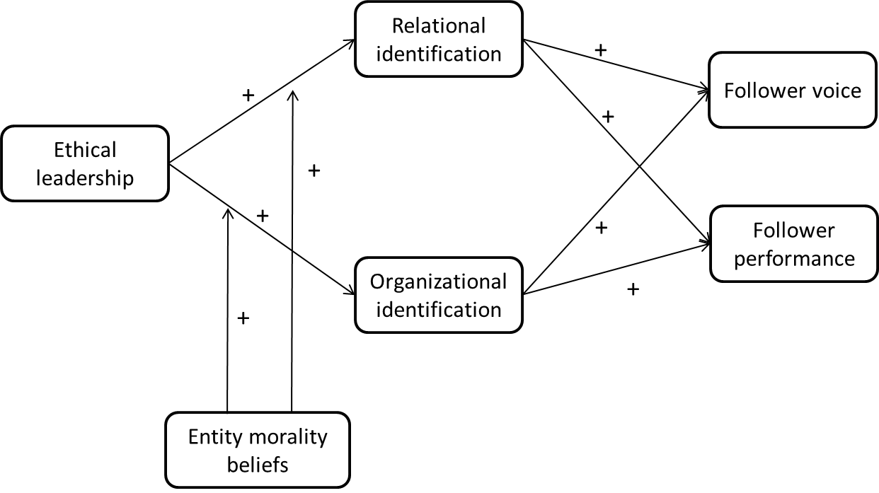

Figure 1. Conceptual model

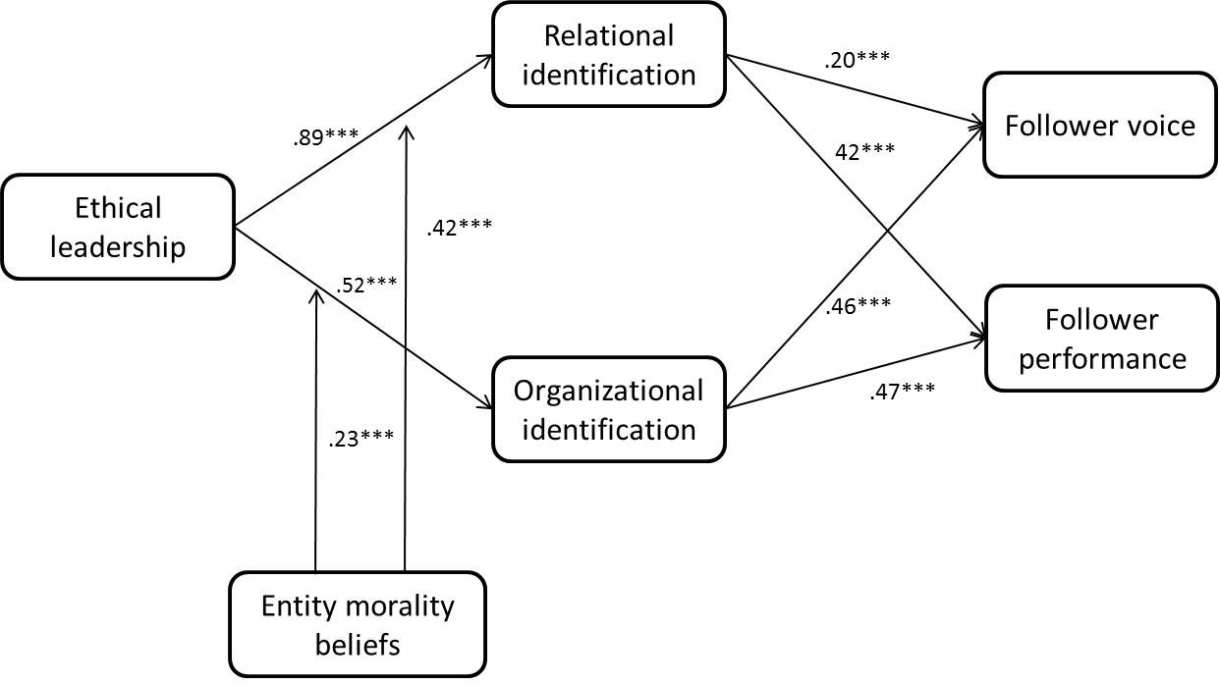
Note: The main effect of entity morality beliefs is not included in this figure for simplicity purpose. Please refer to Table 3 for these effects. Standardized coefficients are reported. *** p < .001
Figure 2. Conceptual model with coefficient estimation results

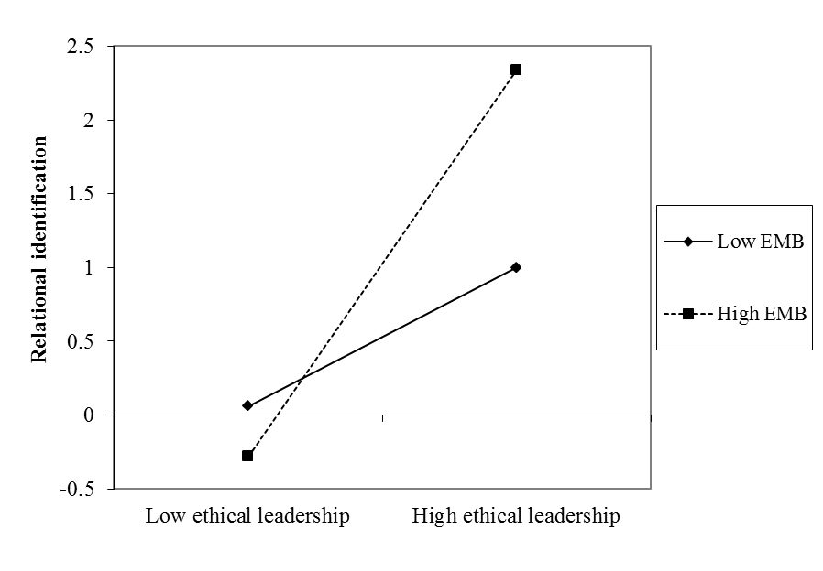
Figure 3. Moderating effect of entity morality beliefs on the relationship between ethical leadership and employee relational identification

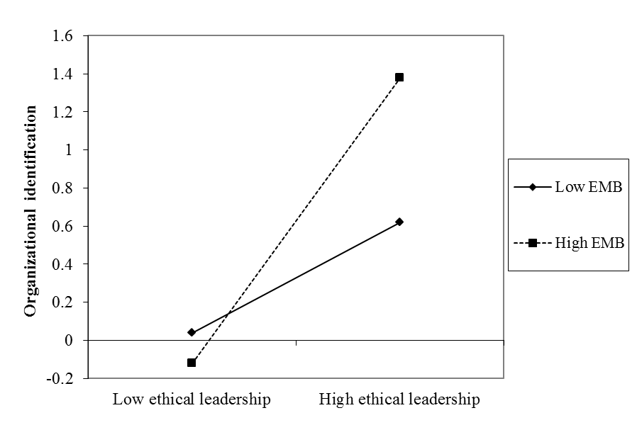
Figure 4. Moderating effect of entity morality beliefs on the relationship between ethical leadership and employee organizational identification

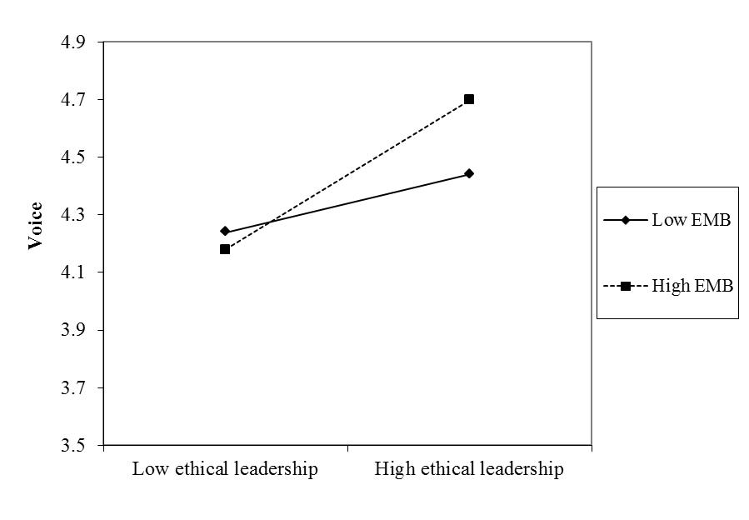
Figure 5. Moderating effect of entity morality beliefs on the indirect relationship between ethical leadership and employee voice through relational identification

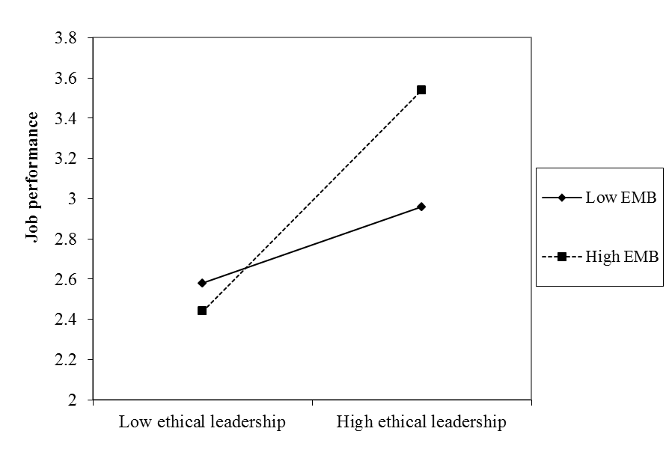
Figure 6. Moderating effect of entity morality beliefs on the indirect relationship between ethical leadership and employee job performance through relational identification
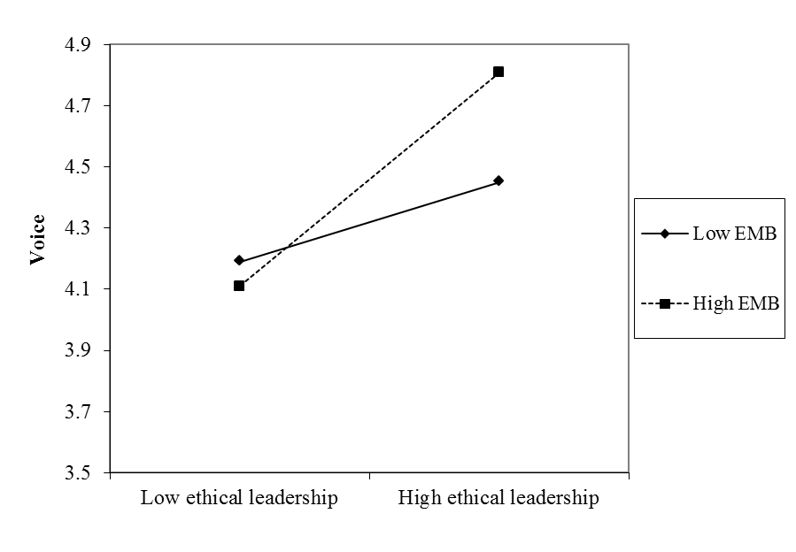
Figure 7. Moderating effect of entity morality beliefs on the indirect relationship between ethical leadership and employee voice through organizational identification

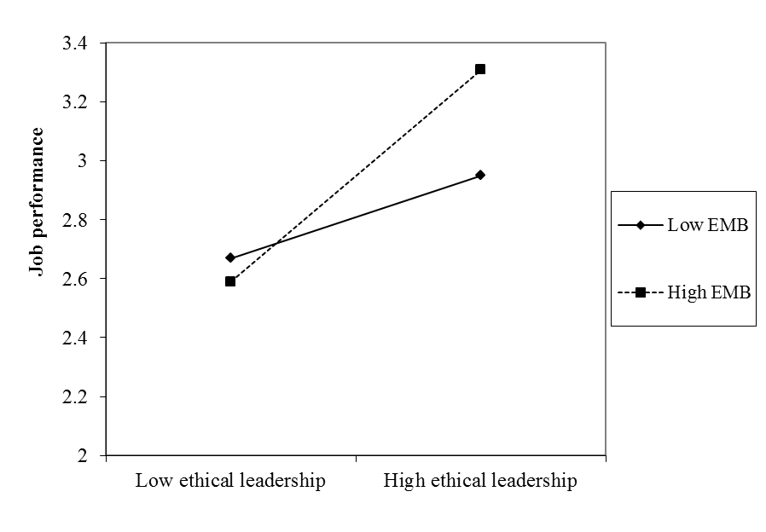
Figure 8. Moderating effect of entity morality beliefs on the indirect relationship between ethical leadership and employee job performance through organizational identification

