**Thermal Conductivity Enhancement Phenomena in Ionic Liquid – Based Nanofluids (Ionanofluids)**

*K. Oster*A,B,F*, C. Hardacre*A,B,F*, J. Jacquemin*B,C, *A. P. C. Ribeiro*D*, A. Elsinawi*E

A The University of Manchester, School of Chemical Engineering & Analytical Science, Sackville Street, M13 9PL, Manchester, The United Kingdom e-mail: [kamil.oster@manchester.ac.uk,](mailto:oster@manchester.ac.uk) c.hardacre@manchester.ac.uk

B Queen’s University Belfast, School of Chemistry & Chemical Engineering, Stranmillis Road, BT9 5AG, Belfast, The United Kingdom

C Université de Tours, Laboratoire PCM2E, Parc de Grandmont 37200, Tours, France

D Universidade de Lisboa, Centro de Química Estrutural, Instituto Superior Técnico, Av. Rovisco Pais 1, 1049-001, Lisboa, Portugal

E King Fasial University, Materials Engineering Department, College of Engineering, Al-Hasa, 31982, Hofuf, Saudi Arabia

F Corresponding authors. Email: kamil.oster@manchester.ac.uk; c.hardacre@manchester.ac.uk

**Abstract**

The dispersion of nanoparticles into ionic liquids leads to enhancement of their thermal conductivity. Several literature papers report on various enhancement values, whereas the comparison between these values with those from theoretical calculations is not always performed. These thermal conductivity enhancements are desired due to their beneficial impact on the heat transfer performance in a process requesting the utilization of heat transfer fluids. Moreover, on the one hand, the theoretical modelling of these enhancements might lead to an easier, cheaper and faster heat transfer unit design, which could be an enormous advantage in the design of novel industrial applications. On the other hand, it gives a significant impact onto the enhancement mechanism. The aim of this work is to discuss the enhancement of thermal conductivity caused by the dispersion of nanoparticles in ionic liquids, including the analysis of their errors, followed by its theoretical modelling. Furthermore, a comparison between data reported, herein, with those available in the literature is carried out with following reproducibility of thermal conductivity statement. The ionic liquids studied are the 1-butyl-3-methylimidazolium dicyanamide, 1-butyl-3-methylimidazolium bis(trifluoromethylsulfonyl)imide, 1-ethyl-3-methylimidazolium ethylsulfate, 1-butyl-1-methylpyrrolidinium bis(trifluoromethylsulfonyl)imide, 1-hexyl-3-methylimidazolium hexafluorophosphate, while carbon nanotubes, boron nitride and graphite were selected as nanoparticles to be dispersed in investigated ILs to design novel heat transfer fluids.

**Introduction**

Current technologies require more efficient and cheaper solutions in many areas, including in heat transfer processes. Heat transfer fluids (HTFs) are materials liable for heat transfer, distribution and storage. This definition covers a wide range of applications including engines, radiators/air conditioners, electronics or welding, nuclear systems, solar water, drilling, refrigeration, space, high-power lasers and biomedical application.[1–3] The main properties responsible for these materials are the thermal conductivity, heat capacity, density and viscosity, while the latter is desired to have as low values as possible to assure high pumpability.[4–6] Nevertheless, there are several other properties which are not negligible, *i.e.* corrosivity, liquid range, thermal stability, maintenance, flash point, impact on environment, biodegradability, *etc.*[7,8] The most common heat transfer fluids used in industry are water, mineral oils, synthetic aromatics, silicones, fluorocarbons, ethylene glycol or propylene glycol mixtures with water.[7,8] On the one hand, water has good thermal properties but it is highly corrosive and has a low liquid range (high freezing point and low boiling point) which significantly influences its applicability. Thus, each heat transfer fluid is generally designed for a given application.[4–6]

Recently, ionic liquids have been investigated to design novel and safer heat transfer fluids.[4,9–11] Ionic liquids are compounds containing only ions in their molecular structure like classical molten salts but with lower melting points.[12] They have a range of desirable properties, such as wide liquid range temperature (dictated by high thermal stability and low freezing point),[13] low flammability (caused by extremely low vapor pressure),[14] relatively high thermal conductivity and heat capacity in comparison to other commonly used heat transfer fluids.[4,15] However, they are usually viscous compared with molecular liquids and expensive.

In comparison to previous solutions for efficient heat transfer fluids, a further development originally proposed by Choi and Eastman (**1995**), is based on the formulation of mixtures of dispersed nanoparticles in a given liquid, creating nanofluids.[16] It was observed that the addition of nanoparticles into the liquid increases the thermal conductivity, for example, an increase of 60% is observed by adding 5% (*V*/*V*) of CuO in water,[17] while an enhancement of 33% is achieved by adding 5% (*V*/*V*) TiO2 in water,[18] showing the impact of the nanoparticles structure on the observed enhancement of the thermal conductivity of water. Similarly, an enhancement close to 44% or 160% is observed by adding 0.052% (*V*/*V*) of Cu or 1% (*V*/*V*) of multi-walled carbon nanotubes in oil, respectively.[17-19] Moreover, the real interest for these heat transfer fluids is attested by the fact that these fluids are commercially available from Dynalene company (product name: Dynalene FC). Another development in this area was made by Nieto de Castro *et al.* (**2009**) through the dispersion of nanoparticles into the ionic liquids, creating the so-called ionanofluids.[20] Since that report, other studies have been performed and also showed that an enhancement of thermal conductivity was observed, particularly highlighting differences caused by the structure of ionic liquids, for example, 16% for 1% (*w*/*w*) multi-walled carbon nanotubes + [C4C1Im][Dca],[21] 11% for 1% (*w*/*w*) multi-walled carbon nanotubes + [C2C1Im][C2SO4],[22] 9% for 1% (w/w) multi-walled carbon nanotubes + [C4C1Im][CF3SO3], which shows the impact of interactions between nanoparticles and ionic liquids on the thermal conductivity enhancement.[20]

The phenomena of thermal conductivity enhancement caused by the dispersion of nanoparticles into liquids has been widely discussed in the literature, for example the mechanism was explained by Brownian motion of nanoparticles, liquid layering at the liquid/particle interface, nature of heat transport across nanoparticles, nanoparticle clustering, while the interface layering was proven to be the most sensible explanation in a good agreement with experimental and theoretical works.[1–3,23–26] Different various models were also proposed to correlate the thermal conductivity enhancement and a number of reviews have been published.[1,2,23–25] Nevertheless, the availability of data for ionanofluids is still very limited so the comparison of each literature position is difficult, to date.

The aim of this work is to present the thermal conductivity of ionic liquid-based nanofluids previously reported in the literature,[20–22] and to study the performance of novel ionanofluids by selecting other nanomaterials in order to investigate the impact of IL and nanoparticle structure and composition on the enhancement of their thermal conductivity. For this reason, the ionic liquids used in this work are the 1-butyl-3-methylimidazolium dicyanamide, [C4C1Im][Dca], 1-butyl-3-methylimidazolium bis(trifluoromethylsulfonyl)imide, [C4C1Im][NTf2], 1-ethyl-3-methylimidazolium ethylsulfate, [C2C1Im][C2SO4], 1-butyl-1-methylpyrrolidinium bis(trifluoromethylsulfonyl)imide, [C4C1Pyrr][NTf2] 1-hexyl-3-methylimidazolium hexafluorophosphate, [C6C1Im][PF6], and carbon nanotubes, boron nitride and graphite as the nanoparticles. Ionanofluids were then formulated with a nanoparticle concentration up to 3 % (by weight) in solution and their thermal conductivity was measured from ~278 K to ~358 K at atmospheric pressure. The comparison of enhancements obtained in this work with those available in the literature was then performed based on errors analyses.[20–22] Finally, models available in the literature were then used to assess their predictive capability through the calculations of expected enhancements for each solution investigated herein.[27–33]

**Experimental**

***Materials***

The ionic liquids used in this work are 1-butyl-3-methylimidazolium dicyanamide (Merck, CAS: 448245-52-1, purity ≥98%, ≤0.01% halides, catalogue number: 4900150500), [C4C1Im][Dca], 1-butyl-3-methylimidazolium bis(trifluoromethylsulfonyl)imide (Sigma-Aldrich, CAS: 174899-83-3, purity ≥98%, catalogue number: 711713), [C4C1Im][NTf2], 1-butyl-1-methylpyrrolidinium bis(trifluoromethylsulfonyl)imide (in-house synthesis following the procedure,[34-36] CAS: 223437-11-4, purity ≥98%), [C4C1Pyrr][NTf2], 1-hexyl-3-methylimidazolium hexafluorophosphate (in-house synthesis following the procedure,[34-36] CAS: 304680-35-1, purity ≥98%), [C6C1Im][PF6], 1-ethyl-3-methylimidazolium ethylsulfate (in-house synthesis following the procedure,[34-36] CAS: 342573-75-5, purity ≥98%), [C2C1Im][C2SO4]. The ILs were washed with ultrapure water (18 MΩ cm) and extracted with dichloromethane 3-5 times. Thereafter, the ILs were dried under high vacuum (10-3 Pa) at 333.15 K for at least 72h. The purity of all ILs was assessed by 1H and 13C NMR (**Fig. S1-S5, SI1**), as ≥ 98 % for all investigated materials. Karl-Fisher titration (Metrohm 899 Coulometer with 803 Ti Stand and Hydranal Coulomat AG) was used to determine the water content, before and after each measurement and no significant change was observed in these values thus only the initial water contents are reported, herein, with all values < 2 ∙ 10-4 in water mass fraction unit. This also shows that the measurement does not lead to contamination of the sample, and the system is completely isolated from the environment. The summary of ILs purity can be found in **Table 1**, as well as their structures in **Fig. 1**.

**Table 1** Chemicals description.A

|  |  |  |  |  |  |
| --- | --- | --- | --- | --- | --- |
| Chemical name  [CAS] | Supplier | Mass fraction purity | Purification method | Analysis method | Halide content ppmB |
| [C4C1Im][Dca]F [448245-52-1] | Merck | ≥ 0.98 | Washing-extraction  Vacuum | 1H and 13C NMR  Karl Fisher titration | < 5 |
| [C4C1Im][NTf2]F [174899-83-3] | Merck | ≥ 0.98 | Washing-extraction  Vacuum | 1H and 13C NMR  Karl Fisher titration | < 5 |
| [C4C1Pyrr][NTf2]F [223437-11-4] | In house | ≥ 0.98 | Washing-extraction  Vacuum | 1H and 13C NMR  Karl Fisher titration | < 5 |
| [C6C1Im][PF6]F [304680-35-1] | In house | ≥ 0.98 | Washing-extraction  Vacuum | 1H and 13C NMR  Karl Fisher titration | < 5 |
| [C2C1Im][C2SO4]F [342573-75-5] | In house | ≥ 0.98 | Washing-extraction  Vacuum | 1H and 13C NMR  Karl Fisher titration | < 5 |
| [C8C1Im][NTf2]F [178631-04-4] | In house | ≥ 0.98 | Washing-extraction  Vacuum | 1H, 13 C and 31P NMR  Karl Fisher titration | < 5 |
| MWCNTF [308068-56-6] | Bayer Material Science | ≥ 0.99 | - | Ashing,C TEM,C SEM,D EN ISO 60,C XRD, laser diffraction technique | - |
| BNF [10043-11-5] | US Research Nanomaterials, Inc. | ≥ 0.998 | - | SEM,D XRDD | - |
| GF [7782-42-5] | US Research Nanomaterials, Inc. | ≥ 0.999 | - | SEM,D XRDD | - |
| Toluene [108-88-3] | Sigma-Aldrich | ≥ 0.995 | - | - | - |
| Glycerine [56-81-5] | Sigma-Aldrich | ≥ 0.99 | - | - | - |
| NaClF [7647-14-5] | Sigma-Aldrich | ≥ 0.99 | - | - | - |
| Water [7732-18-5] | Deionised | Ultrapure, type 1 | Deionisation | UV, conductivity measurementE | - |
| AgNO3F [7761-88-8] | Sigma-Aldrich | ≥ 0.999999 | - | - | - |

A1H and 13C NMR refer to proton, carbon and phosphorus nuclear magnetic resonance spectroscopy, respectively;

B determined by AgNO3 titration;

C as reported by the supplier;

D as reported by supplier and confirmed by measurement;

E Merck Millipore Direct-Q 3UV equipment.

F Chemicals names abbreviations are as follows: 1-butyl-3-methylimidazolium dicyanamide, [C4C1Im][Dca], 1-butyl-3-methylimidazolium bis(trifluoromethylsulfonyl)imide, [C4C1Im][NTf2], 1-ethyl-3-methylimidazolium ethylsulfate, [C2C1Im][C2SO4], 1-butyl-1-methylpyrrolidinium bis(trifluoromethylsulfonyl)imide, [C4C1Pyrr][NTf2] 1-hexyl-3-methylimidazolium hexafluorophosphate, [C6C1Im][PF6], multiwalled carbon nanotubes, MWCNT, boron nitride, BN, graphite, G, sodium chloride, NaCl, silver nitrate, AgNO3.



**Fig. 1** Structures of investigated ionic liquids.

Moreover, for the calibration purpose, 1-octyl-3-methylimidazolium bis[(trifluoromethyl)sulfonyl]imide (CAS: 178631-04-4), [C8C1Im][NTf2], was synthesized in accordance to the procedure available in [37]. After synthesis, the IL was washed with ultrapure deionised water (18 MΩ cm) 5 times (the chloride content was checked by silver nitrate test, until no precipitation), and dried under reduced pressure at 328.15 K. The [C8C1Im][NTf2] was then finally dried under high vacuum (10−3 Pa) at 328.15 K for at least 72 h. The synthesis procedure and purity assessment were extensively presented previously. [38]

The nanomaterials used in this work are multiwalled carbon nanotubes (Bayer Material Science , trade name: Baytubes C150 HP, CAS: 308068-56-6, purity ≥ 99 %, 3-15 number of walls, 13-16 nm outer mean diameter, 5-20 nm outer diameter distribution, 4 nm inner mean diameter, 2-6 nm inner diameter distribution, 1-10 mm length, 140-230 kg m-3 bulk density; according to the specifications provided by the supplier), MWCNT, hexagonal boron nitride (US Research Nanomaterials, Inc., CAS: 10043-11-5, purity ≥ 99.8 %, 70-80 nm size, 2290 kg m-3 theoretical true density, < 0.03 % Fe2O3, < 0.002 % CaO, < 0.04 % MgO, < 0.1 % B2O3), BN, and graphite (US Research Nanomaterials, Inc., CAS: 7782-42-5, ≥ 99.9 % purity, 400-1200 nm size, < 0.1 % impurities, ~0.2 % water), G. To assure the proper particles size of boron nitride and graphite, ball milling was used (Retsch Mixer Mill MM 400, frequency 20 Hz, 3 times for 1800 s). The final purity of all nanomaterials was checked with X-ray diffractometry (X’Pert Powder PANalytical, 15-90o scan range, 0.0084o scan step size, **Fig. S6, SI1**), and the particles size with scanning electron microscope (650 FEI Quanta FEG, 15-20, < 900, < 300 nm for carbon nanotubes, boron nitride and graphite, respectively, **Fig. S7, SI1**), and dynamic light scattering (Mastersizer Malvern, dispersion with water, stabilized with sodium laureth sulfate as anionic surfactant, refractive index of 1.330, 1.650 and 2.420 for water, boron nitride and both carbon-based nanomaterials, respectively; 26.60 ± 0.15 nm, 154.5 ± 1.7 nm, and 159.1 ± 3.1 nm for carbon nanotubes, boron nitride and graphite, respectively, **Fig. S8, SI1**).

The preparation of nanofluids is very delicate process, therefore, a consistent and highly recognized and proven procedure must be applied.[20-22] The thermal conductivity for only carbon nanotubes-doped ionanofluids was reported, so far. Thus, the possibility of comparison to literature is limited to these systems, excluding those with boron nitride and graphite. The nanoparticles were added to ILs in the desired amount, followed by 30 min of magnetic stirring prior to 1h sonication, to assure that the agglomerates were broken up. The choice of systems (mainly ionic liquids) was dictated by the literature data availability. Moreover, carbon nanotubes were reported to enhance the physical properties significantly. [20,21,39] Boron nitride has very unique other properties (tribological, thermal transport or rheological), while the thermal conductivity has not been investigated so far.[40-42] On the other hand, graphite is a very cheap material of which the thermal properties (such as thermal conductivity) in nanofluids were not investigated. The summary of all investigated systems can be found in **Table 2**.

**Table 2** Summary of investigated ionanofluids, including the mass fraction *wm,NP*.

|  |  |  |  |
| --- | --- | --- | --- |
|  | 100 × *wm,NP* (%) | | |
|  | MWCNT | BN | G |
| [C4C1Im][Dca] | 0.5, 1.0, 3.0 | 0.5, 1.0, 3.0 | 0.5, 1.0, 3.0 |
| [C4C1Im][NTf2] | 0.5, 1.0, 3.0 | - | - |
| [C2C1Im][C2SO4] | 0.5, 1.0, 3.0 | - | - |
| [C4C1Pyrr][NTf2] | 0.5, 1.0, 3.0 | 0.5, 1.0, 3.0 | 0.5, 1.0, 3.0 |
| [C6C1Im][PF6] | 0.5, 1.0, 3.0 | 0.5, 1.0, 3.0 | 0.5, 1.0, 3.0 |

***Techniques***

The thermal conductivity measurements were performed using KD2 Pro Thermal Properties Analyzer (Decagon company), based on transient hot-wire principle (KS-1 sensor, 60 mm length, 1.3 mm diameter, standard uncertainty reported by the company ±0.01 W m-1 K-1). To assure the proper heat transfer occurring between the sensor and investigated material during the measurement, the approximate volume of sample was 30 cm3. The cell was completely closed against the environment, immersed in bath circulator (Grant TC120, 50% (*V*/*V*) ethylene glycol/water, thermal stability ± 0.05 K and uniformity ± 0.1 K). The time gap between each measurement after the temperature stabilisation was at least 15 min. The temperature range of measurement was (~278 – ~358) K within an uncertainty close to *u*(*T*) = 0.05 K. To obtain accurate results, the calibration procedure was performed with water (ultrapure obtained by using Barnstead Nanopure Diamond, purity: 18 MΩ cm), toluene (Sigma-Aldrich, ACS Reagent, CAS: 108-88-3, purity: ≥99.5%, water content: 0.150% *w*/*w*), glycerine (Sigma-Aldrich, for molecular biology, CAS: 56-81-5, purity: ≥99%, water content: 0.138% *w*/*w*), 50% (*w*/*w*) glycerine/water, 2.702 mol kg−1 sodium chloride in water (Sigma-Aldrich, ACS Reagent, CAS: 7647-14-5, purity: ≥99%). Finally, the calibration was ascertain by the measurement of thermal conductivity of well-known ionic liquid material [C8C1Im][NTf2]. The full description of calibration procedure can be found in [38], with the calibration constant standard uncertainty of 1.50 %, and standard uncertainty of thermal conductivity values of about 3.44 %.[43] The thermal conductivity, *λ*, was also correlated with temperature by the following linear equation:

 (1)

where *ai* is the fitting coefficient, *T* is temperature. The standard deviation of *ai* parameters, δ*ai*, were calculated based on the least-square approach, and coefficient of determination, *R2*, was used to describe the fitting goodness.

***Calculations***

The thermal conductivity experimental data presented in this work were compared to values calculated based on the available models in the literature.[20-22] The very first model, derived by Maxwell (**1881**) from the definition of the effective thermal conductivity of two-component mixture, *λeff*:[27]

 (2)

where (∂*T*/∂*x*) is overall average temperature gradient, *φ* is volume fraction, subscript *NP* and *IL* refer to nanoparticles and ionic liquids, respectively. The volume fraction is defined as follows:

 (3)

where *V* is volume, *m* is mass, *ρ* density, *wm* is mass fraction (densities for nanomaterials were previously characterized in [44]).

Application of the effective medium approximation of randomly dispersed, and uniformly sized spherical particles leads to:

 (4)

where *α* is a shape factor of the dispersed particles, (assumption: spherical particles, *α* = 3), which finally gives the following formulae:

 (5)

where *λMaxwell* is the effective thermal conductivity of nanofluid based on Maxwell model. Further improvement was done by Hamilton and Crosser (**1962**) where the shape factor, *α*, was not replaced with a set value of 3 (equal to sphericity), and different nanoparticles shapes were investigated.[28] Finally, the following formulae was proposed:

 (6)

Another widely investigated and extended model of Tinga *et al.* (**1973**) was developed by Leong *et al.* (**2006**) and Murshed *et al.* (**2008**).[29-31] The final form of this model is divided into spherical- and cylindrical-shaped nanoparticles: [31]

****(7)

****(8)

where *ω* is the ratio of interfacial layer thermal conductivity, *λlr*, and ionic liquid thermal conductivity, *λIL*, *ω* = *λlr*/*λIL*, *γ* is the ratio of interfacial layer thickness, *l*, and particle diameter, *r*, defined as *γ* = 1 + *l*/*r* and *γ1* = 1 + *l*/2*r*. The thickness and thermal conductivity of interfacial nanolayer are impossible to be measured experimentally, thus, some assumptions are necessary. Leong *et al.* (**2006**) showed that the predictions are the most reliable for *ω* equals to 2, and that the interfacial nanolayer equals to 1 nm. [30] Furthermore, Timofeeva *et al.* (**2007**) investigated the shape, size and motions of nanoparticles.[32] Finally, in a good agreement with the effective medium theory, the authors proposed the following formulae:

** (**9)

To the best of our knowledge, there is only one model developed for ionanofluids. Atashrouz *et al.* (**2015**) developed an equation based on the Maxwell model and modified geometric mean, with better correlative capability than Maxwell model (mean absolute relative deviation of below 5.7%) in case of ionic liquid – based nanofluid: [33]

** (**10)

Undoubtedly there are more models available for such systems with molecular solvents, however, those discussed herein are the most recognized with a solid elementary description, and widely studied for several different systems. Also, many reviews have been published. [1-3,23,24,45]

The limitation is made by the thermal conductivity of nanoparticles. To perform the modelling as a function of temperature, the thermal conductivity of nanoparticles is required at elevated temperature. However, this type of study is very rare, and only performed at low temperatures, to date. [46-48]

The errors of enhancement were assessed based on the neglected covariance (as the values of thermal conductivity and those errors are similar), therefore, the errors do not propagate excessive numerical artefacts:

**(**11)

where *ε* is the absolute enhancement, *λINF*/*λIL*.

**Results and discussion**

***Thermal Conductivity of Pure Ionic Liquids***

The thermal conductivity was measured in the temperature range of about (278 – 358) K, at atmospheric pressure (101 kPa), for pure ionic liquids, in the first instance, and compared to literature data, as shown in **Fig. 2**. The linear equation fitting parameters were reported in **Table 3**. The experimental data were collected in **Excel spreadsheet file Supporting Information SI2**

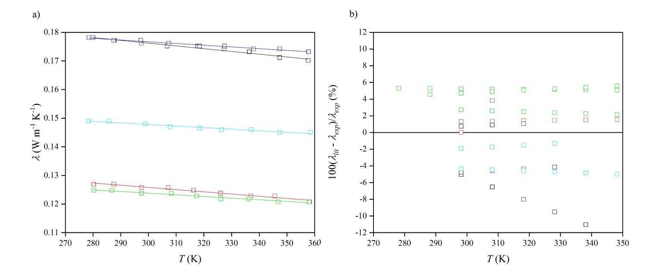

**Fig. 2** **a)** Thermal conductivity as a function of temperature for pure ionic liquids; **b)** relative deviation between values reported in this work and those in the literature for   
[C4C1Im][Dca] , [21] [C4C1Im][NTf2] ,[49,50] [C2C1Im][C2SO4] ,[49,51,52] [C4C1Pyrr][NTf2] , [20,49] [C6C1Im][PF6] . [20,53]

**Table 3** Linear fitting parameters, *a1* and *a0*, and their standard uncertainties, δ*a1* and δ*a0*, respectively, of *λ*(*T*) for all investigated systems including pure ionic liquids.

|  |  |  |  |
| --- | --- | --- | --- |
|  | (*a0* ± δ*a0*) ∙ 10-3  W m-1 K-1 | -(*a1* ± δ*a1*) ∙ 10-5  W m-1 K-2 | *R2* |
| [C4C1Im][Dca] neat | 205.3 ± 2.1 | 9.69 ± 0.66 | 0.96412 |
| [C4C1Im][Dca] + 0.5% MWCNT | 209.3 ± 1.7 | 8.79 ± 0.52 | 0.97230 |
| [C4C1Im][Dca] + 0.5% BN | 208.7 ± 1.4 | 9.50 ± 0.45 | 0.98237 |
| [C4C1Im][Dca] + 0.5% G | 210.8 ± 3.0 | 10.65 ± 0.95 | 0.93922 |
| [C4C1Im][Dca] + 1.0% MWCNT | 211.7 ± 2.4 | 7.77 ± 0.74 | 0.93154 |
| [C4C1Im][Dca] + 1.0% BN | 209.1 ± 1.5 | 8.30 ± 0.48 | 0.97347 |
| [C4C1Im][Dca] + 1.0% G | 219.8 ± 1.2 | 11.80 ± 0.39 | 0.99122 |
| [C4C1Im][Dca] + 3.0% MWCNT | 228.5 ± 2.2 | 5.71 ± 0.69 | 0.89274 |
| [C4C1Im][Dca] + 3.0% BN | 228.6 ± 1.2 | 8.58 ± 0.37 | 0.98549 |
| [C4C1Im][Dca] + 3.0% G | 233.1 ± 3.0 | 11.25 ± 0.94 | 0.94703 |
| [C4C1Im][NTf2] neat | 148.9 ± 1.7 | 7.70 ± 0.54 | 0.96230 |
| [C4C1Im][NTf2] + 0.5% MWCNT | 154.3 ± 1.2 | 8.69 ± 0.38 | 0.98517 |
| [C4C1Im][NTf2] + 1.0% MWCNT | 155.2 ± 2.2 | 6.66 ± 0.69 | 0.92061 |
| [C4C1Im][NTf2] + 3.0% MWCNT | 184.6 ± 2.3 | 8.52 ± 0.71 | 0.94693 |
| [C4C1Pyrr][NTf2] neat | 141.2 ± 1.4 | 5.46 ± 0.44 | 0.95550 |
| [C4C1Pyrr][NTf2] + 0.5% MWCNT | 147.2 ± 1.2 | 7.18 ± 0.39 | 0.97644 |
| [C4C1Pyrr][NTf2] + 0.5% BN | 142.1 ± 1.3 | 4.34 ± 0.41 | 0.93217 |
| [C4C1Pyrr][NTf2] + 0.5% G | 147.0 ± 6.2 | 6.16 ± 0.19 | 0.99201 |
| [C4C1Pyrr][NTf2] + 1.0% MWCNT | 159.2 ± 1.3 | 7.82 ± 0.42 | 0.97763 |
| [C4C1Pyrr][NTf2] + 1.0% BN | 144.7 ± 1.3 | 4.34 ± 0.41 | 0.93217 |
| [C4C1Pyrr][NTf2] + 1.0% G | 156.4 ± 5.4 | 7.58 ± 0.17 | 0.99596 |
| [C4C1Pyrr][NTf2] + 3.0% MWCNT | 171.4 ± 2.7 | 5.17 ± 0.85 | 0.81851 |
| [C4C1Pyrr][NTf2] + 3.0% BN | 173.6 ± 1.9 | 8.26 ± 0.59 | 0.96063 |
| [C4C1Pyrr][NTf2] + 3.0% G | 168.4 ± 1.7 | 7.55 ± 0.52 | 0.96270 |
| [C2C1Im][C2SO4] neat | 194.8 ± 1.2 | 6.02 ± 0.37 | 0.97086 |
| [C2C1Im][C2SO4] + 0.5% MWCNT | 200.0 ± 1.2 | 6.85 ± 0.38 | 0.97650 |
| [C2C1Im][C2SO4] + 1.0% MWCNT | 206.7 ± 1.4 | 6.26 ± 0.43 | 0.96331 |
| [C2C1Im][C2SO4] + 3.0% MWCNT | 223.0 ± 2.0 | 2.06 ± 0.61 | 0.96455 |
| [C6C1Im][PF6] neat | 164.3 ± 1.4 | 5.50 ± 0.42 | 0.95453 |
| [C6C1Im][PF6] + 0.5% MWCNT | 174.5 ± 1.8 | 8.27 ± 0.55 | 0.96522 |
| [C6C1Im][PF6] + 0.5% BN | 174.8 ± 1.1 | 7.71 ± 0.33 | 0.98520 |
| [C6C1Im][PF6] + 0.5% G | 171.5 ± 1.2 | 7.08 ± 0.37 | 0.97909 |
| [C6C1Im][PF6] + 1.0% MWCNT | 178.8 ± 3.1 | 7.12 ± 0.98 | 0.86666 |
| [C6C1Im][PF6] + 1.0% BN | 168.9 ± 1.9 | 4.26 ± 0.59 | 0.86349 |
| [C6C1Im][PF6] + 1.0% G | 173.7 ± 2.2 | 6.55 ± 0.67 | 0.92133 |
| [C6C1Im][PF6] + 3.0% MWCNT | 196.7 ± 1.6 | 4.64 ± 0.49 | 0.91603 |
| [C6C1Im][PF6] + 3.0% BN | 204.8 ± 1.2 | 8.31 ± 0.36 | 0.98492 |
| [C6C1Im][PF6] + 3.0% G | 197.9 ± 1.2 | 7.70 ± 0.39 | 0.98007 |

Four different cations, [C4C1Im]+, [C4C1Pyrr]+, [C2C1Im]+, [C6C1Im]+, and four different anions, [Dca]-, [NTf2]-, [C2SO4]-, [PF6]-, were used as the constituents of the investigated ionic liquids. Zhao *et al.* (**2016**) calculated the volume of several cations and anions by COSMO-RS modelling – 154 Å3 for [C2C1Im]+, 197 Å3 for [C4C1Im]+, 242 Å3 for [C6C1Im]+, 214 Å3 for [C4C1Pyrr]+, 222 Å3 for [NTf2]-, 104 Å3 for [PF6]-, 82 Å3 for [Dca]- and 104 Å3 for [C1SO4]- (value for [C2SO4]- was not reported, therein).[54] This given, the volume of cation + anion is in the following order: [C2C1Im][C1SO4] (258 Å3) < [C4C1Im][Dca] (279 Å3) < [C6C1Im][PF6] (346 Å3) < [C4C1Im][NTf2] (419 Å3) < [C4C1Pyrr][NTf2] (436 Å3). Thermal conductivity, as a transport property, should be dependent on the volume/mass of molecules. As presented above, and shown in **Fig. 2a**, the dependence follows this order. Therefore, the thermal conductivity could be easily predicted qualitatively based purely on the size of cation/anion.

The thermal conductivity is found to decrease with temperature, as expected. Moreover, the slope for each ionic liquid is similar which means that the thermal conductivity is governed by the same mechanism with a reduced contribution of convection. The difference between lowest and highest temperature is relatively small, (4.70, 5.05, 2.89, 3.31 and 2.76) % for [C4C1Im][Dca], [C4C1Im][NTf2], [C2C1Im][C2SO4], [C4C1Pyrr][NTf2] and [C6C1Im][PF6], respectively.

Differences of about (-13 – 5) % can be found between values in this work and those reported in the literature, while the maximum for [C2C1Im][C2SO4] (5.33% between 0.1742 W m-1 K-1 in this work and 0.184 W m-1 K-1 in [52], at 348.15 K), and [C4C1Im][Dca] (-12.74% between 0.1725 W m-1 K-1 in this work and 0.153 W m-1 K-1 in [21], at 338.15 K). All deviations with literature data for pure ionic liquids are presented in **Fig. 2b**, [20,21,49-53] while selected positions were taken for further discussion (the same references as those used for the comparison of ionanofluids results).[20-22]

The standard uncertainties of measurement in the literature are (7.1, 6.5, 6.4, 4.2 and 3.5) % for [C4C1Im][NTf2],[22] [C4C1Im][Dca],[21] [C2C1Im][C2SO4],[22] [C4C1Pyrr][NTf2],[20] and [C6C1Im][PF6],[20] respectively. Calibration of the equipment used for thermal conductivity measurement is a significant process because it is possible to introduce a range of factors which result in an increase of the uncertainty in this property, for example viscosity (different liquids of various viscosity values should be used, *i.e.* toluene, water, glycerol and its water solutions), electrical conductivity (this factor can be included by using water solutions of sodium chloride or ionic liquids), thermal conductivity (to ensure the proper calibration along the whole range of thermal conductivity measurement, *i.e.* toluene, glycerol, water), and temperature (in order to ensure that the calibration is reliable over the whole range of temperatures investigated).[21,22,55,56] All of these factors were included in the calibration of the equipment in this work.[38] Moreover, the calibration was also validated with one ionic liquid, [C8C1Im][NTf2], and the values obtained are in an excellent agreement with literature (average absolute relative deviation below 1 %). [38,49] This issue can be addressed to work of Nieto de Castro *et al.* (**2010**) where only water and glycerol were used to perform the calibration.[20] Also, As can be seen, the data for [C4C1Pyrr][NTf2] and [C6C1Im][PF6] originated from work of Nieto de Castro *et al.* (**2010**) are consistently deviated which explains the excessive deviations from the results in this work, (0.118 and 0.1238) W m-1 K-1 or relative deviation of 4.9 % for [C4C1Pyrr][NTf2] at 298.15 K, (0.142 and 0.1480) W m-1 K-1 or relative deviation of 4.2 % for [C6C1Im][PF6] at 298.15 K. Moreover, to ensure the proper heat transfer occurring in the investigated system, a minimum volume of the sample is required (depending on the construction of cell, minimum of 30 cm3).[21] While in work of Nieto de Castro *et al.* (**2010**) the volume of sample is approximately 15 cm3.[20] Unlike other properties, such as heat capacity or viscosity, water has less impact on thermal conductivity – those with 800 ppm of water in ILs do not differ significantly in comparison to those with 400 ppm of water in ILs. [57] Therefore, this is not an issue of consideration herein due to very low amounts of water in each literature position and this work.

Another significant deviation can be found for [C4C1Im][Dca] (up to -11.03 % of relative deviation, 0.1725 W m-1 K-1 in this work and 0.153 W m-1 K-1 in [21], at 338.15 K), however, in the work of França *et al.* (**2014**), the proper calibration was presented, along with high purity chemicals.[21] França *et al.* (**2014**) compared their results of 1-ethyl-3-methylimidazolium dicyanamide with literature and reported relative deviation of (10 – 15) %,[51] increasing with temperature.[21] Similar relative deviations can be found between this work and França *et al.* (**2014**).[21] It might appear as some systematic error being propagated in the work of França *et al.* (**2014**),[21] whereas the data in this work represent better accuracy. However, the origin of such deviations is unknown, and the value of the error starts to be higher than the standard uncertainty above approximately 318 K.

***Thermal Conductivity of Ionanofluids***

The thermal conductivity of each investigated ionanofluid was measured in the temperature range of (278 – 358) K, at atmospheric pressure (101 kPa). The experimental data were collected in **Excel spreadsheet file Supporting Information SI2**, and presented in **Fig. 3**, **Fig. 4** and **Fig. 5**. The coefficients of linear fitting have been collected in **Table 3**.

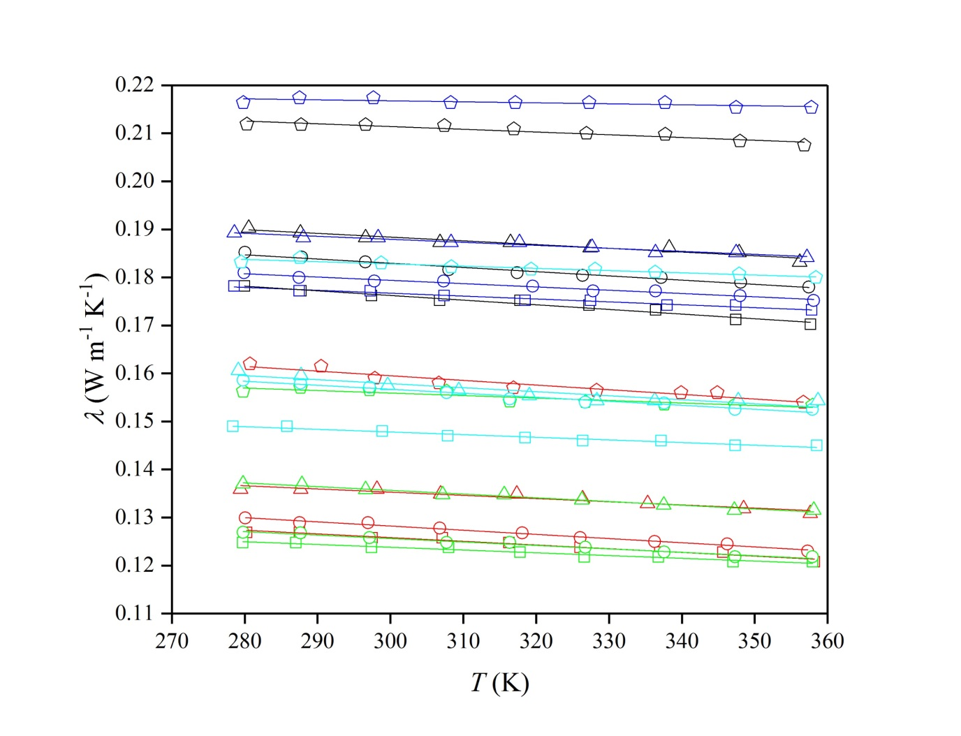

**Fig. 3** Thermal conductivity coefficient as a function of temperature, *λ*(*T*), for   
[C4C1Im][Dca] , [C4C1Im][Dca] + 0.5 wt% MWCNT , [C4C1Im][Dca] + 1.0 wt% MWCNT , [C4C1Im][Dca] + 3.0 wt% MWCNT , [C4C1Im][NTf2] , [C4C1Im][NTf2] + 0.5 wt% MWCNT , [C4C1Im][NTf2] + 1.0 wt% MWCNT , [C4C1Im][NTf2] + 3.0 wt% MWCNT , [C2C1Im][C2SO4]  , [C2C1Im][C2SO4] + 0.5 wt% MWCNT , [C2C1Im][C2SO4] + 1.0 wt% MWCNT , [C2C1Im][C2SO4] + 3.0 wt% MWCNT , [C4C1Pyrr][NTf2] , [C4C1Pyrr][NTf2] + 0.5 wt% MWCNT , [C4C1Pyrr][NTf2] + 1.0 wt% MWCNT , [C4C1Pyrr][NTf2] + 3.0 wt% MWCNT , [C6C1Im][PF6] , [C6C1Im][PF6] + 0.5 wt% MWCNT , [C6C1Im][PF6] + 1.0 wt% MWCNT , [C6C1Im][PF6] + 3.0 wt% MWCNT .

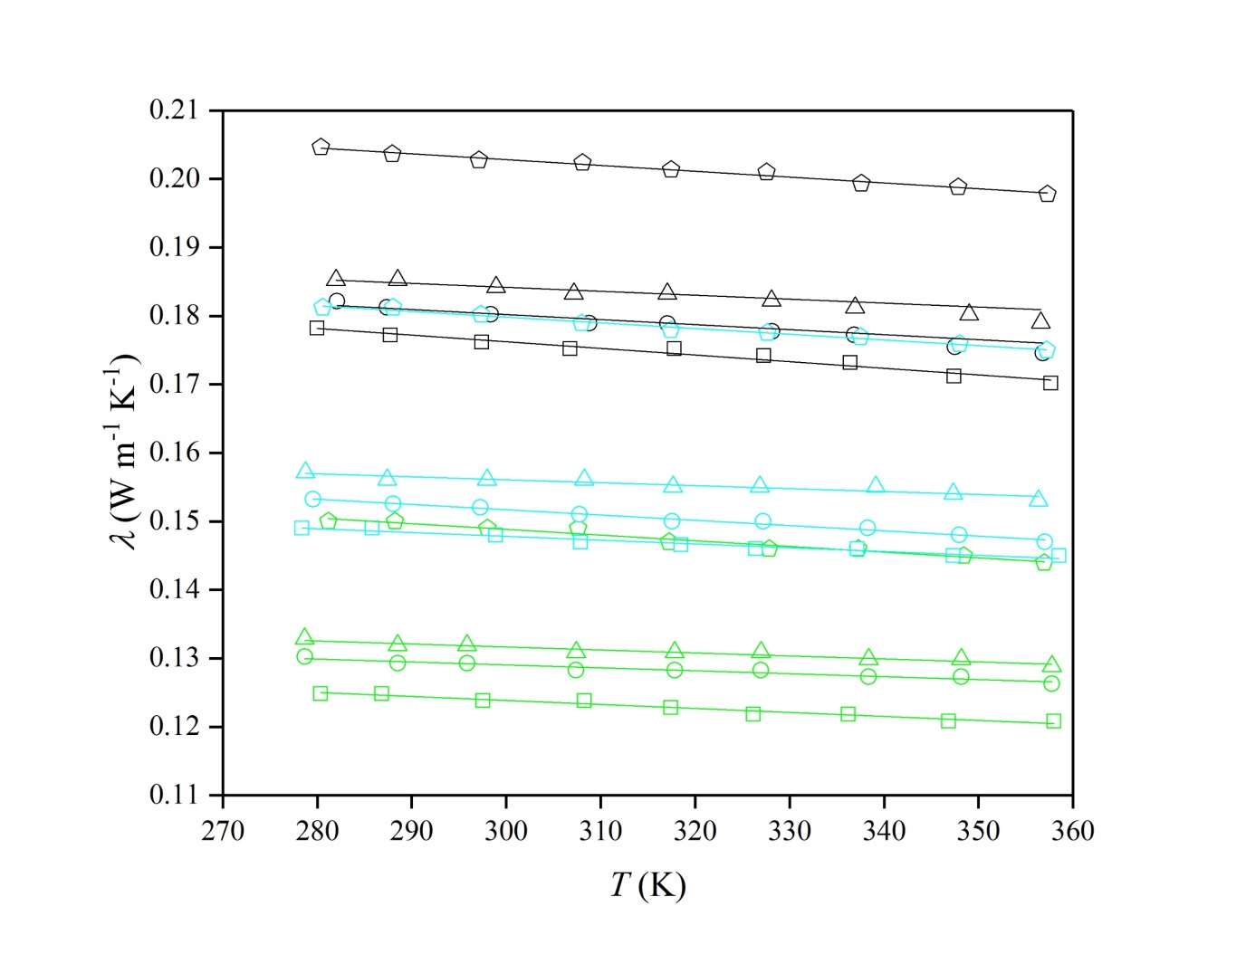

**Fig. 4** Thermal conductivity coefficient as a function of temperature, *λ*(*T*), for [C4C1Im][Dca] , [C4C1Im][Dca] + 0.5 wt% BN , [C4C1Im][Dca] + 1.0 wt% BN , [C4C1Im][Dca] + 3.0 wt% BN , [C4C1Pyrr][NTf2] , [C4C1Pyrr][NTf2] + 0.5 wt% BN , [C4C1Pyrr][NTf2] + 1.0 wt% BN , [C4C1Pyrr][NTf2] + 3.0 wt% BN , [C6C1Im][PF6] , [C6C1Im][PF6] + 0.5 wt% BN , [C6C1Im][PF6] + 1.0 wt% BN , [C6C1Im][PF6] + 3.0 wt% BN .

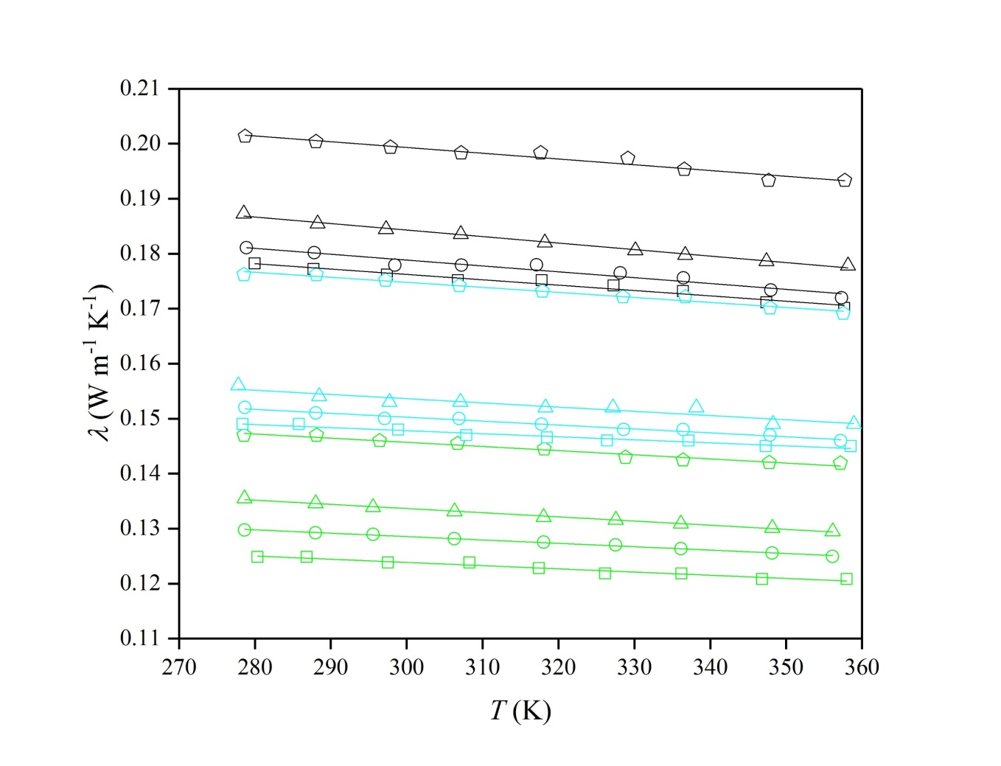

**Fig. 5** Thermal conductivity coefficient as a function of temperature, *λ*(*T*), for [C4C1Im][Dca] , [C4C1Im][Dca] + 0.5 wt% G , [C4C1Im][Dca] + 1.0 wt% G , [C4C1Im][Dca] + 3.0 wt% G , [C4C1Pyrr][NTf2] , [C4C1Pyrr][NTf2] + 0.5 wt% G , [C4C1Pyrr][NTf2] + 1.0 wt% G , [C4C1Pyrr][NTf2] + 3.0 wt% G , [C6C1Im][PF6] , [C6C1Im][PF6] + 0.5 wt% G , [C6C1Im][PF6] + 1.0 wt% G , [C6C1Im][PF6] + 3.0 wt% G .

The thermal conductivity of solids is generally higher than that of liquids, moreover the thermal conductivity of nanoparticles is particularly higher.[58] Various effects could explain this behavior in case of nanoparticles, for example when considering the theory of phonon transport, more porous materials have shorter effective size of nanoparticles in which this phonon transport occurs, the specific surface area is increased, or the wavelength of incident radiation (namely de Broglie wavelength) is comparable to the nanoparticles diameter. This affects the electron properties of such material in which the electron conduction can be trapped (called quantum trapping), resulting in modification of the bandgap. For example, in 10 nm particles, about 10% of atoms are at the surface, and they are more active than the atoms in the volume. As a result, their electron energy levels are higher which is caused by the imperfections or actives sides due to the partially saturated bonds. When the electromagnetic wave reaches these electrons, the polarization of the free electrons is induced. When the energy of the electromagnetic wave is high enough, the oscillation energy of these electrons is achieved and causes surface plasmon absorption.[59] A short but conclusive description of mathematical fundamentals of nanotechnology was given by Marchiori (**2016**).[60] The previously reported values of thermal conductivity at 298.15 K for investigated nanomaterials are (3223.4, 874.1 and 35.7) W m-1 K-1 for carbon nanotubes,[48] boron nitride,[47] and graphite,[46] respectively, whereas those for liquids are values of 10-1 W m-1 K-1 order. The addition of nanoparticles shifts the thermal conductivity to higher values than pure ionic liquids. The dependence of ionic liquid structure on the thermal conductivity was discussed in the previous section. As can be seen in **Fig. 3**, **Fig. 4** and **Fig. 5**, the thermal conductivity behaviour as a function of temperature remains the same and is linear.

As a result, the thermal conductivity of nanofluids exhibits higher values than in comparison to pure fluids and an enhancement is observed as shown in **Fig. 6**, **Fig. 7** and **Fig. 8** for carbon nanotubes-, boron nitride- and graphite-doped ionanofluids, respectively. The results were also collected in **Excel spreadsheet file Supporting Information SI2**

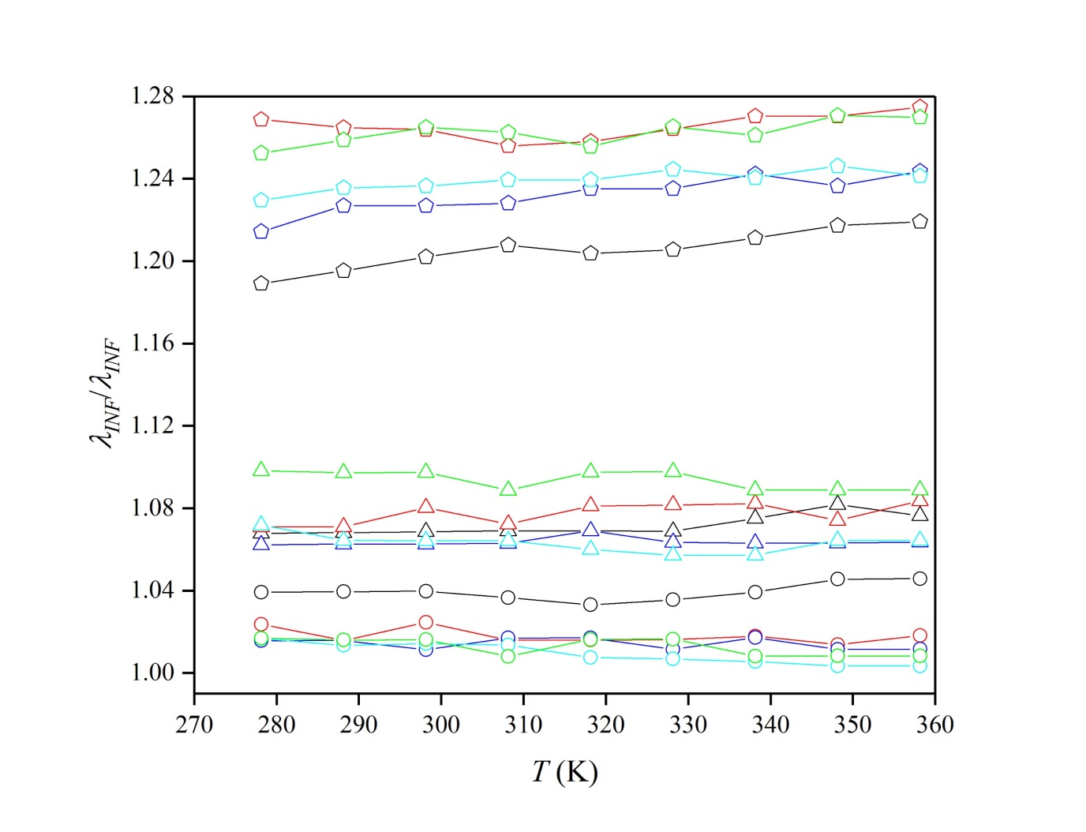

**Fig. 6** The thermal conductivity enhancement, *λINF*/*λIL*, as a function of the temperature, *T*, for [C4C1Im][Dca] + 0.5 wt% MWCNT , [C4C1Im][Dca] + 1.0 wt% MWCNT , [C4C1Im][Dca] + 3.0 wt% MWCNT , [C4C1Im][NTf2] + 0.5 wt% MWCNT , [C4C1Im][NTf2] + 1.0 wt% MWCNT , [C4C1Im][NTf2] + 3.0 wt% MWCNT , [C2C1Im][C2SO4] + 0.5 wt% MWCNT , [C2C1Im][C2SO4] + 1.0 wt% MWCNT , [C2C1Im][C2SO4] + 3.0 wt% MWCNT , [C4C1Pyrr][NTf2] + 0.5 wt% MWCNT , [C4C1Pyrr][NTf2] + 1.0 wt% MWCNT , [C4C1Pyrr][NTf2] + 3.0 wt% MWCNT , [C6C1Im][PF6] + 0.5 wt% MWCNT , [C6C1Im][PF6] + 1.0 wt% MWCNT , [C6C1Im][PF6] + 3.0 wt% MWCNT .

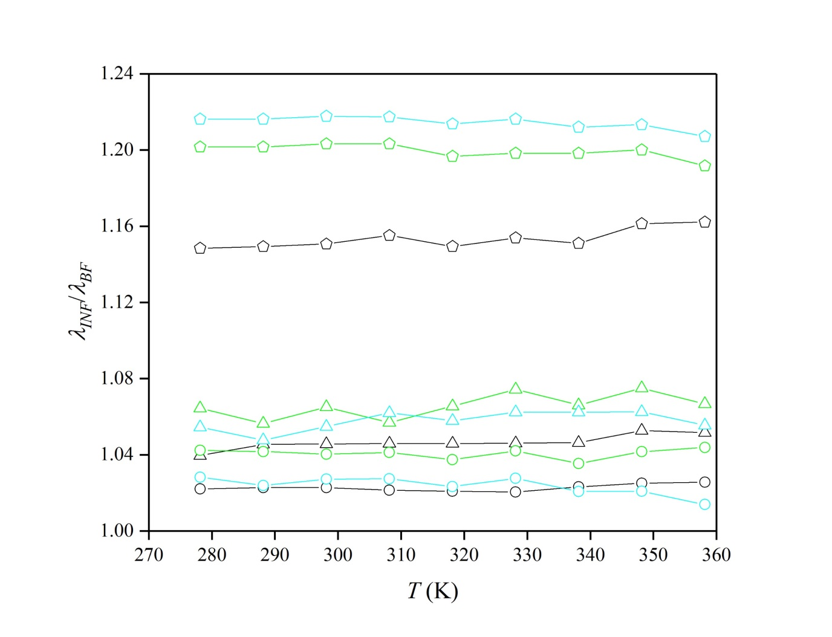

**Fig. 7** The thermal conductivity enhancement, *λINF*/*λIL*, as a function of the temperature, *T*, for [C4C1Im][Dca] + 0.5 wt% BN , [C4C1Im][Dca] + 1.0 wt% BN , [C4C1Im][Dca] + 3.0 wt% BN , [C4C1Pyrr][NTf2] + 0.5 wt% BN , [C4C1Pyrr][NTf2] + 1.0 wt% BN , [C4C1Pyrr][NTf2] + 3.0 wt% BN , [C6C1Im][PF6] + 0.5 wt% BN , [C6C1Im][PF6] + 1.0 wt% BN , [C6C1Im][PF6] + 3.0 wt% BN .

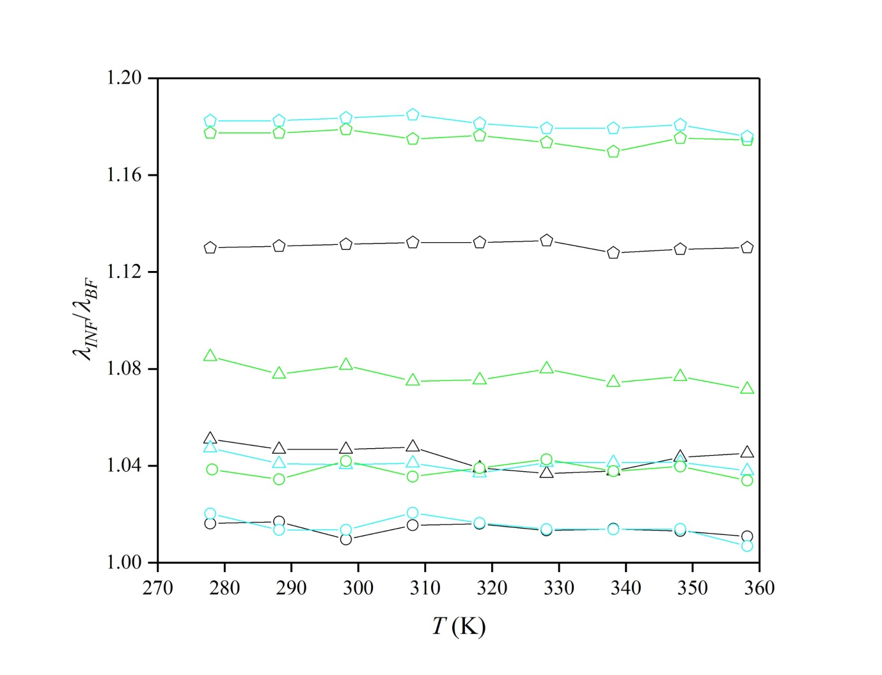

**Fig. 8** The thermal conductivity enhancement, *λINF*/*λIL*, as a function of the temperature, *T*, for [C4C1Im][Dca] + 0.5 wt% G , [C4C1Im][Dca] + 1.0 wt% G , [C4C1Im][Dca] + 3.0 wt% G , [C4C1Pyrr][NTf2] + 0.5 wt% G , [C4C1Pyrr][NTf2] + 1.0 wt% G , [C4C1Pyrr][NTf2] + 3.0 wt% G , [C6C1Im][PF6] + 0.5 wt% G , [C6C1Im][PF6] + 1.0 wt% G , [C6C1Im][PF6] + 3.0 wt% G .

As a consequence, the thermal conductivity enhancement was found to be an increasing function of nanoparticles concentration in solution. Even though the exact mechanism of heat transfer is still a subject of intensive investigation, there were a number of attempts to described the enhancement, for example the mechanism was explained by Brownian motion of nanoparticles, liquid layering at the liquid/particle interface, nature of heat transport across nanoparticles, nanoparticle clustering, while the interface layering was proven to be most sensible explanation.[1-3, 23-26] However, the most recent work of França *et al.* (**2017**) described these phenomena based on experimental and theoretical studies, and revealed the enhancement based on the ionic liquids adsorption layering onto the surface of nanoparticles.[26] As shown in **Fig. 6**, **Fig. 7** and **Fig. 8**, the values of the enhancements are dependent on the type of nanoparticles, the highest for carbon nanotubes-doped (up to 27.48%, for 0.1541 W m-1 K-1 of [C4C1Im][NTf2] + 3.0 wt% MWCNT and 0.1213 W m-1 K-1 of pure [C4C1Im][NTf2], at 358.15 K), lower for boron nitride-doped (up to 21.77%, for 0.1800 W m-1 K-1 of [C6C1Im][PF6] + 3.0 wt% BN and 0.1479 W m-1 K-1 of pure [C6C1Im][PF6], at 298.15 K), and the lowest for graphite-doped (up to 18.49%, for 0.1742 W m-1 K-1 of [C6C1Im][PF6] + 3.0 wt% BN and 0.1474 W m-1 K-1 of pure [C6C1Im][PF6], at 308.15 K) ionanofluids. This is in an agreement with the size of nanoparticles and their values of thermal conductivity: carbon nanotubes < boron nitride < graphite. Moreover, the enhancement calculated using ionic liquid as a reference (in this case the value of *λINF* divided by *λIL*, *λINF*/*λIL*) shows the dependence on the nanoparticles type (as well as the size and chemical nature). The following relationship is in good agreement with the thermal conductivity of nanoparticles, and it was also reflected in almost linear dependence on the nanoparticles concentration. As can be seen, these enhancements are more or less constant over the whole temperature range, with some deviations from the linearity, however, still remaining similarity in terms of those errors. The enhancement is still consistent in terms of the enhancement and thermal conductivity of pure nanomaterials, in the decreasing sequence – nanofluids consisting of carbon nanotubes, boron nitride and graphite. From an engineering perspective, a knowledge of thermal conductivity dependence over the temperature is very important as it reflects the heat transfer efficiency which occurs in the system. Carbon nanotubes, boron nitride and graphite were objects of investigation in terms of surface charge, in the meaning of zeta potential. All of them were represented with negative zeta potential caused by the adsorption of negatively charged ions (the positive surface charge of nanoparticles).[61-63] Therefore, the expectation was that the enhancement in this work would depend on the type of anions. It can be observed in **Fig. 6**, **Fig. 7** and **Fig. 8** that there is a dependence on the type of ionic liquid. Including the volumes of ionic liquids’ constituents from COSMO-RS methodology, it can be observed that the enhancement is in the following order: [C4C1Im][Dca] (*V[C4C1Im]+*=197 Å3, *V[Dca]-*=82 Å3, *V[C4C1Im][Dca]*=279 Å3) < [C2C1Im][C2SO4] (*V[C2C1Im]+*=154 Å3, *V[C1SO4]-*=104 Å3, *V[C2C1Im][C1SO4]*=258 Å3) < [C6C1Im][PF6] (*V[C6C1Im]+*=242 Å3, *V[PF6]-*=104 Å3, *V[C6C1Im][PF6]*=346 Å3) < [C4C1Im][NTf2] (*V[C4C1Im]+*=197 Å3, *V[NTf2]-*=222 Å3, *V[C4C1Im][NTf2]*=419 Å3) < [C4C1Pyrr][NTf2] (*V[C4C1Pyrr]+*=214 Å3, *V[NTf2]-*=222 Å3, *V[C4C1Pyrr][NTf2]*=436 Å3). Clearly, the enhancement is dependent on the type of anion and increasing the volume of anion results in a larger enhancement. As explained above, bigger molecules (with larger molecular size/volume) tend to have smaller thermal conductivity. Bulkier anions have less possibilities to adsorb onto the surface of nanoparticles, therefore, the effective molecular volume/size of nanoparticle-liquid molecules is smaller (and also observed, as presented above). On the other hand, there was no dependence on type of cation found, herein. This is also in a good agreement with the zeta potential discussion presented herein. Carbon-based materials tend to have positive charge, therefore, exhibiting negative zeta potential (caused by the adsorption of anions). The surface of boron nitride is described with negative charge from N-atom (electrons acceptor) and positive charge from B-atom (electrons donor).[64] However, in this work an adsorption of anions seems to be dominant and also observed in the results (as presented above).

Interestingly, many methods for nanofluids preparation can be used, including different nanomaterials pre-treatment, their average size, or agitation and ultrasonication time.[65-67] Moreover, the studies on the influence of these differences in case of ionic liquid – based nanofluids have not been investigated previously, in particular the effect on the enhancement of thermal conductivity. The comparison between thermal conductivity in this work and literature data can be performed based on the enhancement as several aspects can influence the values of thermal conductivity – particularly the value of pure ionic liquids as base fluids. This comparison is shown in **Fig. 9**. Unfortunately, the comparison is possible for only ionanofluids containing multi-walled carbon nanotubes, as boron nitride and graphite have not been used before in such studies. Therefore, further assumption in the nomenclature of (io)nanofluids is that the carbon nanotubes are used, instead of boron nitride and graphite, in terms of enhancement comparison to the literature analysis. The first deliberation should be done for the methodology of ionanofluids preparation. All literature positions are consistent in terms of the ionanofluids preparation, as described in the Experimental section. The other factor influencing the results is the source of nanomaterials. In this case (multiwalled carbon nanotubes) are from the same source (Baytubes C150 HP from Bayer Material Science). Another source of deviations can be the purity of pure ionic liquids, in particular the thermal conductivity values. This was discussed in the previous section (“Thermal Conductivity of Pure Ionic Liquids”) devoted to the deviations of pure ionic liquids thermal conductivity observed in this work and the literature. On the other hand, the treatment of the sample is another influencing factor (including the transportation, storage, etc.). Probably the most important source of deviations is the measurement methodology (also described in Experimental section), as various techniques, methodologies or calibration might shift the values of thermal conductivity.[38] To quantify the deviations between the thermal conductivity in this work and literature, the absolute average relative deviation was ascertain as 3.37 %. The most deviated points were for [C4C1Im][NTf2] + 0.5 wt% MWCNT at 308.15 K (6.19 % relative deviation, 1.0159 in this work and 1.0788 in [22]) and [C6C1Im][PF6] + 0.5 wt% MWCNT at 328.15 K (-4.66 % relative deviation, 1.0642 in this work and 1.0146 in [20]). Moreover, 31 points out of 52 were above the standard uncertainty of determined enhancement. This shows that the reported thermophysical properties (in particular the thermal conductivity) might vary in the literature, which is very important for the engineering application and further theoretical modelling.

More work on the unification of the thermophysical properties needs to be performed, since it is pivotal for the proper application in industry and related areas where the economical factor is determinant for the utilization in processes where heat transfer is very important. The first influence is made by the values of pure ionic liquid thermal conductivity which is further propagated into the thermal conductivity of ionanofluid. Therefore, the comparison of absolute thermal conductivity of ionanofluids obtained in literature is impossible, and thus, the enhancement seems to be a better property to compare.

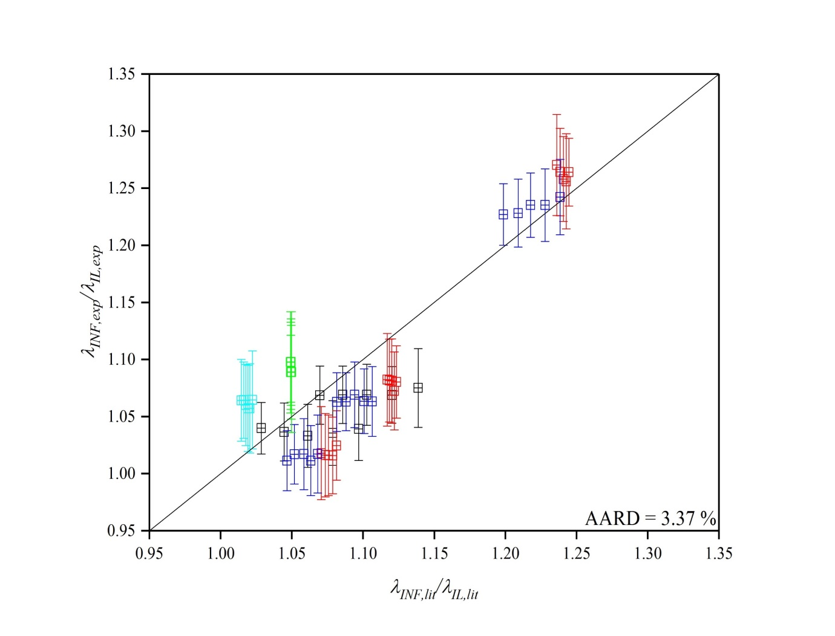

**Fig. 9** The thermal conductivity enhancement from this work, over the results from literature, for [C4C1Im][Dca] ,[21] [C4C1Im][NTf2] ,[22] [C2C1Im][C2SO4] , [22] [C4C1Pyrr][NTf2] ,[20] [C6C1Im][PF6] ,[20] with multi-walled carbon nanotubes, MWCNT, at 298.15 K.

***Ionanofluids Thermal Conductivity Modelling***

The calculated thermal conductivity values for ionanofluids can be found in The experimental data were collected in **Excel spreadsheet file Supporting Information SI2**. The enhancement of ionanofluids thermal conductivity in comparison to pure ionic liquids was also tested in case of theoretical modelling. Overall, 6 models were used, while only one was designed for ionic liquid – based nanofluids (Atashrouz). As also shown in **Fig. 10**, **Fig. 11** and **Fig. 12**, the pure non-ionic-solvent-based-like models were highly deviated from the experimental data (Maxwell, Hamilton-Crosser, both versions of Tinga-Leong-Murshed, and Timofeeva models). This is not surprising in the case of the Maxwell model because of the assumption of spherical nanoparticles.[27] The possible explanation of the failure of other models may be due to the fact that they do not describe the interactions between nanoparticles and liquid which might shift the thermal conductivity (to higher values, as observed). The model of Atashrouz is based on the modified geometric mean in which the interactions between ionic liquids and nanoparticles are included.[33] Moreover, different types of ionic liquids and nanoparticles were analyzed. As can be observed, this model produces accurate values of enhancement – all of those modelled are statistically comparable to experimental data. Therefore, this approach seems to be the most reliable and versatile. Moreover, apart from the original work of Atashrouz *et al.* (**2015**), this model is used in this work for the first time, along with the performance evaluation.[33]

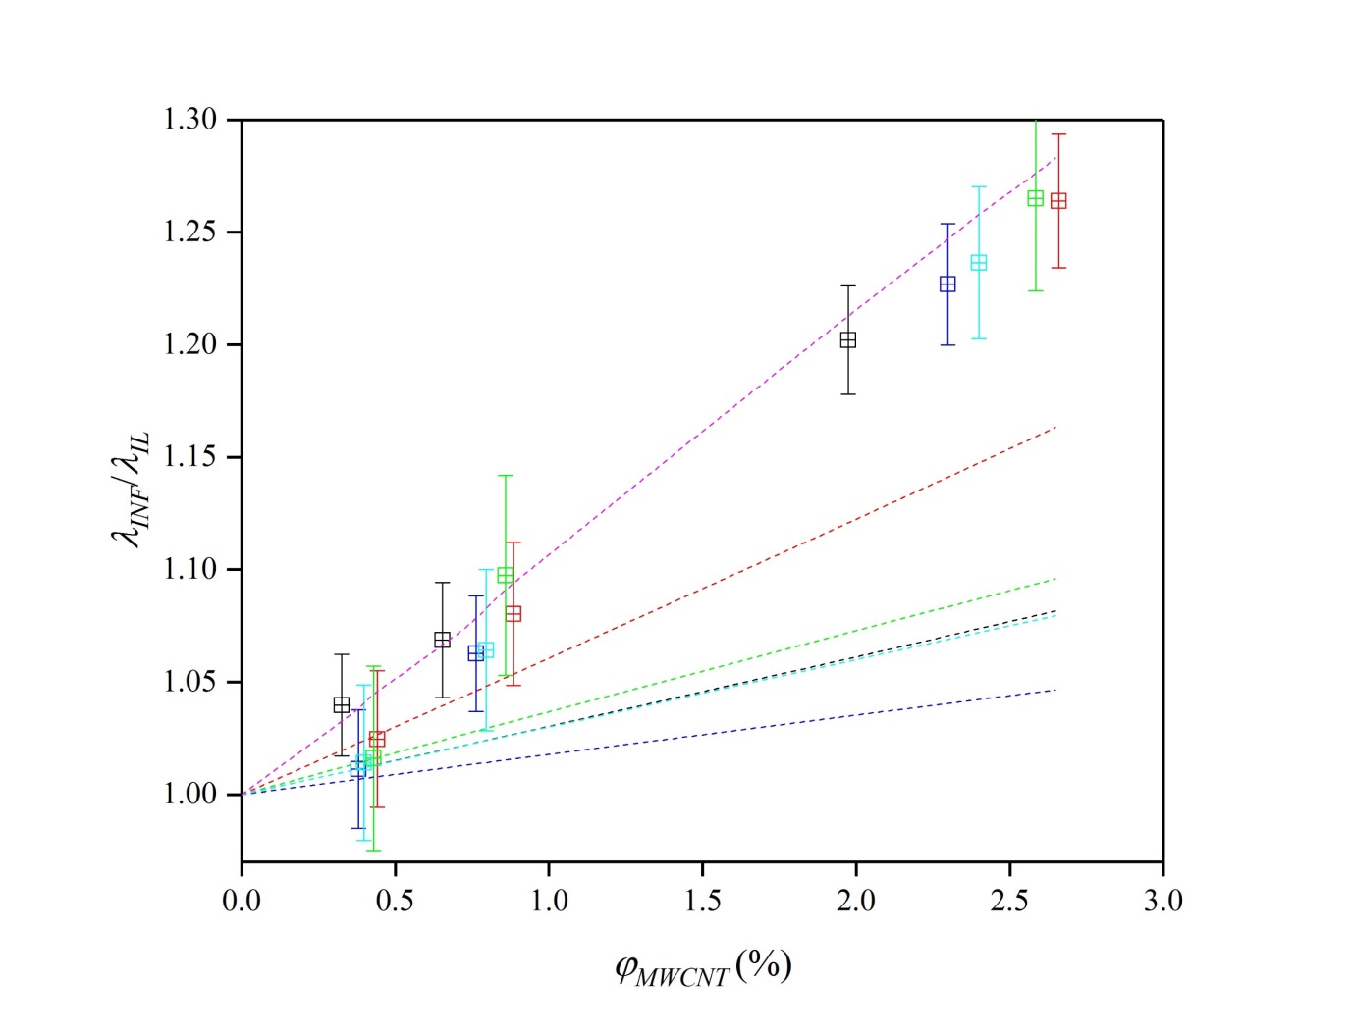

**Fig. 10** Thermal conductivity enhancement of nanofluids, *λINF*/*λIL*, in comparison to pure ionic liquids as a function of multi-walled carbon nanotubes, MWCNT, volume fraction, *φMWCNT*, for [C4C1Im][Dca] , [C4C1Im][NTf2] , [C2C1Im][C2SO4] , [C4C1Pyrr][NTf2] , [C6C1Im][PF6] , with MWCNT, at 298.15 K. Dash lines represent modelled values for Maxwell model , Hamilton & Crosser model , cylindrical Tinga-Leong-Murshed model , spherical Tinga-Leong-Murshed model , Timofeeva model , Atashrouz model .

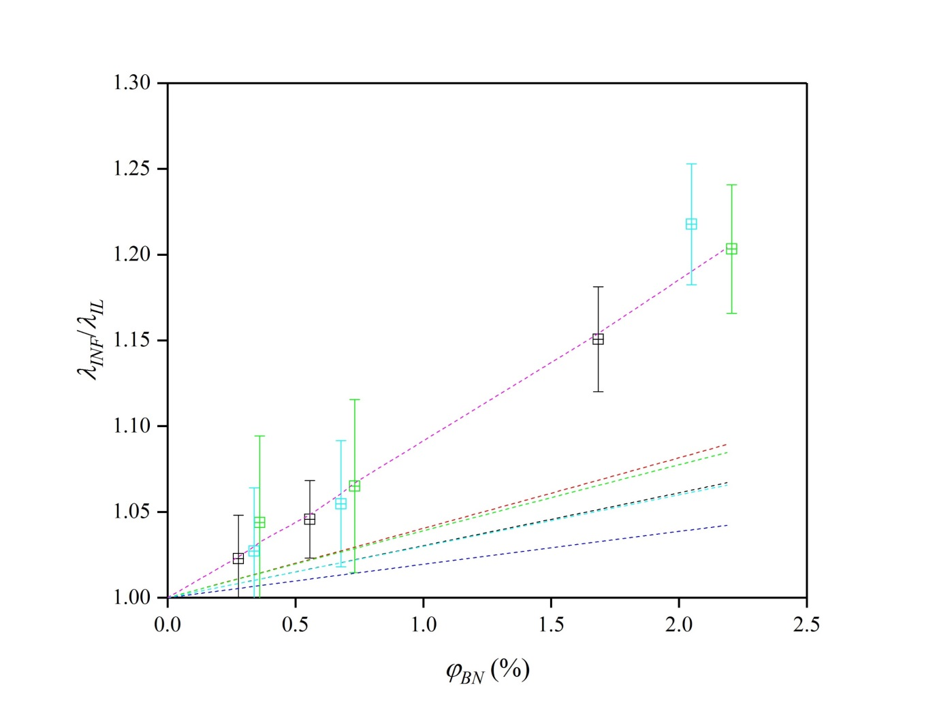

**Fig. 11** Thermal conductivity enhancement of nanofluids, *λINF*/*λIL*, in comparison to pure ionic liquids as a function boron nitride, BN, volume fraction, *φBN*, for [C4C1Im][Dca] , [C4C1Pyrr][NTf2] , [C6C1Im][PF6] , with BN, at 298.15 K. Dash lines represent modelled values for Maxwell model , Hamilton & Crosser model , cylindrical Tinga-Leong-Murshed model , spherical Tinga-Leong-Murshed model , Timofeeva model , Atashrouz model .

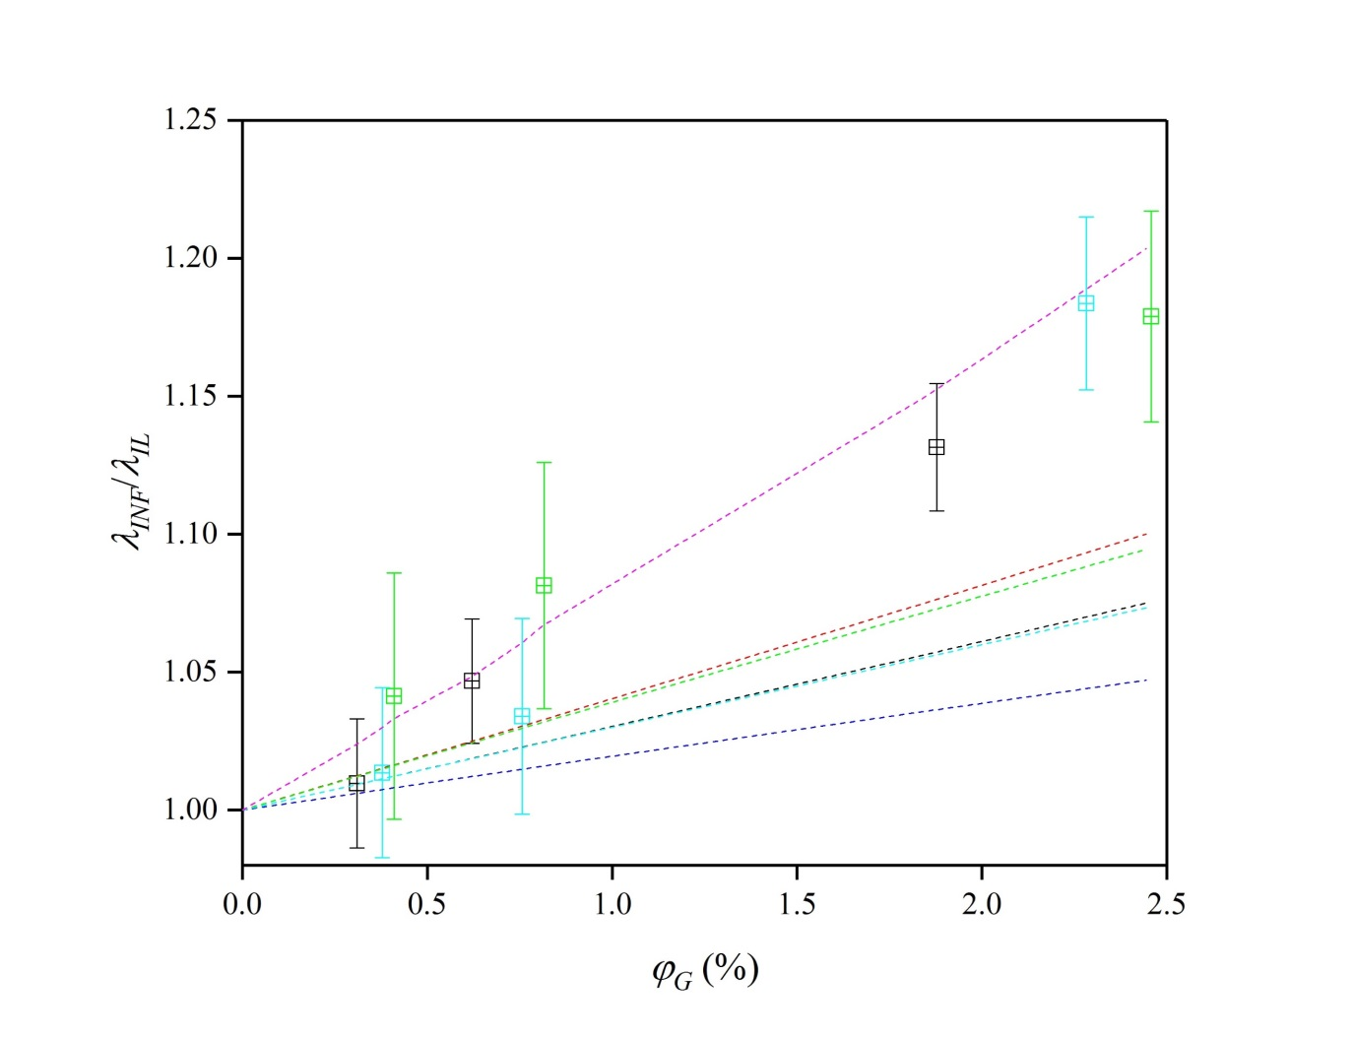

**Fig. 12** Thermal conductivity enhancement of nanofluids, *λINF*/*λIL*, in comparison to pure ionic liquids as a function graphite, G, volume fraction, *φG*, for [C4C1Im][Dca] , [C4C1Pyrr][NTf2] , [C6C1Im][PF6] , with G, at 298.15 K. Dash lines represent modelled values for Maxwell model , Hamilton & Crosser model , cylindrical Tinga-Leong-Murshed model , spherical Tinga-Leong-Murshed model , Timofeeva model , Atashrouz model .

After the initial assessment of most reliable model for the ionanofluids thermal conductivity modelling, the calculations as a function of temperature were also performed using the Atashrouz model. Nevertheless, the thermal conductivity of nanoparticles is needed to perform such calculations. The impact of nanoparticles thermal conductivity in Atashrouz model was estimated, and the results are shown in **Fig. 13**. As expected, the impact of nanoparticles thermal conductivity is increasing with increasing the concentration, in the logarithmic-function-like shape, becoming less dependent at high nanoparticle thermal conductivity values. Based on the literature on the thermal conductivity as a function of temperature,[46-48, 68] in the range of investigated temperature, (278 – 358) K, the changes in thermal conductivity of nanoparticles are negligible. Therefore, the values of thermal conductivity of nanoparticles at 298.15 K are used for the calculations at higher temperature, up to 358 K, (3223.4, 874.1 and 35.7) W m-1 K-1 for carbon nanotubes,[48] boron nitride,[47] and graphite,[46] respectively. This is also a reasonable explanation for the weak dependence of temperature on the thermal conductivity enhancement values observed in **Fig. 6**, **Fig. 7** and **Fig. 8**. The results of the modelling as a function of temperature are presented in **Fig. 14a**, where the comparison of experimental *vs.* calculated values can be found. The deviations between experimental and calculated values are presented in **Fig. 14b**. The absolute average relative deviation was found as 1.44 %, and maximum positive relative deviations were found as (4.19, 1.93 and 3.92) % for [C4C1Im][NTf2] + 3 wt% MWCNT at 308.15 K, [C4C1Pyrr][NTf2] + 3 wt% BN at 358.15 K and [C4C1Pyrr][NTf2] + 3 wt% G at 338.15 K, respectively, while the negative relative deviations were found as –(1.44, 2.06 and 1.66) % for [C4C1Im][Dca] + 1 wt% MWCNT at 348.15 K, [C6C1Im][PF6] + 3 wt% BN at 298.15 K and [C4C1Pyrr][NTf2] + 1 wt% MWCNT at 278.15 K, respectively. It should be noticed that the thermal conductivity standard uncertainty was about 3.44 %, therefore, the modelled values of enhancement with Atashrouz model were reasonable.

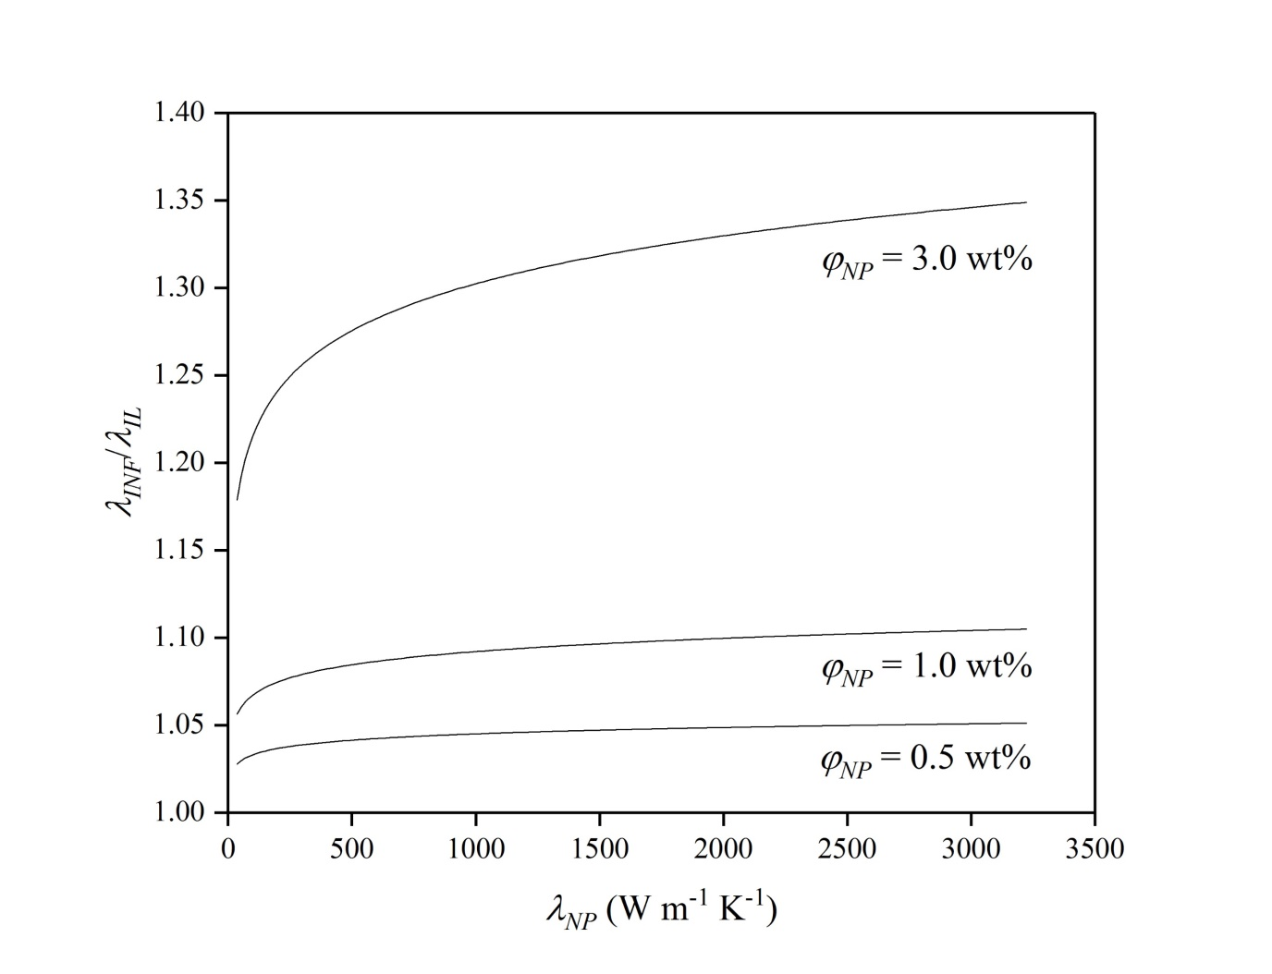

**Fig. 13** Impact of nanoparticles thermal conductivity, *λNP*, onto the thermal conductivity enhancement, *λINF*/*λIL*, for investigated volume concentrations of nanoparticles, *φNP*. Simulation for Atashrouz model.

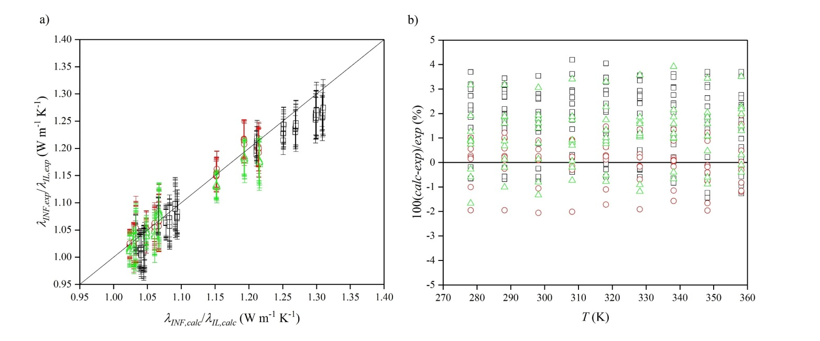

**Fig. 14 a)** Thermal conductivity enhancement calculated vs experimental for whole range of investigated temperature; **b)** Deviation between calculated and experimental thermal conductivity enhancement as a function of temperature. Used model: Atashrouz. Symbols: multiwalled carbon nanotubes MWCNT , boron nitride BN , graphite G 

**Conclusions**

In this work, an extensive study of thermal conductivity was conducted for various ILs and ionanofluids. Based on the measurements carried out, the thermal conductivity enhancement of ionic liquid – based nanofluids with carbon nanotubes, boron nitride and graphite, in comparison to pure ionic liquid equivalents, was discussed. The enhancements observed were up to about 27 % for carbon nanotubes, 22 % for boron nitride, and 18 % for graphite. The driving force of the enhancement was the type of nanoparticles and the magnitude was dependent on their thermal conductivity (the highest for carbon nanotubes, smaller for boron nitride and the weakest of graphite). On the other hand, the type of anion in ionic liquids was observed to be another factor influencing the thermal conductivity with more bulky anions leading to higher enhancement values (with [NTf2]- as highest, and the weakest for [Dca]-). The enhancements were also compared to literature with average absolute relative deviation of 3.37 %. This work also shown that the thermal conductivity enhancement caused by the dispersion of nanoparticles is related to nanoparticles-liquid nanolayering. A theoretical modelling was used to calculate the theoretical enhancement in ionanofluids. Several models were used, however, only one model which was constructed for ionic liquid based nanofluids (Atashrouz) was found to be the most accurate. As an extension, this model was also used to predict the enhancement at elevated temperature and successfully achieved average absolute relative deviation of 1.44 % (with the assumption of independence of nanoparticles thermal conductivity over the temperature).

**Supplementary Material**

The control purity of pure ionic liquids (NMR), nanoparticle characterization (XRD, SEM, size distribution), experimental data of thermal conductivity for all investigated systems, and calculated values are available on the Journal’s website.

**Acknowledgments**

The project was supported by King Faisal University (Saudi Arabia) through a research fund from the International Cooperation and Knowledge Exchange Administration department at KFU.

**References**

[1] X.-Q. Wang, A.S. Mujumdar, *International Journal of Thermal Sciences* **2007**, *46*, 1. doi: 10.1016/j.ijthermalsci.2006.06.010

[2] S. Kakaç, A. Pramuanjaroenkij, *International Journal of Heat and Mass Transfer* **2009**, *52*, 3187. doi: 10.1016/j.ijheatmasstransfer.2009.02.006

[3] V. Trisaksri, S. Wongwises, *Renewable and Sustainable Energy Reviews* **2007**, *11*, 512. doi: 10.1016/j.rser.2005.01.010

[4] J.M.P. França, C.A. Nieto de Castro, M.M. Lopes, V.M.B. Nunes, *Journal of Chemical Engineering Data* **2009**, *54*, 2569. doi: 10.1021/je900107t

[5] V.M.B. Nunes, M.J. V Lourenço, F.J. V Santos, C.A. Nieto de Castro, *Journal of Chemical Engineering Data* **2003**, *48*, 446. doi: 10.1021/je020160l

[6] A.J.F. Mendonca, C.A. Nieto de Castro, M.J. Assael, W.A. Wakeham, *Revista Portuguesa de Quimica* **1981**, *23*, 7. doi: 10.1021/je900107t

[7] J. Singh, *Heat Transfer Fluids and Systems for Process and Energy Applications* **1985** (Office of Scientific and Technical Information).

[8] N. Canter, *Tribology & Lubrication Technology* **2009**, *65*, 28.

[9] M. Musiał, K. Malarz, A. Mrozek-Wilczkiewicz, R. Musiol, E. Zorębski, M. Dzida, *ACS Sustainable Chemistry & Engineering* **2017**, *5*, 11024. doi: 10.1021/acssuschemeng.7b02918

[10] D.M. Blake, L. Moens, M.J. Hale, H. Price, D. Kearney, U. Herrmann, in: *Proceedings of the 11th SolarPACES International Symposium On concentrating Solar Power and Chemical Energy Technologies* **2002**, chapter: *New Heat Transfer and Storage Fluids for Parabolic Trough Solar Thermal Electric Plants*.

[11] M.E. Van Valkenburg, R.L. Vaughn, M. Williams, J.S. Wilkes, *Thermochimica Acta* **2005**, *425*, 181. doi: 10.1016/j.tca.2004.11.013

[12] J.H. Davis Jr, C.M. Gordon, C. Hilgers, P. Wasserscheid, T. Welton, *Ionic Liquids in Synthesis* **2003** (Wiley-VCH Verlag GmbH Co, New York).

[13] M. Freemantle, *An introduction to ionic liquids* **2010** (Royal Society of Chemistry)

[14] M.J. Earle, J.M.S.S. Esperança, M.A. Gilea, J.N.C. Lopes, L.P.N. Rebelo, J.W. Magee, K.R. Seddon, J.A. Widegren, *Nature* **2006**, *439*, 831. doi: 10.1038/nature04451

[15] E.A. Chernikova, L.M. Glukhov, V.G. Krasovskiy, L.M. Kustov, M.G. Vorobyeva, A.A. Koroteev, *Russian Chemical Reviews* **2015**, *84*, 875. doi: 10.1070/RCR4510

[16] S.U.S. Choi, J.A. Eastman, *Enhancing thermal conductivity of fluids with nanoparticles* **1995** (Argonne National Lab., IL).

[17] J.A. Eastman, U.S. Choi, S. Li, L.J. Thompson, S. Lee, *MRS Online Proceedings Library Archive:* *Nanophase and Nanocomposite II* **1996**, *457*, 1.

[18] S.M.S. Murshed, K.C. Leong, C. Yang, *International Journal of Thermal Sciences* **2005**, *44*, 367. doi: 10.1016/j.ijthermalsci.2004.12.005

[19] S.U.S. Choi, Z.G. Zhang, Wl. Yu, F.E. Lockwood, E.A. Grulke, *Applied Physics Letters* **2001**, *79*, 2252. doi: 10.1063/1.1408272

[20] C.A. Nieto de Castro, M.J. V Lourenço, A.P.C. Ribeiro, E. Langa, S.I.C. Vieira, P. Goodrich, C. Hardacre, *Journal of Chemical Engineering Data* **2009**, *55*, 653. doi: 10.1021/je900648p

[21] J.M.P. França, F. Reis, S.I.C. Vieira, M.J. V Lourenço, F.J. V Santos, C.A.N. De Castro, A.A.H. Padua, *Journal of Chemical Thermodynamics* **2014**, *79*, 248. doi: 10.1016/j.jct.2014.05.008

[22] J.M.P. França, S.I.C. Vieira, M.J. V Lourenço, S.M.S. Murshed, C.A. Nieto de Castro, *Journal of Chemical Engineering Data* **2013**, *58*, 467. doi: 10.1021/je301183r

[23] W. Yu, D.M. France, J.L. Routbort, S.U.S. Choi, *Heat Transfer Engineering* **2008**, *29*, 432. doi: 10.1080/01457630701850851

[24] S. Özerinç, S. Kakaç, A.G. Yazıcıoğlu, *Microfluidics and Nanofluidics* **2010**, *8*, 145. doi: 10.1007/s10404-009-0524-4

[25] C. Kleinstreuer, Y. Feng, *Nanoscale Research Letters* **2011**, *6*, 229. doi: 10.1186/1556-276X-6-229

[26] J. França, C.A.N. de Castro, A.A.H. Padua, *Physical Chemistry Chemical Physics* **2017**, *19*, 17075. doi: 10.1039/C7CP01952A

[27] J.C. Maxwell, *A treatise on electricity and magnetism* **1881** (Clarendon Press).

[28] R.L. Hamilton, O.K. Crosser, *Industrial & Engineering Chemistry Fundamentals* **1962**, *1*, 187. doi: 10.1021/i160003a005

[29] W.R. Tinga, W.A.G. Voss, D.F. Blossey, *Journal of Applied Physics* **1973**, *44*, 3897. doi: 10.1063/1.1662868

[30] K.C. Leong, C. Yang, S.M.S. Murshed, *Journal of Nanoparticle Research* **2006**, *8*, 245. doi: 10.1007/s11051-005-9018-9

[31] S.M.S. Murshed, K.C. Leong, C. Yang, *International Journal of Thermal Sciences* **2008**, *47*, 560. doi: 10.1016/j.ijthermalsci.2007.05.004

[32] E. V Timofeeva, A.N. Gavrilov, J.M. McCloskey, Y. V Tolmachev, S. Sprunt, L.M. Lopatina, J. V Selinger, *Physical Review E* **2007**, *76*, 61203. doi: 10.1103/PhysRevE.76.061203

[33] S. Atashrouz, M. Mozaffarian, G. Pazuki, *Industrial & Engineering Chemistry Research* **2015**, *54*, 8600. doi: 10.1021/acs.iecr.5b00932

[34] A.K. Burrell, R.E. Del Sesto, S.N. Baker, T.M. McCleskey, G.A. Baker, *Green Chemistry* **2007**, *9*, 449. doi: 10.1039/B615950H

[35] M.J. Earle, C.M. Gordon, N. V Plechkova, K.R. Seddon, T. Welton, *Analytical Chemistry* **2007**, *79*, 758. doi: 10.1021/ac061481t

[36] J.D. Holbrey, W.M. Reichert, R.P. Swatloski, G.A. Broker, W.R. Pitner, K.R. Seddon, R.D. Rogers, *Green Chemistry* **2002**, *4*, 407. doi: 10.1039/B204469B

[37] J.D. Holbrey, K.R. Seddon, R. Wareing, *Green Chemistry* **2001**, *3*, 33. doi: 10.1039/B009459P

[38] K. Oster, P. Goodrich, J. Jacquemin, C. Hardacre, A.P.C. Ribeiro, A. Elsinawi, *Journal of Chemical Thermodynamics* **2018**, *121*, 97. doi: 10.1016/j.molliq.2018.01.025

[39] A.P.C. Ribeiro, S.I.C. Vieira, P. Goodrich, C. Hardacre, M.J. V Lourenço, C.A. de Castro, *Journal of Nanofluids* **2013**, *2*, 55. doi: 10.1166/jon.2013.1035

[40] C. Zhi, Y. Xu, Y. Bando, D. Golberg, *ACS Nano* **2011**, *5*, 6571. doi: 10.1021/nn201946x

[41] G. Żyła, A. Witek, M. Gizowska, *Journal of Applied Physics* **2015**, *117*, 14302. doi: 10.1063/1.4903737

[42] Q. Wan, Y. Jin, P. Sun, Y. Ding, *Procedia Engineering* **2015**, *102*, 1038.doi: 10.1016/j.proeng.2015.01.226

[43] K. Oster, J. Jacquemin, C. Hardacre, A.P.C. Ribeiro, A. Elsinawi, *Journal of Chemical Thermodynamics* **2018**, *118*, 1. doi: 10.1016/j.jct.2017.10.010

[44] K. Oster, C. Hardacre, J. Jacquemin, A.P.C. Ribeiro, A. Elsinawi, *Journal of Molecular Liquids* **2018**, *253*, 326. doi: 10.1016/j.molliq.2018.01.025

[45] J. Fan, L. Wang, *Journal of Heat Transfer* **2011**, *133*, 40801. doi: 10.1115/1.4002633

[46] R. Taylor, *Philosophical Magazine* **1966**, *13*, 157. doi: 10.1080/14786436608211993

[47] E.K. Sichel, R.E. Miller, M.S. Abrahams, C.J. Buiocchi, *Physical Review B* **1976**, *13*, 4607. doi: 10.1103/PhysRevB.13.4607

[48] P. Kim, L. Shi, A. Majumdar, P.L. McEuen, *Physica B: Condensed Matter* **2002**, *323*, 67. doi: 10.1016/S0921-4526(02)00969-9

[49] R. Ge, C. Hardacre, P. Nancarrow, D.W. Rooney, *Journal of Chemical Engineering Data* **2007**, *52*, 1819. doi: 10.1021/je700176d

[50] H. Chen, Y. He, J. Zhu, H. Alias, Y. Ding, P. Nancarrow, C. Hardacre, D. Rooney, C. Tan, *International Journal of Heat and Fluid Flow* **2008**, *29*, 149. doi: 10.1016/j.ijheatfluidflow.2007.05.002

[51] A.P. Fröba, M.H. Rausch, K. Krzeminski, D. Assenbaum, P. Wasserscheid, A. Leipertz, *International Journal of Thermophysics* **2010**, *31*, 2059. doi: 10.1007/s10765-010-0889-3

[52] Q.-L. Chen, K.-J. Wu, C.-H. He, *Journal of Chemical Engineering Data* **2013**, *58*, 2058. doi: 10.1021/je400268t

[53] D. Tomida, S. Kenmochi, T. Tsukada, K. Qiao, C. Yokoyama, *International Journal of Thermophysics* **2007**, *28*, 1147. doi: 10.1007/s10765-007-0241-8

[54] N. Zhao, J. Jacquemin, R. Oozeerally, V. Degirmenci, *Journal of Chemical Engineering Data* **2016**, *61*, 2160. doi: 10.1021/acs.jced.6b00161

[55] C.-J. Ho, M.W. Chen, Z.W. Li, *International Journal of Heat and Mass Transfer* **2008**, *51*, 4506. doi: 10.1016/j.ijheatmasstransfer.2007.12.019

[56] E. Abu-Nada, *International Journal of Heat and Fluid Flow* **2009**, *30*, 679. doi: 10.1016/j.ijheatfluidflow.2009.02.003

[57] C.N. de Castro, A.P.C. Ribeiro, S.I.C. Vieira, J.M.P. França, M.J. V Lourenço, F. V Santos, S.M.S. Murshed, P. Goodrich, C. Hardacre, In: *Ionic Liquids – New Aspects for the Future* **2013**, Chapter: *Synthesis, Properties and Physical Applications of IoNanofluids* (InTech).

[58] R.C. Zeller, R.O. Pohl, *Physical Review B* **1971**, *4*, 2029. doi: 10.1103/PhysRevB.4.2029

[59] I.H. El-Sayed, X. Huang, M.A. El-Sayed, *Nano Letters* **2005**, *5*, 829. doi: 10.1021/nl050074e

[60] R. Marchiori, In: *Nanostructures* **2016**, Chapter 8: *Mathematical Fundamentals of Nanotechnology* (William Andrew Applied Science Publishers).

[61] V.K. Paruchuri, A. V Nguyen, J.D. Miller, *Colloids and Surfaces A: Physicochemical and Engineering Aspects* **2004**, *250*, 519. doi: 10.1016/j.colsurfa.2004.04.098

[62] W. Lei, V.N. Mochalin, D. Liu, S. Qin, Y. Gogotsi, Y. Chen, *Nature Communications* **2015**, *6*, 8849. doi: 10.1038/ncomms9849

[63] B. White, S. Banerjee, S. O’Brien, N.J. Turro, I.P. Herman, *The Journal of Physical Chemistry C* **2007**, *111*, 13684. doi: 10.1021/jp070853e

[64] B. Ouyang, J. Song, *Applied Physics Letters* **2013**, *103*, 102401. doi: 10.1063/1.4819266

[65] W. Yu, H. Xie, *Journal of Nanomaterials* **2012**, *2012*, 1. doi: 10.1155/2012/435873

[66] Y. Li, S. Tung, E. Schneider, S. Xi, *Powder Technology* **2009**, *196*, 89. doi: 10.1016/j.powtec.2009.07.025

[67] Z. Haddad, C. Abid, H.F. Oztop, A. Mataoui, *International Journal of Thermal Sciences* **2014**, *76*, 168. doi: 10.1016/j.ijthermalsci.2013.08.010

[68] S. Berber, Y.-K. Kwon, D. Tománek, *Physical Reviews Letters* **2000**, *84*, 4613. doi: 10.1103/PhysRevLett.84.4613