Understanding the Heat Capacity Enhancement in Ionic Liquid-Based Nanofluids (Ionanofluids)
K. Oster^{1,2*}, C. Hardacre^{1,2*}, J. Jacquemin^{2,3}, A. P. C. Ribeiro⁴, A. Elsinawi⁵

¹The University of Manchester, School of Chemical Engineering & Analytical Science, Sackville Street, M13 9PL, Manchester, UK, kamil.oster@manchester.ac.uk
²Queen’s University Belfast, School of Chemistry & Chemical Engineering, Stranmillis Road, BT9 5BW, Belfast, UK
³Université de Tours, Laboratoire PCM2E, Parc de Grandmont 37200 Tours, France
⁴Universidade de Lisboa, Centro de Química Estrutural, Instituto Superior Técnico, Av. Rovisco Pais 1, 1049-001, Lisboa, Portugal
⁵King Fasial University, Materials Engineering Department, College of Engineering, Al-Hasa, 31982, Hofuf, Saudi Arabia

Nanofluids, systems consisting of a base fluid and dispersed nanoparticles, have attained a large scientific interest recently, mainly due to unusual enhancement in their thermal properties like the thermal conductivity and heat capacity. Whilst both molecular solvents and ionic liquids have been examined, ionic liquids are known for the specific properties caused by the interactions occurring in these systems. Physical properties of very mixtures containing an ionic liquid and nanoparticles still remain not fully investigated and analyzed in the literature, to date. One of the possible issues which limits the fundamental understanding of such systems is related to the determination of the mechanism explaining the unusual enhancement of the thermal properties, in particular the heat capacity. The aim of this work is to discuss the mechanism of heat capacity enhancement of several ionic liquid-based nanofluids doped with carbon nanotubes, boron nitride and graphite, based on the experimental data of density and heat capacity determined as the function of the nanofluid composition and temperature from (298.15 to 363.15) K at 0.1 MPa.

Keywords: Ionic Liquids, IoNanofluids, Isobaric Heat Capacity, Carbon Nanotubes, Boron Nitride, Graphite, Nanoparticles

- Introduction
Nanofluids are systems consisting of base fluids (i.e. water, ethylene glycol or oils) and nanoparticles (i.e. carbon nanotubes, oxides or metals) dispersed, therein. The effort undertaken in preparing such materials, is usually driven by the fact that these solutions exhibit specific properties, which are unusual when compared to other individual components, for example the loading of nanoparticles causes thermal conductivity to increase, as well as the specific heat capacity.[1] This group of systems is particularly of interest due to a large range of possible combinations, driven by the selection of the types of base fluids,[2–4] through a wide variety of nanoparticles,[5–8] to be dispersed and ending on more sophisticated eutectic mixtures.[9–11] In particular, the thermal conductivity and the heat capacity of nanofluids have attained an extraordinary scientific attention because of the unusual enhancement of these properties when a given nanoparticle is dispersed in a specific base fluid. While thermal conductivity was widely investigated in the literature and many theories were proposed,[12–17] heat capacity remained abandoned for a long time, to date. The main point was focused about unusual enhancement caused by the addition of nanoparticles which have usually lower heat capacity than liquids.[18] Following the first approach to describe this behavior based on mixing theory for ideal gas mixtures, the heat capacity should be a decreasing function of nanoparticles loading, which was proved to be wrong.[19] A further derivation leads to the assumption of thermal equilibrium between the particles and the surrounding fluid by including the density of liquid and nanoparticles. Still the reproducibility was very limited.[19] A meaningful theory was recommended by Shin and Banerjee (2011).[10] These authors discussed the specific surface properties of nano-sized materials, the properties of the liquid around nanoparticles and, finally, the layering, caused by liquid molecule adsorption, onto the nanoparticles. The most recent work, reported by Hentschke (2016), introduced the full mathematical fundamentals of the enhancement.[20] This includes the interfacial layering, and some type of overlapping mesolayers.
Ionic liquids are a group of compounds composed solely of ions with melting point below 373.15 K.[21] This is caused by specific interactions occurring between cations and anions, and their cohesive energy is driven by a combination of Coulombic interactions, van der Waals interactions and hydrogen bonding in solution.[22] Their reminiscent properties include, generally, low flammability, wide liquid range, low vapor pressure, high thermal stability and ionic conductivity.[23] All these advantages have led many researchers to consider ionic liquids in many applications, for example, catalysis, extraction or as lubricants.[24–27] Ionic liquids have also been used to prepare nanofluids which result in ionanofluids.[28] It has been reported that these particular mixtures can be used as potential materials for many applications (particularly those using heat transfer fluids) driven by the specific properties of ionic liquids.[29] The first report of ionanofluids was described by Nieto de Castro et al. (2010) in which the thermal conductivity enhancement was investigated.[30] Nevertheless, the mechanism of this heat capacity enhancement was not discussed in case of ionanofluids.
The aim of this work is the experimental determination of density and specific heat capacity of ionanofluids based on 1-butyl-3-methylimidazolium dicyanamide, 1-butyl-3-methylimidazolium bis(trifluoromethylsulfonyl)imide, 1-butyl-1-methylpyrrolidinium bis(trifluoromethylsulfonyl)imide, 1-hexyl-3-methylimidazolium hexafluorophosphate, and 1-ethyl-3-methylimidazolium ethylsulfate, mixed with different loadings of nanoparticles, such as carbon nanotubes, boron nitride and graphite, up to a nanoparticle weight fraction close to 0.03 (i.e. 3% wt%). A further significant analysis of experimental work in terms of possible mechanisms explaining the unusual enhancement of their thermal properties by following those already proposed for simple nanofluids has been performed.

- Experimental
Materials
1-Butyl-3-methylimidazolium dicyanamide (CAS: 448245-52-1), [C₄C₁Im][Dca], and 1-butyl-3-methylimidazolium bis(trifluoromethylsulfonyl)imide (CAS: 174899-83-3), [C₄C₁Im][NTf₂], were bought from Merck (purity ≥98%, ≤0.01% halides, catalogue number: 4900150500) and Sigma-Aldrich (purity ≥98%, catalogue number: 711713), respectively. 1-Butyl-1-methylpyrrolidinium bis(trifluoromethylsulfonyl)imide (CAS: 223437-11-4), [C₄C₁Pyrr][NTf₂], 1-hexyl-3-methylimidazolium hexafluorophosphate (CAS: 304680-35-1), [C₆C₁Im][PF₆], and 1-ethyl-3-methylimidazolium ethylsulfate (CAS: 342573-75-5), [C₂C₁Im][C₂SO₄], were synthesized in-house by following the procedures available in the literature.[31–33] All ILs were washed 3-5 times with ultrapure water (18 MΩ cm), and extracted with dichloromethane. Thereafter, the ILs were dried under high vacuum (10⁻⁴ Pa) and elevated temperature (333.15 K) for at least 72 h. The final purity of each IL was then checked with ¹H and ¹³C NMR (Figure S1, SI), and found to be ≥ 98 % in each case. The water content was assessed by Karl-Fisher titration (Metrohm 899 Coulometer with 803 Ti Stand and Hydranal Coulomat AG), before and after each measurement. All values were below 2 ∙ 10⁻⁴ in water mass fraction unit. Moreover, the water content values after each measurement were not deviated from those measured before, showing a non-contamination of water during each measurement. The specification of all the ILs used in this work are reported in Table 1, while the structures of investigated ionic liquids are presented in Figure 1.

Table 1 Chemicals description.ª
Chemical name  [CAS] | Supplier | Mass fraction purity | Purification method | Analysis method | Halide content ppm^{b}
1-Butyl-3-methylimidazolium dicyanamide  [448245-52-1] | Merck | ≥ 0.98 | Washing-extraction  Vacuum | ¹H and ¹³C NMR  Karl Fisher titration | < 5
1-Butyl-3-methylimidazolium bis(trifluoromethylsulfonyl)imide  [174899-83-3] | Merck | ≥ 0.98 | Washing-extraction  Vacuum | ¹H and ¹³C NMR  Karl Fisher titration | < 5
1-Butyl-1-methylpyrrolidinium bis(trifluoromethylsulfonyl)imide  [223437-11-4] | In house | ≥ 0.98 | Washing-extraction  Vacuum | ¹H and ¹³C NMR  Karl Fisher titration | < 5
1-Hexyl-3-methylimidazolium hexafluorophosphate  [304680-35-1] | In house | ≥ 0.98 | Washing-extraction  Vacuum | ¹H and ¹³C NMR  Karl Fisher titration | < 5
1-Ethyl-3-methylimidazolium ethylsulfate  [342573-75-5] | In house | ≥ 0.98 | Washing-extraction  Vacuum | ¹H and ¹³C NMR  Karl Fisher titration | < 5
Multi-walled carbon nanotubes  [308068-56-6] | Bayer Material Science | ≥ 0.99 | - | Ashing,^{c} TEM, ^{c} SEM,^{d} EN ISO 60,^{c} XRD, laser diffraction technique | -
Boron nitride  [10043-11-5] | US Research Nanomaterials, Inc. | ≥ 0.998 | - | SEM,^{d} XRD^{d} | -
Graphite  [7782-42-5] | US Research Nanomaterials, Inc. | ≥ 0.999 | - | SEM,^{d} XRD^{d} | -
^{a 1}H and ¹³C NMR refer to proton, carbon and nuclear magnetic resonance spectroscopy, respectively; ^{b} determined by AgNO₃ titration; ^{c} as reported by the supplier; ^{d} as reported by supplier and confirmed by measurement.

Figure 1 Structures of investigated ionic liquids.

The carbon nanotubes used were Multiwalled Carbon Nanotubes Baytubes C150 HP from Bayer Material Science (MWCNT, CAS: 308068-56-6, purity ≥ 99 %, 3-15 number of walls, 13-16 nm outer mean diameter, 5-20 nm outer diameter distribution, 4 nm inner mean diameter, 2-6 nm inner diameter distribution, 1-10 mm length, 140-230 kg m⁻³ bulk density; according to the specifications provided by the supplier). Hexagonal boron nitride and graphite nanoparticles were bought from US Research Nanomaterials, Inc. (BN, CAS: 10043-11-5, purity ≥ 99.8 %, 70-80 nm size, 2290 kg m⁻³ theoretical true density, < 0.03 % Fe₂O₃, < 0.002 % CaO, < 0.04 % MgO, < 0.1 % B₂O₃ for boron nitride, and G, CAS: 7782-42-5, ≥ 99.9 % purity, 400-1200 nm size, < 0.1 % impurities, ~0.2 % water for graphite, respectively). Boron nitride and graphite were pre-processed by ball milling (Retsch Mixer Mill MM 400, frequency 20 Hz, 3 times for 1800 s). The purity of nanomaterials was repeated with X-ray diffractometry (X’Pert Powder PANalytical, 15-90º scan range, 0.0084º scan step size, Figure S2, SI3). The particle size was checked with scanning electron microscope (650 FEI Quanta FEG, 15-20, < 90, < 100 nm for carbon nanotubes, boron nitride and graphite, respectively, Figure S3, SI3), and with light scattering (Mastersizer Malvern, dispersion with water, stabilized with sodium laureth sulfate as anionic surfactant, refractive index of 1.330, 1.650 and 2.420 for water, boron nitride and both carbon-based nanomaterials, respectively; 26.60 ± 0.15 nm, 154.5 ± 1.7 nm, and 159.1 ± 3.1 nm for carbon nanotubes, boron nitride and graphite, respectively, Figure S4, SI3).
Based on the literature review, the most reliable thermophysical properties were presented in the works published by França et al. (2014),[34] França et al. (2013),[35] and Nieto de Castro et al. (2010).[30] Thus, systems reported in these works were selected to compare with the data measured in this study. Nevertheless, only ionanofluids based on carbon nanotubes doped ionic liquids are reported, to date. In fact, to the best of our knowledge, the physical properties of ionanofluids containing boron nitride or graphite dispersed in ILs have not been reported, to date. Manufacture of ionanofluids is a very delicate process, and it requires a careful treatment and the same protocols used previously to produce reproducible nanofluids have been applied, herein. This was also applied in this work: after the nanoparticles were added to ILs, 30 min of magnetic stirring was applied prior to the 1h of sonication required to the formation of nanofluids instead of so-called bucky gels, and the nanoparticles agglomeration breakage. The summary of all investigated ionanofluids are reported in Table 2.

Table 2 Summary of investigated ionanofluids, including the mass fraction w_{m,NP}.
 | 100 × w_{m,NP} (%)
 | Carbon nanotubes | Boron nitride | Graphite
[C₄C₁Im][Dca] | 0.5, 1.0, 3.0 | 0.5, 1.0, 3.0 | 0.5, 1.0, 3.0
[C₄C₁Im][NTf₂] | 0.5, 1.0, 3.0 | - | -
[C₂C₁Im][C₂SO₄] | 0.5, 1.0, 3.0 | - | -
[C₄C₁Pyrr][NTf₂] | 1.0, 3.0 | 1.0, 3.0 | 1.0, 3.0
[C₆C₁Im][PF₆] | 0.5, 1.0, 3.0 | 0.5, 1.0, 3.0 | 0.5, 1.0, 3.0

Methods
Density, ρ, was measured as a function of the temperature, T, using an Anton Paar DMA 4500M densitometer (calibration on ultrapure degassed water and dry air, relative standard uncertainty of density, u_{r}(ρ) = 0.1 %, relative standard uncertainty of temperature, u_{r}(T) = 0.01 K, viscosity-induced errors reduced). This equipment works on the principle of oscillating U-tube where approximately 1.5 cm³ sample volume is used within 3 independent repeats of measurement. The temperature range of each measurement was set from (298.15 to 363.15) K.
To correlate the density with temperature, the following linear equation was then used:
(1)
where a_{i} is the regression parameter determined by the least-square method, along with the standard uncertainty, δa_{i}. The coefficient of determination, R², was used to describe the fit. The nanoparticles density was calculated using the following empirical formulae:[36]
(2)
where w is mass fraction, IL and NP refer to ionic liquids and nanoparticles, respectively. The excess molar volume, VE, was also calculated using the following formulae:
(3)
where M and x are the molar mass and the mole fraction of each component in selected solutions.
Specific heat capacity, c_{p}, was measured as a function of the temperature, T, by using differential scanning calorimeter equipment, Q100 TA instruments (modulated differential scanning calorimetry technique, calibration on sapphire with further checking on 1-hexyl-3-methylimidazolium bis(trifluoromethylsulfonyl)imide as a NIST standard.[37] Relative standard uncertainty of measurement u_{r}(c_{p}) = 3 %, while the temperature relative standard uncertainty, u_{r}(T) = 0.01 K, nitrogen gas flow rate of 50 cm³ min⁻¹, heating rate dT/dt = 2 K min⁻¹, amplitude ± 0.5 K, modulation period 60 s, 3 independent repeats of the measurement with 5% repeatability). The specific heat capacity was described as a function of the temperature by the second-order equation:
(4)
To represent the specific heat capacity as a function of the nanoparticles loading, the mass fraction, w_{m,NP} was recalculated to volume fraction, ϕ_{NP} with the following equation, as it reflects in proper concentration of multiple phase systems description:
(5)
where m is a mass, V is a volume, density of nanoparticles, ρ_{NP}, was calculated using equation (2), and density of ionic liquids, ρ_{IL}, was determined experimentally.

- Results and discussion

Properties of pure ionic liquids
The density and heat capacity were measured for pure ionic liquids and the purity before and after each measurement was studied, in particular the water content which may increase during/after the data collection. Thus, the water content after heat capacity assessments was checked by weighing the mass of the pan, and directly by using Karl Fischer titration after density measurement. No changes were recorded which means that the pans containing studied samples were sealed from the environment and water absorption. It was previously reported that water may influence the physical properties.[38] In the case of heat capacity, 1% of water shifts the heat capacity for about 1.6% (1-butyl-3-methylimidazolium tetrafluoroborate).[39] Nevertheless, density is much less dependent on the water content – 20% of water content changes the density of 1-butyl-3-methylimidazolium bis(trifluoromethylsulfonyl)imide for about 1%.[40]
The experimental data for the density and the heat capacity of the pure ILs are reported in supporting information files (SI1 and SI2). Their values were also compared to those previously reported. An extensive comparison to NIST ILs database was performed by taking into account all available literature positions, the relative deviations are presented in Figure 2 and Figure 3 for pure IL density and heat capacity, respectively. As can be seen, the density is a very extensively investigated property of ILs. The deviations observed were approximately (-1.2 – 1.2) % while the main concentration of them is between (-0.2 – 0.2) % as it could be expected regarding solely the standard uncertainty of each equipment used, with maximum of -1.15 %.[41] In the case of heat capacity, the deviations were about (-10 – 20) %, with maximum of 19.06 %.[42] Whereas the standard uncertainty of density measurement is 0.1% and heat capacity of 3%. Such high deviations may be related to different impurity levels and measurement methodology (technique, heating rate, gas flow rate, crucibles used, samples preparation and treatment, calibration). Moreover, such deviations (1% and 20% for density and heat capacity, respectively, or even 40% for heat capacity) are commonly observed in the literature for ionic liquids.[39,43] Diedrichs and Gmehling (2006) critically reviewed the heat capacity measurement approaches, including different techniques and parameters.[44] To the best of our knowledge, and following the above and others’ recommendations, the heat capacity determined in this work are highly accurate.[39,44,42,45] The deviations of pure ILs properties can be observed. Further considerations according to the physical properties and more complicated systems – liquid-liquid (i.e. water-saturated equilibrium),[46] solid-liquid (i.e. nanofluids),[47] liquid-gas (i.e. gas solubility in ILs).[48]

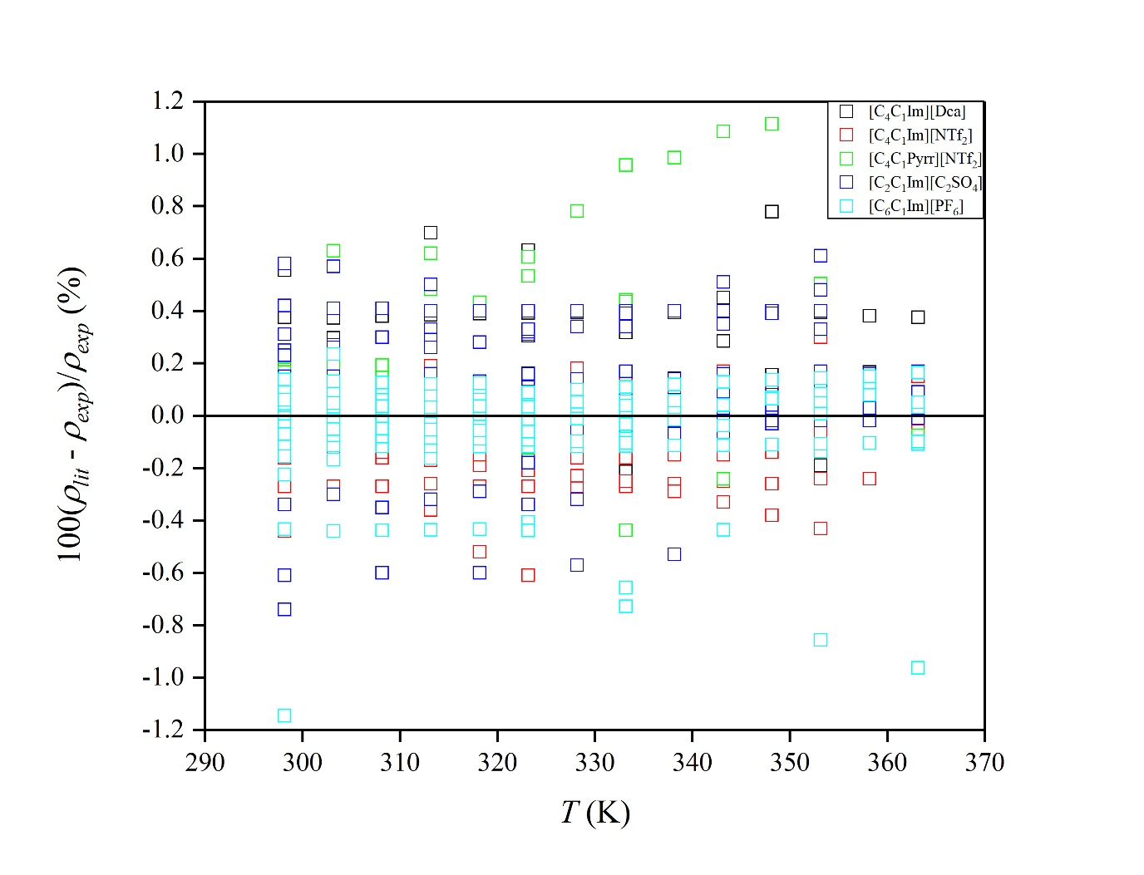
Figure 2 Density deviations between values in this work (SI) and literature data for [C₄C₁Im][Dca],[34,49–69] [C₄C₁Im][NTf₂],[40,52,55,58,68,70–111,43,112–123] [C₂C₁Im][C₂SO₄],[40,52,58,90,91,95,99,103,118,124–171] [C₄C₁Pyrr][NTf₂],[58,61,94,96,113,137,172–189] [C₆C₁Im][PF₆].[41,81,86,88,99,43,190–211]
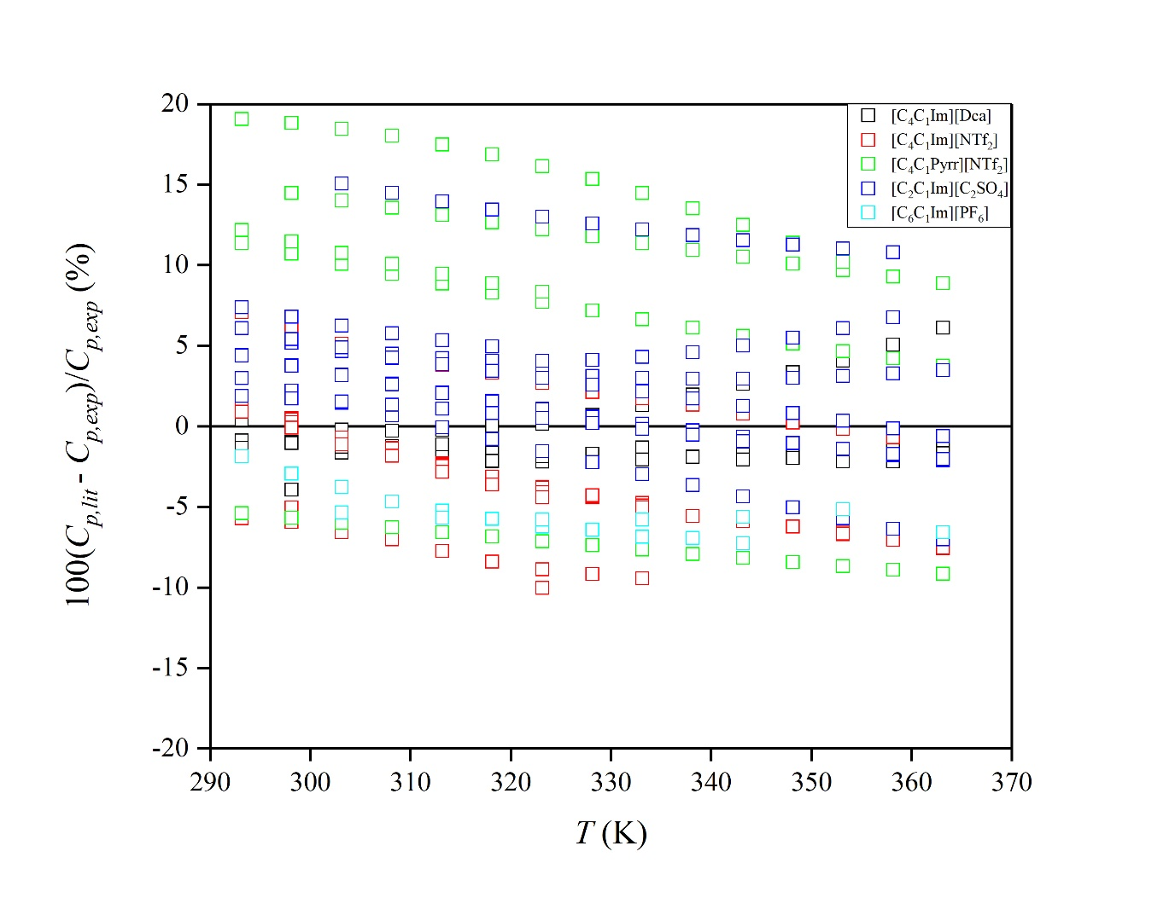
Figure 3 Isobaric heat capacity deviations between values in this work (SI) and literature data for [C₄C₁Im][Dca],[39,52,55,56,212,213] [C₄C₁Im][NTf₂],[42,52,55,85,114,214–220] [C₂C₁Im][C₂SO₄],[39,42,52,134,138,221–226] [C₄C₁Pyrr][NTf₂],[39,42,218,227,228] [C₆C₁Im][PF₆].[193,220]

Density of ionanofluids
The density of ionanofluids containing different loading of carbon nanotubes, boron nitride or graphite nanoparticles dispersed in selected ILs was measured as a function of temperature. The results are shown in Figure 4, Figure 5 and Figure 6 for ionanofluids with carbon nanotubes, boron nitride and graphite, respectively. The parameters of equation (1) are summarized in Table 3. It can be seen that, for all cases, the density decreased as a function of temperature, whereas the loading of nanoparticles caused the density shift to higher density values, as expected. It indicates that the bulk density of all solid materials exhibits higher values. The experimental data were collected in an Excel file (SI1). It can be observed that the addition of nanoparticles into ionic liquid is the base fluid independent. In the literature, it can be found that the density of nanofluids could be then determined by using the empirical equation (2) originally proposed by Pak and Cho (1998) or by using an ideal excess molar volume-based approach.[36,229] In other words, the assumption made during the calculation of nanoparticles density in the case of the ideal excess molar volume-based approach is that the ideal molar volume is equal to the real molar volume of each nanofluid and investigated temperature. These two methods were applied during this work and the results of both nanoparticles density calculations are summarized in an Excel file available in the supporting information, and shown in Figure S5 (SI3). Interestingly, the overall AARD for the density prediction of ionanofluids by using the empirical equation (2) model is close to 0.10 % in each case, while larger deviations are observed using the ideal excess molar volume-based approach, close to (0.44, 0.79 and 0.60) % for carbon nanotubes, boron nitride and graphite based ionanofluids, respectively. Herein, deviations observed using the ideal excess molar volume-based approach are presented in Figures S6-S8 of the SI. In fact, this latter approach does not lead to better results of ionanofluids density prediction (higher AARD) than that proposed by Pak and Cho. However, as shown in Figures S9-S11 of the SI, the hypothetical excess molar volumes calculated using the NPs density values determined from this empirical equation (2) model resulted in larger absolute values (all negatives in the present cases) than those observed using the ideal excess molar volume-based approach, as expected. This finding is also in a good agreement with previous assessments about the scientific meaning of excess properties of systems consisting of more than two phases in solution. From a thermodynamic perspective, in such a case, this excess property is meaningless as an ideal reference state cannot be truly defined.[230] Therefore, the empirical equation (2) model originally proposed by Pak and Cho seems to be more reliable to determine NPs density as a function of NP structure and temperature.[36]
Using this recommended approach, the density values at 298.15 K are (1626.34, 1911.89 and 1711.99) kg m⁻³ for carbon nanotubes, boron nitride and graphite, respectively, with the standard uncertainty as described in the experimental part for density. It can be seen that carbon nanotubes and graphite have similar density values which indicates similarity in the packing of particles in the IL, as well as, the interactions between the ionic liquids and these nanoparticles (any bulky layering on the surface). These data are necessary for efficient and accurate nanofluids properties prediction while most of these are correlated to volumetric concentration of nanomaterials, for example thermal conductivity.[35]
The values of calculated density were further used to calculate the theoretical density with equation (2). The results are summarized in the Excel file (SI1). The representation of calculated density values against the experimental data is shown in Figure 7, while the deviations can be found in Figure 8, Figure 9 and Figure 10 for ionanofluids containing carbon nanotubes, boron nitride and graphite doped, respectively. The AARD values were 0.10 % in each case, which indicated high correlative capability, and the values did not exceed 0.3 % deviation, apart from the system containing [C₄C₁Im][NTf₂] + 3% MWCNT (w/w) where deviations close to (0.3 – 0.4) % are observed.
França et al. (2014) investigated the thermophysical properties of dicyanamide-based ionic liquids, including the density. Based on these density values of ionanofluids containing the carbon nanotubes, one can see that is also possible to accurately calculate ionanofluids density at 298.15 K using equation (2), within RAD values close to (0.11, 0.09, 0.17, 0.25, 0.03, 0.17) % for [C₂C₁Im][Dca] + 0.5% MWCNT (w/w), [C₂C₁Im][Dca] + 1.0% MWCNT (w/w), [C₄C₁Im][Dca] + 0.5% MWCNT (w/w), [C₄C₁Im][Dca] + 1.0% MWCNT (w/w), [C₄C₁Pyrr][Dca] + 0.5% MWCNT (w/w), [C₄C₁Pyrr][Dca] + 1.0% MWCNT (w/w), respectively.[34]
Density is a highly accurate property which may give a useful information about interfacial structure of nanoparticles. Shin and Banarjee (2011) showed that there is a specific interfacial organization occurring between fluid and nanoparticles.[10] Hentschke (2016) gave a full theoretical interpretation of the interfacial layer on nanoparticles with including the density and mass fraction of interfacial layer.[20] However, the assumption made in his work was that the density of interfacial layer is similar to this of bulk liquid. Based on the results reported in this work (for example the empirical equation (2)), it can be seen that the density of interfacial layer is similar to that of the bulk liquid because no excessive deviations are observed. Finally, the most recent theoretical and experimental work of França et al. (2017) proved the existence of interfacial layer.[231]

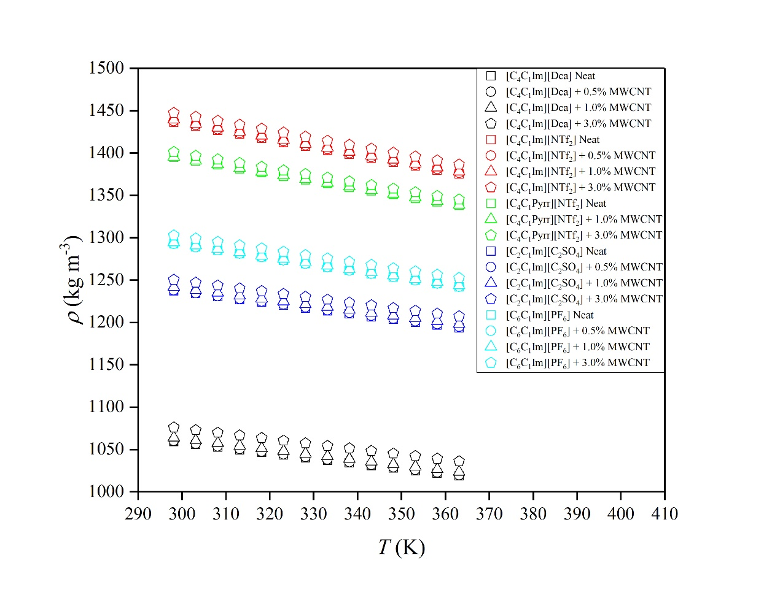
Figure 4 Temperature dependence of the density of investigated multiwalled carbon nanotubes-doped (MWCNT) ionanofluids.

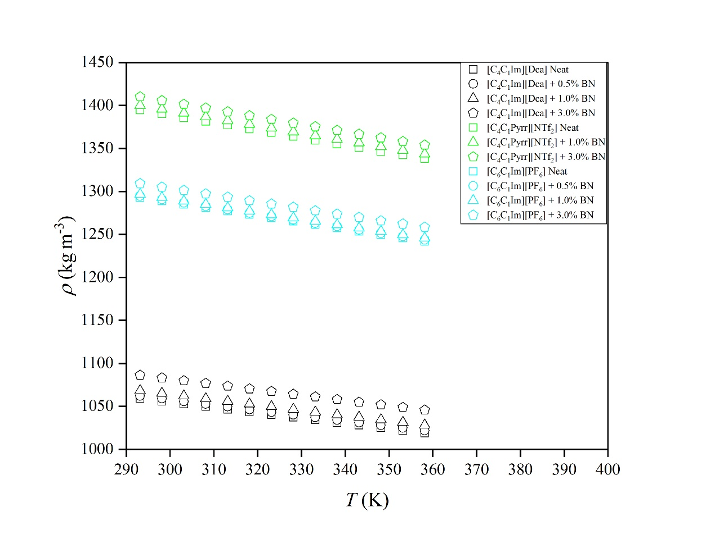
Figure 5 Temperature dependence on the density of investigated boron nitride-doped (BN) ionanofluids.

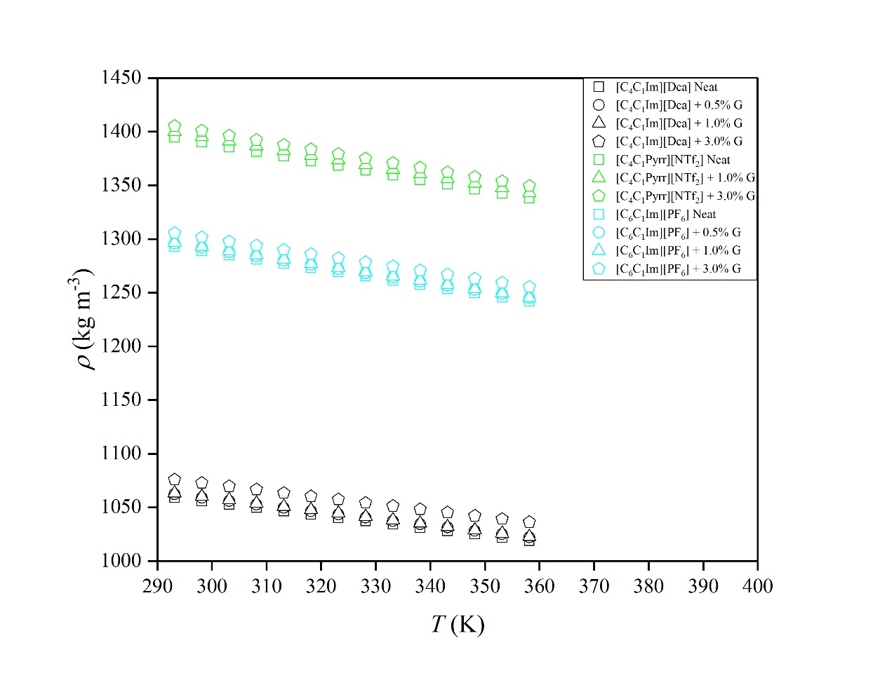
Figure 6 Temperature dependence on the density of investigated graphite-doped (G) ionanofluids.
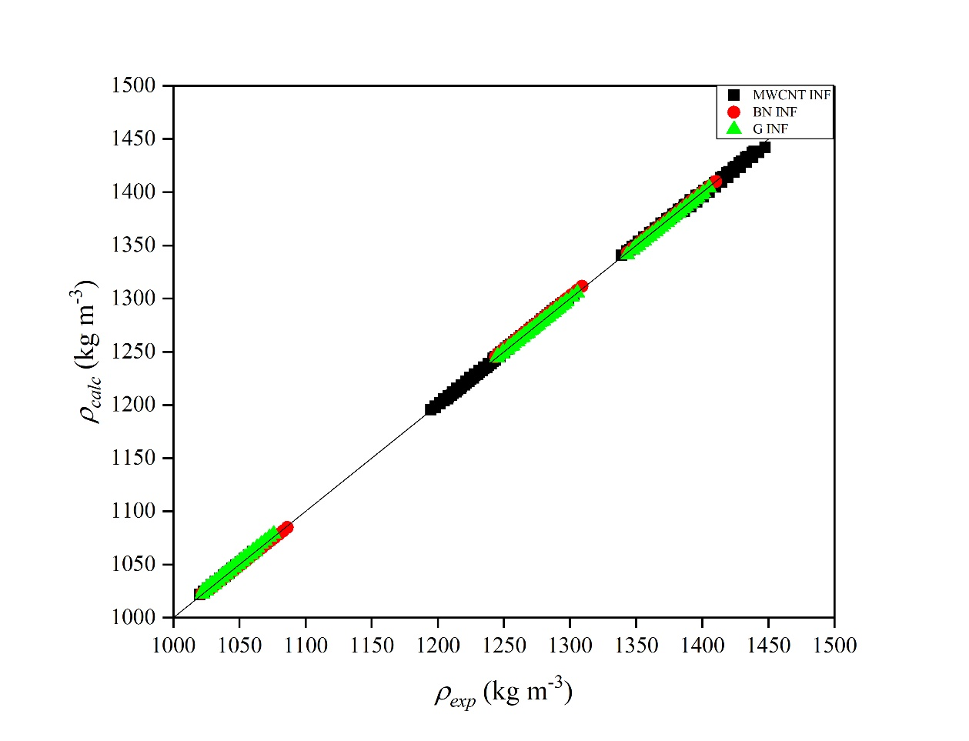
Figure 7 Calculated density over the experimental values (SI) for ionanofluids (INF) incorporating multi-walled carbon nanotubes (MWCNT), boron nitride (BN), and graphite (G), by empirical equation (2).

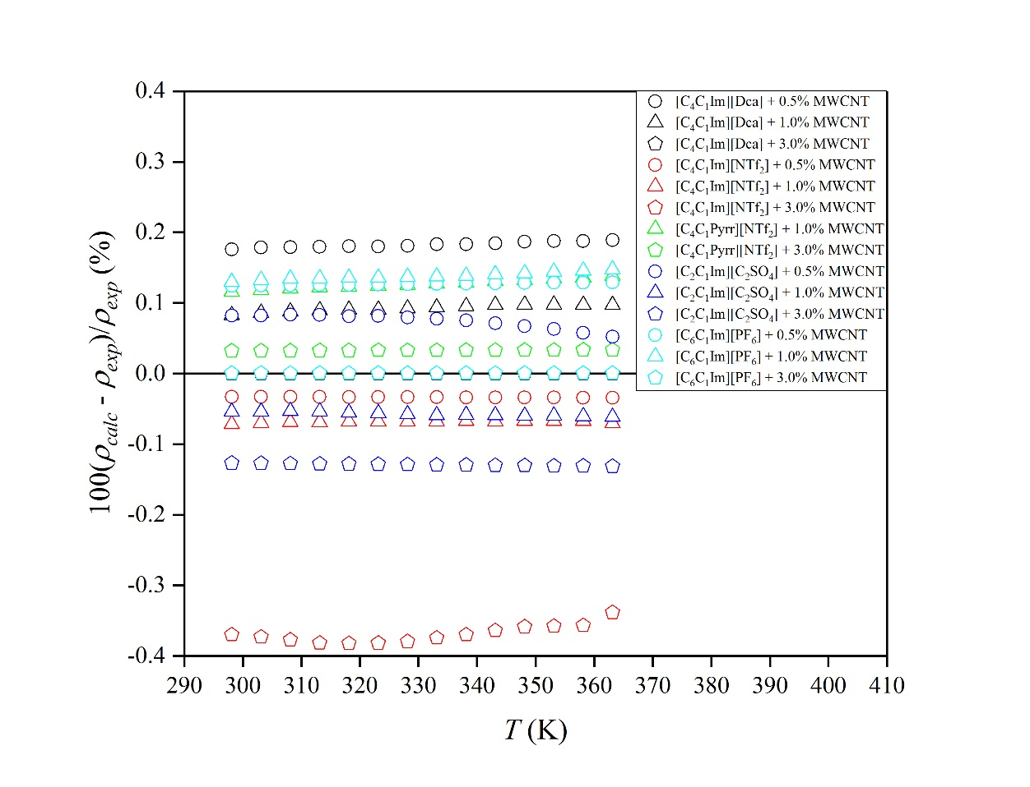
Figure 8 Deviations between calculated density and experimental values (SI) for ionanofluids with multiwalled carbon nanotubes (MWCNT), by empirical equation (2).

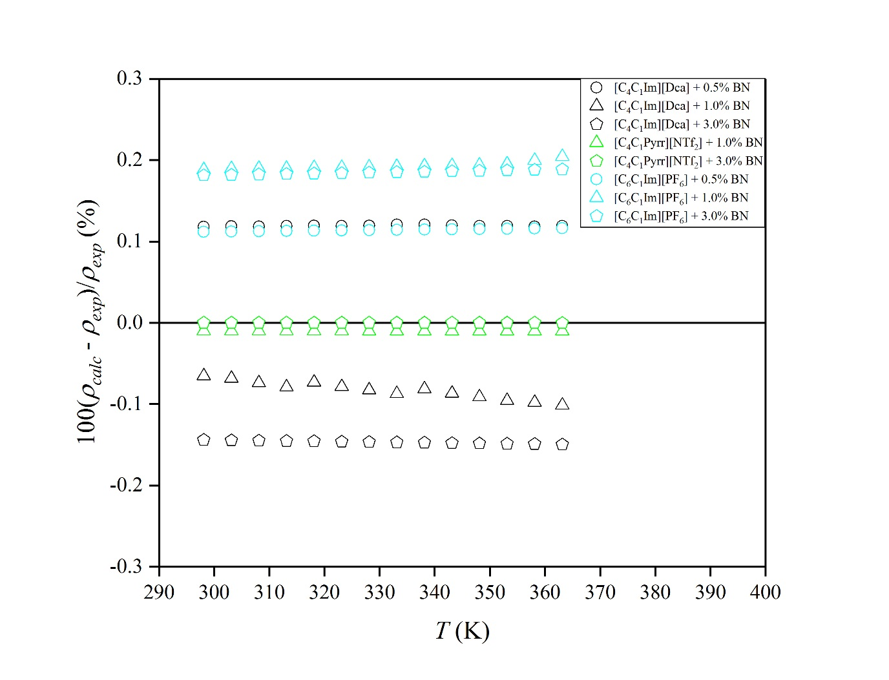
Figure 9 Deviations between calculated density and experimental values (SI) for ionanofluids with boron nitride (BN), by empirical equation (2).
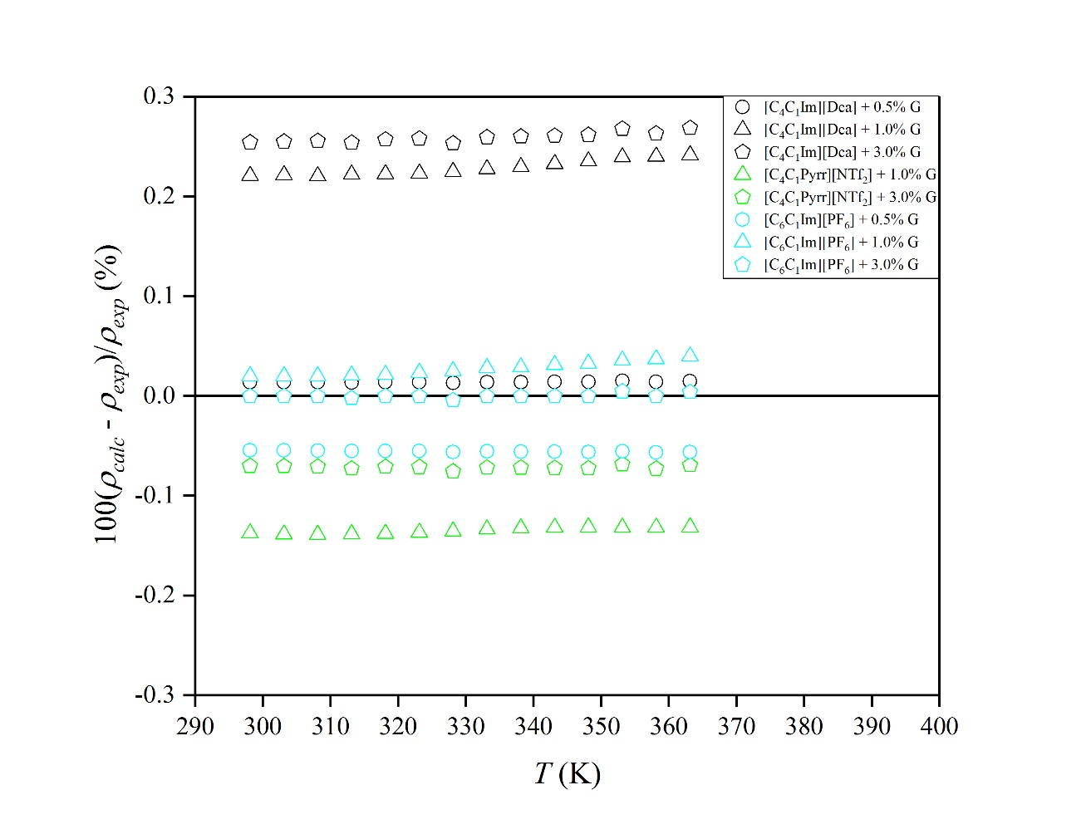
Figure 10 Deviations between calculated density and experimental values (SI) for ionanofluids with graphite (G), by empirical equation (2).

Table 3 The parameters, a₀ and a₁, with their standard uncertainties, δa₀ and δa₁, for ρ(T).
 | a₀ ± δa₀  kg m⁻³ | -(a₁ ± δa₁) ∙ 10⁻³  kg m⁻³ K⁻¹ | R²
[C₄C₁Im][Dca] neat | 1243.56 ± 0.39 | 619.1 ± 1.2 | 0.99995
[C₄C₁Im][Dca] + 0.5% MWCNT | 1244.54 ± 0.38 | 619.2 ± 1.2 | 0.99995
[C₄C₁Im][Dca] + 0.5% BN | 1243.39 ± 0.43 | 618.9 ± 1.3 | 0.99994
[C₄C₁Im][Dca] + 0.5% G | 1243.11 ± 0.40 | 617.5 ± 1.2 | 0.99995
[C₄C₁Im][Dca] + 1.0% MWCNT | 1248.39 ± 0.46 | 619.3 ± 1.4 | 0.99994
[C₄C₁Im][Dca] + 1.0% BN | 1248.54 ± 0.46 | 615.2 ± 1.4 | 0.99993
[C₄C₁Im][Dca] + 1.0% G | 1244.44 ± 0.35 | 618.1 ± 1.1 | 0.99996
[C₄C₁Im][Dca] + 3.0% MWCNT | 1259.22 ± 0.44 | 614.4 ± 1.3 | 0.99994
[C₄C₁Im][Dca] + 3.0% BN | 1268.34 ± 0.50 | 621.6 ± 1.5 | 0.99992
[C₄C₁Im][Dca] + 3.0% G | 1254.50 ± 0.48 | 609.7 ± 1.5 | 0.99992
[C₄C₁Im][NTf₂] neat | 1717.43 ± 0.38 | 943.1 ± 1.1 | 0.99998
[C₄C₁Im][NTf₂] + 0.5% MWCNT | 1718.14 ± 0.38 | 940.8 ± 1.2 | 0.99998
[C₄C₁Im][NTf₂] + 1.0% MWCNT | 1719.26 ± 0.45 | 939.5 ± 1.4 | 0.99997
[C₄C₁Im][NTf₂] + 3.0% MWCNT | 1727.40 ± 0.25 | 938.74 ± 0.77 | 0.99999
[C₄C₁Pyrr][NTf₂] neat | 1654.39 ± 0.34 | 871.6 ± 1.0 | 0.99998
[C₄C₁Pyrr][NTf₂] + 1.0% MWCNT | 1654.86 ± 0.34 | 870.8 ± 1.0 | 0.99998
[C₄C₁Pyrr][NTf₂] + 1.0% BN | 1654.85 ± 0.37 | 869.9 ± 1.1 | 0.99998
[C₄C₁Pyrr][NTf₂] + 1.0% G | 1654.32 ± 0.39 | 868.8 ± 1.2 | 0.99998
[C₄C₁Pyrr][NTf₂] + 3.0% MWCNT | 1657.27 ± 0.39 | 859.3 ± 1.2 | 0.99998
[C₄C₁Pyrr][NTf₂] + 3.0% BN | 1664.06 ± 0.45 | 866.5 ± 1.4 | 0.99997
[C₄C₁Pyrr][NTf₂] + 3.0% G | 1655.51 ± 0.44 | 854.6 ± 1.4 | 0.99997
[C₂C₁Im][C₂SO₄] neat | 1436.86 ± 0.31 | 670.27 ± 0.93 | 0.99998
[C₂C₁Im][C₂SO₄] + 0.5% MWCNT | 1435.65 ± 0.54 | 663.3 ± 1.6 | 0.99992
[C₂C₁Im][C₂SO₄] + 1.0% MWCNT | 1440.45 ± 0.31 | 667.02 ± 0.94 | 0.99997
[C₂C₁Im][C₂SO₄] + 3.0% MWCNT | 1448.31 ± 0.35 | 664.1 ± 1.1 | 0.99997
[C₆C₁Im][PF₆] neat | 1526.73 ± 0.27 | 784.48 ± 0.82 | 0.99999
[C₆C₁Im][PF₆] + 0.5% MWCNT | 1526.32 ± 0.28 | 782.88 ± 0.85 | 0.99998
[C₆C₁Im][PF₆] + 0.5% BN | 1524.34 ± 0.29 | 784.08 ± 0.88 | 0.99998
[C₆C₁Im][PF₆] + 0.5% G | 1524.90 ± 0.28 | 782.10 ± 0.85 | 0.99998
[C₆C₁Im][PF₆] + 1.0% MWCNT | 1528.01 ± 0.25 | 783.24 ± 0.76 | 0.99999
[C₆C₁Im][PF₆] + 1.0% BN | 1526.98 ± 0.16 | 785.80 ± 0.49 | 0.99999
[C₆C₁Im][PF₆] + 1.0% G | 1530.35 ± 0.25 | 783.40 ± 0.77 | 0.99999
[C₆C₁Im][PF₆] + 3.0% MWCNT | 1533.89 ± 0.35 | 774.9 ± 1.1 | 0.99998
[C₆C₁Im][PF₆] + 3.0% BN | 1538.28 ± 0.40 | 782.1 ± 1.2 | 0.99997
[C₆C₁Im][PF₆] + 3.0% G | 1531.11 ± 0.36 | 770.2 ± 1.1 | 0.99997

Heat capacity of ionanofluids
The results of the heat capacity measurements for pure ILs and systems with multi-walled carbon nanotubes, boron nitride and graphite are shown in Figure 11, Figure 12 and Figure 13 for carbon nanotubes-, boron nitride- and graphite-doped ionanofluids, respectively, while the parameters of second-order equation (4) are summarized in Table 4. The experimental data are shown in SI2. Unfortunately, very few datasets have been previously reported for similar systems, to date, which limits the comparison that can be made. As can be seen the heat capacity of all data increases with temperature, as expected.
The specific heat capacity was also found to increase with nanomaterials loading (with restriction up to 3% in nanoparticles mass fraction units, as investigated), as can be clearly seen in Figure 11, Figure 12 and Figure 13 for carbon nanotubes-, boron nitride- and graphite-doped ionanofluids, respectively. Figure 14, Figure 15 and Figure 16 shows the heat capacity enhancement (in comparison to pure ILs) as a function of nanoparticles loading (volume fraction) for carbon nanotubes-, boron nitride- and graphite-doped nanofluids, respectively. The enhancements observed were in the ranges of (5 – 13, 5 – 21 and 12 – 28) % for carbon nanotubes-, boron nitride- and graphite-based ionanofluids. As can be seen, the effect of the addition of carbon nanotubes was the smallest and compared with graphite which showed the largest changes. These dependencies were found to be linear functions:
The mechanism of the heat capacity enhancement has been widely discussed and is based on the mixing theory for ideal gas mixtures.[232] However, it has been shown that this approach is not relevant for nanofluids, where the specific heat capacity of carbon nanotubes is lower than liquids and the enhancement of heat capacity is observed.[20] Another theory proposed is based on the assumption of thermal equilibrium between the fluid and nanoparticles.[232] It was shown that it reproduces better values, however, is still not accurate enough, and the specific mechanism is not explained within this theory. The first attempt to explain the heat capacity increasing was proposed by Shin et al. (2011).[10] The authors discussed three different modes: (i) higher specific heat capacity of nanoparticles in comparison to their bulk equivalents (based on Al₂O₃, up to 25%)[233] which is related to the quantization of phonon spectrum with discrete values, which is not limited by the size of nanoparticles (due to resolved surface area); (ii) high solid-fluid interaction energy caused by the high surface area per unit mass of nanoparticles which increases the interfacial thermal resistance and acts as additional thermal storage; (iii) layering of liquid molecules at the surface of nanoparticles due to the liquid molecules adsorption as semi-solid layer with higher thermal properties than the bulk liquid (usually ~2-5 nm).
The most recent work of Hentschke (2016) discussed the possible mechanism of the heat capacity enhancement, including the mathematical foundation.[20] It was shown that the observed enhancement may be caused by one or both of the following factors: (i) nanolayering of nanoparticles with liquid molecules, with the layer of higher heat capacity in comparison to liquids and dependent on the nanoparticles type; (ii) the new phenomenological theory based on the attendant mesolayer interacting with other mesolayers with the assumption that the enhancement occurs until some specific loading of nanoparticles, and then becomes a decreasing function of nanoparticles concentration (a few parameters were introduced while the maximum mass fraction concentration was always below 3%). Nevertheless, all of these theories are based on molecular solvents-like nanofluids, and none of them considered ionic liquids as basefluids.
The observed enhancement clearly indicated the existence of interfacial nanolayers. Moreover, as can be seen in Figure 14, Figure 15 and Figure 16 for carbon nanotubes-, boron nitride- and graphite-doped ionanofluids, respectively, the value of the enhancements observed are different in the case of each type of nanoparticle. This shows that the mechanism is based on the type of nanoparticles instead of type of ionic liquid.
As shown by Hentschke (2016) a maximum enhancement is maintained by the existence of overlapping mesolayers. In this work, this was not recorded (as no significant maximum of the enhancement was observed below 3 wt%) which may indicate a smaller impact of this type of interactions caused by stronger interactions between ionic liquids and nanoparticles, and as a result more compact interfacial layer. The different types of ionic liquids used in this work provide the information about impact of the base fluid on the enhancement. However, due to the linear dependency, it can be assumed that the base fluid type and structure is not an influencing factor (based on the dependency upon the nanoparticles concentration). While different values of enhancements prove the fact that enhancement depends on the type of nanoparticles. Moreover, as pointed out by Hentschke (2016) the heat capacity enhancement depends on the particle size, and thus, the surface area, it can be observed that the enhancement intensity depends in the following sequence: graphite > boron nitride > carbon nanotubes, as well as the nanoparticle size (and reverse order for surface areas), which is in a good agreement with experimental data.
The most likely mechanism for the enhancement in case of ionic liquid-based nanofluids is based on the semi-solid-like liquid ordering on the nanoparticles surface which was described in the work of Shin and Banerjee (2011), with further extension by Hentschke (2016), excluding the interacting mesolayers as no experimental result indicates such a behavior in this work.
Similar work was carried out by França et al. (2017) with molecular dynamics simulations of surface nanolayering including the thermal conductivity modelling. The results presented in this work clearly indicate the existence of liquid nanolayers on the nanoparticles surface which is mainly responsible of the enhancement of the thermal properties when a nanofluid is dispersed in a fluid base. As well, no mesolayer interaction was observed. The results presented herein are in a good agreement with those published by França et al. (2017).
From an industrial perspective, the prior knowledge of the specific heat capacity as a function of temperature is crucial. More specifically, the enhancement in the heat capacity caused by the presence of nanoparticles in base fluids as the function of composition and temperature is of high interest. Figure S12-S14 show that the enhancements obtained for carbon nanotubes-, boron nitride- and graphite-doped ionanofluids (SI3) are ranged from (3.1 to 13.2, 5.3 to 22.0, 10.9 to 34.2) %, respectively. The maximum of enhancement observed were (13.2, 22.0 and 34.2) % for [C₄C₁Im][Dca] + 3% MWCNT at 293.15 K, [C₄C₁Im][Dca] + 3% BN at 343.15 K and [C₄C₁Im][Dca] + 3% G at 363.15 K, respectively. Moreover, the enhancement for carbon nanotubes-doped ionanofluids decreased with temperature whereas is was approximately constant in the case of boron nitride-doped ionanofluids, and increased for the graphite-doped ionanofluids. This also reflects in different type of prospective industrial applications in case of desired temperature profile of heat transfer fluids.

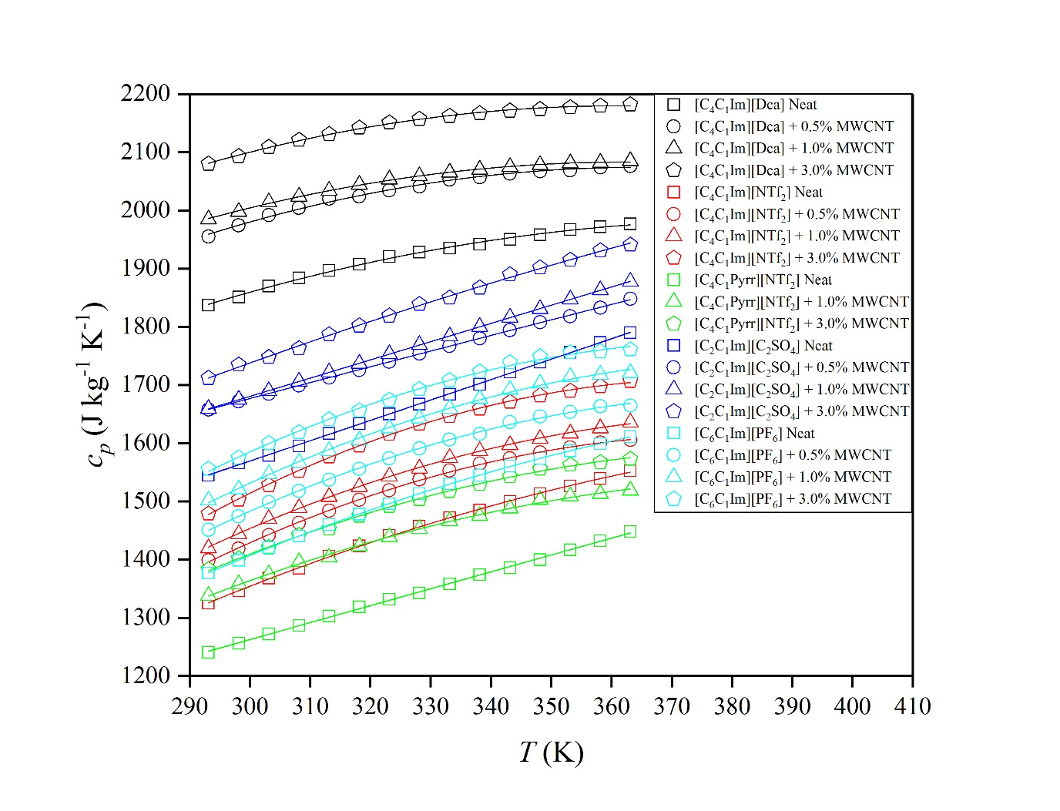
Figure 11 Temperature dependence on the specific heat capacity of investigated multiwalled carbon nanotubes-doped (MWCNT) ionanofluids.
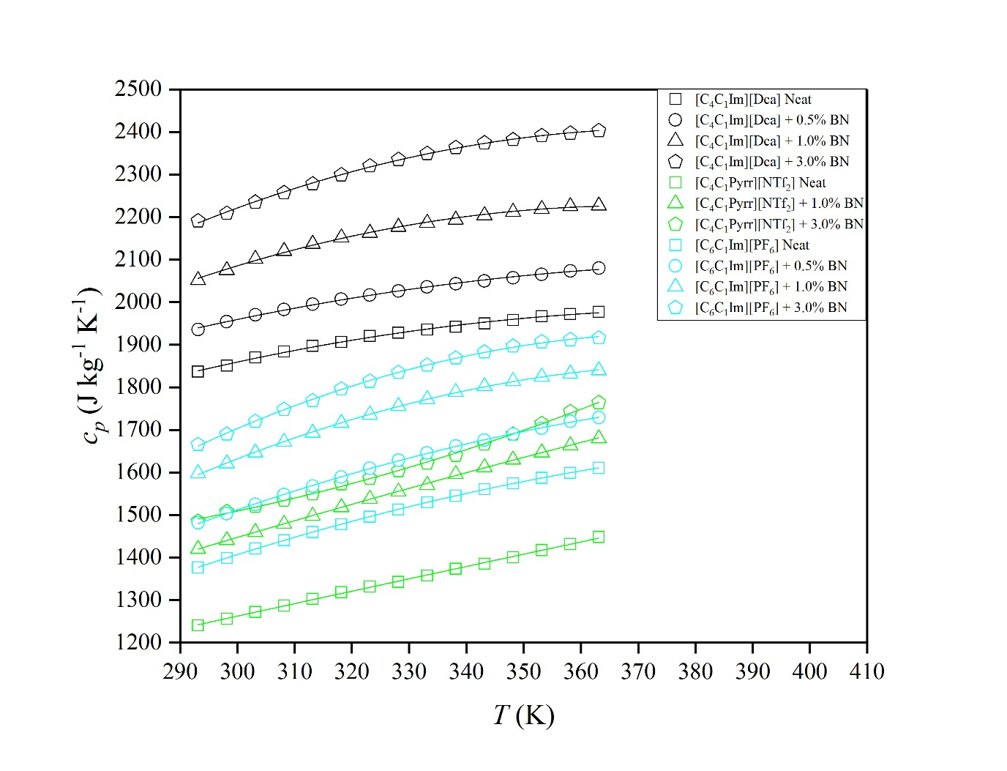
Figure 12 Temperature dependence on the specific heat capacity of investigated boron nitride-doped (BN) ionanofluids.
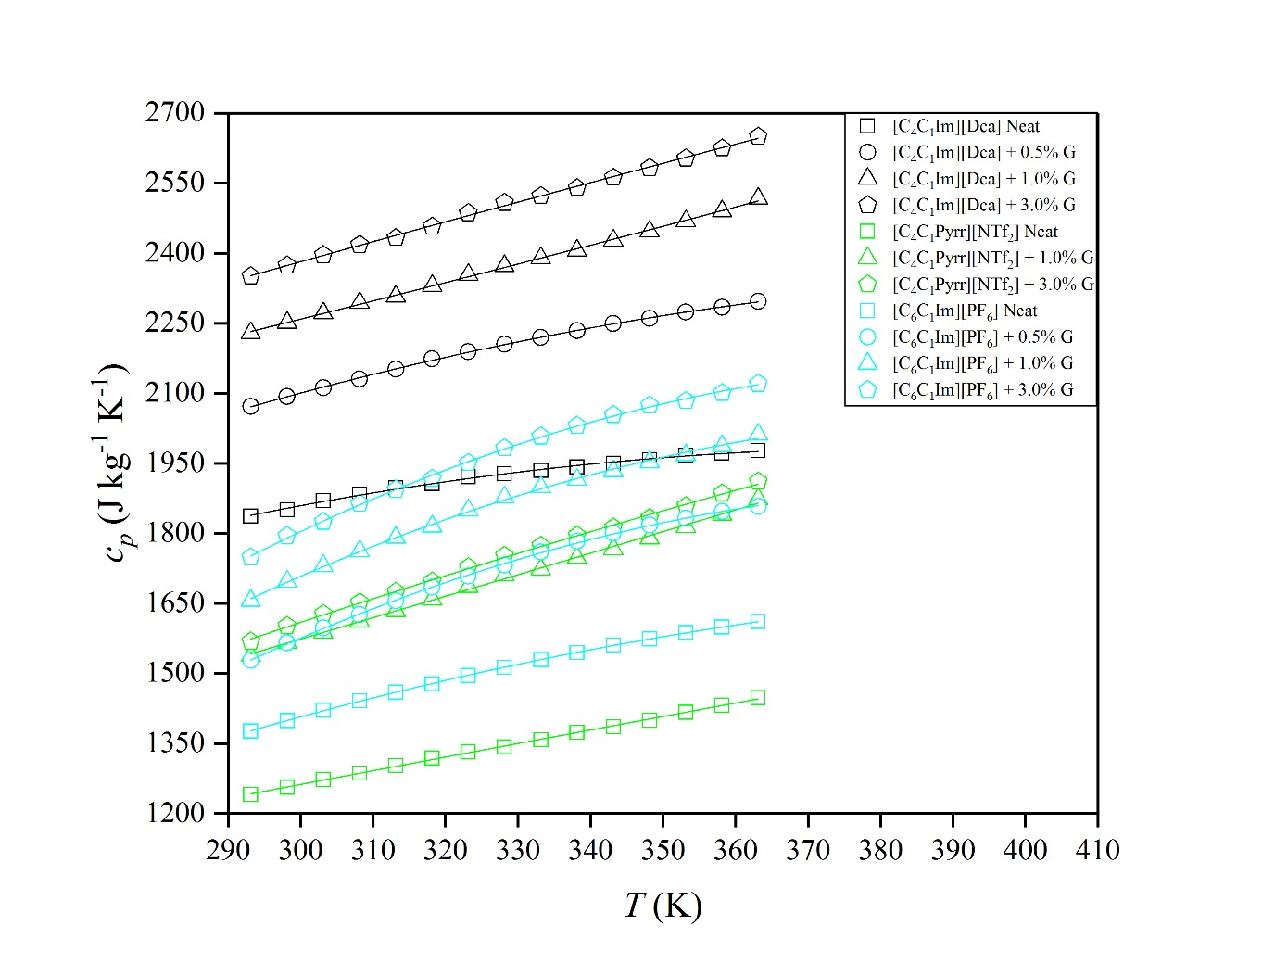
Figure 13 Temperature dependence on the specific heat capacity of investigated graphite-doped (G) ionanofluids.

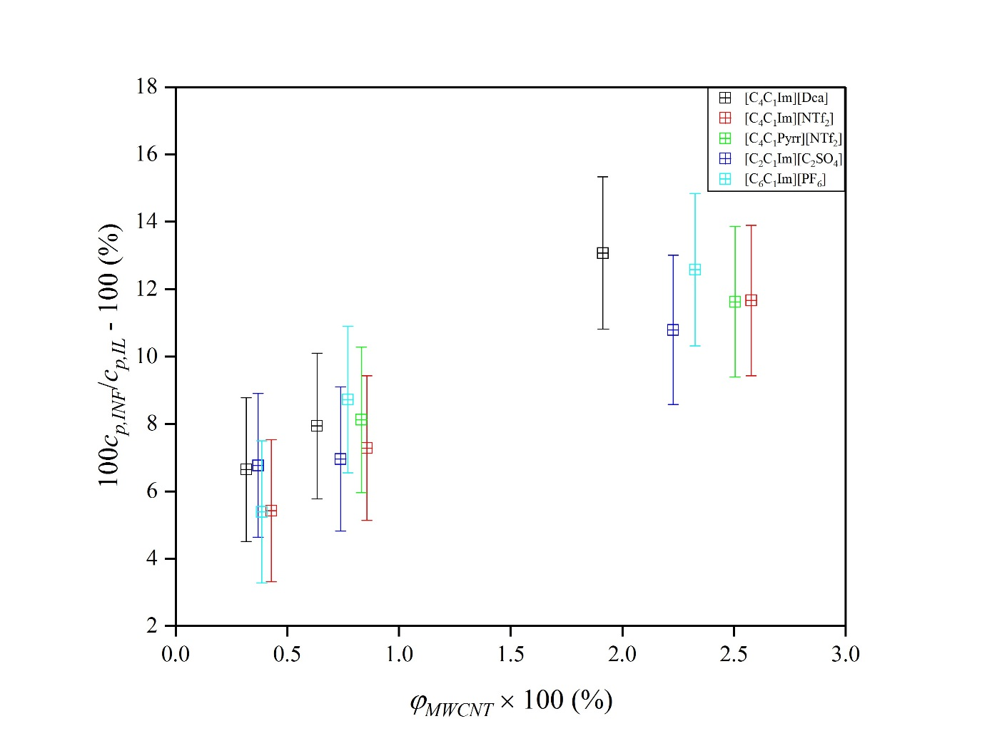
Figure 14 Heat capacity enhancement as a function of the multiwalled carbon nanotubes loading (MWCNT) at 298.15 K.

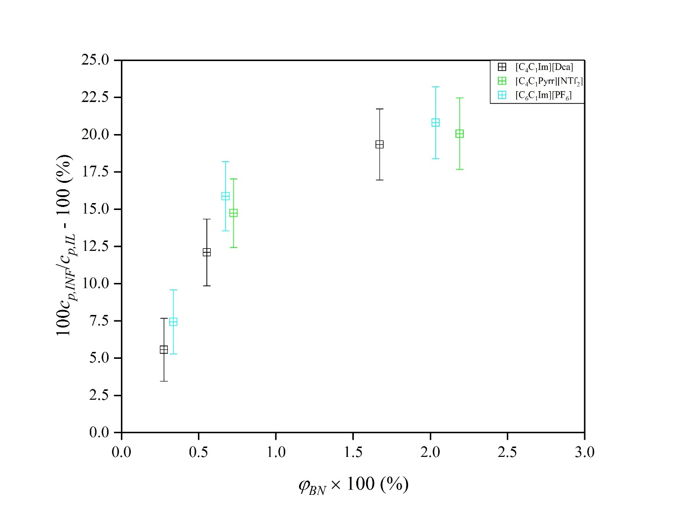
Figure 15 Heat capacity enhancement as a function of the boron nitride loading (BN) at 298.15 K.

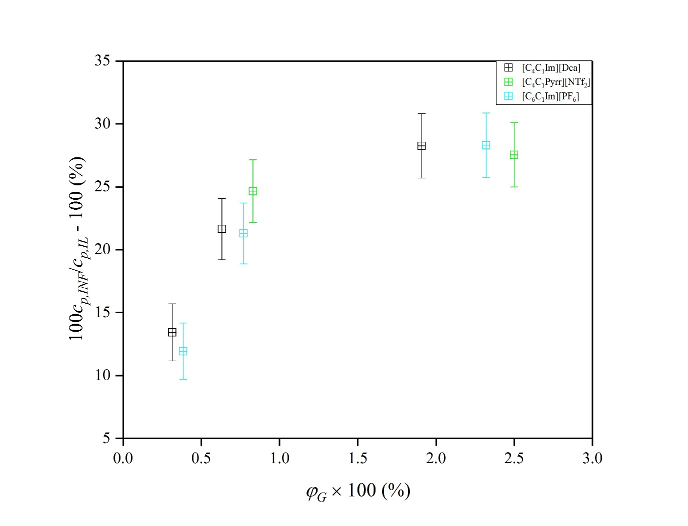
Figure 16 Heat capacity enhancement as a function of the graphite loading (G) at 298.15 K.

Table 4 The parameters, a₀, a₁ and a₂, with their standard uncertainties, δa₀, δa₁ and δa₂, for c_{p}(T).
 | -(a₀ ± δa₀)  J kg⁻¹ K⁻¹ | a₁ ± δa₁  J kg⁻¹ K⁻² | -(a₂ ± δa₂) ∙ 10⁻³  J kg⁻¹ K⁻³ | R²
[C₄C₁Im][Dca] neat | 530 ± 160 | 13.0 ± 1.0 | 16.9 ± 1.5 | 0.99693
[C₄C₁Im][Dca] + 0.5% MWCNT | 920 ± 180 | 16.4 ± 1.1 | 22.5 ± 1.7 | 0.99497
[C₄C₁Im][Dca] + 0.5% BN | 530 ± 160 | 13.0 ± 1.0 | 16.9 ± 1.5 | 0.99693
[C₄C₁Im][Dca] + 0.5% G | 690 ± 110 | 14.44 ± 0.65 | 17.12 ± 0.99 | 0.99951
[C₄C₁Im][Dca] + 1.0% MWCNT | 560 ± 78 | 14.57 ± 0.48 | 20.09 ± 0.73 | 0.99867
[C₄C₁Im][Dca] + 1.0% BN | 210 ± 140 | 11.65 ± 0.86 | 14.8 ± 1.3 | 0.99775
[C₄C₁Im][Dca] + 1.0% G | -1060 ± 12 | 3.992 ± 0.038 | - | 0.99874
[C₄C₁Im][Dca] + 3.0% MWCNT | 610 ± 110 | 15.46 ± 0.69 | 21.4 ± 1.0 | 0.99737
[C₄C₁Im][Dca] + 3.0% BN | 1800 ± 200 | 21.7 ± 1.2 | 29.4 ± 1.8 | 0.99719
[C₄C₁Im][Dca] + 3.0% G | -1121 ± 14 | 4.203 ± 0.042 | - | 0.99863
[C₄C₁Im][NTf₂] neat | 1190 ± 100 | 12.93 ± 0.62 | 14.82 ± 0.94 | 0.99956
[C₄C₁Im][NTf₂] + 0.5% MWCNT | 2520 ± 110 | 21.74 ± 0.66 | 28.6 ± 1.0 | 0.99944
[C₄C₁Im][NTf₂] + 1.0% MWCNT | 2150 ± 110 | 19.58 ± 0.67 | 25.2 ± 1.0 | 0.99943
[C₄C₁Im][NTf₂] + 3.0% MWCNT | 2980 ± 120 | 24.89 ± 0.73 | 33.0 ± 1.1 | 0.99942
[C₄C₁Pyrr][NTf₂] neat | -391.2 ± 7.3 | 2.905 ± 0.022 | - | 0.99919
[C₄C₁Pyrr][NTf₂] + 1.0% MWCNT | 1460 ± 180 | 15.1 ± 1.1 | 19.0 ±1.7 | 0.99786
[C₄C₁Pyrr][NTf₂] + 1.0% BN | 328.7 ± 9.9 | 3.734 ± 0.030 | - | 0.99909
[C₄C₁Pyrr][NTf₂] + 1.0% G | -191 ± 18 | 4.608 ± 0.056 | - | 0.99791
[C₄C₁Pyrr][NTf₂] + 3.0% MWCNT | 1760 ± 160 | 17.1 ± 1.0 | 21.9 ± 1.5 | 0.99848
[C₄C₁Pyrr][NTf₂] + 3.0% BN | 2360 ± 230 | -8.5 ± 1.4 | -19.0 ± 2.1 | 0.99850
[C₄C₁Pyrr][NTf₂] + 3.0% G | 570 ± 280 | 9.4 ± 1.7 | 7.1 ± 2.6 | 0.99868
[C₂C₁Im][C₂SO₄] neat | -519.1 ± 6.4 | 3.501 ± 0.020 | - | 0.99956
[C₂C₁Im][C₂SO₄] + 0.5% MWCNT | 780 ± 58 | 3.24 ± 0.36 | 0.82 ± 0.54 | 0.99979
[C₂C₁Im][C₂SO₄] + 1.0% MWCNT | - 740.8 ± 1.1 | 3.1321 ± 0.0035 | - | 0.99998
[C₂C₁Im][C₂SO₄] + 3.0% MWCNT | -746 ± 17 | 3.314 ± 0.050 | - | 0.99676
[C₆C₁Im][PF₆] neat | 1284 ± 34 | 13.71 ± 0.21 | 15.81 ± 0.32 | 0.99995
[C₆C₁Im][PF₆] + 0.5% MWCNT | 2210 ± 160 | 20.04 ± 0.99 | 25.8 ± 1.5 | 0.99883
[C₆C₁Im][PF₆] + 0.5% BN | 1517 ± 98 | 15.59 ± 0.60 | 18.32 ± 0.92 | 0.99966
[C₆C₁Im][PF₆] + 0.5% G | 3450 ± 150 | 26.88 ± 0.90 | 33.7 ± 1.4 | 0.99957
[C₆C₁Im][PF₆] + 1.0% MWCNT | 2250 ± 220 | 20.4 ± 1.4 | 26.2 ± 2.1 | 0.99793
[C₆C₁Im][PF₆] + 1.0% BN | 2650 ± 110 | 23.35 ± 0.67 | 30.2 ± 1.0 | 0.99958
[C₆C₁Im][PF₆] + 1.0% G | 3250 ± 310 | 26.3 ± 1.9 | 32.7 ± 2.9 | 0.99820
[C₆C₁Im][PF₆] + 3.0% MWCNT | 2360 ± 250 | 21.7 ± 1.5 | 28.3 ± 2.3 | 0.99720
[C₆C₁Im][PF₆] + 3.0% BN | 3270 ± 150 | 27.44 ± 0.94 | 36.2 ± 1.4 | 0.99925
[C₆C₁Im][PF₆] + 3.0% G | 3760 ± 260 | 29.7 ± 1.6 | 37.3 ± 2.4 | 0.99894
- Conclusions
During this work, an extensive study on density and heat capacity of ionic liquids-based nanofluids was carried out. Ionic liquids with different cations and anions combinations were chosen for investigations, moreover, as well as using multiwalled carbon nanotubes, which have been studied previously, other nanoparticles types were selected, namely boron nitride and graphite that have not been investigated in such manners, resulting in the deeper insight into the physical properties, in particular the heat capacity enhancement. The density of nanoparticles was determined based on the density measurements with the original empirical model proposed by Pak and Cho. Further mechanism of the heat capacity enhancement was also studied. Based on the previous reports on the simple molecular solvents-based nanofluids, the mechanism of the heat capacity enhancement of ionanofluids is probably driven by the existing interfacial nanolayering occurring on the surface of nanoparticles. The possibility of mesolayers overlapping, which was also proposed previously, was not found to be present in the present study. Moreover, the heat capacity enhancement is determined by the type of nanoparticles, instead of type of ionic liquid. As a bridge to the industrial application of such results, the heat capacity enhancement as a function of temperature showed a high improvement, even up to about 34% in case of graphite-doped ionanofluids, whereas different type of temperature profile of enhancements were presented.

Abbreviations and symbols
IL(s) | Ionic Liquid(s)
NP(s) | Nanoparticle(s)
[C₄C₁Im][Dca] | 1-Butyl-3-methylimidazolium dicyanamide
[C₄C₁Im][NTf₂] | 1-butyl-3-methylimidazolium bis(trifluoromethylsulfonyl)imide
[C₄C₁Pyrr][NTf₂] | 1-Butyl-1-methylpyrrolidinium bis(trifluoromethylsulfonyl)imide
[C₆C₁Im][PF₆] | 1-hexyl-3-methylimidazolium hexafluorophosphate (CAS: 304680-35-1)
[C₂C₁Im][C₂SO₄] | 1-ethyl-3-methylimidazolium ethylsulfate
MWCNT | Multiwalled carbon nanotubes
BN | Boron nitride
G | Graphite
w_{m} | mass fraction
ρ | Density (kg m⁻³)
T | Temperature (K)
a_{i} | i-regression parameter
δa_{i} | i-regression parameter error
R² | Coefficient of determination
VE | Excess molar volume (m³ mol⁻¹)
M | Molar mass (kg mol⁻¹)
x | Mole fraction
c_{p} | Specific isobaric heat capacity (J kg⁻¹ mol⁻¹)
ϕ_{NP} | Volume fraction
m | mass (kg)
V | Volume (m³)
AARD | Average absolute relative deviation (%)
RAD | Relative absolute deviation (%)

Acknowledgments
The project was supported by King Faisal University (Saudi Arabia) through a research fund from the International Cooperation and Knowledge Exchange Administration department at KFU.

References
[1] Y. Xuan, Q. Li, Heat transfer enhancement of nanofluids, Int. J. Heat Fluid Flow. 21 (2000) 58–64.
[2] J.A. Eastman, S.U.S. Choi, S. Li, W. Yu, L.J. Thompson, Anomalously increased effective thermal conductivities of ethylene glycol-based nanofluids containing copper nanoparticles, Appl. Phys. Lett. 78 (2001) 718–720.
[3] K. Kwak, C. Kim, Viscosity and thermal conductivity of copper oxide nanofluid dispersed in ethylene glycol, Korea-Australia Rheol. J. 17 (2005) 35–40.
[4] P.K. Namburu, D.P. Kulkarni, D. Misra, D.K. Das, Viscosity of copper oxide nanoparticles dispersed in ethylene glycol and water mixture, Exp. Therm. Fluid Sci. 32 (2007) 397–402.
[5] Y. Ding, H. Alias, D. Wen, R.A. Williams, Heat transfer of aqueous suspensions of carbon nanotubes (CNT nanofluids), Int. J. Heat Mass Transf. 49 (2006) 240–250.
[6] L. Fedele, L. Colla, S. Bobbo, Viscosity and thermal conductivity measurements of water-based nanofluids containing titanium oxide nanoparticles, Int. J. Refrig. 35 (2012) 1359–1366.
[7] D.P. Kulkarni, R.S. Vajjha, D.K. Das, D. Oliva, Application of aluminum oxide nanofluids in diesel electric generator as jacket water coolant, Appl. Therm. Eng. 28 (2008) 1774–1781.
[8] B. Wang, X. Wang, W. Lou, J. Hao, Ionic liquid-based stable nanofluids containing gold nanoparticles, J. Colloid Interface Sci. 362 (2011) 5–14.
[9] D. Shin, D. Banerjee, Effects of silica nanoparticles on enhancing the specific heat capacity of carbonate salt eutectic (work in progress), Int. J. Struct. Chang. Solids. 2 (2010) 25–31.
[10] D. Shin, D. Banerjee, Enhancement of specific heat capacity of high-temperature silica-nanofluids synthesized in alkali chloride salt eutectics for solar thermal-energy storage applications, Int. J. Heat Mass Transf. 54 (2011) 1064–1070.
[11] D. Shin, D. Banerjee, Specific heat of nanofluids synthesized by dispersing alumina nanoparticles in alkali salt eutectic, Int. J. Heat Mass Transf. 74 (2014) 210–214.
[12] S.P. Jang, S.U.S. Choi, Role of Brownian motion in the enhanced thermal conductivity of nanofluids, Appl. Phys. Lett. 84 (2004) 4316–4318.
[13] P. Keblinski, S.R. Phillpot, S.U.S. Choi, J.A. Eastman, Mechanisms of heat flow in suspensions of nano-sized particles (nanofluids), Int. J. Heat Mass Transf. 45 (2002) 855–863.
[14] S.M.S. Murshed, K.C. Leong, C. Yang, Investigations of thermal conductivity and viscosity of nanofluids, Int. J. Therm. Sci. 47 (2008) 560–568.
[15] R. Prasher, P. Bhattacharya, P.E. Phelan, Thermal conductivity of nanoscale colloidal solutions (nanofluids), Phys. Rev. Lett. 94 (2005) 25901.
[16] N. Putra, P. Thiesen, W. Roetzel, Temperature dependence of thermal conductivity enhancement for nanofluids, J. Heat Transfer. 125 (2003) 567–574.
[17] W. Yu, S.U.S. Choi, The role of interfacial layers in the enhanced thermal conductivity of nanofluids: a renovated Maxwell model, J. Nanoparticle Res. 5 (2003) 167–171.
[18] M.P. Shevelyova, Y.U. Paulechka, G.J. Kabo, A. V Blokhin, A.G. Kabo, T.M. Gubarevich, Physicochemical properties of imidazolium-based ionic nanofluids: density, heat capacity, and enthalpy of formation, J. Phys. Chem. C. 117 (2013) 4782–4790.
[19] H. O’Hanley, J. Buongiorno, T. McKrell, L. Hu, Measurement and model correlation of specific heat capacity of water-based nanofluids with silica, alumina and copper oxide nanoparticles, in: ASME 2011 Int. Mech. Eng. Congr. Expo., American Society of Mechanical Engineers, 2011: pp. 1209–1214.
[20] R. Hentschke, On the specific heat capacity enhancement in nanofluids, Nanoscale Res. Lett. 11 (2016) 88.
[21] T. Welton, Room-temperature ionic liquids. Solvents for synthesis and catalysis, Chem. Rev. 99 (1999) 2071–2084.
[22] P.A. Hunt, C.R. Ashworth, R.P. Matthews, Hydrogen bonding in ionic liquids, Chem. Soc. Rev. 44 (2015) 1257–1288.
[23] C. Chiappe, D. Pieraccini, Ionic liquids: solvent properties and organic reactivity, J. Phys. Org. Chem. 18 (2005) 275–297.
[24] N. V Plechkova, K.R. Seddon, Applications of ionic liquids in the chemical industry, Chem. Soc. Rev. 37 (2008) 123–150.
[25] R.D. Rogers, K.R. Seddon, Ionic liquids--solvents of the future?, Science (80-. ). 302 (2003) 792–793.
[26] P. Wasserscheid, W. Keim, Ionic liquids—new “solutions” for transition metal catalysis, Angew. Chemie Int. Ed. 39 (2000) 3772–3789.
[27] S. Zhu, Y. Wu, Q. Chen, Z. Yu, C. Wang, S. Jin, Y. Ding, G. Wu, Dissolution of cellulose with ionic liquids and its application: a mini-review, Green Chem. 8 (2006) 325–327.
[28] C.A.N. De Castro, S.M.S. Murshed, M.J. V Lourenço, F.J. V Santos, M.L.M. Lopes, J.M.P. França, Enhanced thermal conductivity and specific heat capacity of carbon nanotubes ionanofluids, Int. J. Therm. Sci. 62 (2012) 34–39.
[29] A.P.C. Ribeiro, S.I.C. Vieira, P. Goodrich, C. Hardacre, M.J. V Lourenço, C.A. de Castro, Thermal Conductivity of [C n mim][(CF3SO2) 2N] and [C4mim][BF4] IoNanofluids with Carbon Nanotubes—Measurement, Theory and Structural Characterization, J. Nanofluids. 2 (2013) 55–62.
[30] C.A. Nieto de Castro, M.J. V Lourenço, A.P.C. Ribeiro, E. Langa, S.I.C. Vieira, P. Goodrich, C. Hardacre, Thermal properties of ionic liquids and ionanofluids of imidazolium and pyrrolidinium liquids, J. Chem. Eng. Data. 55 (2009) 653–661.
[31] A.K. Burrell, R.E. Del Sesto, S.N. Baker, T.M. McCleskey, G.A. Baker, The large scale synthesis of pure imidazolium and pyrrolidinium ionic liquids, Green Chem. 9 (2007) 449–454.
[32] M.J. Earle, C.M. Gordon, N. V Plechkova, K.R. Seddon, T. Welton, Decolorization of ionic liquids for spectroscopy, Anal. Chem. 79 (2007) 758–764.
[33] J.D. Holbrey, W.M. Reichert, R.P. Swatloski, G.A. Broker, W.R. Pitner, K.R. Seddon, R.D. Rogers, Efficient, halide free synthesis of new, low cost ionic liquids: 1, 3-dialkylimidazolium salts containing methyl-and ethyl-sulfate anions, Green Chem. 4 (2002) 407–413.
[34] J.M.P. França, F. Reis, S.I.C. Vieira, M.J. V Lourenço, F.J. V Santos, C.A.N. De Castro, A.A.H. Padua, Thermophysical properties of ionic liquid dicyanamide (DCA) nanosystems, J. Chem. Thermodyn. 79 (2014) 248–257.
[35] J.M.P. França, S.I.C. Vieira, M.J. V Lourenço, S.M.S. Murshed, C.A. Nieto de Castro, Thermal Conductivity of [C4mim][(CF3SO2) 2N] and [C2mim][EtSO4] and Their IoNanofluids with Carbon Nanotubes: Experiment and Theory, J. Chem. Eng. Data. 58 (2013) 467–476.
[36] R.S. Vajjha, D.K. Das, B.M. Mahagaonkar, Density measurement of different nanofluids and their comparison with theory, Pet. Sci. Technol. 27 (2009) 612–624.
[37] N.G. Polikhronidi, R.G. Batyrova, I.M. Abdulagatov, J.W. Magee, J.T. Wu, Saturated and compressed liquid heat capacity at constant volume for 1-hexyl-3-methylimidazolium bis [(trifluoromethyl) sulfonyl] imide, Phys. Chem. Liq. 52 (2014) 657–679.
[38] K.R. Seddon, A. Stark, M.-J. Torres, Influence of chloride, water, and organic solvents on the physical properties of ionic liquids, Pure Appl. Chem. 72 (2000) 2275–2287.
[39] Y.U. Paulechka, A.G. Kabo, A. V Blokhin, G.J. Kabo, M.P. Shevelyova, Heat capacity of ionic liquids: experimental determination and correlations with molar volume, J. Chem. Eng. Data. 55 (2010) 2719–2724.
[40] J. Jacquemin, P. Husson, A.A.H. Padua, V. Majer, Density and viscosity of several pure and water-saturated ionic liquids, Green Chem. 8 (2006) 172–180.
[41] T.M. Letcher, P. Reddy, Ternary (liquid+ liquid) equilibria for mixtures of 1-hexyl-3-methylimidazolium (tetrafluoroborate or hexafluorophosphate)+ benzene+ an alkane at T= 298.2 K and p= 0.1 MPa, J. Chem. Thermodyn. 37 (2005) 415–421.
[42] R. Ge, C. Hardacre, J. Jacquemin, P. Nancarrow, D.W. Rooney, Heat capacities of ionic liquids as a function of temperature at 0.1 MPa. Measurement and prediction, J. Chem. Eng. Data. 53 (2008) 2148–2153.
[43] M. Tariq, P.A.S. Forte, M.F.C. Gomes, J.N.C. Lopes, L.P.N. Rebelo, Densities and refractive indices of imidazolium-and phosphonium-based ionic liquids: Effect of temperature, alkyl chain length, and anion, J. Chem. Thermodyn. 41 (2009) 790–798.
[44] A. Diedrichs, J. Gmehling, Measurement of heat capacities of ionic liquids by differential scanning calorimetry, Fluid Phase Equilib. 244 (2006) 68–77.
[45] G. Höhne, W. Hemminger, H.J. Flammersheim, Differential Scanning Calorimetry: An Introduction for Practitioners, Springer-Verlag, 1996. https://books.google.co.uk/books?id=erjvAAAAMAAJ.
[46] C.M.S.S. Neves, P.J. Carvalho, M.G. Freire, J.A.P. Coutinho, Thermophysical properties of pure and water-saturated tetradecyltrihexylphosphonium-based ionic liquids, J. Chem. Thermodyn. 43 (2011) 948–957.
[47] C.N. de Castro, A.P.C. Ribeiro, S.I.C. Vieira, J.M.P. França, M.J. V Lourenço, F. V Santos, S.M.S. Murshed, P. Goodrich, C. Hardacre, Synthesis, Properties and Physical Applications of IoNanofluids, in: Ion. Liq. Asp. Futur., InTech, 2013.
[48] S.F.R. Taylor, C. McCrellis, C. McStay, J. Jacquemin, C. Hardacre, M. Mercy, R.G. Bell, N.H. de Leeuw, CO2 Capture in Wet and Dry Superbase Ionic Liquids, J. Solution Chem. 44 (2015) 511–527.
[49] M.S. Calado, A.S.H. Branco, J.C.F. Diogo, J.M.N.A. Fareleira, Z.P. Visak, Solubility, volumetric properties and viscosity of the sustainable systems of liquid poly (ethylene glycol) 200 with imidazolium-and phosphonium-based ionic liquids: Cation and anion effects, J. Chem. Thermodyn. 80 (2015) 79–91.
[50] N. Calvar, E.J. González, Á. Domínguez, E.A. Macedo, Acoustic, volumetric and osmotic properties of binary mixtures containing the ionic liquid 1-butyl-3-methylimidazolium dicyanamide mixed with primary and secondary alcohols, J. Chem. Thermodyn. 50 (2012) 19–29.
[51] P.J. Carvalho, T. Regueira, L.M. Santos, J. Fernandez, J.A.P. Coutinho, Effect of water on the viscosities and densities of 1-butyl-3-methylimidazolium dicyanamide and 1-butyl-3-methylimidazolium tricyanomethane at atmospheric pressure, J. Chem. Eng. Data. 55 (2009) 645–652.
[52] C.A.N. de Castro, E. Langa, A.L. Morais, M.L.M. Lopes, M.J. V Lourenço, F.J. V Santos, M.S.C.S. Santos, J.N.C. Lopes, H.I.M. Veiga, M. Macatrão, Studies on the density, heat capacity, surface tension and infinite dilution diffusion with the ionic liquids [C 4 mim][NTf 2],[C 4 mim][dca],[C 2 mim][EtOSO 3] and [Aliquat][dca], Fluid Phase Equilib. 294 (2010) 157–179.
[53] M. Engelmann, H. Schmidt, J. Safarov, J. Nocke, E. Hassel, Thermal properties of 1-butyl-3-methylimidazolium dicyanamide at high pressures and temperatures, Acta Chim. Slovaca. 5 (2012) 86–94.
[54] C.K. Foo, C.Y. Leo, R. Aramesh, M.K. Aroua, N. Aghamohammadi, M.S. Shafeeyan, A. Shamiri, Density and viscosity of aqueous mixtures of N-methyldiethanolamines (MDEA), piperazine (PZ) and ionic liquids, J. Mol. Liq. 209 (2015) 596–602.
[55] C.P. Fredlake, J.M. Crosthwaite, D.G. Hert, S.N.V.K. Aki, J.F. Brennecke, Thermophysical properties of imidazolium-based ionic liquids, J. Chem. Eng. Data. 49 (2004) 954–964.
[56] E.J. González, Á. Domínguez, E.A. Macedo, Physical and excess properties of eight binary mixtures containing water and ionic liquids, J. Chem. Eng. Data. 57 (2012) 2165–2176.
[57] M. Larriba, P. Navarro, J. García, F. Rodríguez, Liquid–liquid extraction of toluene from heptane using [emim][DCA],[bmim][DCA], and [emim][TCM] ionic liquids, Ind. Eng. Chem. Res. 52 (2013) 2714–2720.
[58] G. McHale, C. Hardacre, R. Ge, N. Doy, R.W.K. Allen, J.M. MacInnes, M.R. Bown, M.I. Newton, Density− viscosity product of small-volume ionic liquid samples using quartz crystal impedance analysis, Anal. Chem. 80 (2008) 5806–5811.
[59] C.M.S.S. Neves, K.A. Kurnia, J.A.P. Coutinho, I.M. Marrucho, J.N.C. Lopes, M.G. Freire, L.P.N. Rebelo, Systematic study of the thermophysical properties of imidazolium-based ionic liquids with cyano-functionalized anions, J. Phys. Chem. B. 117 (2013) 10271–10283.
[60] L.G. Sanchez, J.R. Espel, F. Onink, G.W. Meindersma, A.B. de Haan, Density, viscosity, and surface tension of synthesis grade imidazolium, pyridinium, and pyrrolidinium based room temperature ionic liquids, J. Chem. Eng. Data. 54 (2009) 2803–2812.
[61] R.G. Seoane, S. Corderí, E. Gómez, N. Calvar, E.J. González, E.A. Macedo, A. Domínguez, Temperature dependence and structural influence on the thermophysical properties of eleven commercial ionic liquids, Ind. Eng. Chem. Res. 51 (2012) 2492–2504.
[62] M.B. Shiflett, B.A. Elliott, A. Yokozeki, Phase behavior of vinyl fluoride in room-temperature ionic liquids [emim][Tf 2 N],[bmim][N (CN) 2],[bmpy][BF 4],[bmim][HFPS] and [omim][TFES], Fluid Phase Equilib. 316 (2012) 147–155.
[63] A. Stoppa, J. Hunger, R. Buchner, Conductivities of binary mixtures of ionic liquids with polar solvents, J. Chem. Eng. Data. 54 (2008) 472–479.
[64] F. Xu, H. Gao, H. Dong, Z. Wang, X. Zhang, B. Ren, S. Zhang, Solubility of CO 2 in aqueous mixtures of monoethanolamine and dicyanamide-based ionic liquids, Fluid Phase Equilib. 365 (2014) 80–87.
[65] R. Yusoff, M.K. Aroua, A. Shamiri, A. Ahmady, N.S. Jusoh, N.F. Asmuni, L.C. Bong, S.H. Thee, Density and viscosity of aqueous mixtures of N-methyldiethanolamines (MDEA) and ionic liquids, J. Chem. Eng. Data. 58 (2013) 240–247.
[66] N. Zec, M. Bešter-Rogač, M. Vraneš, S. Gadžurić, Volumetric and viscosimetric properties of [bmim][DCA]+ γ-butyrolactone binary mixtures, J. Chem. Thermodyn. 97 (2016) 307–314.
[67] O. Zech, A. Stoppa, R. Buchner, W. Kunz, The conductivity of imidazolium-based ionic liquids from (248 to 468) KB Variation of the anion, J. Chem. Eng. Data. 55 (2010) 1774–1778.
[68] S.N.V.K. Aki, B.R. Mellein, E.M. Saurer, J.F. Brennecke, High-pressure phase behavior of carbon dioxide with imidazolium-based ionic liquids, J. Phys. Chem. B. 108 (2004) 20355–20365.
[69] G.V.S.M. Carrera, C.A.M. Afonso, L.C. Branco, Interfacial properties, densities, and contact angles of task specific ionic liquids, J. Chem. Eng. Data. 55 (2010) 609.
[70] J.-M. Andanson, X. Meng, M. Traïkia, P. Husson, Quantification of the impact of water as an impurity on standard physico-chemical properties of ionic liquids, J. Chem. Thermodyn. 94 (2016) 169–176.
[71] A.E. Andreatta, A. Arce, E. Rodil, A. Soto, Physico-chemical properties of binary and ternary mixtures of ethyl acetate+ ethanol+ 1-butyl-3-methyl-imidazolium bis (trifluoromethylsulfonyl) imide at 298.15 K and atmospheric pressure, J. Solution Chem. 39 (2010) 371–383.
[72] A.E. Andreatta, M. Francisco, E. Rodil, A. Soto, A. Arce, Isobaric vapour–liquid equilibria and physical properties for isopropyl acetate+ isopropanol+ 1-butyl-3-methyl-imidazolium bis (trifluoromethylsulfonyl) imide mixtures, Fluid Phase Equilib. 300 (2011) 162–171.
[73] A.E. Andreatta, E. Rodil, A. Arce, A. Soto, Surface tension of binary mixtures of 1-alkyl-3-methyl-imidazolium bis (trifluoromethylsulfonyl) imide ionic liquids with alcohols, J. Solution Chem. 43 (2014) 404–420.
[74] I. Bahadur, K. Osman, C. Coquelet, P. Naidoo, D. Ramjugernath, Solubilities of carbon dioxide and oxygen in the ionic liquids methyl trioctyl ammonium bis (trifluoromethylsulfonyl) imide, 1-butyl-3-methyl imidazolium bis (trifluoromethylsulfonyl) imide, and 1-butyl-3-methyl imidazolium methyl sulfate, J. Phys. Chem. B. 119 (2015) 1503–1514.
[75] M.L.S. Batista, L.I.N. Tomé, C.M.S.S. Neves, J.R.B. Gomes, J.A.P. Coutinho, Characterization of systems of thiophene and benzene with ionic liquids, J. Mol. Liq. 192 (2014) 26–31.
[76] N. Calvar, I. Domínguez, E. Gómez, J. Palomar, Á. Domínguez, Evaluation of ionic liquids as solvent for aromatic extraction: Experimental, correlation and COSMO-RS predictions, J. Chem. Thermodyn. 67 (2013) 5–12.
[77] N. Calvar, B. González, E. Gómez, Á. Domínguez, Vapor–liquid equilibria for the ternary system ethanol+ water+ 1-ethyl-3-methylimidazolium ethylsulfate and the corresponding binary systems containing the ionic liquid at 101.3 kPa, J. Chem. Eng. Data. 53 (2008) 820–825.
[78] Y.-Y. Choi, I.-C. Hwang, S.-H. Shin, S.-J. Park, Liquid–liquid equilibria, excess molar volume and deviations of the refractive indices at 298.15 K for mixtures of solvents used in the molybdenum extraction process, Fluid Phase Equilib. 354 (2013) 59–65.
[79] S. Corderí, B. González, Ethanol extraction from its azeotropic mixture with hexane employing different ionic liquids as solvents, J. Chem. Thermodyn. 55 (2012) 138–143.
[80] I. Domínguez, E.J. González, R. González, Á. Domínguez, Extraction of benzene from aliphatic compounds using commercial ionic liquids as solvents: study of the liquid–liquid equilibrium at T= 298.15 K, J. Chem. Eng. Data. 56 (2011) 3376–3383.
[81] S. V Dzyuba, R.A. Bartsch, Influence of structural variations in 1‐alkyl (aralkyl)‐3‐methylimidazolium hexafluorophosphates and bis (trifluoromethylsulfonyl) imides on physical properties of the ionic liquids, ChemPhysChem. 3 (2002) 161–166.
[82] M. Geppert-Rybczyńska, A. Heintz, J.K. Lehmann, A. Golus, Volumetric properties of binary mixtures containing ionic liquids and some aprotic solvents, J. Chem. Eng. Data. 55 (2010) 4114–4120.
[83] M. Geppert-Rybczyńska, M. Sitarek, Acoustic and volumetric properties of binary mixtures of ionic liquid 1-butyl-3-methylimidazolium bis (trifluoromethylsulfonyl) imide with acetonitrile and tetrahydrofuran, J. Chem. Eng. Data. 59 (2014) 1213–1224.
[84] M.F.C. Gomes, L. Pison, A.S. Pensado, A.A.H. Pádua, Using ethane and butane as probes to the molecular structure of 1-alkyl-3-methylimidazolium bis [(trifluoromethyl) sulfonyl] imide ionic liquids, Faraday Discuss. 154 (2012) 41–52.
[85] R. Hamidova, I. Kul, J. Safarov, A. Shahverdiyev, E. Hassel, Thermophysical properties of 1-butyl-3-methylimidazolium bis (trifluoromethylsulfonyl) imide at high temperatures and pressures, Brazilian J. Chem. Eng. 32 (2015) 303–316.
[86] K.R. Harris, M. Kanakubo, L.A. Woolf, Temperature and Pressure Dependence of the Viscosity of the Ionic Liquids 1-Hexyl-3-methylimidazolium Hexafluorophosphate and 1-Butyl-3-methylimidazolium Bis (trifluoromethylsulfonyl) imide, J. Chem. Eng. Data. 52 (2007) 1080–1085.
[87] Y. Hiraga, A. Kato, Y. Sato, R.L. Smith Jr, Densities at Pressures up to 200 MPa and Atmospheric Pressure Viscosities of Ionic Liquids 1-Ethyl-3-methylimidazolium Methylphosphate, 1-Ethyl-3-methylimidazolium Diethylphosphate, 1-Butyl-3-methylimidazolium Acetate, and 1-Butyl-3-methylimidazolium Bis , J. Chem. Eng. Data. 60 (2015) 876–885.
[88] J.G. Huddleston, A.E. Visser, W.M. Reichert, H.D. Willauer, G.A. Broker, R.D. Rogers, Characterization and comparison of hydrophilic and hydrophobic room temperature ionic liquids incorporating the imidazolium cation, Green Chem. 3 (2001) 156–164.
[89] J. Jacquemin, P. Husson, V. Majer, M.F.C. Gomes, Influence of the cation on the solubility of CO2 and H2 in ionic liquids based on the bis (trifluoromethylsulfonyl) imide anion, J. Solution Chem. 36 (2007) 967–979.
[90] J. Jacquemin, R. Ge, P. Nancarrow, D.W. Rooney, M.F. Costa Gomes, A.A.H. Pádua, C. Hardacre, Prediction of ionic liquid properties. I. Volumetric properties as a function of temperature at 0.1 MPa, J. Chem. Eng. Data. 53 (2008) 716–726.
[91] J. Jacquemin, P. Husson, V. Mayer, I. Cibulka, High-pressure volumetric properties of imidazolium-based ionic liquids: effect of the anion, J. Chem. Eng. Data. 52 (2007) 2204–2211.
[92] M. Kanakubo, K.R. Harris, Density of 1-Butyl-3-methylimidazolium Bis (trifluoromethanesulfonyl) amide and 1-Hexyl-3-methylimidazolium Bis (trifluoromethanesulfonyl) amide over an Extended Pressure Range up to 250 MPa, J. Chem. Eng. Data. 60 (2015) 1408–1418.
[93] M. Kanakubo, T. Makino, T. Umecky, CO 2 solubility in and physical properties for ionic liquid mixtures of 1-butyl-3-methylimidazolium acetate and 1-butyl-3-methylimidazolium bis (trifluoromethanesulfonyl) amide, J. Mol. Liq. 217 (2016) 112–119.
[94] S. Katsuta, Y. Shiozawa, K. Imai, Y. Kudo, Y. Takeda, Stability of ion pairs of bis (trifluoromethanesulfonyl) amide-based ionic liquids in dichloromethane, J. Chem. Eng. Data. 55 (2009) 1588–1593.
[95] M. Krummen, P. Wasserscheid, J. Gmehling, Measurement of activity coefficients at infinite dilution in ionic liquids using the dilutor technique, J. Chem. Eng. Data. 47 (2002) 1411–1417.
[96] H. Liu, E. Maginn, A.E. Visser, N.J. Bridges, E.B. Fox, Thermal and transport properties of six ionic liquids: an experimental and molecular dynamics study, Ind. Eng. Chem. Res. 51 (2012) 7242–7254.
[97] N.I. Malek, S.P. Ijardar, Binary mixtures of ([C 4 mim][NTf 2]+ molecular organic solvents): Thermophysical, acoustic and transport properties at various compositions and temperatures, J. Chem. Thermodyn. 93 (2016) 75–85.
[98] H. Matsuda, Y. Norizuki, M. Kawai, K. Kurihara, K. Tochigi, K. Ochi, Liquid–Liquid Equilibria for Extraction of Citrus Essential Oil Using Ionic Liquids, J. Solution Chem. 43 (2014) 1561–1573.
[99] M.G. Montalban, C.L. Bolivar, F.G. Díaz Baños, G. Villora, Effect of temperature, anion, and alkyl chain length on the density and refractive index of 1-alkyl-3-methylimidazolium-based ionic liquids, J. Chem. Eng. Data. 60 (2015) 1986–1996.
[100] M.B. Oliveira, M. Dominguez-Perez, O. Cabeza, J.A. Lopes-da-Silva, M.G. Freire, J.A.P. Coutinho, Surface tensions of binary mixtures of ionic liquids with bis (trifluoromethylsulfonyl) imide as the common anion, J. Chem. Thermodyn. 64 (2013) 22–27.
[101] M.B. Oliveira, M. Domínguez-Pérez, M.G. Freire, F. Llovell, O. Cabeza, J.A. Lopes-da-Silva, L.F. Vega, J.A.P. Coutinho, Surface tension of binary mixtures of 1-alkyl-3-methylimidazolium bis (trifluoromethylsulfonyl) imide ionic liquids: experimental measurements and Soft-SAFT modeling, J. Phys. Chem. B. 116 (2012) 12133–12141.
[102] A. Pal, M. Saini, B. Kumar, Volumetric, ultrasonic and spectroscopic (FT-IR) studies for the binary mixtures of imidazolium based ILs with 1, 2-propanediol, Fluid Phase Equilib. 411 (2016) 66–73.
[103] J. Palgunadi, J.E. Kang, D.Q. Nguyen, J.H. Kim, B.K. Min, S.D. Lee, H. Kim, H.S. Kim, Solubility of CO 2 in dialkylimidazolium dialkylphosphate ionic liquids, Thermochim. Acta. 494 (2009) 94–98.
[104] M.A.A. Rocha, C.M.S.S. Neves, M.G. Freire, O. Russina, A. Triolo, J.A.P. Coutinho, L.M. Santos, Alkylimidazolium based ionic liquids: impact of cation symmetry on their nanoscale structural organization, J. Phys. Chem. B. 117 (2013) 10889–10897.
[105] J. Salgado, T. Regueira, L. Lugo, J. Vijande, J. Fernández, J. García, Density and viscosity of three (2, 2, 2-trifluoroethanol+ 1-butyl-3-methylimidazolium) ionic liquid binary systems, J. Chem. Thermodyn. 70 (2014) 101–110.
[106] R. Salinas, J. Pla-Franco, E. Lladosa, J.B. Montón, Density, speed of sound, viscosity, and excess properties of binary mixtures formed by ethanol and bis (trifluorosulfonyl) imide-based ionic liquids, J. Chem. Eng. Data. 60 (2015) 525–540.
[107] D. Santos, M. Santos, E. Franceschi, C. Dariva, A. Barison, S. Mattedi, Experimental Density of Ionic Liquids and Thermodynamic Modeling with Group Contribution Equation of State Based on the Lattice Fluid Theory, J. Chem. Eng. Data. 61 (2015) 348–353.
[108] R.G. Seoane, E.J. González, B. González, 1-Alkyl-3-methylimidazolium bis (trifluoromethylsulfonyl) imide ionic liquids as solvents in the separation of azeotropic mixtures, J. Chem. Thermodyn. 53 (2012) 152–157.
[109] H. Shirota, T. Mandai, H. Fukazawa, T. Kato, Comparison between dicationic and monocationic ionic liquids: liquid density, thermal properties, surface tension, and shear viscosity, J. Chem. Eng. Data. 56 (2011) 2453–2459.
[110] S. Singh, I. Bahadur, P. Naidoo, G. Redhi, D. Ramjugernath, Application of 1-butyl-3-methylimidazolium bis (trifluoromethylsulfonyl) imide ionic liquid for the different types of separations problem: Activity coefficients at infinite dilution measurements using gas-liquid chromatography technique, J. Mol. Liq. 220 (2016) 33–40.
[111] M. Součková, J. Klomfar, J. Pátek, Measurements and group contribution analysis of 0.1 MPa densities for still poorly studied ionic liquids with the [PF 6] and [NTf 2] anions, J. Chem. Thermodyn. 77 (2014) 31–39.
[112] M. Tariq, A.P. Serro, J.L. Mata, B. Saramago, J.M.S.S. Esperança, J.N.C. Lopes, L.P.N. Rebelo, High-temperature surface tension and density measurements of 1-alkyl-3-methylimidazolium bistriflamide ionic liquids, Fluid Phase Equilib. 294 (2010) 131–138.
[113] H. Tokuda, S. Tsuzuki, M.A.B.H. Susan, K. Hayamizu, M. Watanabe, How ionic are room-temperature ionic liquids? An indicator of the physicochemical properties, J. Phys. Chem. B. 110 (2006) 19593–19600.
[114] J. Troncoso, C.A. Cerdeiriña, Y.A. Sanmamed, L. Romaní, L.P.N. Rebelo, Thermodynamic properties of imidazolium-based ionic liquids: densities, heat capacities, and enthalpies of fusion of [bmim][PF6] and [bmim][NTf2], J. Chem. Eng. Data. 51 (2006) 1856–1859.
[115] M. Vranes, S. Dozic, V. Djeric, S. Gadzuric, Physicochemical characterization of 1-butyl-3-methylimidazolium and 1-butyl-1-methylpyrrolidinium bis (trifluoromethylsulfonyl) imide, J. Chem. Eng. Data. 57 (2012) 1072–1077.
[116] M. Vraneš, N. Zec, A. Tot, S. Papović, S. Dožić, S. Gadžurić, Density, electrical conductivity, viscosity and excess properties of 1-butyl-3-methylimidazolium bis (trifluoromethylsulfonyl) imide+ propylene carbonate binary mixtures, J. Chem. Thermodyn. 68 (2014) 98–108.
[117] M. Vraneš, S. Papović, A. Tot, N. Zec, S. Gadžurić, Density, excess properties, electrical conductivity and viscosity of 1-butyl-3-methylimidazolium bis (trifluoromethylsulfonyl) imide+ γ-butyrolactone binary mixtures, J. Chem. Thermodyn. 76 (2014) 161–171.
[118] A. Wandschneider, J.K. Lehmann, A. Heintz, Surface tension and density of pure ionic liquids and some binary mixtures with 1-propanol and 1-butanol, J. Chem. Eng. Data. 53 (2008) 596–599.
[119] L. Xue, E. Gurung, G. Tamas, Y.P. Koh, M. Shadeck, S.L. Simon, M. Maroncelli, E.L. Quitevis, Effect of alkyl chain branching on physicochemical properties of imidazolium-based ionic liquids, J. Chem. Eng. Data. 61 (2016) 1078–1091.
[120] Y. Zhang, T. Zhang, P. Gan, H. Li, M. Zhang, K. Jin, S. Tang, Solubility of Isobutane in Ionic Liquids [BMIm][PF6],[BMIm][BF4], and [BMIm][Tf2N], J. Chem. Eng. Data. 60 (2015) 1706–1714.
[121] E. Widowati, M.-J. Lee, P–V–T properties of binary mixtures of the ionic liquid 1-butyl-3-methylimidazolium bis (trifluoromethylsulfonyl) imide with anisole or acetophenone at elevated pressures, J. Chem. Thermodyn. 63 (2013) 95–101.
[122] M.R. Currás, P. Husson, A.A.H. Pádua, M.F. Costa Gomes, J. García, High-pressure densities of 2, 2, 2-trifluoroethanol+ ionic liquid mixtures useful for possible applications in absorption cycles, Ind. Eng. Chem. Res. 53 (2014) 10791–10802.
[123] J.N. Canongia Lopes, T.C. Cordeiro, J.M.S.S. Esperança, H.J.R. Guedes, S. Huq, L.P.N. Rebelo, K.R. Seddon, Deviations from ideality in mixtures of two ionic liquids containing a common ion, J. Phys. Chem. B. 109 (2005) 3519–3525.
[124] L. Alonso, A. Arce, M. Francisco, A. Soto, Thiophene separation from aliphatic hydrocarbons using the 1-ethyl-3-methylimidazolium ethylsulfate ionic liquid, Fluid Phase Equilib. 270 (2008) 97–102.
[125] A. Arce, E. Rodil, A. Soto, Volumetric and viscosity study for the mixtures of 2-ethoxy-2-methylpropane, ethanol, and 1-ethyl-3-methylimidazolium ethyl sulfate ionic liquid, J. Chem. Eng. Data. 51 (2006) 1453–1457.
[126] A. Arce, H. Rodríguez, A. Soto, Use of a green and cheap ionic liquid to purify gasoline octane boosters, Green Chem. 9 (2007) 247–253.
[127] L.A. Blanchard, Z. Gu, J.F. Brennecke, High-pressure phase behavior of ionic liquid/CO2 systems, J. Phys. Chem. B. 105 (2001) 2437–2444.
[128] N. Calvar, E. Gómez, B. González, Á. Domínguez, Experimental determination, correlation, and prediction of physical properties of the ternary mixtures ethanol+ water with 1-octyl-3-methylimidazolium chloride and 1-ethyl-3-methylimidazolium ethylsulfate, J. Chem. Eng. Data. 52 (2007) 2529–2535.
[129] N. Calvar, B. González, E. Gómez, A. Domínguez, Vapor− liquid equilibria for the ternary system ethanol+ water+ 1-butyl-3-methylimidazolium methylsulfate and the corresponding binary systems at 101.3 kPa, J. Chem. Eng. Data. 54 (2009) 1004–1008.
[130] A.P. Carneiro, O. Rodríguez, C. Held, G. Sadowski, E. A. Macedo, Density of mixtures containing sugars and ionic liquids: experimental data and PC-SAFT modeling, J. Chem. Eng. Data. 59 (2014) 2942–2954.
[131] A.P. Carneiro, O. Rodríguez, E.A. Macedo, Solubility of xylitol and sorbitol in ionic liquids–Experimental data and modeling, J. Chem. Thermodyn. 55 (2012) 184–192.
[132] J.C.F. Diogo, F.J.P. Caetano, J.M.N.A. Fareleira, W.A. Wakeham, Viscosity measurements of three ionic liquids using the vibrating wire technique, Fluid Phase Equilib. 353 (2013) 76–86.
[133] J.C.F. Diogo, F.J.P. Caetano, J.M.N.A. Fareleira, W.A. Wakeham, Viscosity measurements on ionic liquids: a cautionary tale, Int. J. Thermophys. 35 (2014) 1615–1635.
[134] U. Domańska, M. Laskowska, Phase equilibria and volumetric properties of (1-ethyl-3-methylimidazolium ethylsulfate+ alcohol or water) binary systems, J. Solution Chem. 37 (2008) 1271–1287.
[135] A. Fernández, J. García, J.S. Torrecilla, M. Oliet, F. Rodríguez, Volumetric, transport and surface properties of [bmim][MeSO4] and [emim][EtSO4] ionic liquids as a function of temperature, J. Chem. Eng. Data. 53 (2008) 1518–1522.
[136] A.P. Fröba, H. Kremer, A. Leipertz, Density, refractive index, interfacial tension, and viscosity of ionic liquids [EMIM][EtSO4],[EMIM][NTf2],[EMIM][N (CN) 2], and [OMA][NTf2] in dependence on temperature at atmospheric pressure, J. Phys. Chem. B. 112 (2008) 12420–12430.
[137] F.M. Gaciño, T. Regueira, L. Lugo, M.J.P. Comuñas, J. Fernández, Influence of molecular structure on densities and viscosities of several ionic liquids, J. Chem. Eng. Data. 56 (2011) 4984–4999.
[138] G. García-Miaja, J. Troncoso, L. Romaní, Excess properties for binary systems ionic liquid+ ethanol: Experimental results and theoretical description using the ERAS model, Fluid Phase Equilib. 274 (2008) 59–67.
[139] E. Gómez, B. González, N. Calvar, E. Tojo, Á. Domínguez, Physical properties of pure 1-ethyl-3-methylimidazolium ethylsulfate and its binary mixtures with ethanol and water at several temperatures, J. Chem. Eng. Data. 51 (2006) 2096–2102.
[140] B. González, N. Calvar, E. González, Á. Domínguez, Density and viscosity experimental data of the ternary mixtures 1-propanol or 2-propanol+ water+ 1-ethyl-3-methylimidazolium ethylsulfate. Correlation and prediction of physical properties of the ternary systems, J. Chem. Eng. Data. 53 (2008) 881–887.
[141] E.J. González, N. Calvar, I. Domínguez, Á. Domínguez, Extraction of toluene from aliphatic compounds using an ionic liquid as solvent: Influence of the alkane on the (liquid+ liquid) equilibrium, J. Chem. Thermodyn. 43 (2011) 562–568.
[142] E.J. González, N. Calvar, B. González, A. Domínguez, Liquid extraction of benzene from its mixtures using 1-ethyl-3-methylimidazolium ethylsulfate as a solvent, J. Chem. Eng. Data. 55 (2010) 4931–4936.
[143] E.J. González, B. González, N. Calvar, Á. Domínguez, Physical properties of binary mixtures of the ionic liquid 1-ethyl-3-methylimidazolium ethyl sulfate with several alcohols at T=(298.15, 313.15, and 328.15) K and atmospheric pressure, J. Chem. Eng. Data. 52 (2007) 1641–1648.
[144] T. Hofman, A. Gołdon, A. Nevines, T.M. Letcher, Densities, excess volumes, isobaric expansivity, and isothermal compressibility of the (1-ethyl-3-methylimidazolium ethylsulfate+ methanol) system at temperatures (283.15 to 333.15) K and pressures from (0.1 to 35) MPa, J. Chem. Thermodyn. 40 (2008) 580–591.
[145] I.C. Hwang, S.J. Park, R.H. Kwon, Liquid–liquid equilibria for ternary mixtures of methyl tert-amyl ether+ methanol (or ethanol)+ imidazolium-based ionic liquids at 298.15 K, Fluid Phase Equilib. 316 (2012) 11–16.
[146] H.-D. Kim, I.-C. Hwang, S.-J. Park, Isothermal Vapor− Liquid Equilibrium Data at T= 333.15 K and Excess Molar Volumes and Refractive Indices at T= 298.15 K for the Dimethyl Carbonate+ Methanol and Isopropanol+ Water with Ionic Liquids, J. Chem. Eng. Data. 55 (2010) 2474–2481.
[147] M. Larriba, S. García, J. García, J.S. Torrecilla, F. Rodríguez, Thermophysical properties of 1-ethyl-3-methylimidazolium 1, 1, 2, 2-tetrafluoroethanesulfonate and 1-ethyl-3-methylimidazolium ethylsulfate ionic liquids as a function of temperature, J. Chem. Eng. Data. 56 (2011) 3589–3597.
[148] D. Matkowska, A. Gol̷don, T. Hofman, Densities, excess volumes, isobaric expansivities, and isothermal compressibilities of the 1-ethyl-3-methylimidazolium ethylsulfate+ ethanol system at temperatures (283.15 to 343.15) K and pressures from (0.1 to 35) MPa, J. Chem. Eng. Data. 55 (2009) 685–693.
[149] D. Matkowska, T. Hofman, High-pressure volumetric properties of ionic liquids: 1-butyl-3-methylimidazolium tetrafluoroborate,[C 4 mim][BF 4], 1-butyl-3-methylimidazolium methylsulfate [C 4 mim][MeSO 4] and 1-ethyl-3-methylimidazolium ethylsulfate,[C 2 mim][EtSO 4], J. Mol. Liq. 165 (2012) 161–167.
[150] A.B. Pereiro, F.J. Deive, J. Esperança, A. Rodríguez, Alkylsulfate-based ionic liquids to separate azeotropic mixtures, Fluid Phase Equilib. 294 (2010) 49–53.
[151] A.B. Pereiro, J.M.M. Araújo, F.S. Oliveira, C.E.S. Bernardes, J.M.S.S. Esperança, J.N.C. Lopes, I.M. Marrucho, L.P.N. Rebelo, Inorganic salts in purely ionic liquid media: the development of high ionicity ionic liquids (HIILs), Chem. Commun. 48 (2012) 3656–3658.
[152] A.M. Pinto, H. Rodríguez, A. Arce, A. Soto, Combined physical and chemical absorption of carbon dioxide in a mixture of ionic liquids, J. Chem. Thermodyn. 77 (2014) 197–205.
[153] E. Quijada-Maldonado, S. Van der Boogaart, J.H. Lijbers, G.W. Meindersma, A.B. De Haan, Experimental densities, dynamic viscosities and surface tensions of the ionic liquids series 1-ethyl-3-methylimidazolium acetate and dicyanamide and their binary and ternary mixtures with water and ethanol at T=(298.15 to 343.15 K), J. Chem. Thermodyn. 51 (2012) 51–58.
[154] D. Rabari, N. Patel, M. Joshipura, T. Banerjee, Densities of Six Commercial Ionic Liquids: Experiments and Prediction Using a Cohesion Based Cubic Equation of State, J. Chem. Eng. Data. 59 (2014) 571–578.
[155] M.S. Reddy, S.M. Nayeem, K. Raju, B.H. Babu, The study of solute–solvent interactions in 1-ethyl-3-methylimidazolium tetrafluoroborate+ 2-ethoxyethanol from density, speed of sound, and refractive index measurements, J. Therm. Anal. Calorim. 124 (2016) 959–971.
[156] T. Regueira, L. Lugo, J. Fernández, High pressure volumetric properties of 1-ethyl-3-methylimidazolium ethylsulfate and 1-(2-methoxyethyl)-1-methyl-pyrrolidinium bis (trifluoromethylsulfonyl) imide, J. Chem. Thermodyn. 48 (2012) 213–220.
[157] G. Reyes, M. Cartes, C. Rey-Castro, H. Segura, A. Mejía, Surface tension of 1-ethyl-3-methylimidazolium ethyl sulfate or 1-butyl-3-methylimidazolium hexafluorophosphate with argon and carbon dioxide, J. Chem. Eng. Data. 58 (2013) 1203–1211.
[158] E. Rilo, M. Domínguez-Pérez, J. Vila, L.M. Varela, O. Cabeza, Surface tension of four binary systems containing (1-ethyl-3-methyl imidazolium alkyl sulphate ionic liquid+ water or+ ethanol), J. Chem. Thermodyn. 49 (2012) 165–171.
[159] E. Rilo, L.M. Varela, O. Cabeza, Density and derived thermodynamic properties of 1-ethyl-3-methylimidazolium alkyl sulfate ionic liquid binary mixtures with water and with ethanol from 288 K to 318 K, J. Chem. Eng. Data. 57 (2012) 2136–2142.
[160] H. Rodríguez, J.F. Brennecke, Temperature and composition dependence of the density and viscosity of binary mixtures of water+ ionic liquid, J. Chem. Eng. Data. 51 (2006) 2145–2155.
[161] S. Seki, S. Tsuzuki, K. Hayamizu, Y. Umebayashi, N. Serizawa, K. Takei, H. Miyashiro, Comprehensive refractive index property for room-temperature ionic liquids, J. Chem. Eng. Data. 57 (2012) 2211–2216.
[162] M.R. Shah, R. Anantharaj, T. Banerjee, G.D. Yadav, Quaternary (liquid+ liquid) equilibria for systems of imidazolium based ionic liquid+ thiophene+ pyridine+ cyclohexane at 298.15 K: Experiments and quantum chemical predictions, J. Chem. Thermodyn. 62 (2013) 142–150.
[163] H. Shekaari, M.T. Zafarani-Moattar, N.J. Behrooz, Volumetric, acoustic, and refractometric properties of (thiophene+ hexane/cyclohexane) solutions in the presence of some imidazolium based ionic liquids at T= 298.15 K, J. Chem. Thermodyn. 86 (2015) 188–195.
[164] S. Singh, I. Bahadur, G.G. Redhi, E.E. Ebenso, D. Ramjugernath, Density and speed of sound of 1-ethyl-3-methylimidazolium ethyl sulphate with acetic or propionic acid at different temperatures, J. Mol. Liq. 199 (2014) 518–523.
[165] L.I.N. Tomé, P.J. Carvalho, M.G. Freire, I.M. Marrucho, I.M.A. Fonseca, A.G.M. Ferreira, J.A.P. Coutinho, R.L. Gardas, Measurements and correlation of high-pressure densities of imidazolium-based ionic liquids, J. Chem. Eng. Data. 53 (2008) 1914–1921.
[166] J.S. Torrecilla, J. Palomar, J. García, F. Rodríguez, Effect of cationic and anionic chain lengths on volumetric, transport, and surface properties of 1-alkyl-3-methylimidazolium alkylsulfate ionic liquids at (298.15 and 313.15) K, J. Chem. Eng. Data. 54 (2009) 1297–1301.
[167] J. Vila, P. Gines, E. Rilo, O. Cabeza, L.M. Varela, Great increase of the electrical conductivity of ionic liquids in aqueous solutions, Fluid Phase Equilib. 247 (2006) 32–39.
[168] C.-L. Wong, A.N. Soriano, M.-H. Li, Diffusion coefficients and molar conductivities in aqueous solutions of 1-ethyl-3-methylimidazolium-based ionic liquids, Fluid Phase Equilib. 271 (2008) 43–52.
[169] J.-Z. Yang, X.-M. Lu, J.-S. Gui, W.-G. Xu, A new theory for ionic liquids—the Interstice Model Part 1. The density and surface tension of ionic liquid EMISE, Green Chem. 6 (2004) 541–543.
[170] J.-Z. Yang, X.-M. Lu, J.-S. Gui, W.-G. Xu, H.-W. Li, Volumetric properties of room temperature ionic liquid 2: The concentrated aqueous solutions of {1-methyl-3-ethylimidazolium ethyl sulfate+ water} in a temperature range of 278.2 K to 338.2 K, J. Chem. Thermodyn. 37 (2005) 1250–1255.
[171] H. Schmidt, M. Stephan, J. Safarov, I. Kul, J. Nocke, I.M. Abdulagatov, E. Hassel, Experimental study of the density and viscosity of 1-ethyl-3-methylimidazolium ethyl sulfate, J. Chem. Thermodyn. 47 (2012) 68–75.
[172] J.L. Anthony, J.L. Anderson, E.J. Maginn, J.F. Brennecke, Anion effects on gas solubility in ionic liquids, J. Phys. Chem. B. 109 (2005) 6366–6374.
[173] Y. Deng, P. Husson, A.-M. Delort, P. Besse-Hoggan, M. Sancelme, M.F. Costa Gomes, Influence of an oxygen functionalization on the physicochemical properties of ionic liquids: density, viscosity, and carbon dioxide solubility as a function of temperature, J. Chem. Eng. Data. 56 (2011) 4194–4202.
[174] R.L. Gardas, H.F. Costa, M.G. Freire, P.J. Carvalho, I.M. Marrucho, I.M.A. Fonseca, A.G.M. Ferreira, J.A.P. Coutinho, Densities and derived thermodynamic properties of imidazolium-, pyridinium-, pyrrolidinium-, and piperidinium-based ionic liquids, J. Chem. Eng. Data. 53 (2008) 805–811.
[175] M. Geppert-Rybczyńska, J.K. Lehmann, A. Heintz, Physicochemical properties of two 1-alkyl-1-methylpyrrolidinium bis [(trifluoromethyl) sulfonyl] imide ionic liquids and of binary mixtures of 1-butyl-1-methylpyrrolidinium bis [(trifluoromethyl) sulfonyl] imide with methanol or acetonitrile, J. Chem. Thermodyn. 71 (2014) 171–181.
[176] E.J. González, P.F. Requejo, Á. Domínguez, E.A. Macedo, Physical Properties of Binary Alcohol+ Ionic Liquid Mixtures at Several Temperatures and Atmospheric Pressure, J. Solution Chem. 42 (2013) 746–763.
[177] K.R. Harris, L.A. Woolf, M. Kanakubo, T. Rüther, Transport Properties of N-Butyl-N-methylpyrrolidinium Bis (trifluoromethylsulfonyl) amide, J. Chem. Eng. Data. 56 (2011) 4672–4685.
[178] J. Jacquemin, P. Nancarrow, D.W. Rooney, M.F. Costa Gomes, P. Husson, V. Majer, A.A.H. Pádua, C. Hardacre, Prediction of ionic liquid properties. II. Volumetric properties as a function of temperature and pressure, J. Chem. Eng. Data. 53 (2008) 2133–2143.
[179] R. Kato, J. Gmehling, Systems with ionic liquids: Measurement of VLE and γ∞ data and prediction of their thermodynamic behavior using original UNIFAC, mod. UNIFAC (Do) and COSMO-RS (Ol), J. Chem. Thermodyn. 37 (2005) 603–619.
[180] J. Kumełan, D. Tuma, A. Pérez-Salado Kamps, G. Maurer, Solubility of the single gases carbon dioxide and hydrogen in the ionic liquid [bmpy][Tf2N], J. Chem. Eng. Data. 55 (2009) 165–172.
[181] T. Makino, M. Kanakubo, T. Umecky, A. Suzuki, T. Nishida, J. Takano, Electrical conductivities, viscosities, and densities of n-methoxymethyl-and n-butyl-n-methylpyrrolidinium ionic liquids with the bis (fluorosulfonyl) amide anion, J. Chem. Eng. Data. 57 (2012) 751–755.
[182] F. Mutelet, E.-S.R.E. Hassan, T.W. Stephens, W.E. Acree Jr, G.A. Baker, Activity coefficients at infinite dilution for organic solutes dissolved in three 1-alkyl-1-methylpyrrolidinium bis (trifluoromethylsulfonyl) imide ionic liquids bearing short linear alkyl side chains of three to five carbons, J. Chem. Eng. Data. 58 (2013) 2210–2218.
[183] A.B. Pereiro, H.I.M. Veiga, J.M.S.S. Esperança, A. Rodríguez, Effect of temperature on the physical properties of two ionic liquids, J. Chem. Thermodyn. 41 (2009) 1419–1423.
[184] T. Regueira, L. Lugo, J. Fernández, Influence of the pressure, temperature, cation and anion on the volumetric properties of ionic liquids: New experimental values for two salts, J. Chem. Thermodyn. 58 (2013) 440–448.
[185] R.G. Seoane, E. Gómez, E.J. González, Á. Domínguez, (Liquid+ liquid) equilibria for the ternary mixtures (alkane+ toluene+ ionic liquid) at T= 298.15 K: Influence of the anion on the phase equilibria, J. Chem. Thermodyn. 47 (2012) 402–407.
[186] M. Shamsipur, A.A.M. Beigi, M. Teymouri, S.M. Pourmortazavi, M. Irandoust, Physical and electrochemical properties of ionic liquids 1-ethyl-3-methylimidazolium tetrafluoroborate, 1-butyl-3-methylimidazolium trifluoromethanesulfonate and 1-butyl-1-methylpyrrolidinium bis (trifluoromethylsulfonyl) imide, J. Mol. Liq. 157 (2010) 43–50.
[187] M. Vraneš, A. Tot, S. Papović, N. Zec, S. Dožić, S. Gadžurić, Ideal and non-ideal behaviour of {1-butyl-1-methylpyrrolydinium bis (trifluoromethylsulfonyl) imide+ γ-butyrolactone} binary mixtures, J. Chem. Thermodyn. 81 (2015) 66–76.
[188] D.R. MacFarlane, P. Meakin, J. Sun, N. Amini, M. Forsyth, Pyrrolidinium imides: a new family of molten salts and conductive plastic crystal phases, J. Phys. Chem. B. 103 (1999) 4164–4170.
[189] K. Řehák, P. Morávek, M. Strejc, Determination of mutual solubilities of ionic liquids and water, Fluid Phase Equilib. 316 (2012) 17–25.
[190] M.S. AlTuwaim, K.H.A.E. Alkhaldi, A.S. Al-Jimaz, A.A. Mohammad, Temperature dependence of physicochemical properties of imidazolium-, pyroldinium-, and phosphonium-based ionic liquids, J. Chem. Eng. Data. 59 (2014) 1955–1963.
[191] R.L. Gardas, M.G. Freire, P.J. Carvalho, I.M. Marrucho, I.M.A. Fonseca, A.G.M. Ferreira, J.A.P. Coutinho, High-pressure densities and derived thermodynamic properties of imidazolium-based ionic liquids, J. Chem. Eng. Data. 52 (2007) 80–88.
[192] J. Klomfar, M. Součková, J. Pátek, Low Temperature Densities from (218 to 364) K and up to 50 MPa in Pressure and Surface Tension for Trihexyl (tetradecyl) phosphonium Bis (trifluoromethylsulfonyl) imide and Dicyanamide and 1-Hexyl-3-methylimidazolium Hexafluorophosphate, J. Chem. Eng. Data. 59 (2014) 2263–2274.
[193] J.-G. Li, Y.-F. Hu, S. Ling, J.-Z. Zhang, Physicochemical properties of [C6mim][PF6] and [C6mim][(C2F5) 3PF3] ionic liquids, J. Chem. Eng. Data. 56 (2011) 3068–3072.
[194] N.I. Malek, A. Singh, R. Surati, S.P. Ijardar, Study on thermo physical and excess molar properties of binary systems of ionic liquids. I:[Cnmim][PF 6](n= 6, 8) and alkyl acetates, J. Chem. Thermodyn. 74 (2014) 103–118.
[195] A. Muhammad, M.I.A. Mutalib, C.D. Wilfred, T. Murugesan, A. Shafeeq, Thermophysical properties of 1-hexyl-3-methyl imidazolium based ionic liquids with tetrafluoroborate, hexafluorophosphate and bis (trifluoromethylsulfonyl) imide anions, J. Chem. Thermodyn. 40 (2008) 1433–1438.
[196] H. Ning, M. Hou, Q. Mei, Y. Liu, D. Yang, B. Han, The physicochemical properties of some imidazolium-based ionic liquids and their binary mixtures, Sci. China Chem. 55 (2012) 1509–1518.
[197] A. Pal, B. Kumar, Densities, speeds of sound and 1 H NMR spectroscopic studies for binary mixtures of 1-hexyl-3-methylimidazolium based ionic liquids with ethylene glycol monomethyl ether at temperature from T=(288.15–318.15) K, Fluid Phase Equilib. 334 (2012) 157–165.
[198] A.B. Pereiro, A. Rodriguez, Study on the phase behaviour and thermodynamic properties of ionic liquids containing imidazolium cation with ethanol at several temperatures, J. Chem. Thermodyn. 39 (2007) 978–989.
[199] A.B. Pereiro, A. Rodríguez, A study on the liquid–liquid equilibria of 1-alkyl-3-methylimidazolium hexafluorophosphate with ethanol and alkanes, Fluid Phase Equilib. 270 (2008) 23–29.
[200] A.B. Pereiro, E. Tojo, A. Rodrıguez, J. Canosa, J. Tojo, Properties of ionic liquid HMIMPF 6 with carbonates, ketones and alkyl acetates, J. Chem. Thermodyn. 38 (2006) 651–661.
[201] A.B. Pereiro, A. Rodríguez, Thermodynamic properties of ionic liquids in organic solvents from (293.15 to 303.15) K, J. Chem. Eng. Data. 52 (2007) 600–608.
[202] A.B. Pereiro, A. Rodríguez, Experimental Liquid− Liquid Equilibria of 1-Alkyl-3-methylimidazolium Hexafluorophosphate with 1-Alcohols, J. Chem. Eng. Data. 52 (2007) 1408–1412.
[203] M.A.A. Rocha, F.M.S. Ribeiro, A.I.M.C.L. Ferreira, J.A.P. Coutinho, L.M. Santos, Thermophysical properties of [C N− 1 C 1 im][PF 6] ionic liquids, J. Mol. Liq. 188 (2013) 196–202.
[204] J. Saien, M.M.S. Badieh, M. Norouzi, S. Salehzadeh, Ionic liquid 1-hexyl-3-methylimidazolium hexafluorophosphate, an efficient solvent for extraction of acetone from aqueous solutions, J. Chem. Thermodyn. 91 (2015) 404–413.
[205] K.R. Seddon, A. Stark, M.-J. Torres, Viscosity and density of 1-alkyl-3-methylimidazolium ionic liquids, in: ACS Publications, 2002.
[206] R. Taguchi, H. Machida, Y. Sato, R.L. Smith Jr, High-Pressure Densities of 1-Alkyl-3-methylimidazolium Hexafluorophosphates and 1-Alkyl-3-methylimidazolium Tetrafluoroborates at Temperatures from (313 to 473) K and at Pressures up to 200 MPa, J. Chem. Eng. Data. 54 (2008) 22–27.
[207] D. Tomida, A. Kumagai, S. Kenmochi, K. Qiao, C. Yokoyama, Viscosity of 1-hexyl-3-methylimidazolium hexafluorophosphate and 1-octyl-3-methylimidazolium hexafluorophosphate at high pressure, J. Chem. Eng. Data. 52 (2007) 577–579.
[208] Z. Vaid, U. More, S.P. Ijardar, N.I. Malek, Investigation on thermophysical and excess properties of binary mixtures of imidazolium based ionic liquids at temperatures (293.15 to 323.15) K: III [Cnmim][PF 6](n= 4, 6, 8)+ THF, J. Chem. Thermodyn. 86 (2015) 143–153.
[209] Z. Vaid, U.U. More, R.L. Gardas, N.I. Malek, S.P. Ijardar, Composition and Temperature Dependence of Excess Properties of Binary Mixtures of Imidazolium Based Ionic Liquids: II ([Cnmim][PF6])+ Propylamine, J. Solution Chem. 44 (2015) 718–741.
[210] G. Vakili-Nezhaad, M. Vatani, M. Asghari, I. Ashour, Effect of temperature on the physical properties of 1-butyl-3-methylimidazolium based ionic liquids with thiocyanate and tetrafluoroborate anions, and 1-hexyl-3-methylimidazolium with tetrafluoroborate and hexafluorophosphate anions, J. Chem. Thermodyn. 54 (2012) 148–154.
[211] B.D. Fitchett, T.N. Knepp, J.C. Conboy, 1-Alkyl-3-methylimidazolium Bis (perfluoroalkylsulfonyl) imide water-immiscible ionic liquids the effect of water on electrochemical and physical properties, J. Electrochem. Soc. 151 (2004) E219–E225.
[212] N. Calvar, E. Gómez, E.A. Macedo, Á. Domínguez, Thermal analysis and heat capacities of pyridinium and imidazolium ionic liquids, Thermochim. Acta. 565 (2013) 178–182.
[213] P. Navarro, M. Larriba, E. Rojo, J. García, F. Rodríguez, Thermal properties of cyano-based ionic liquids, J. Chem. Eng. Data. 58 (2013) 2187–2193.
[214] E. Gómez, N. Calvar, Á. Domínguez, E. A. Macedo, Thermal Analysis and Heat Capacities of 1-Alkyl-3-methylimidazolium Ionic Liquids with NTf2–, TFO–, and DCA–Anions, Ind. Eng. Chem. Res. 52 (2013) 2103–2110.
[215] T. Makino, M. Kanakubo, Y. Masuda, H. Mukaiyama, Physical and CO2-Absorption Properties of Imidazolium Ionic Liquids with Tetracyanoborate and Bis (trifluoromethanesulfonyl) amide Anions, J. Solution Chem. 43 (2014) 1601–1613.
[216] M.A.A. Rocha, M. Bastos, J.A.P. Coutinho, L.M. Santos, Heat capacities at 298.15 K of the extended [CnC 1 im][Ntf 2] ionic liquid series, J. Chem. Thermodyn. 53 (2012) 140–143.
[217] Y. Shimizu, Y. Ohte, Y. Yamamura, K. Saito, Effects of thermal history on thermal anomaly in solid of ionic liquid compound,[C4mim][Tf2N], Chem. Lett. 36 (2007) 1484–1485.
[218] E. Zorębski, M. Zorębski, M. Dzida, P. Goodrich, J. Jacquemin, Isobaric and Isochoric Heat Capacities of Imidazolium-Based and Pyrrolidinium-Based Ionic Liquids as a Function of Temperature: Modeling of Isobaric Heat Capacity, Ind. Eng. Chem. Res. 56 (2017) 2592–2606.
[219] A. V Blokhin, Y.U. Paulechka, A.A. Strechan, G.J. Kabo, Physicochemical properties, structure, and conformations of 1-butyl-3-methylimidazolium bis (trifluoromethanesulfonyl) imide [C4mim] NTf2 ionic liquid, J. Phys. Chem. B. 112 (2008) 4357–4364.
[220] J.D. Holbrey, W.M. Reichert, R.G. Reddy, R.D. Rogers, Heat capacities of ionic liquids and their applications as thermal fluids, in: ACS Publications, 2003.
[221] L.E. Ficke, H. Rodríguez, J.F. Brennecke, Heat capacities and excess enthalpies of 1-ethyl-3-methylimidazolium-based ionic liquids and water, J. Chem. Eng. Data. 53 (2008) 2112–2119.
[222] M. Larriba, P. Navarro, J.-B. Beigbeder, J. García, F. Rodríguez, Mixing and decomposition behavior of {[4bmpy][Tf 2 N]+[emim][EtSO 4]} and {[4bmpy][Tf 2 N]+[emim][TFES]} ionic liquid mixtures, J. Chem. Thermodyn. 82 (2015) 58–75.
[223] Y.U. Paulechka, A. V Blokhin, G.J. Kabo, Evaluation of thermodynamic properties for non-crystallizable ionic liquids, Thermochim. Acta. 604 (2015) 122–128.
[224] Y.-H. Yu, A.N. Soriano, M.-H. Li, Heat capacities and electrical conductivities of 1-ethyl-3-methylimidazolium-based ionic liquids, J. Chem. Thermodyn. 41 (2009) 103–108.
[225] Z.-H. Zhang, Z.-C. Tan, L.-X. Sun, Y. Jia-Zhen, X.-C. Lv, Q. Shi, Thermodynamic investigation of room temperature ionic liquid: The heat capacity and standard enthalpy of formation of EMIES, Thermochim. Acta. 447 (2006) 141–146.
[226] A. Fernandez, J.S. Torrecilla, J. García, F. Rodríguez, Thermophysical properties of 1-ethyl-3-methylimidazolium ethylsulfate and 1-butyl-3-methylimidazolium methylsulfate ionic liquids, J. Chem. Eng. Data. 52 (2007) 1979–1983.
[227] G. Chatel, L. Leclerc, E. Naffrechoux, C. Bas, N. Kardos, C. Goux-Henry, B. Andrioletti, M. Draye, Ultrasonic properties of hydrophobic bis (trifluoromethylsulfonyl) imide-based ionic liquids, J. Chem. Eng. Data. 57 (2012) 3385–3390.
[228] C.J. Rao, R.V. Krishnan, K.A. Venkatesan, K. Nagarajan, T.G. Srinivasan, Thermochemical properties of some bis (trifluoromethyl-sulfonyl) imide based room temperature ionic liquids, J. Therm. Anal. Calorim. 97 (2009) 937.
[229] M.T. Zafarani-Moattar, R. Majdan-Cegincara, Effect of temperature on volumetric and transport properties of nanofluids containing ZnO nanoparticles poly (ethylene glycol) and water, J. Chem. Thermodyn. 54 (2012) 55–67.
[230] M.J. Pastoriza-Gallego, L. Lugo, J.L. Legido, M.M. Piñeiro, Enhancement of thermal conductivity and volumetric behavior of Fe x O y nanofluids, J. Appl. Phys. 110 (2011) 14309.
[231] J. França, C.A.N. de Castro, A.A.H. Padua, Molecular Interactions and Thermal Transport in Ionic Liquids with Carbon Nanomaterials, Phys. Chem. Chem. Phys. (2017).
[232] S.-Q. Zhou, R. Ni, Measurement of the specific heat capacity of water-based Al 2 O 3 nanofluid, Appl. Phys. Lett. 92 (2008) 93123.
[233] L. Wang, Z. Tan, S. Meng, D. Liang, G. Li, Enhancement of molar heat capacity of nanostructured Al2O3, J. Nanoparticle Res. 3 (2001) 483–487.

